Soil Amendments and Fertilizers
Knowledge Check
In the GB Learning Library - Core Preparation Sessions
this is Section 5.2 in Module 5: Management Strategies

1. Name a few reasons why a gardener might use a cover crop.

2. Using the online cover crop tool for vegetable growers, http://covercrops.cals.cornell.edu/index.php, provide a recommendation for a cover crop that can help minimize winter soil erosion.

3. What valuable information can a soil test provide about a specific site?

4. Why add organic matter to existing soil? What are some sources of organic matter?

5. On the following label, what do the numbers 2-4-1 indicate?
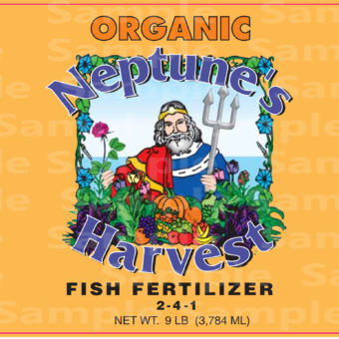
https://goo.gl/images/FMbw1D

6. How many ounces of Nitrogen are in a 20-pound bag with the following label?
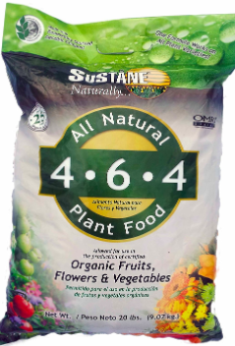

https://goo.gl/images/Tetu8T

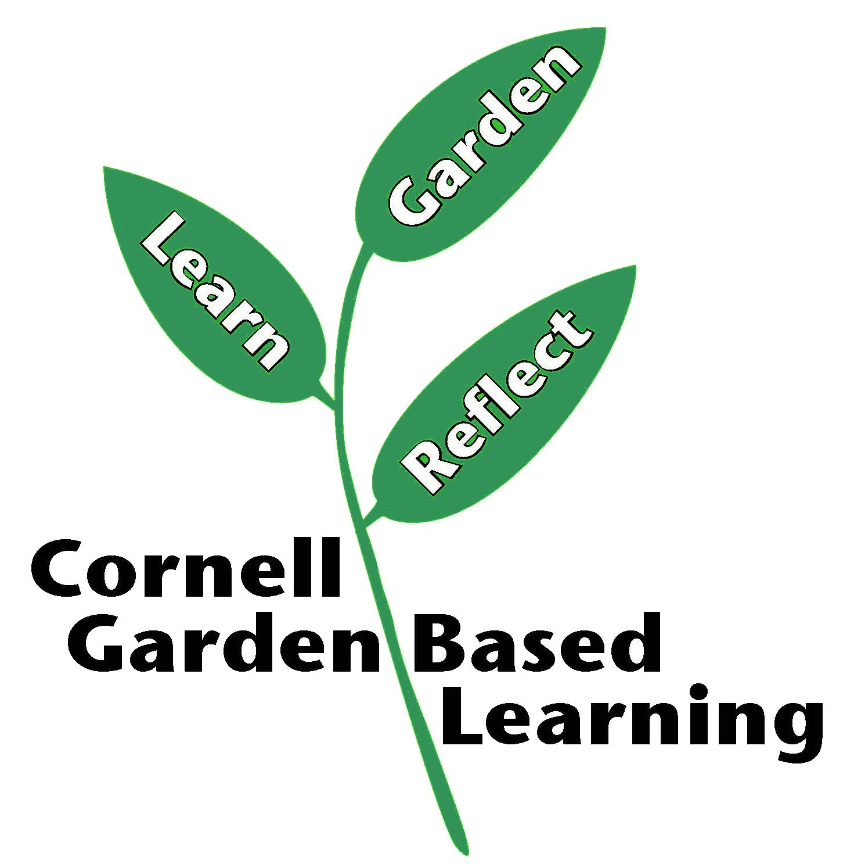

Published: April 2019
Author: Lori Brewer
Reviewer: Fiona Doherty, Michelle Podolec

