4.1b Pesticide Use and Reading Labels
Knowledge Check (3 of 4)
This Knowledge Check covers presentation segments
Environmental Concerns, Laws and Regulations

- Name two considerations for protecting the environment from pesticides.
- Name three possible effects of pesticides in the environment.
- Name three pesticide characteristics that affects how a pesticide moves in the environment and define them.

- What are three ways pesticides can be transported in the environment?
- What are examples of sensitive areas that might be affected by pesticides?
- How can surface water can become contaminated with pesticides?
- What factors affect runoff?
- How can groundwater become contaminated by pesticides?
- What are the pesticide characteristics that affect pesticides leaching to groundwater?

- What are the site characteristics that affect pesticides leaching to groundwater?
- What are ways to prevent water contamination with pesticides?
- What is the Federal Fungicide, Insecticide, and Rodenticide Act and who enforces it?
- What is a minimum-risk pesticide?
- Do minimum-risk pesticides require registration?
- Do minimum-risk pesticide have to be used according to their label?
- Name the New York State law that governs distribution, sale, use, and transportation of pesticides in New York State.

- What state agency is responsible for enforcing pesticide laws and regulations in New York State?

- What are some examples of how the NYSDEC can be more restrictive with pesticides compared to the EPA?

- Where do you go to find what pesticides are currently registered in New York State?
- List 5 unique New York State pesticide requirements.
- Explain how to properly store a pesticide.
- Explain how to properly transport pesticides.
- What is the best way to handle a pesticide spill?

- If you have a pesticide spill, what should you do?
- How do you handle pesticide wastes?
- Explain the responsibilities of Cornell Cooperative Extension educators and Master Gardener Volunteers when making pesticide recommendations.

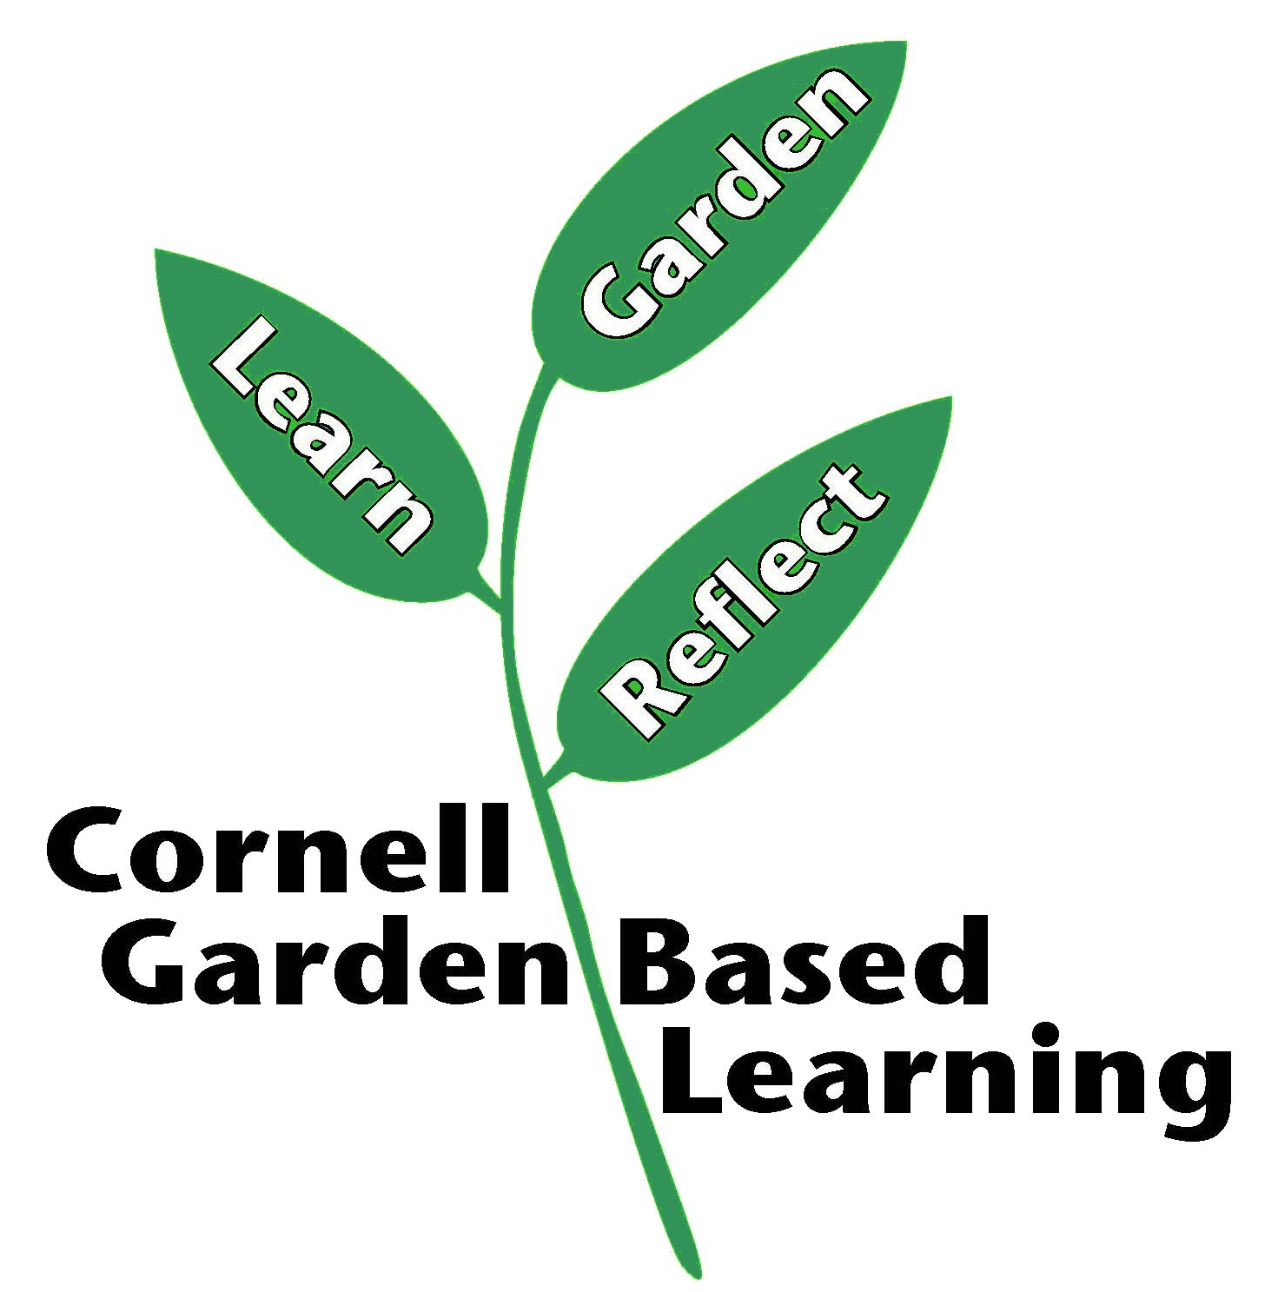

References: Pesticide Management Education Program (PMEP)
Date Published/Updated: September 2, 2020
Author(s)/Contributor(s): Michael Helms (PMEP)
Reviewer(s): Ashley M. Helmholdt, Donna Alese Cooke

