4.1b Pesticide Use and Reading Labels
Knowledge Check (1 of 4)
This Knowledge Check covers presentation segments
Pesticide Basics & Formulations

- What is a pesticide?
- What is not a pesticide?
- What are sources of pesticides?
- How do pesticides differ?
- Identify materials that contain pesticides.
- What are some pesticide characteristics that make it useful?
- What is a pesticide formulation?
- What is a pesticide active ingredient?
- What is a pesticide inert ingredient?
- What is a pesticide trade name?

- What is a pesticide’s chemical name?
- What is a pesticide’s common name?
- What is the relationship between a pesticide’s trade name and its active ingredient or ingredients?

- What might different trade names mean to a pesticide user?
- Why is a pesticide formulation important?
- Name two pesticide formulations available to homeowners.
- When choosing a pesticide formulation, what should you consider?
- Explain the responsibilities of Cornell Cooperative Extension educators and Master Gardener Volunteers when making pesticide recommendations.

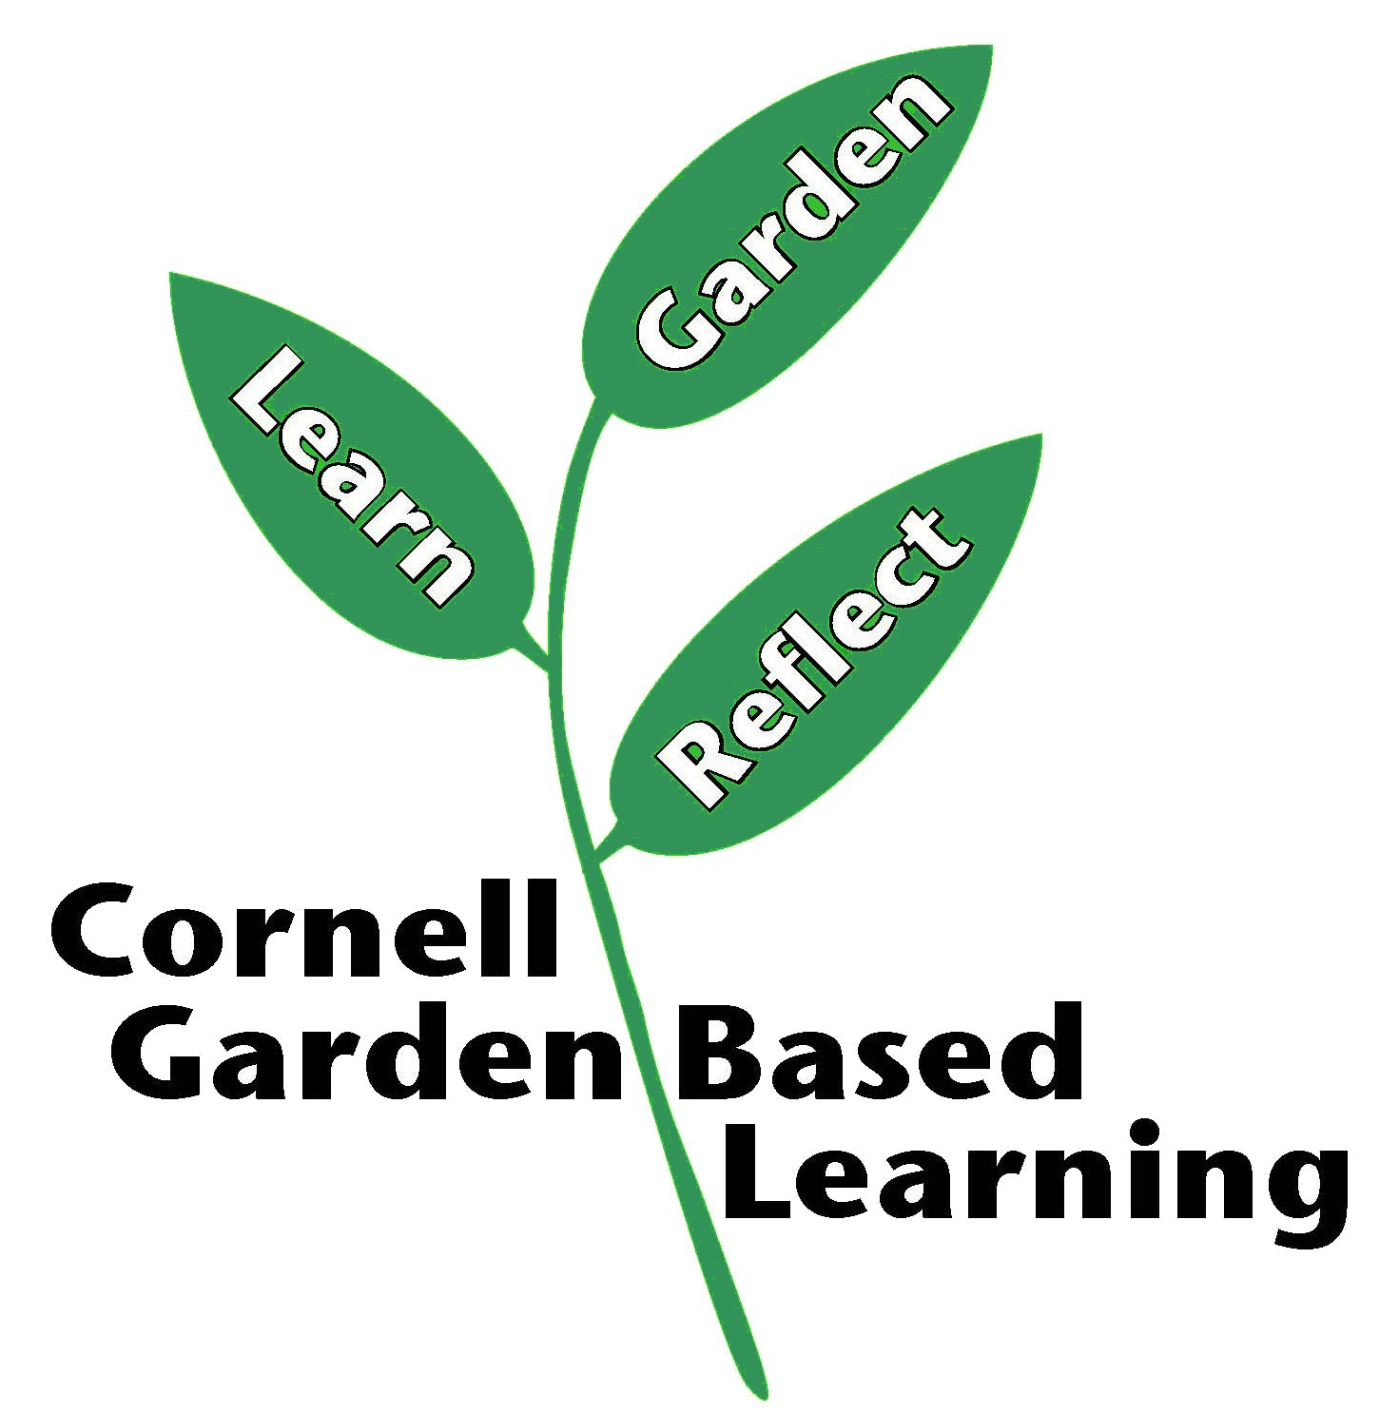

References: Pesticide Management Education Program (PMEP)
Date Published/Updated: September 2, 2020
Author(s)/Contributor(s): Michael Helms (PMEP)
Reviewer(s): Ashley M. Helmholdt, Donna Alese Cooke

