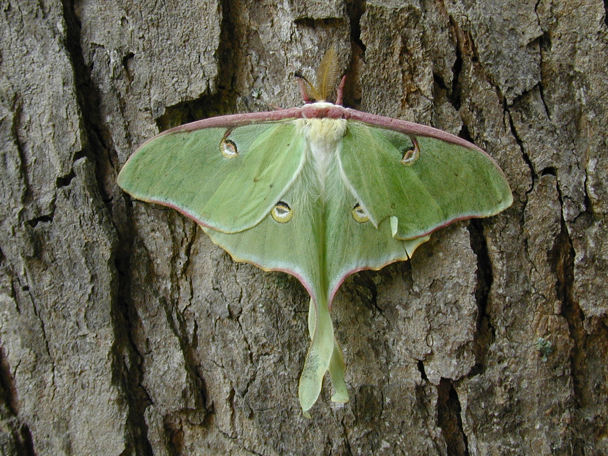

Species | Family | Order | trophic level
Actias luna | Saturniidae | Lepidoptera | herbivore

Luna Moth
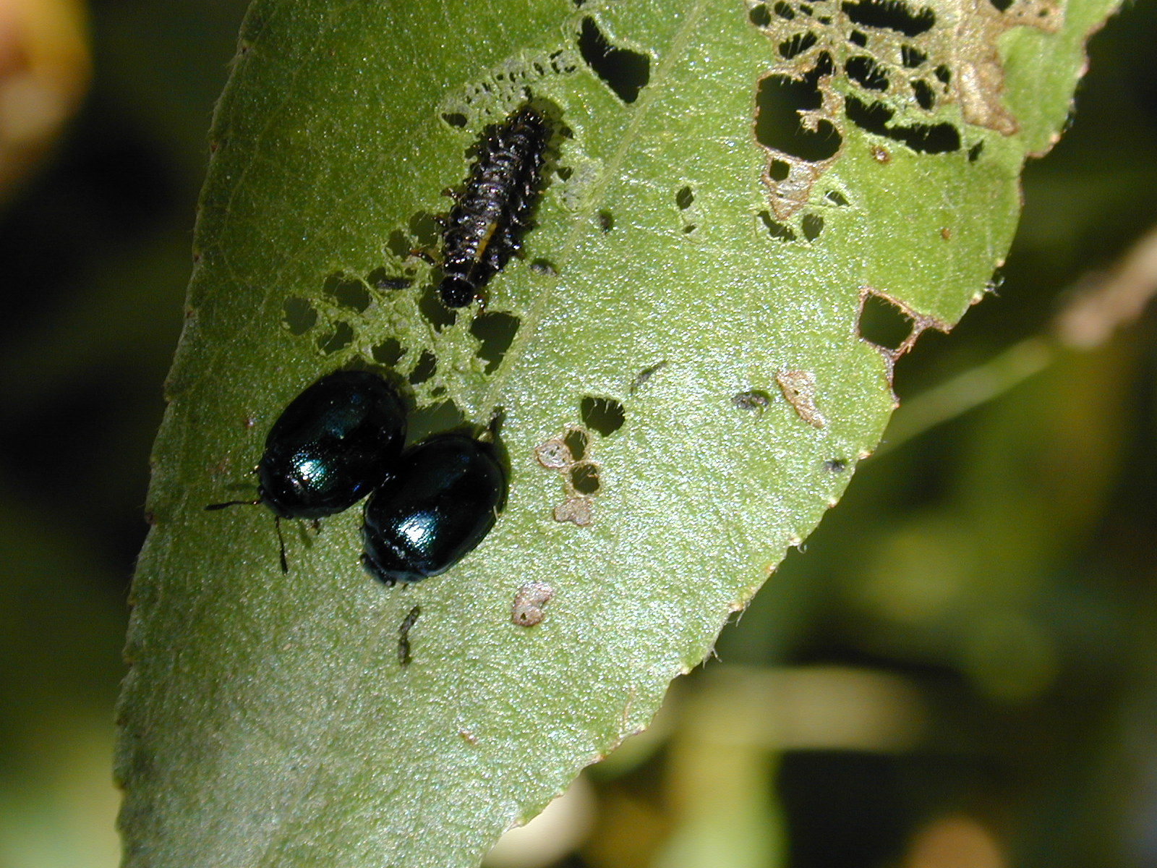
Species | Family | Order | trophic level
Altica sp. | Chrysomelidae | Coleoptera | herbivore

Flea Beetle

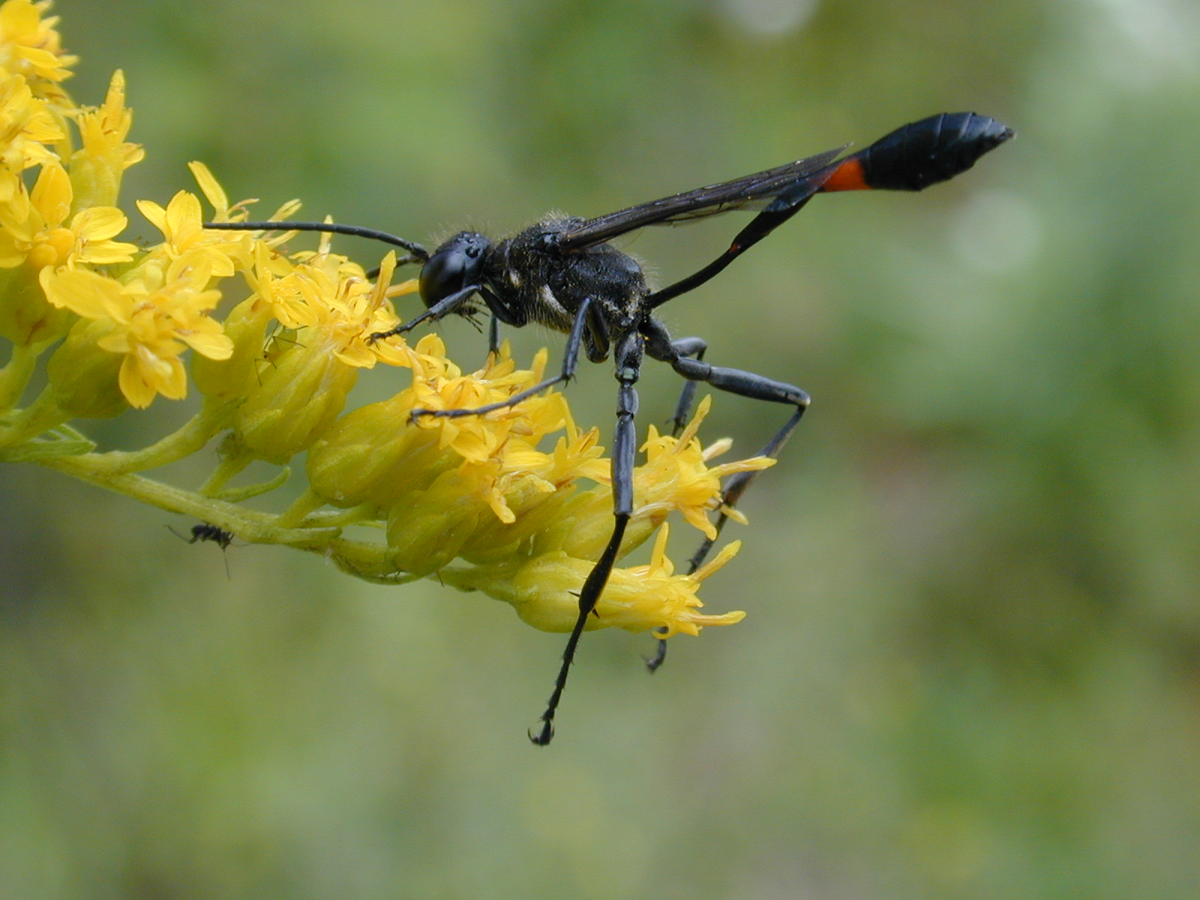
Species | Family | Order | trophic level
Ammophila urnaria | Sphecidae | Hymenoptera | predator and pollinator

Thread-Waisted Wasp

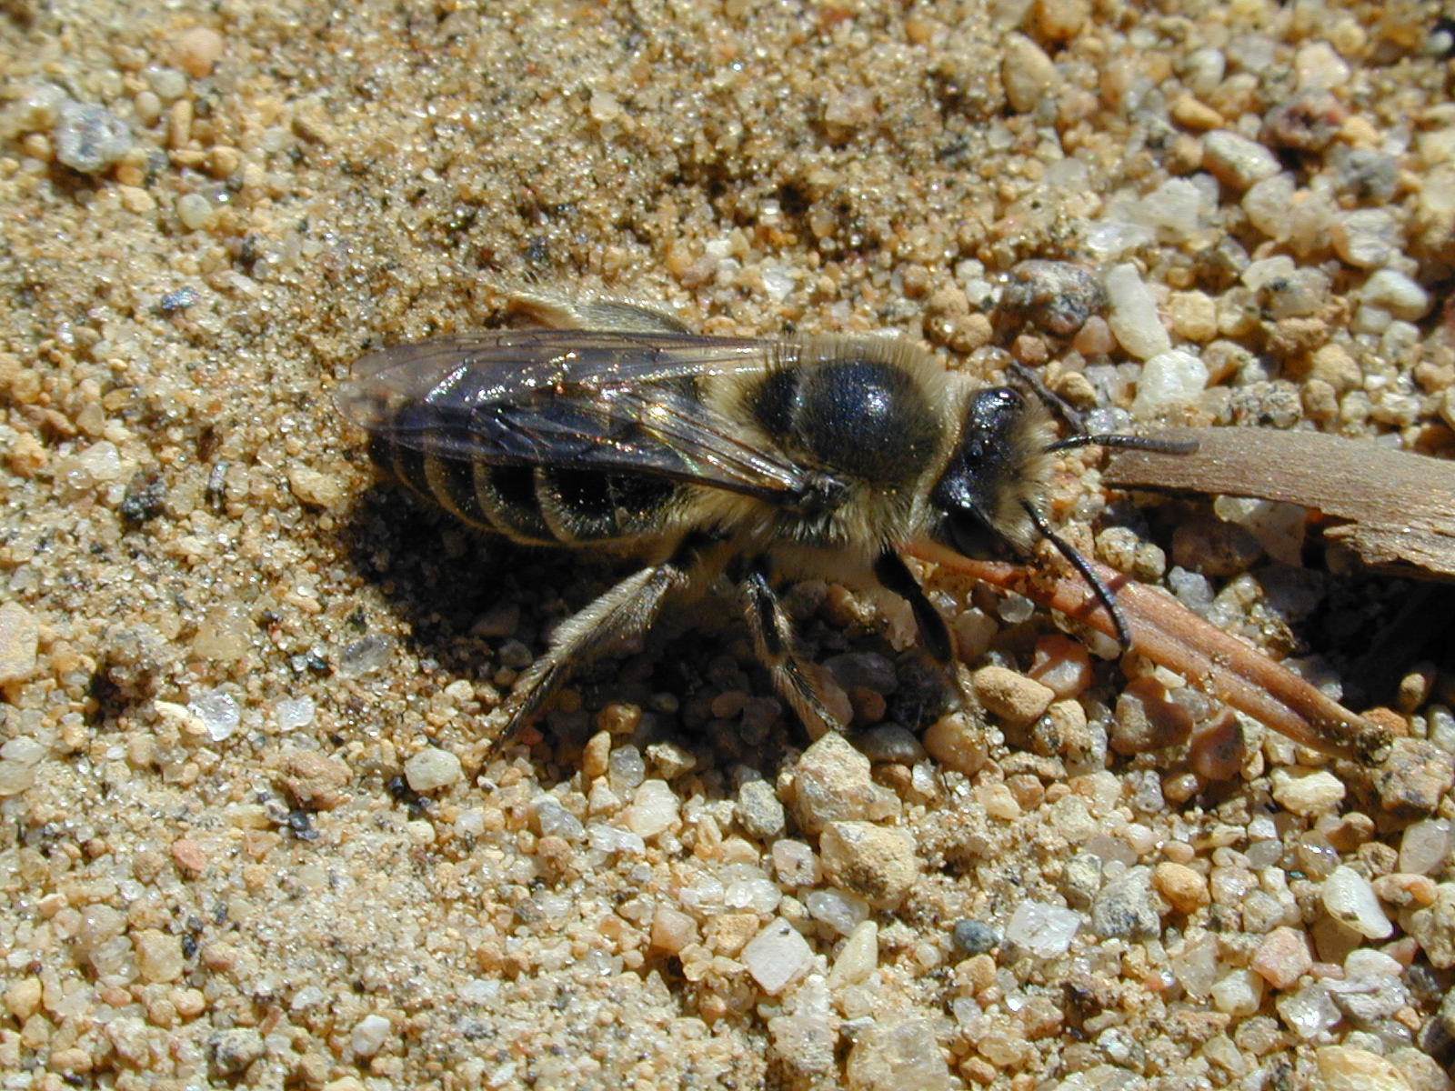
Species | Family | Order | trophic level
Andrena sp. | Andrenidae | Hymenoptera | pollinator

Andrenid Bee

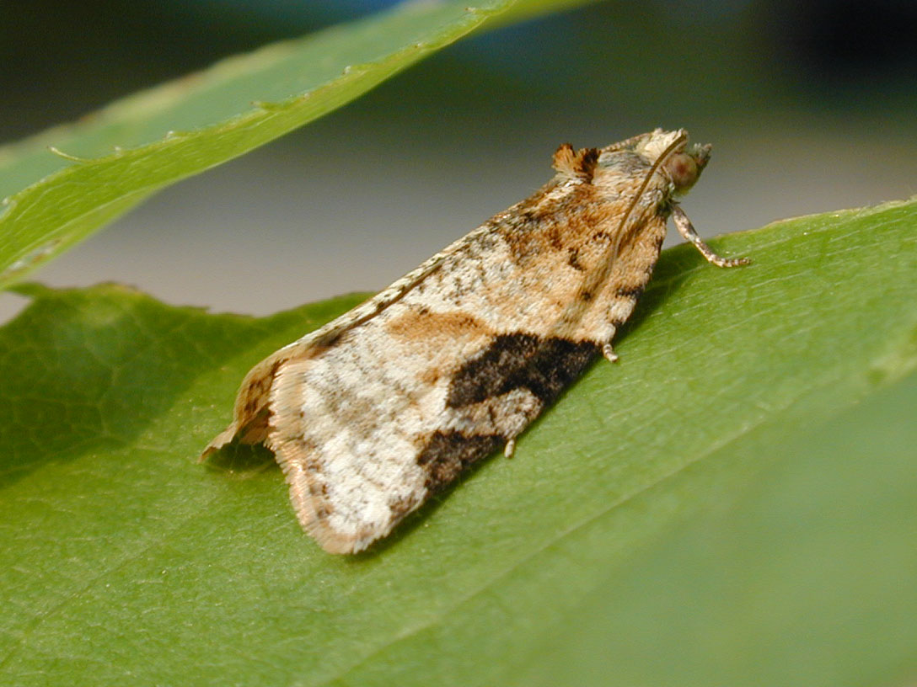
Species | Family | Order | trophic level
Argyrotaenia mariana | Tortricidae | Lepidoptera | herbivore

Grey-banded Leafroller

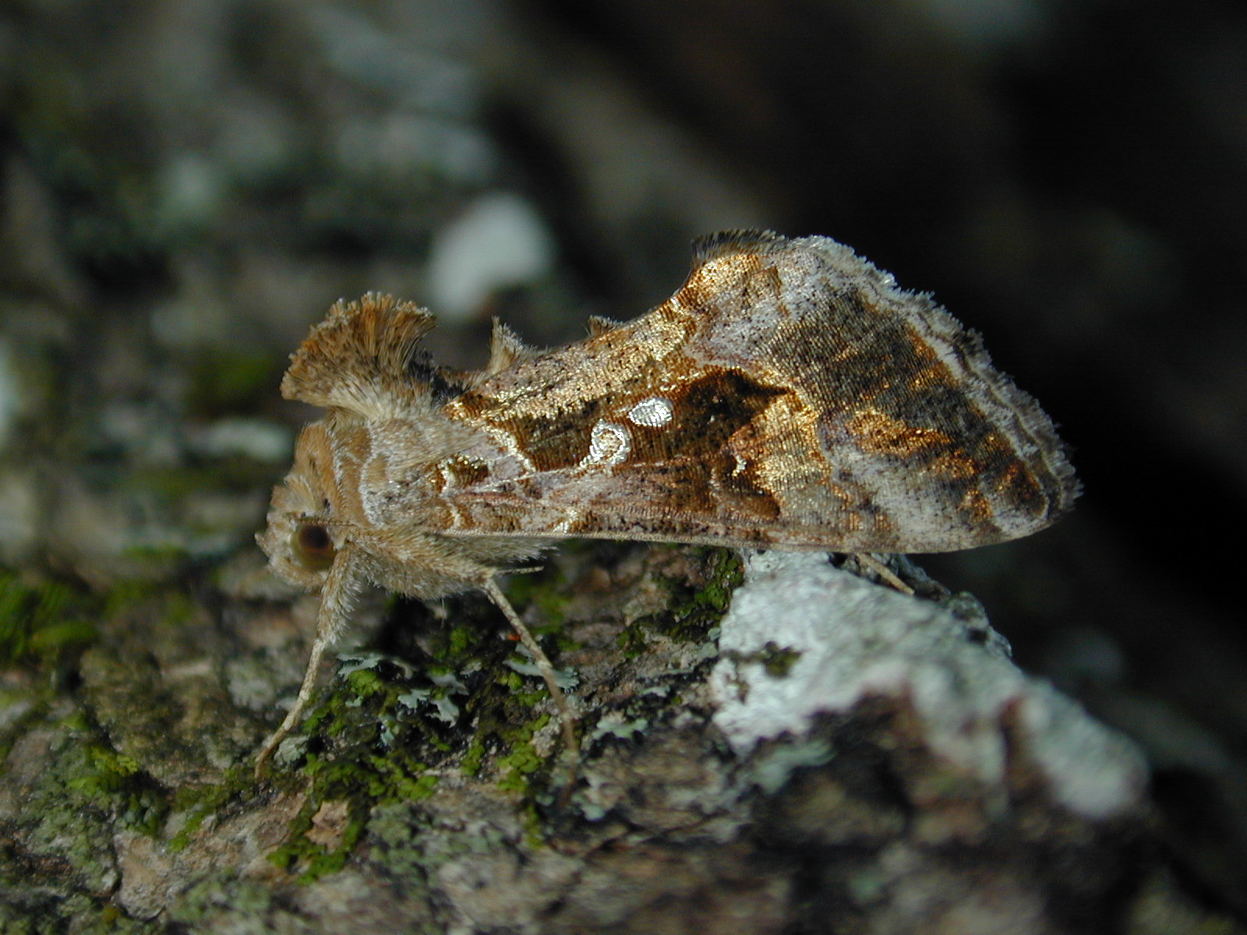
Species | Family | Order | trophic level
Autographa precationis | Noctuidae | Lepidoptera | herbivore and pollinator

Common Looper

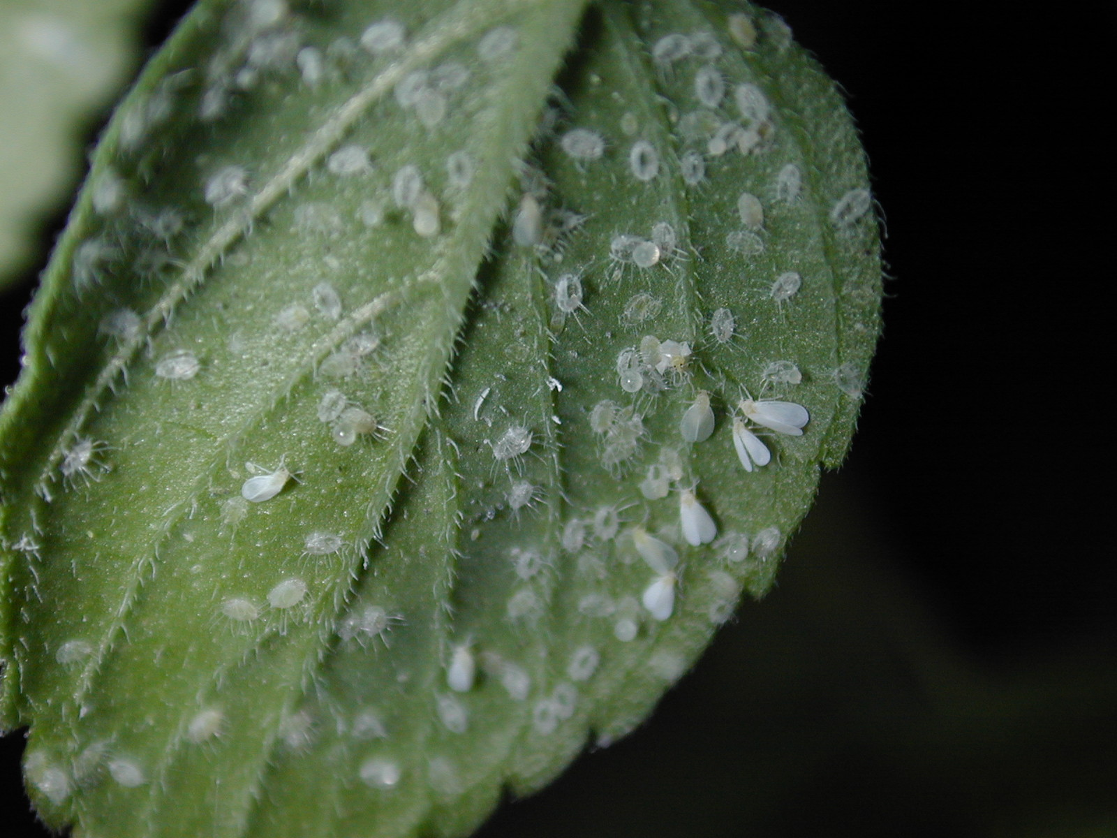
Species | Family | Order | trophic level
Bemisia tabaci or Trialeurodes vaporariorum | Aleyrodidae | Hemiptera | sap feeder

Whitefly

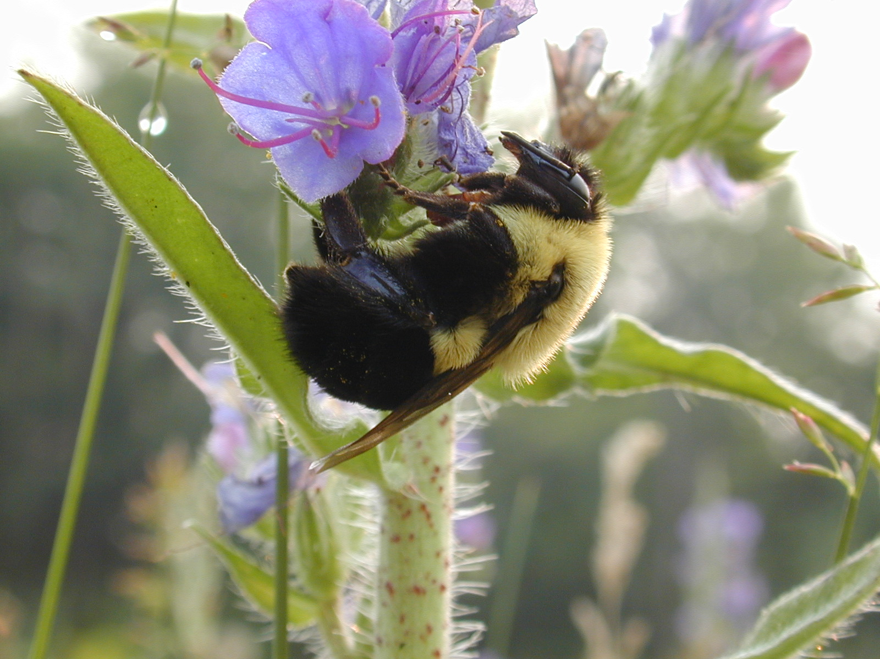
Species | Family | Order | trophic level
Bombus sp. | Apidae | Hymenoptera | pollinator

Bumble Bee

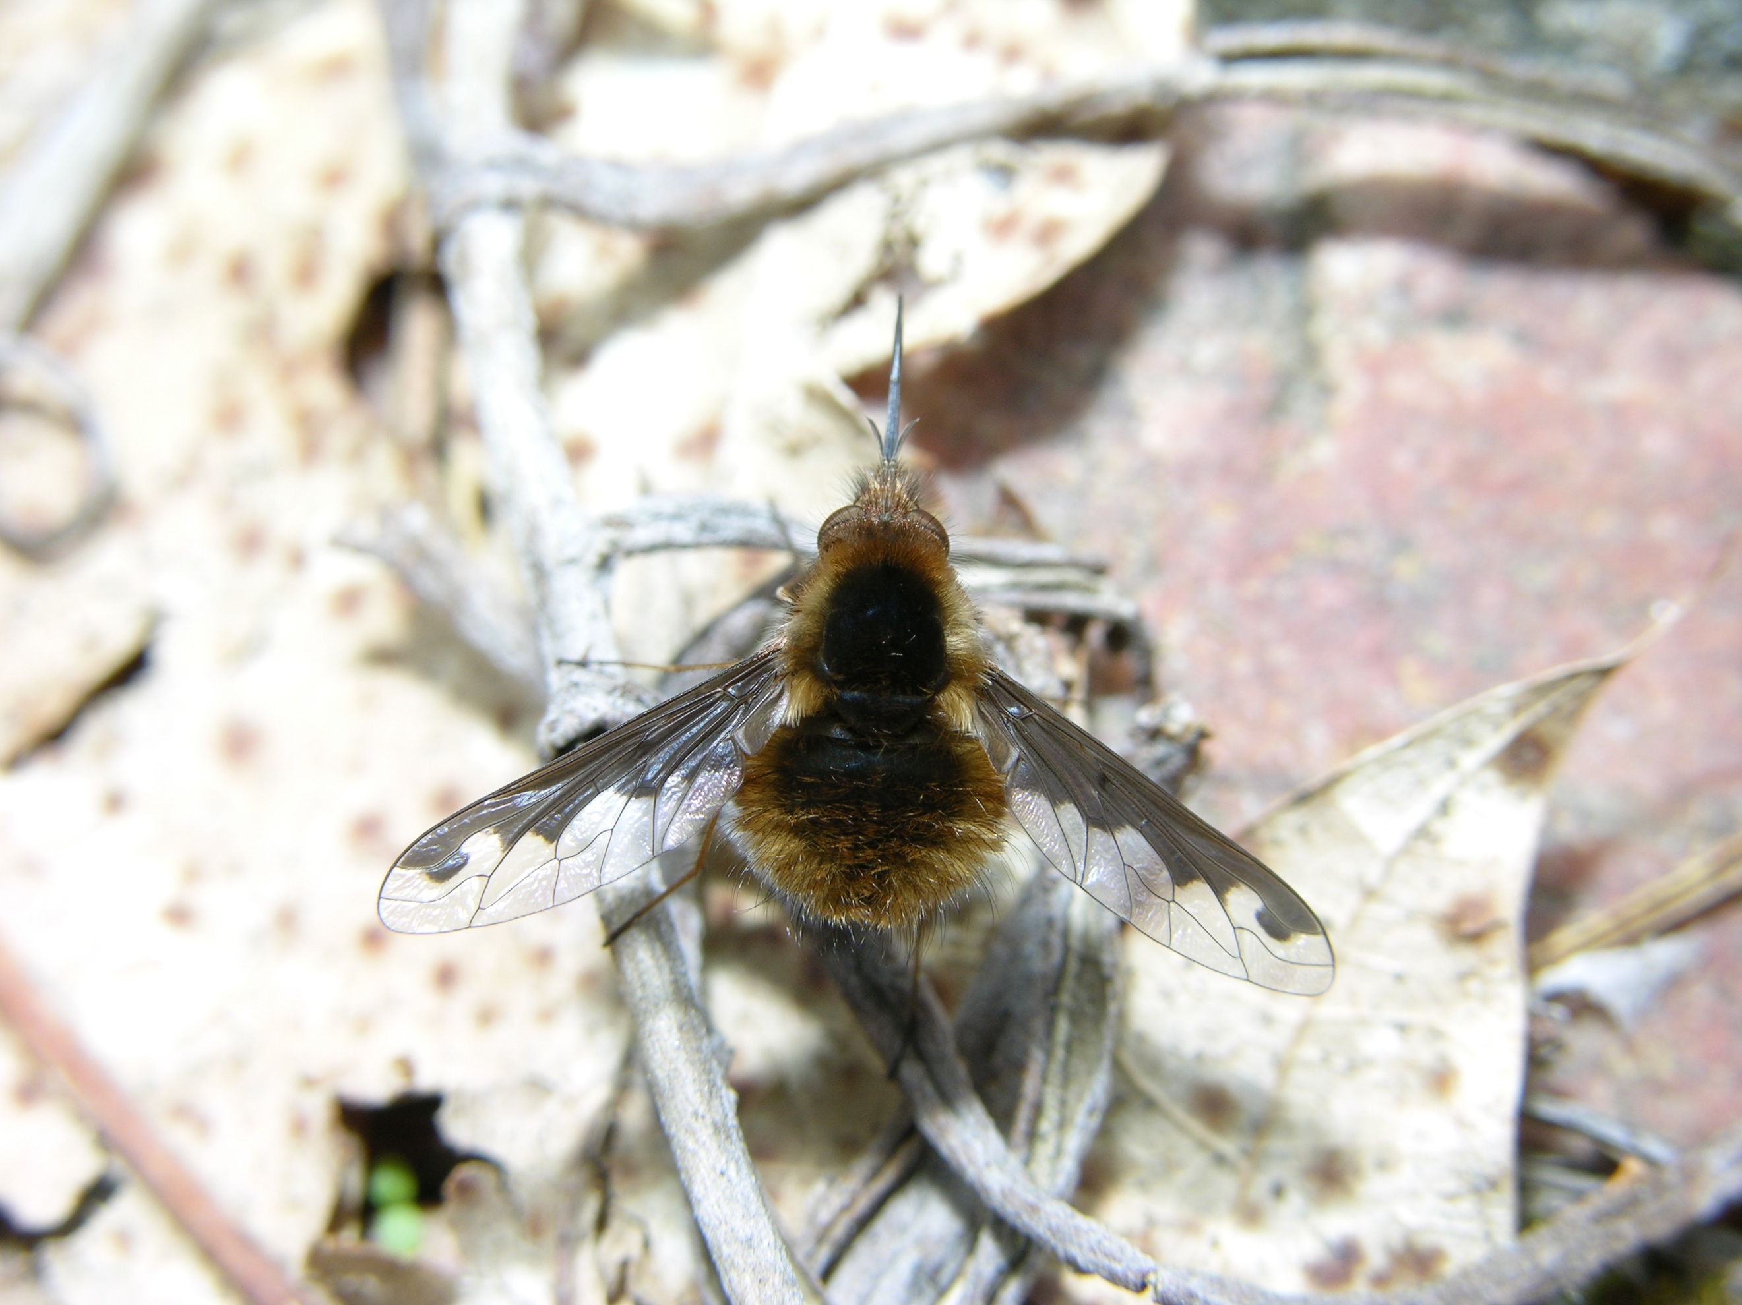
Species | Family | Order | trophic level
Bombylius major | Bombyliidae | Diptera | parasitoid and pollinator

Bee Fly

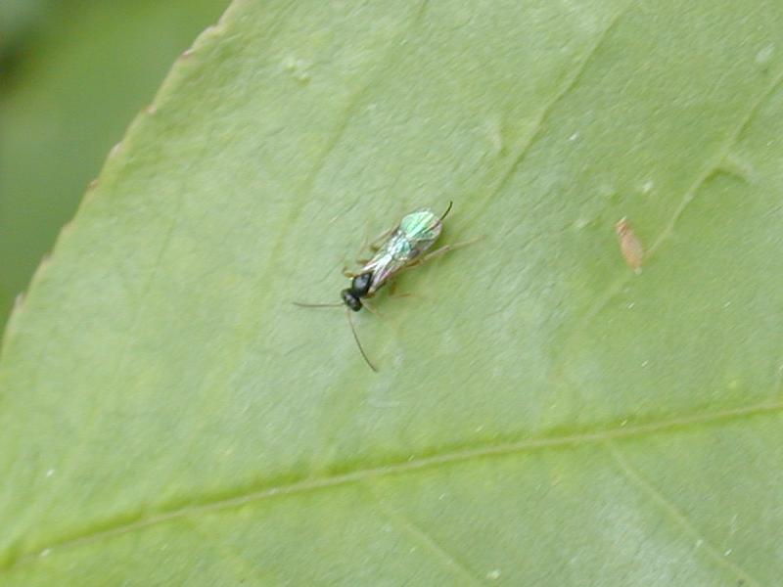

Species | Family | Order | trophic level
Braconidae sp. | Braconidae | Hymenoptera | parasitoid

Braconid Wasp

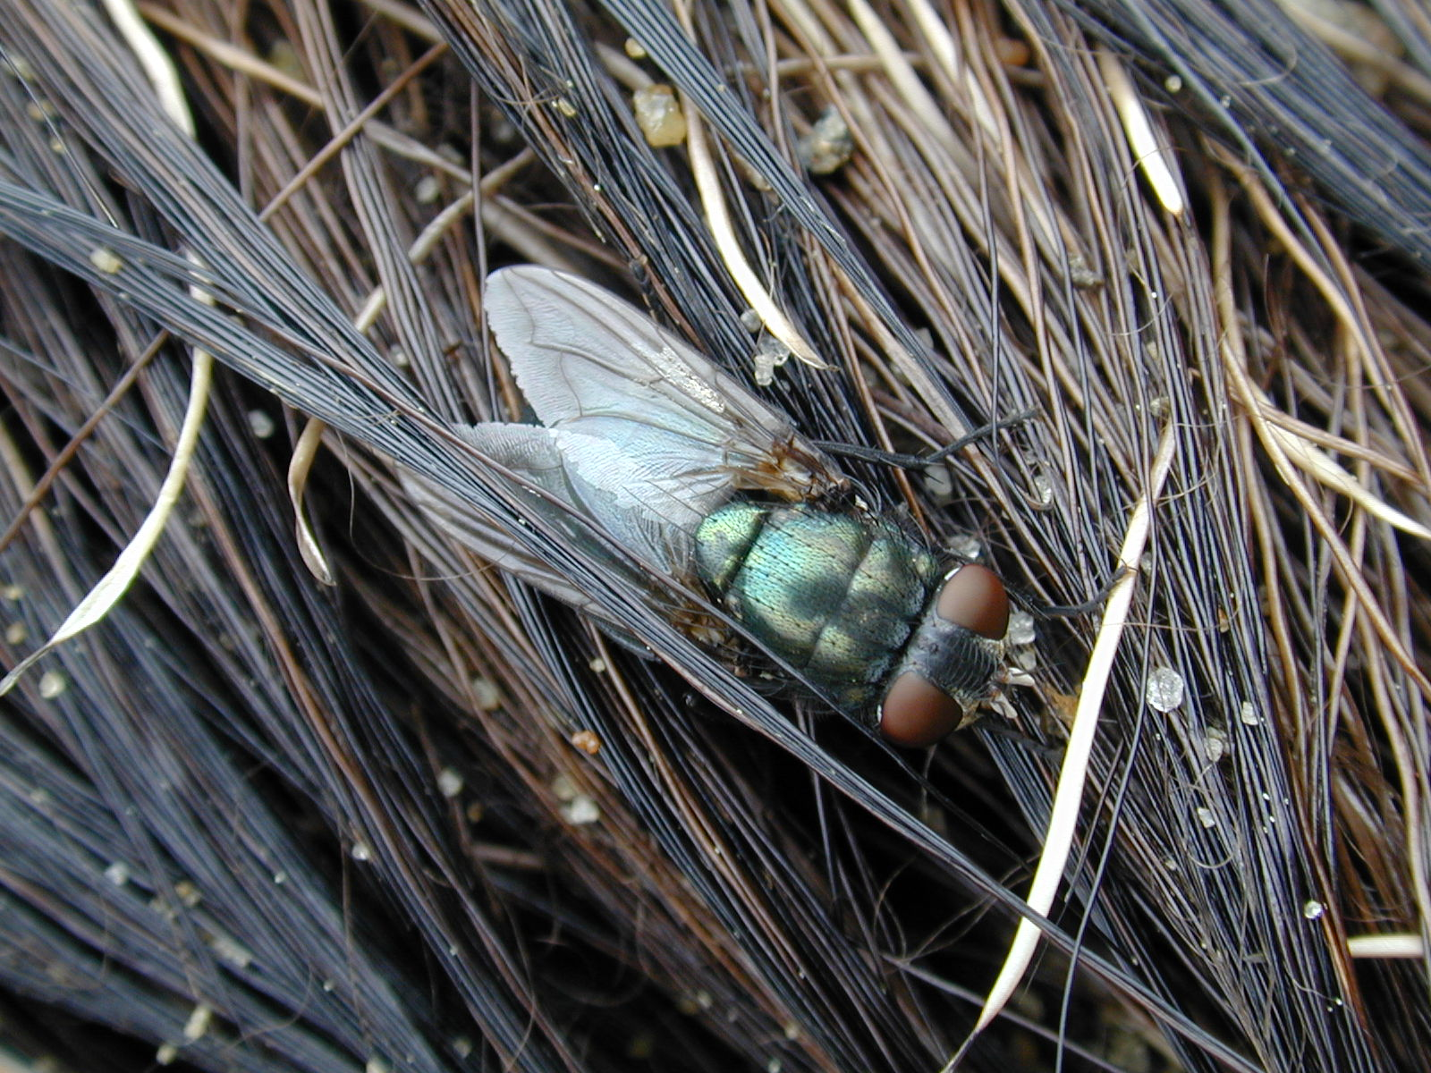
Species | Family | Order | trophic level
Calliphoridae sp. | Calliphoridae | Diptera | decomposer

Blow Fly

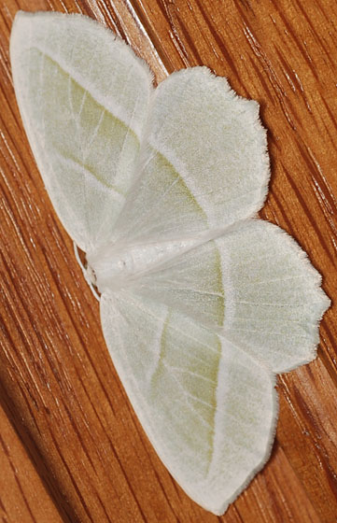

Species | Family | Order | trophic level
Campaea perlata | Geometridae | Lepidoptera | herbivore

Pale Beauty

Photo Sourced: https://bugguide.net/node/view/402197
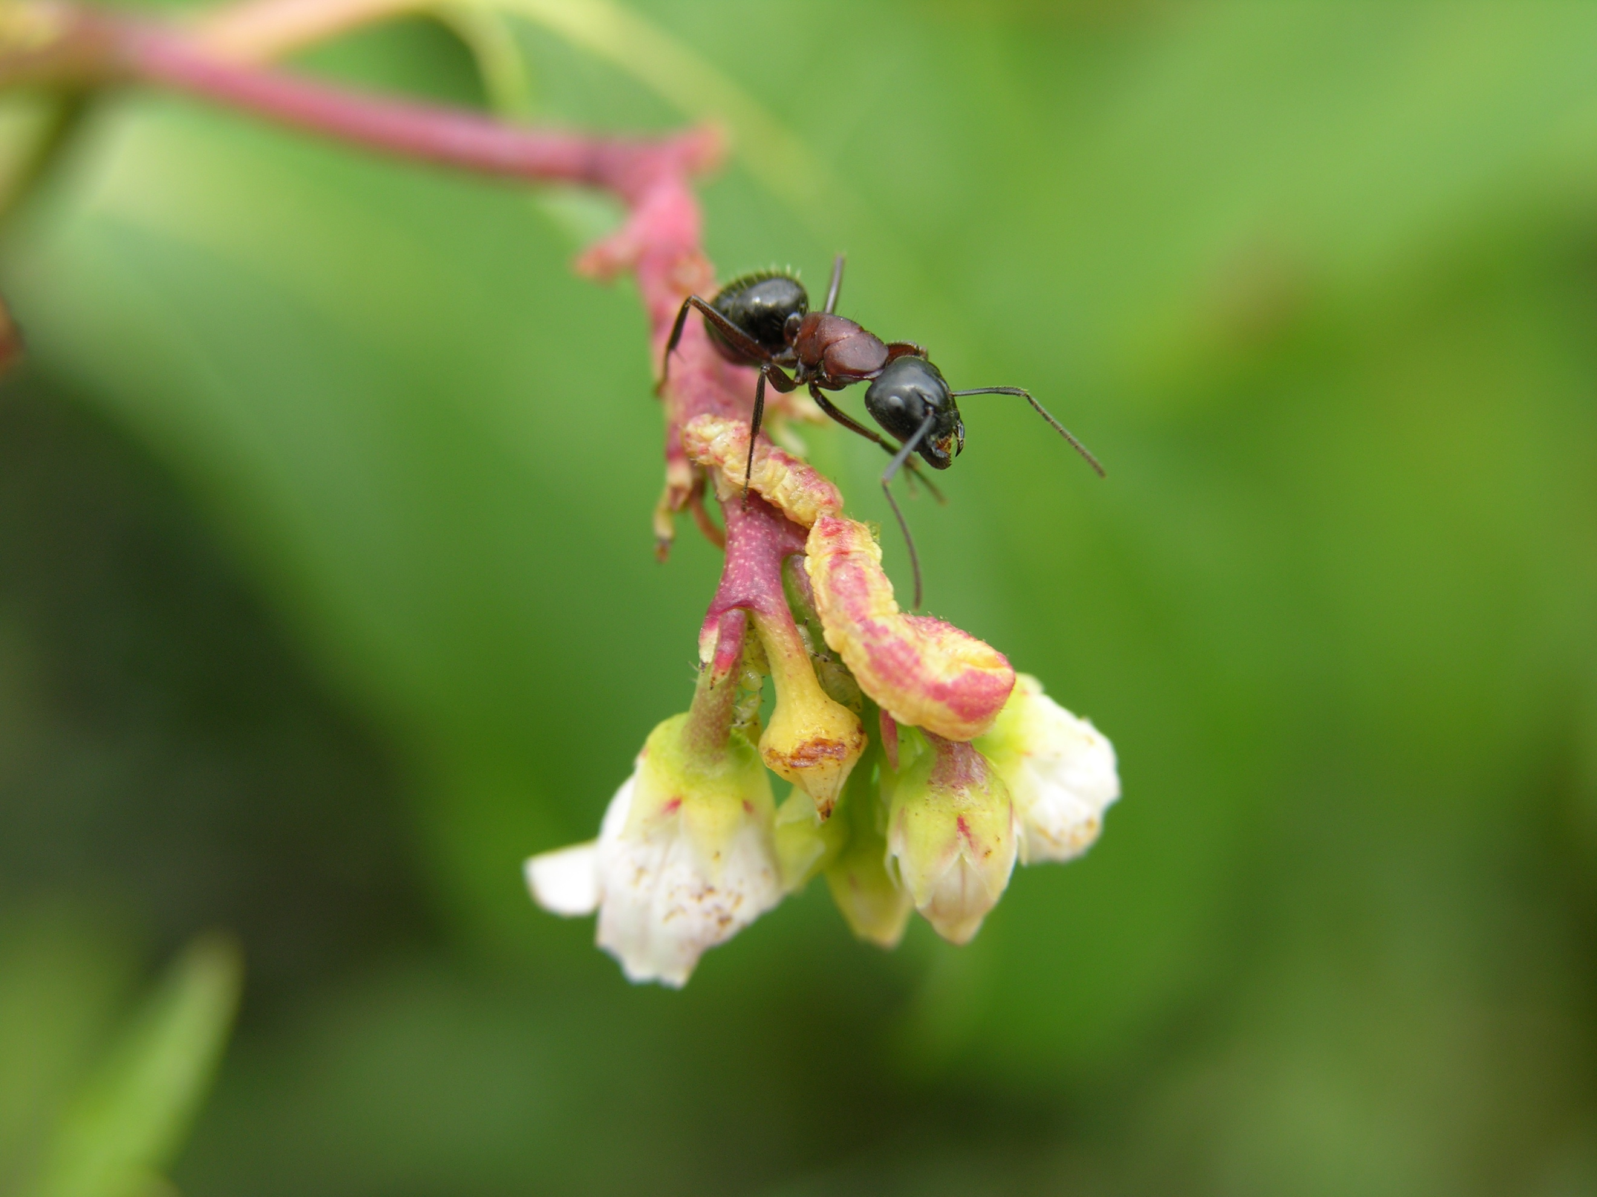

Species | Family | Order | trophic level
Camponotus noveboracensis | Formicidae | Hymenoptera | predator

New York Carpenter Ant
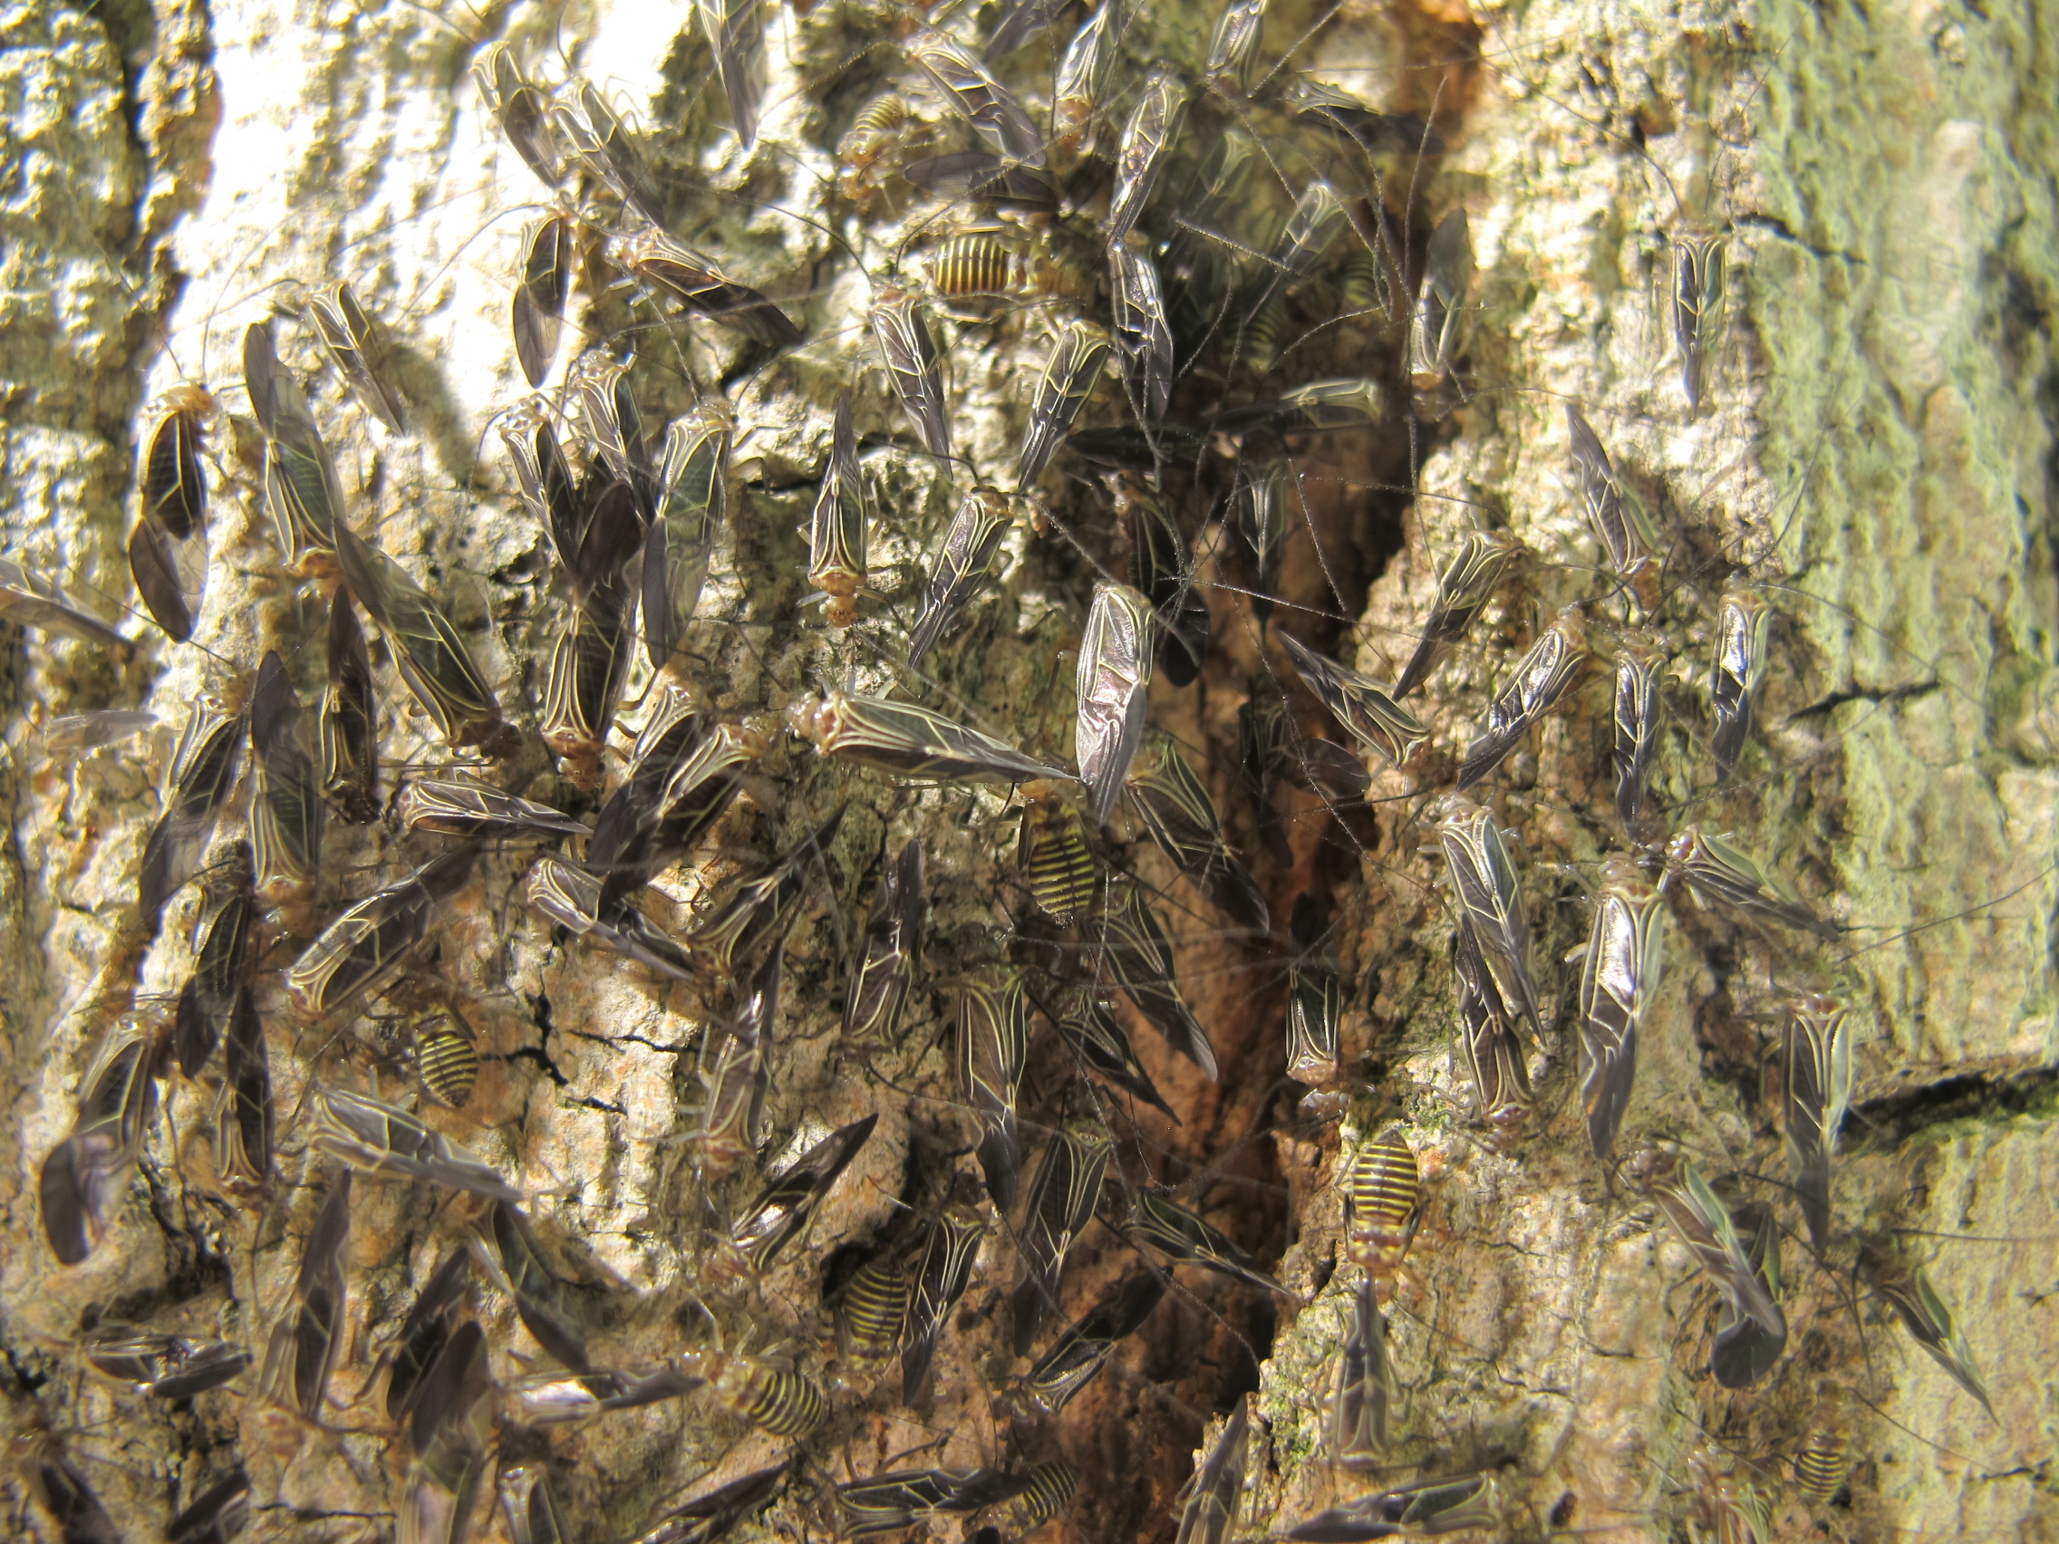
Species | Family | Order | trophic level
Cerastipsocus venosus | Psocidae | Psocodea | scavenger

Barklice

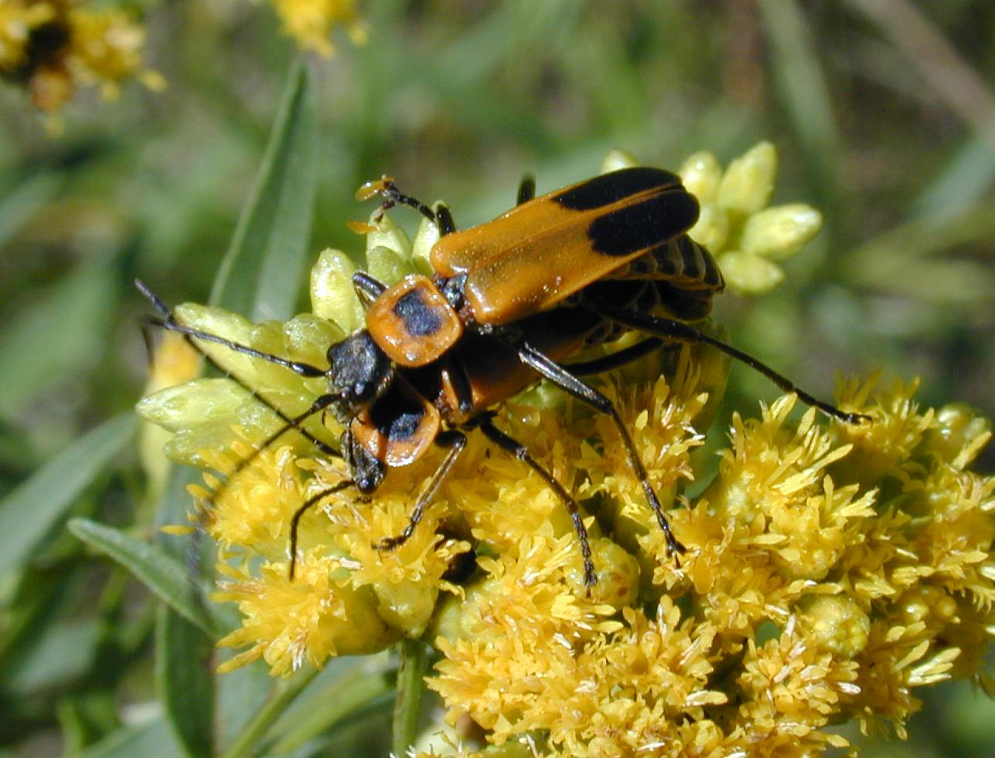
Species | Family | Order | trophic level
Chauliognathus pennsylvanicus | Cantharidae | Coleoptera | predator and pollinator

Soldier Beetle

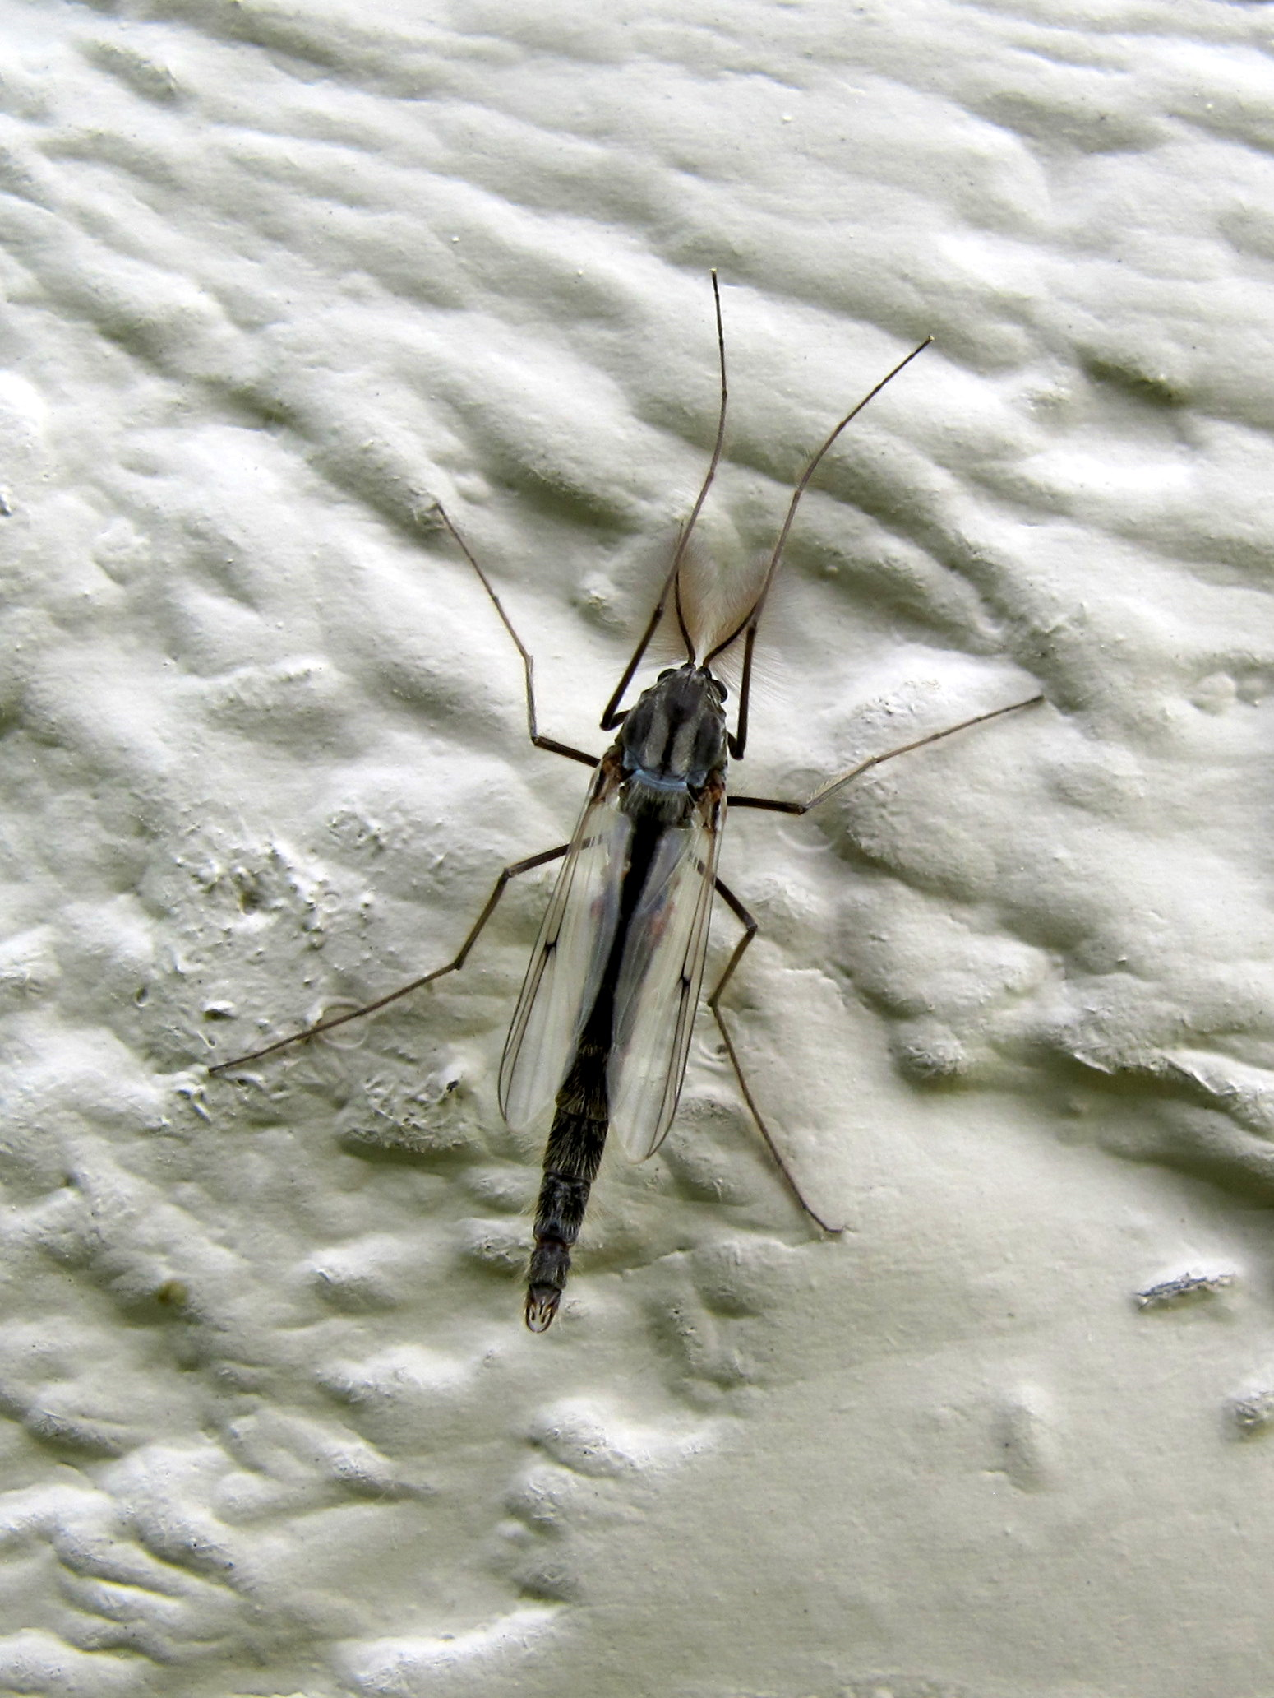
Species | Family | Order | trophic level
Chironomus pilicornis | Chironomidae | Diptera | decomposer, adults don't feed

Midge

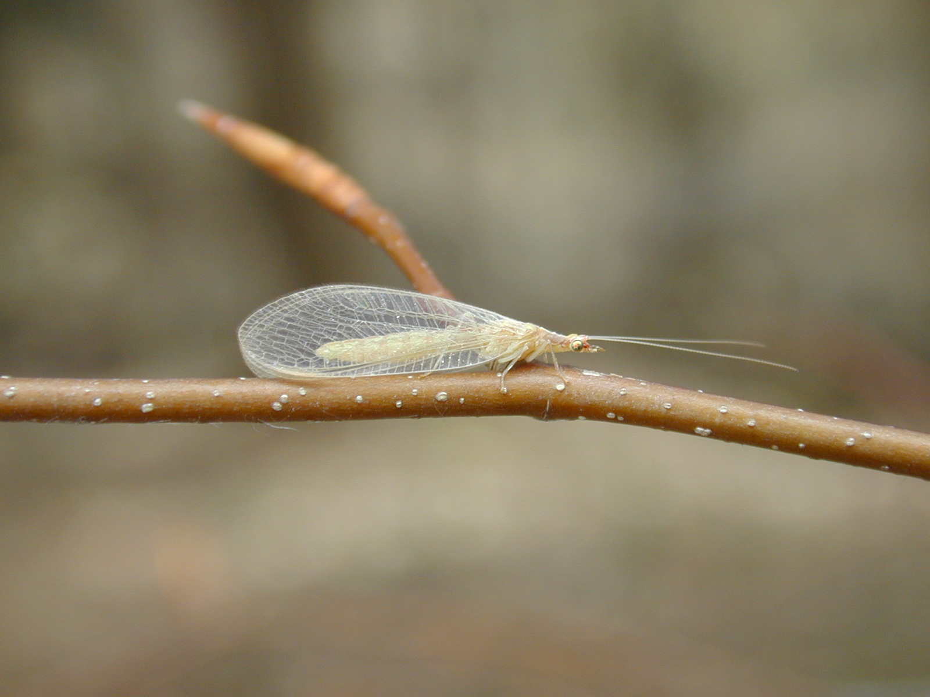
Species | Family | Order | trophic level
Chrysoperla sp. | Chrysopidae | Neuroptera | predator

Green Lacewing

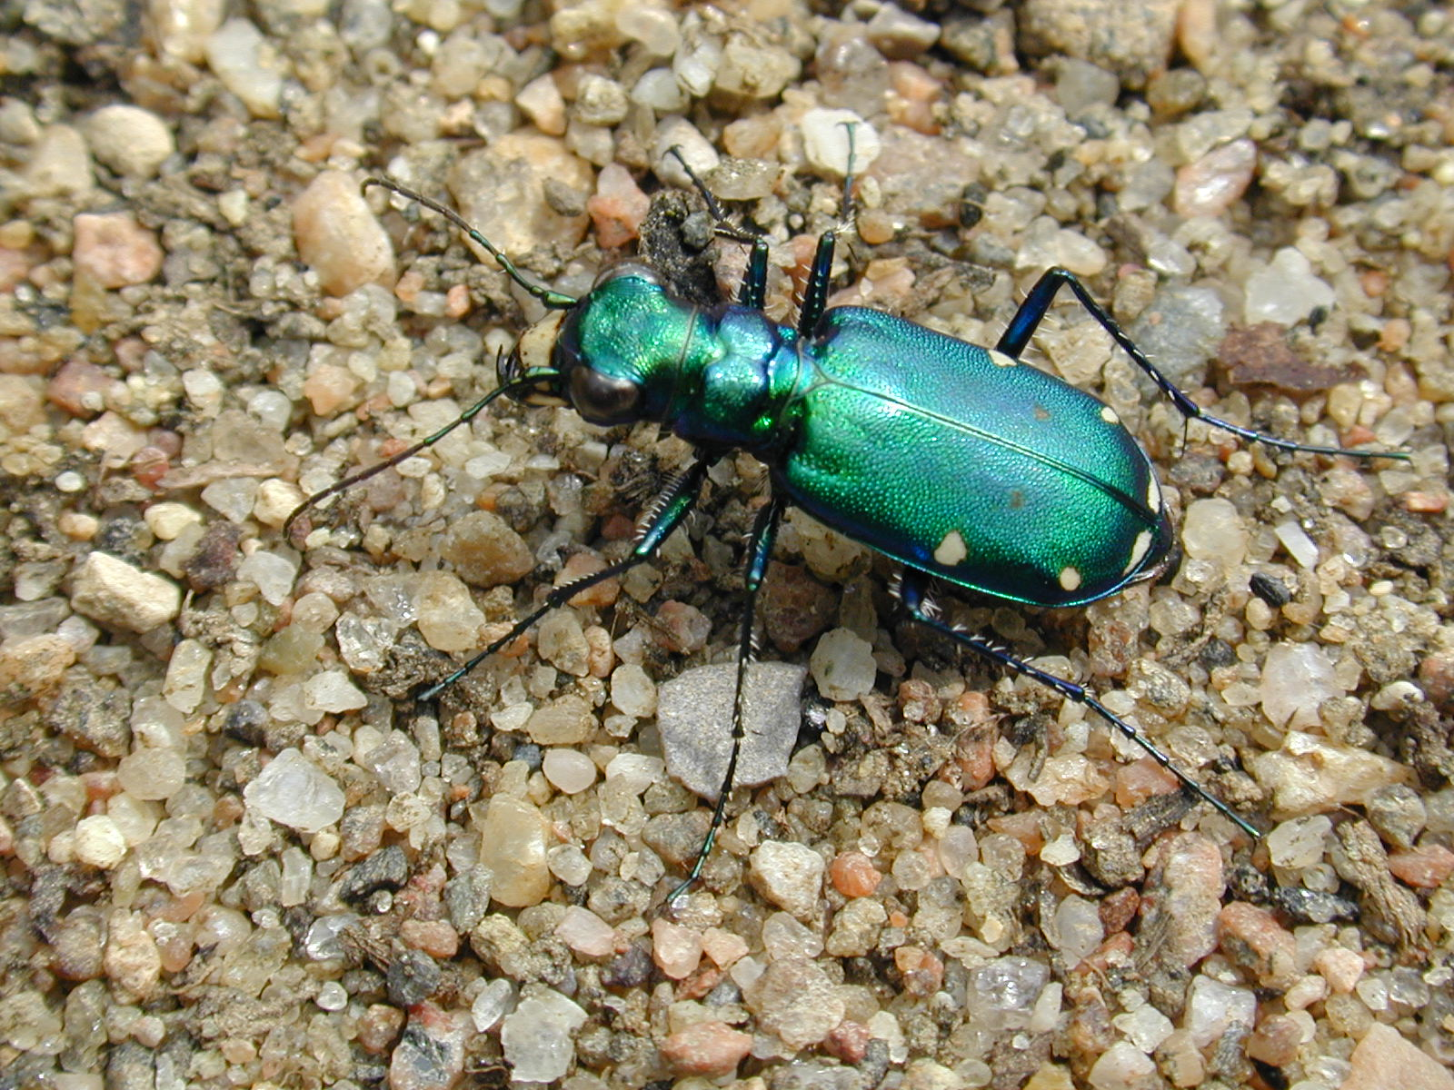
Species | Family | Order | trophic level
Cicindela sexguttata | Carabidae | Coleoptera | predator

Six-spotted Tiger Beetle
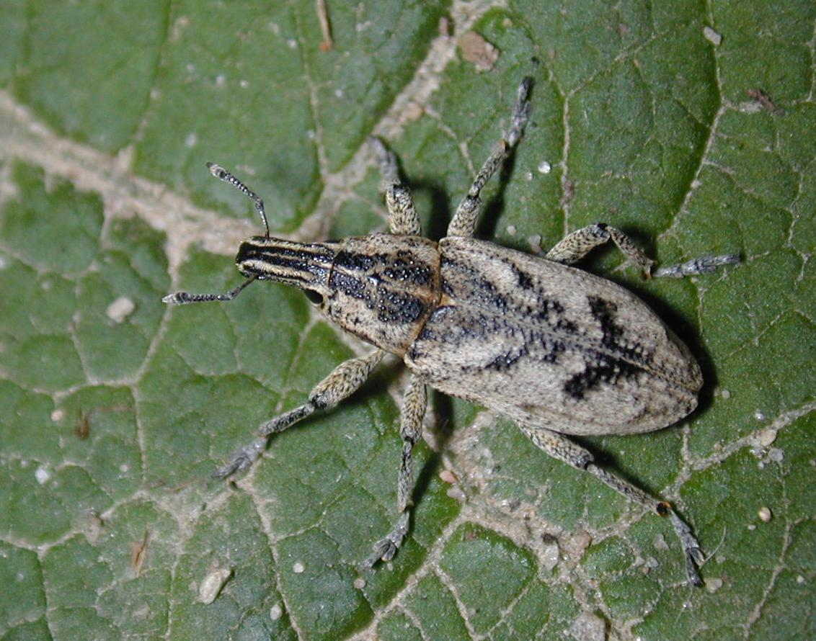
Species | Family | Order | trophic level
Cleonis piger | Curculionidae | Coleoptera | herbivore

Weevil

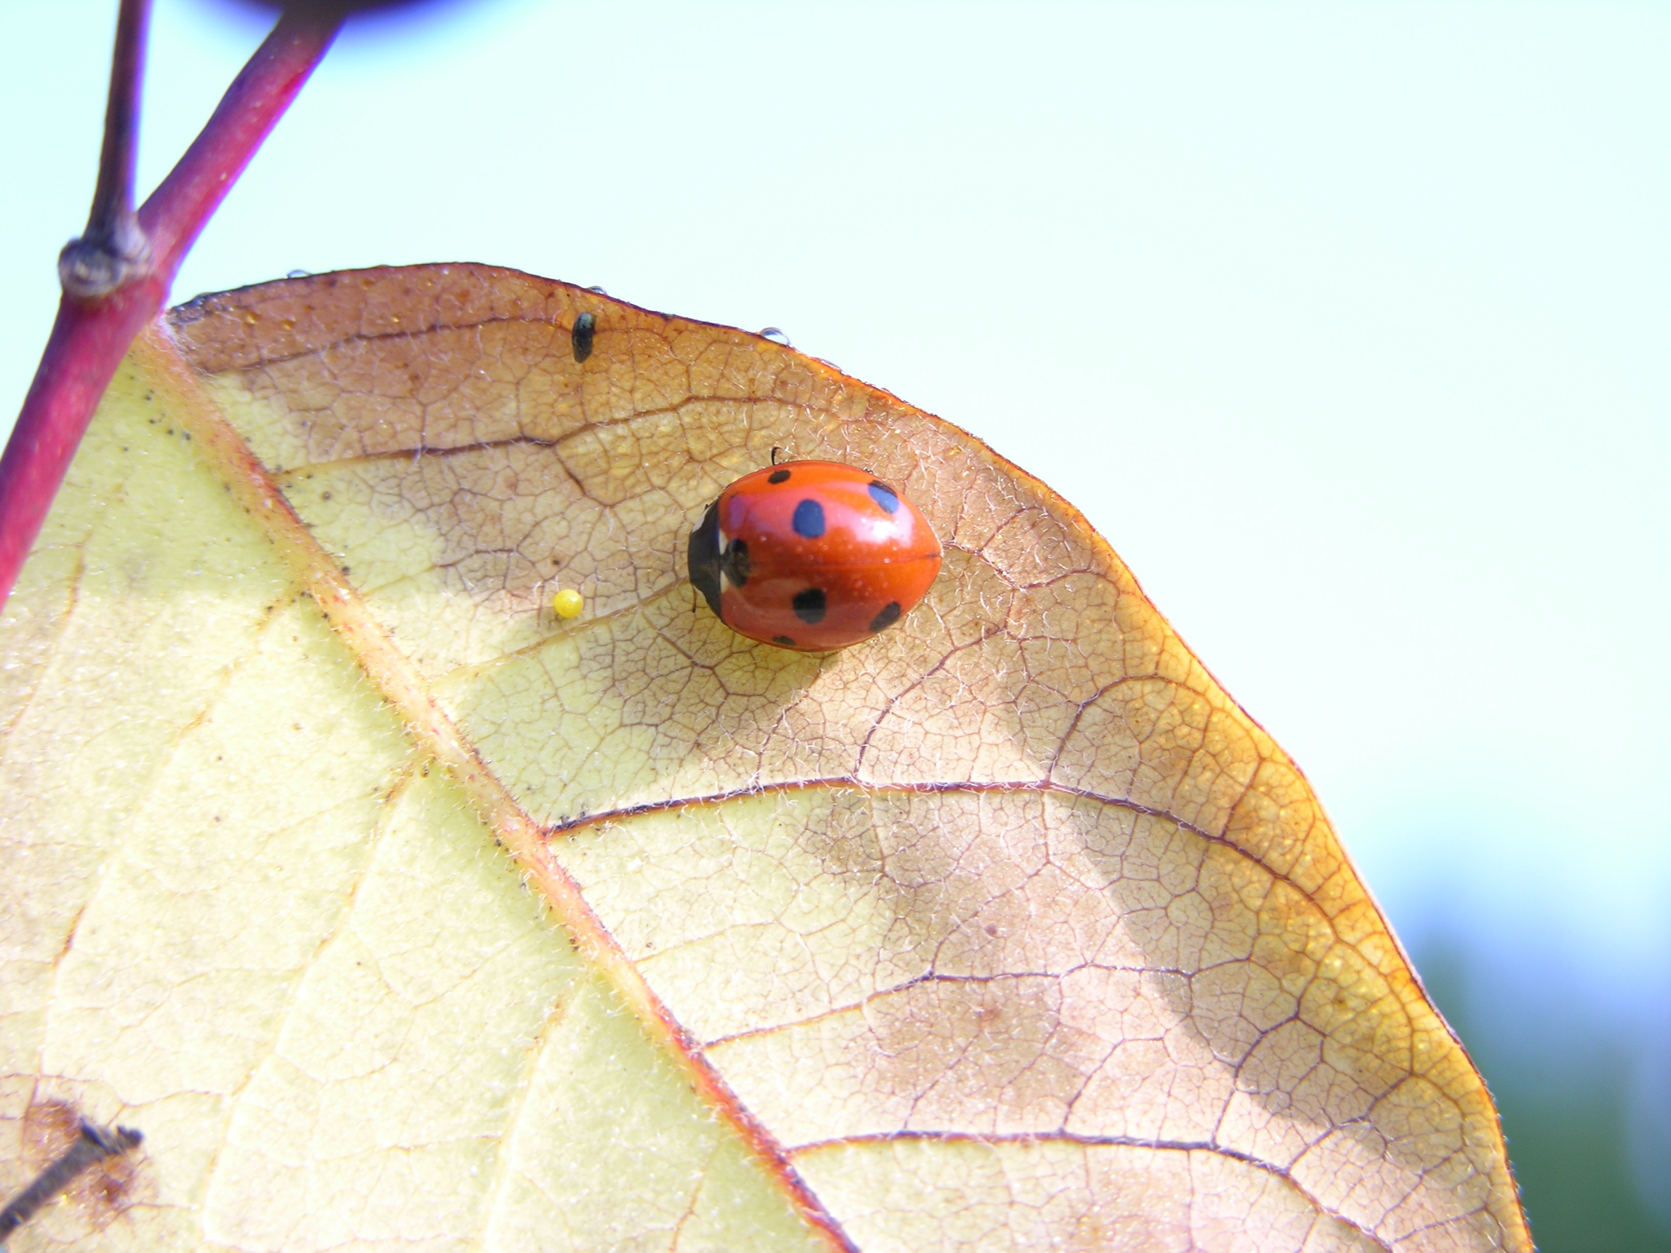
Species | Family | Order | trophic level
Coccinella septempunctata | Coccinellidae | Coleoptera | predator

Seven-spotted Lady Beetle

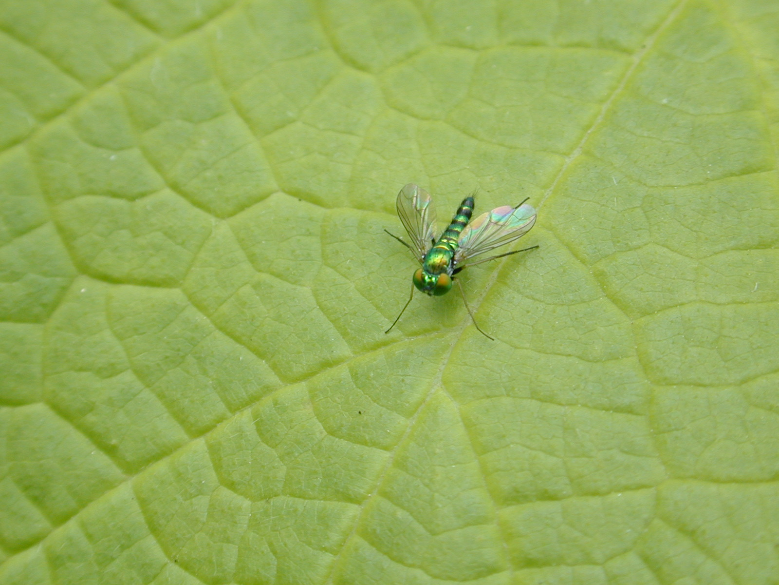
Species | Family | Order | trophic level
Condylostylus caudatus | Dolichopodidae | Diptera | decomposer and predator

Long-legged Fly

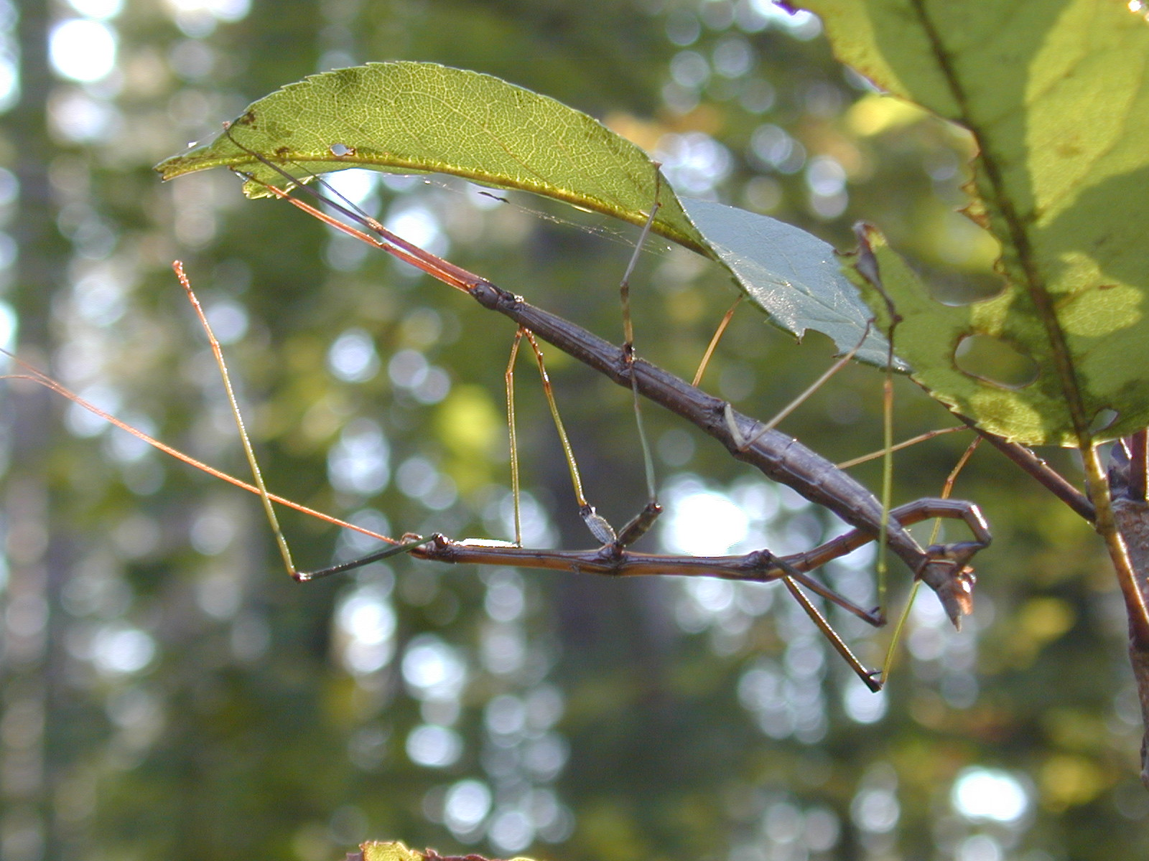
Species | Family | Order | trophic level
Diapheromera femorata | Diapheromeridae | Phasmida | herbivore

Northern Walkingstick

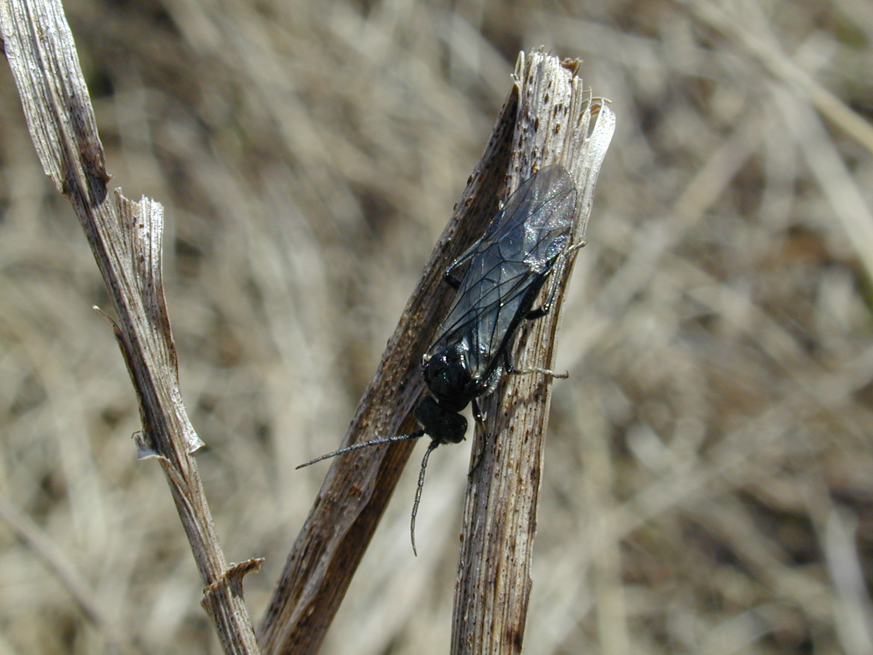
Species | Family | Order | trophic level
Dolerus sp. | Tenthredinidae | Hymenoptera | herbivore and pollinator

Sawfly

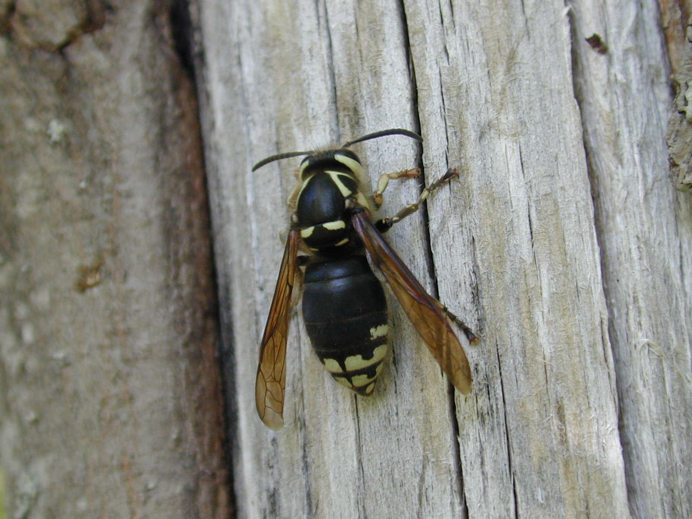
Species | Family | Order | trophic level
Dolichovespula maculata | Vespidae | Hymenoptera | predator and pollinator

Bald-faced Hornet

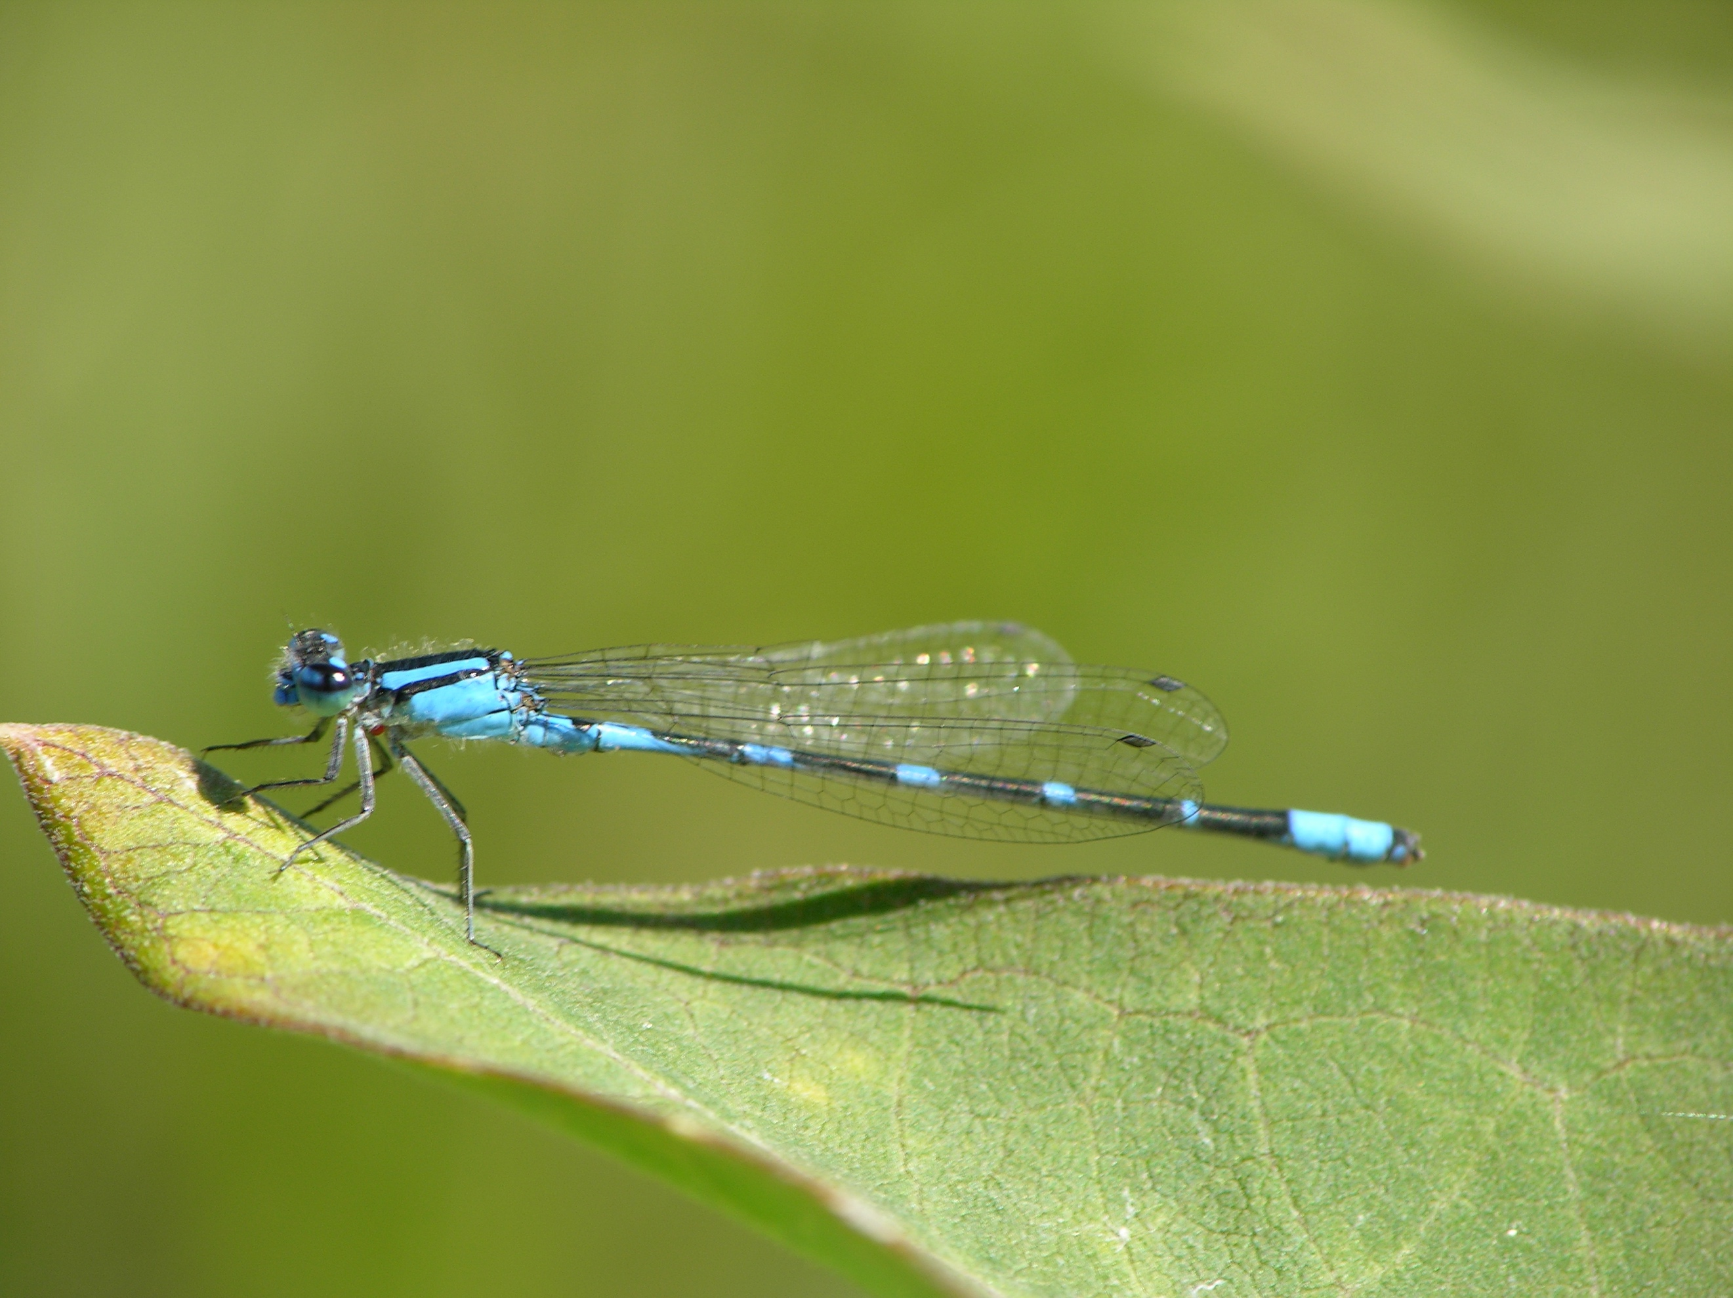
Species | Family | Order | trophic level
Enallagma carunculatum | Coenagrionidae | Odonata | predator

Bluet Damselfly
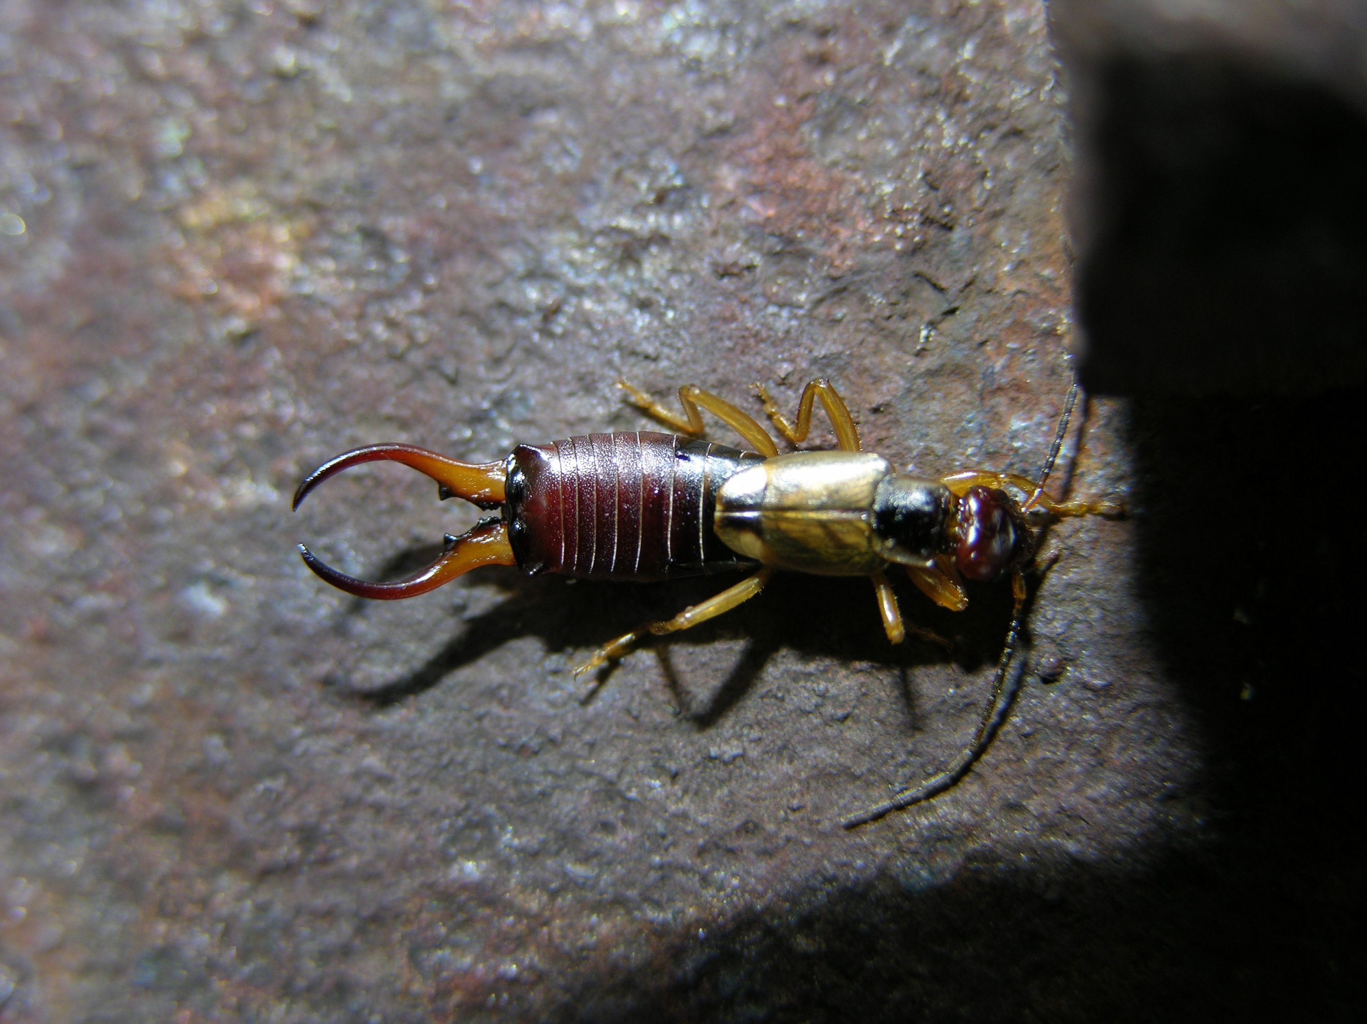
Species | Family | Order | trophic level
Forficula auricularia | Forficulidae | Dermaptera | omnivore

European Earwig

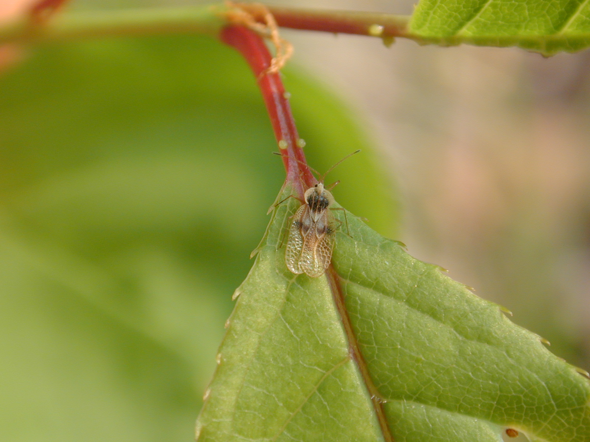
Species | Family | Order | trophic level
Gargaphia tiliae | Tingidae | Hemiptera | sap feeder

Lace Bug

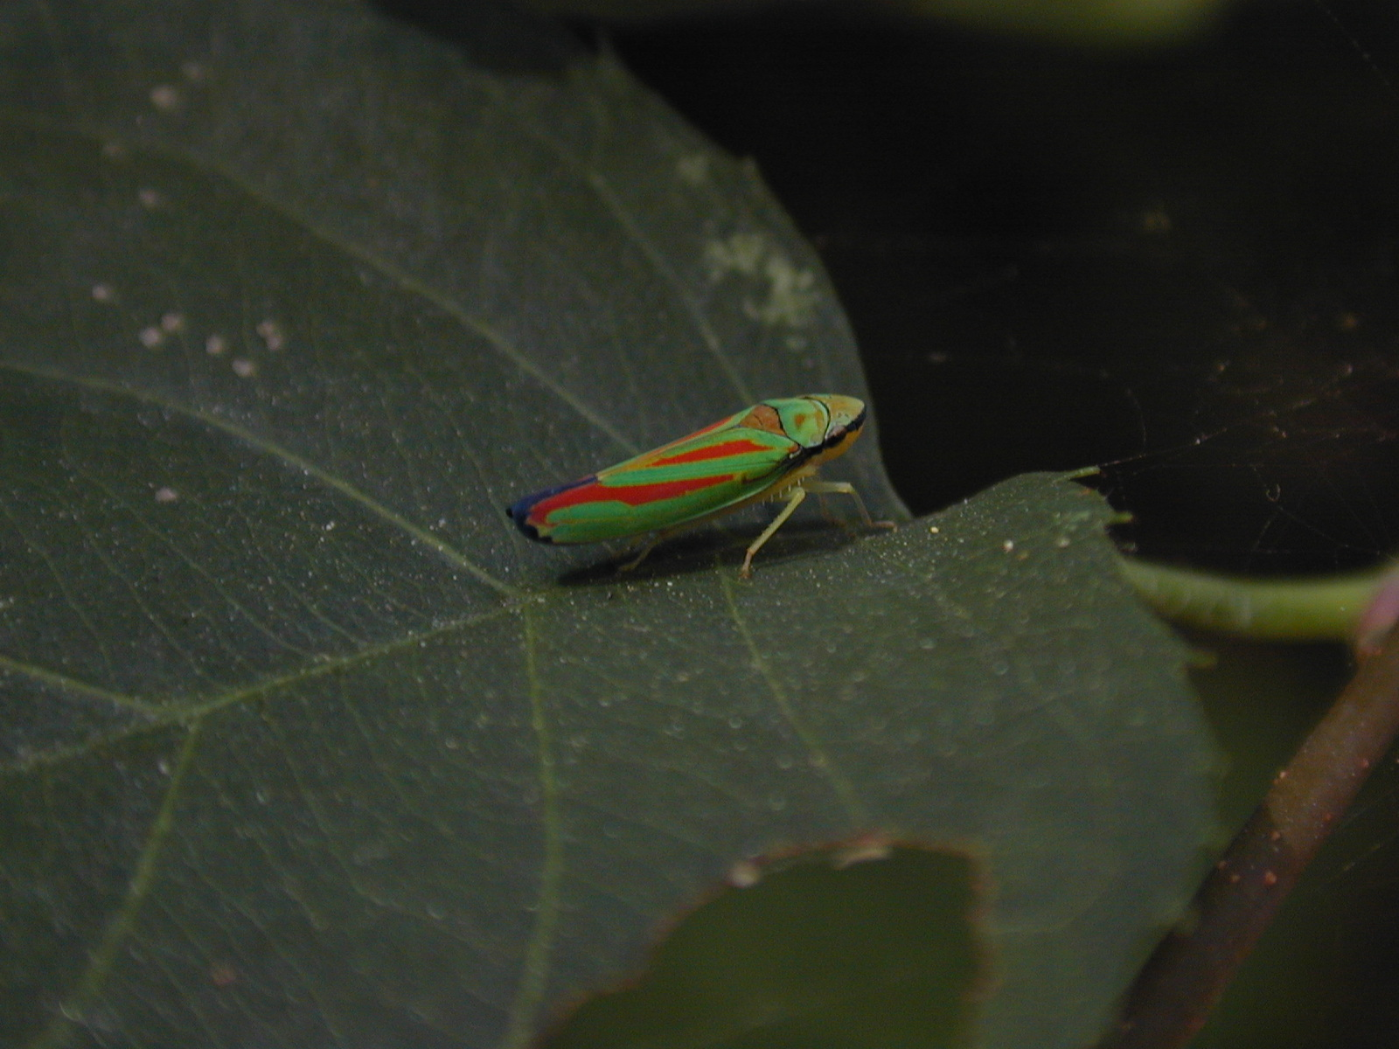
Species | Family | Order | trophic level
Graphocephala sp. | Cicadellidae | Hemiptera | sap feeder

Scarlet-and-Green Leafhopper

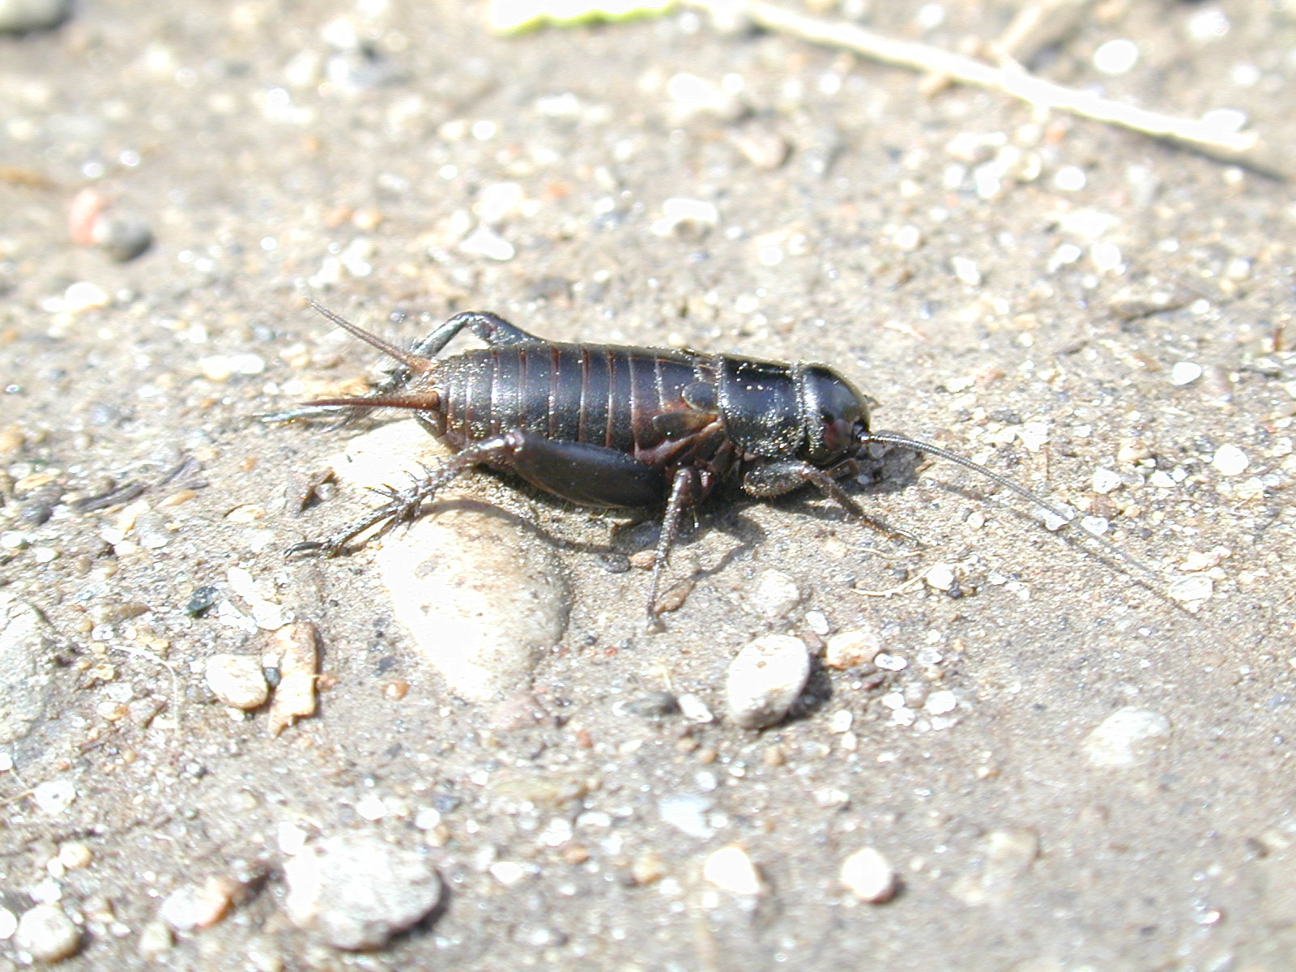
Species | Family | Order | trophic level
Gryllus veletis | Gryllidae | Orthoptera | herbivore and scavenger

Ground Cricket

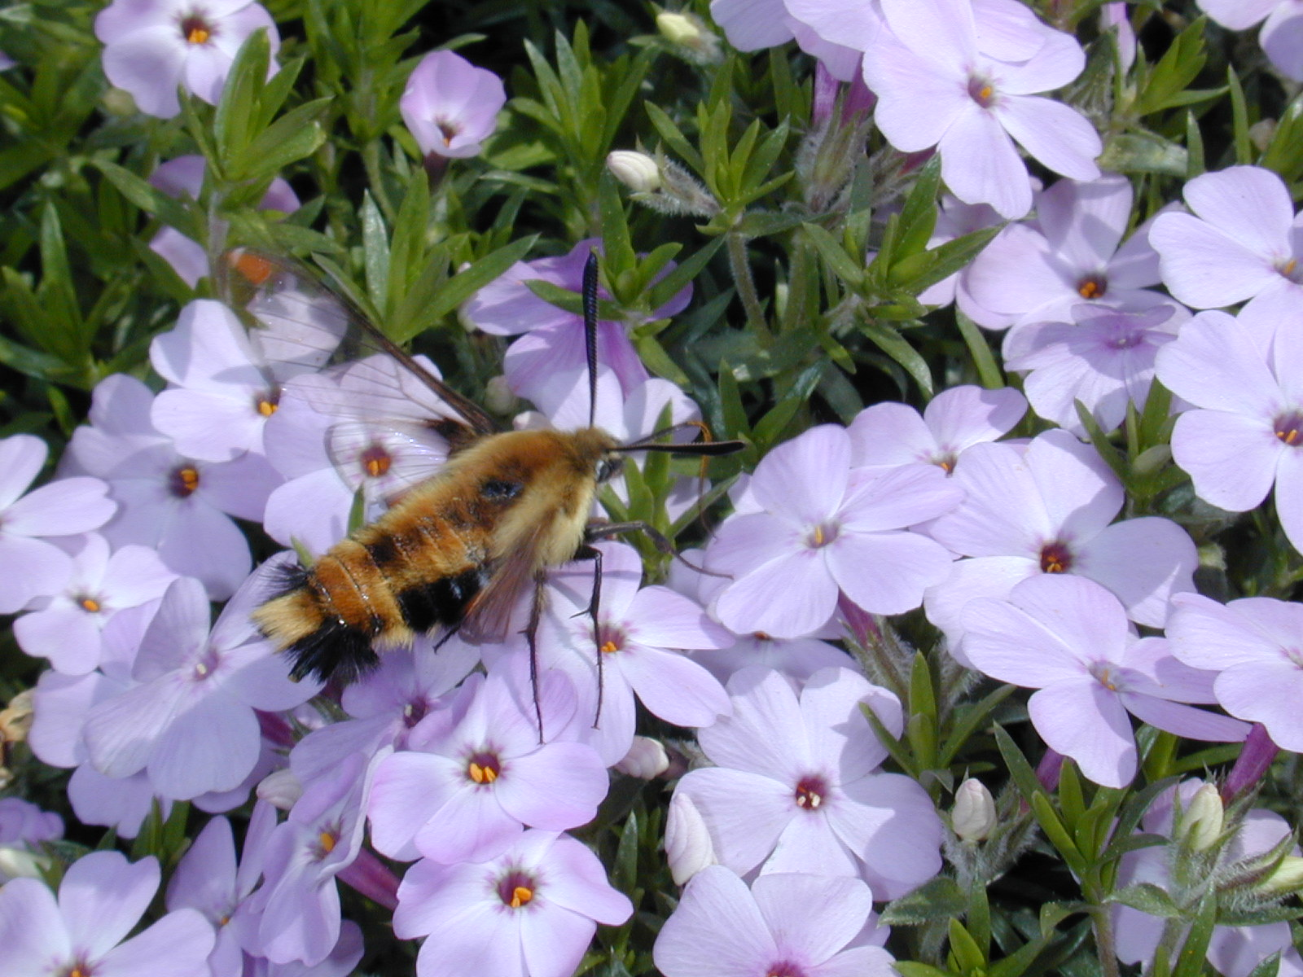
Species | Family | Order | trophic level
Hemaris diffinis | Sphingidae | Lepidoptera | herbivore and pollinator

Snowberry Clearwing

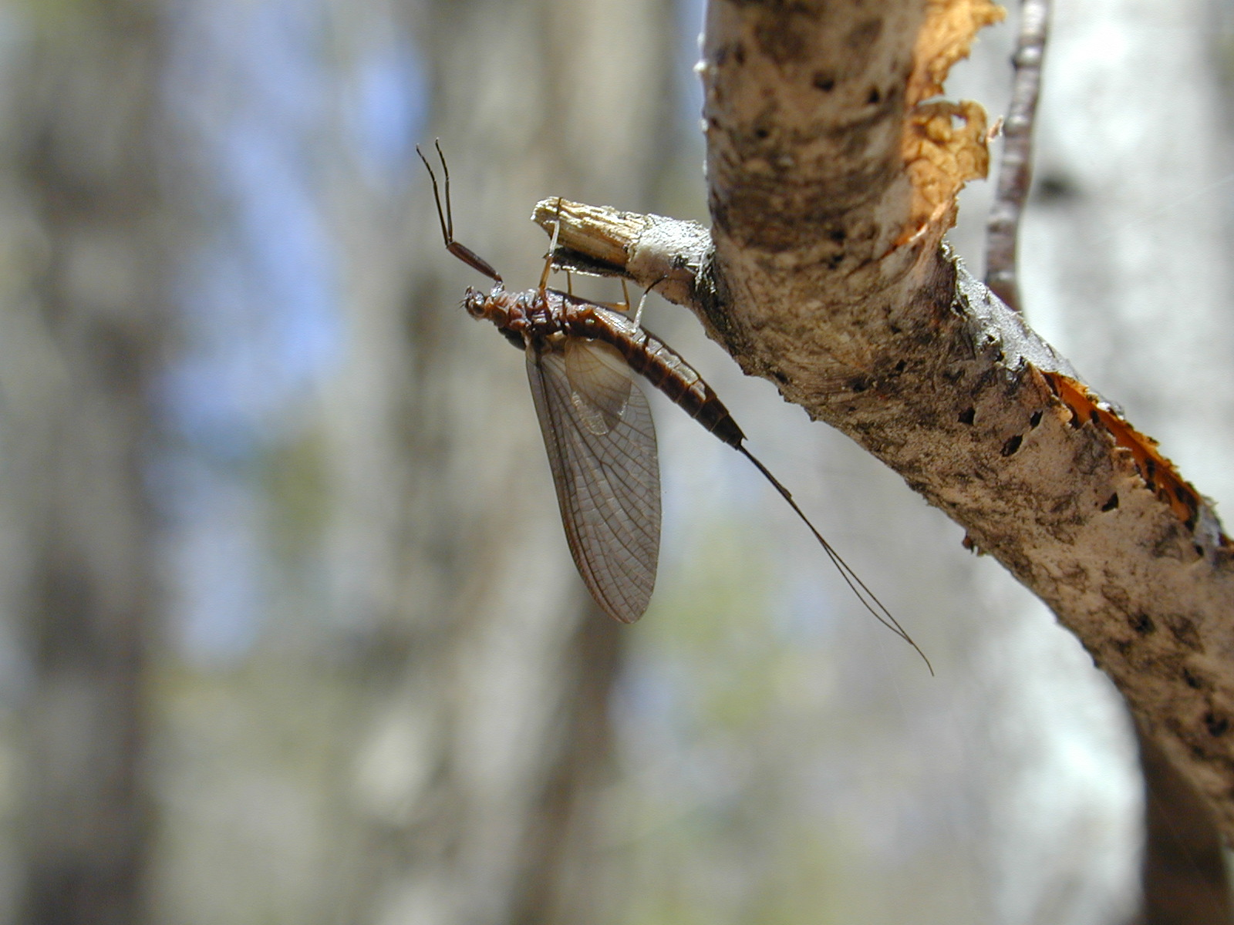
Species | Family | Order | trophic level
Leptophlebia sp. | Leptophlebiidae | Ephemeroptera | detritivore, adults don't feed

Mayfly

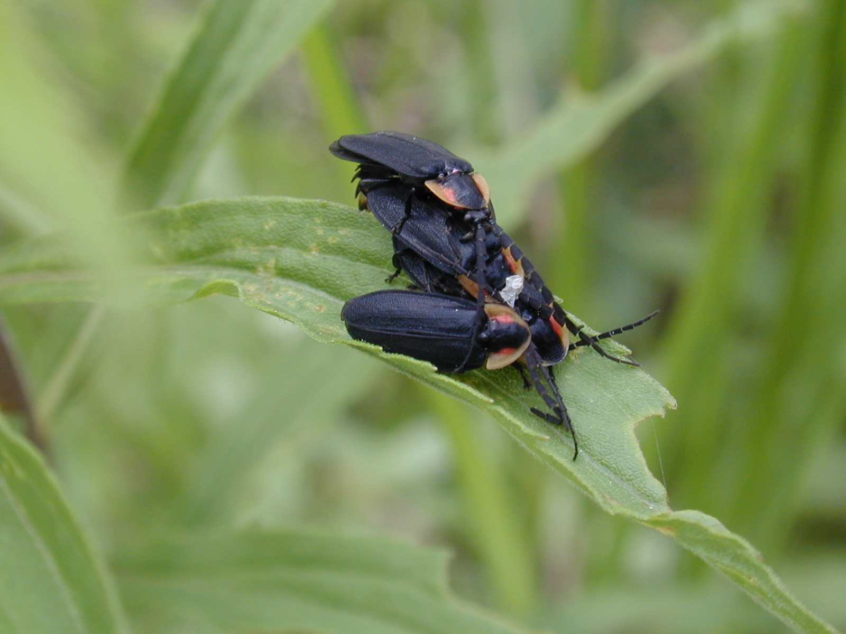
Species | Family | Order | trophic level
Lucidota atra | Lampyridae | Coleoptera | predator

Firefly
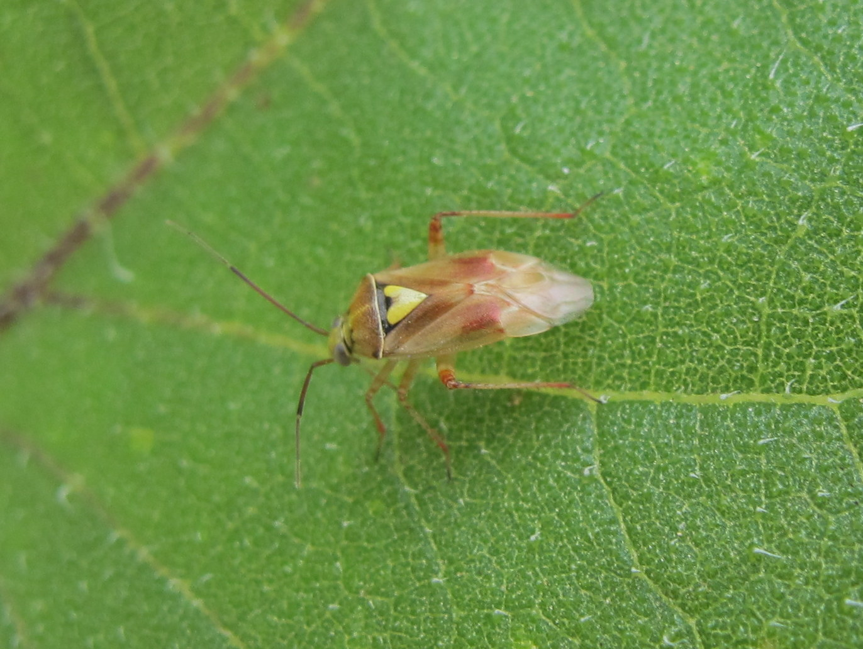
Species | Family | Order | trophic level
Lygus sp. | Miridae | Hemiptera | sap feeder

Plant Bug

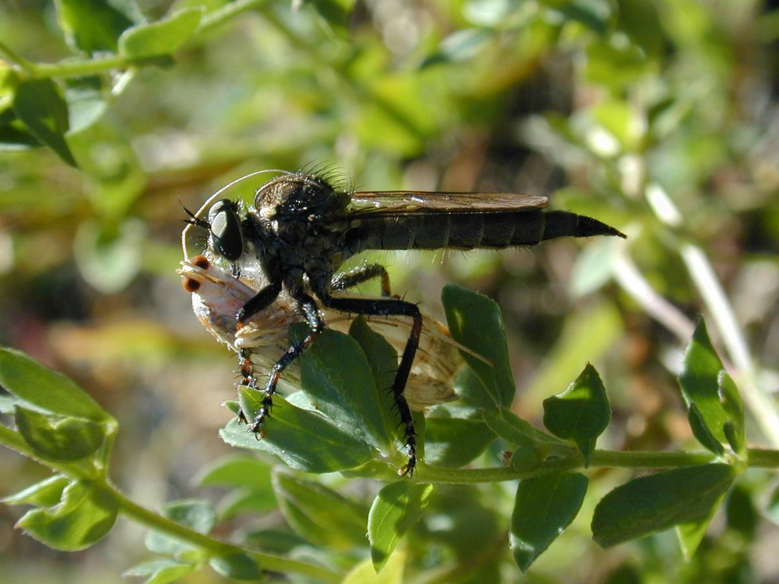
Species | Family | Order | trophic level
Machimus sp. | Asilidae | Diptera | predator

Robber Fly

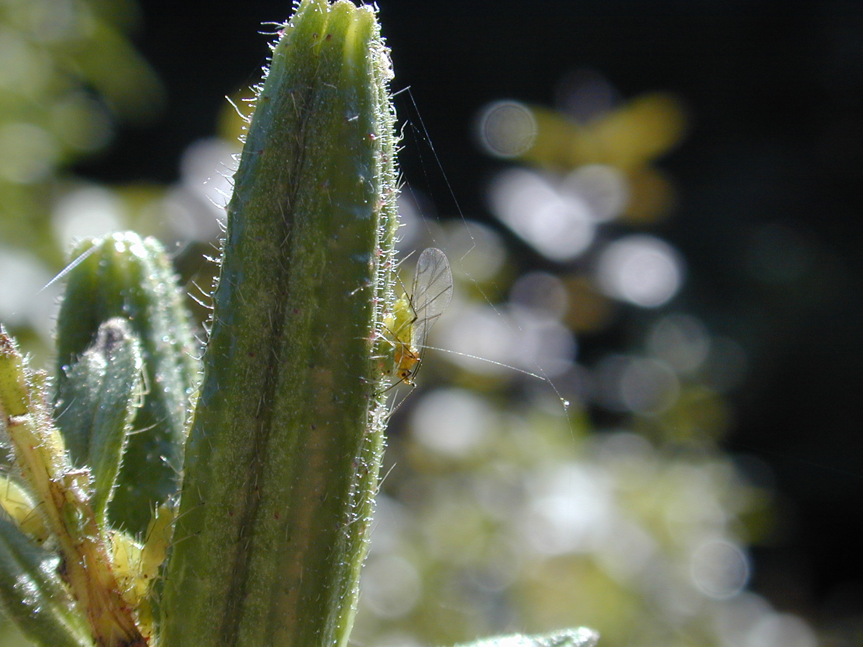
Species | Family | Order | trophic level
Macrosiphum sp. | Aphididae | Hemiptera | sap feeder

Aphid

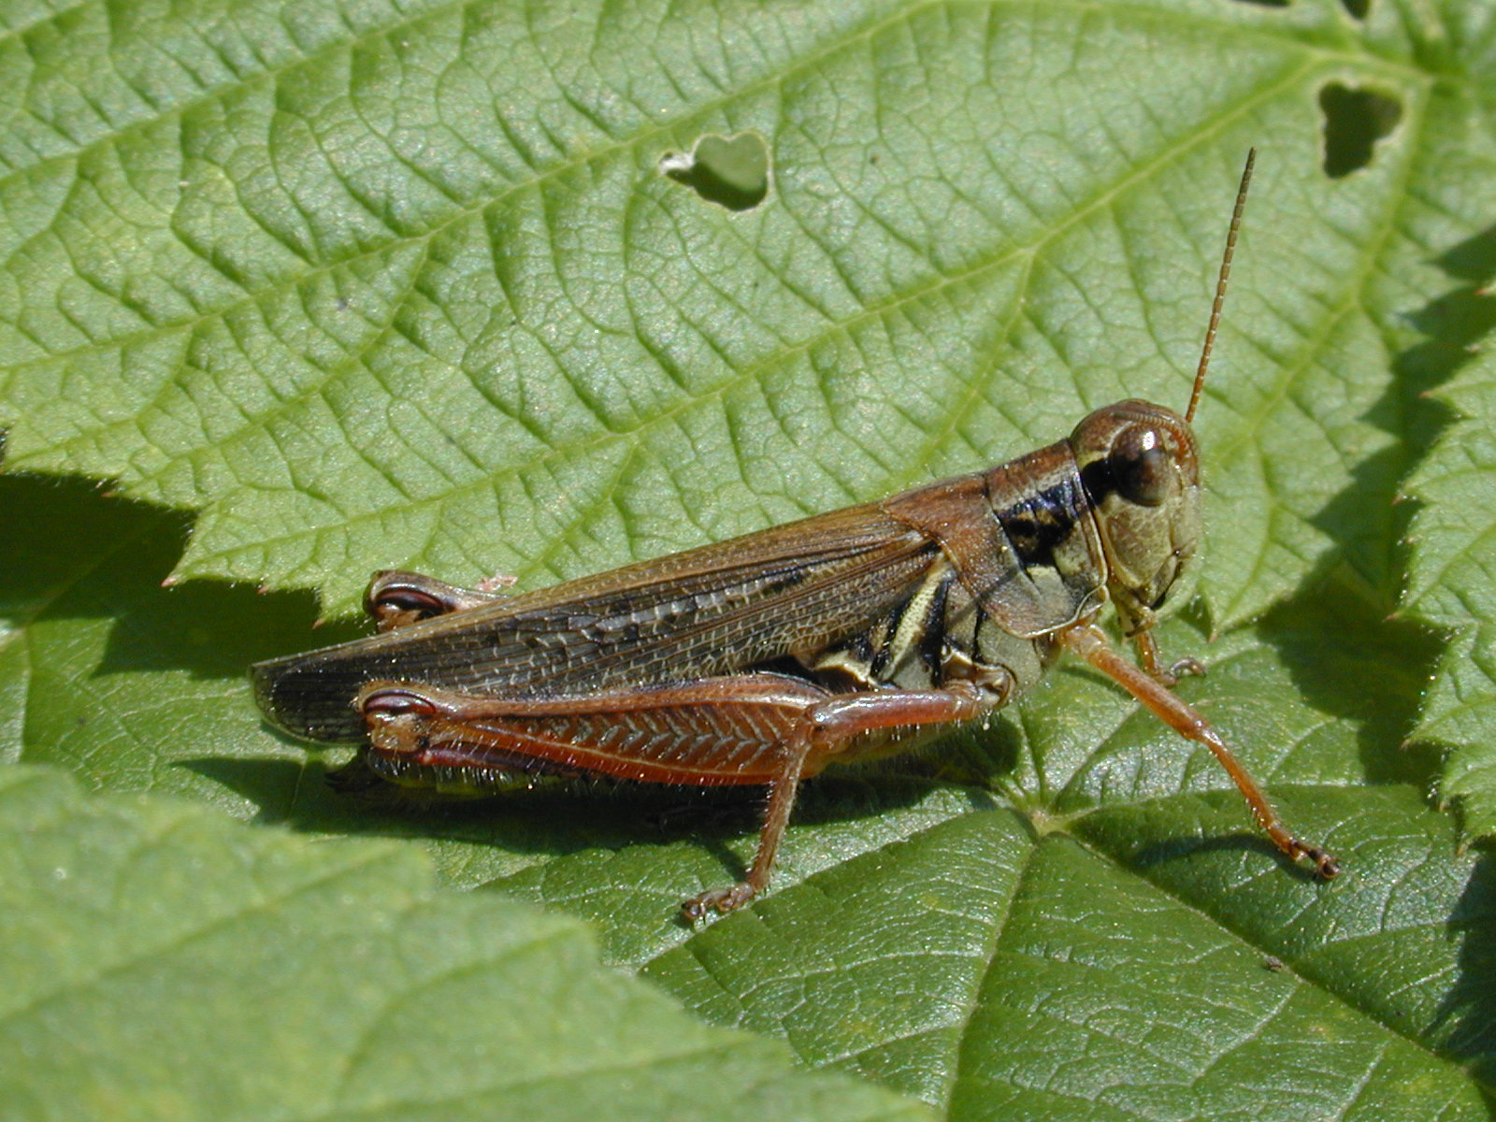
Species | Family | Order | trophic level
Melanoplus femurrubrum | Acrididae | Orthoptera | herbivore

Red-legged Grasshopper

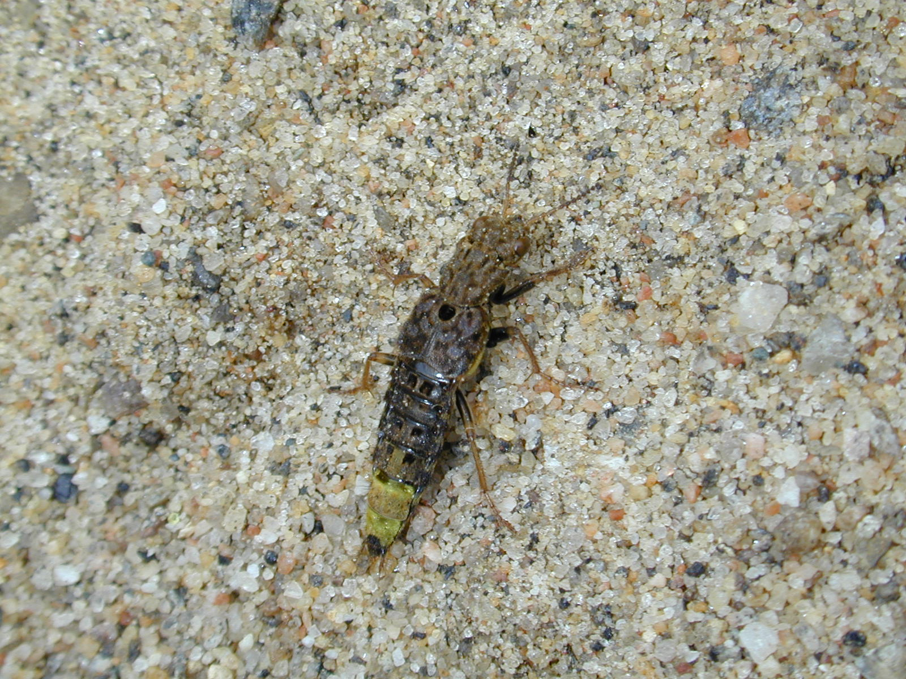
Species | Family | Order | trophic level
Ontholestes cingulatus | Staphylinidae | Coleoptera | predator

Gold and Brown Rove Beetle

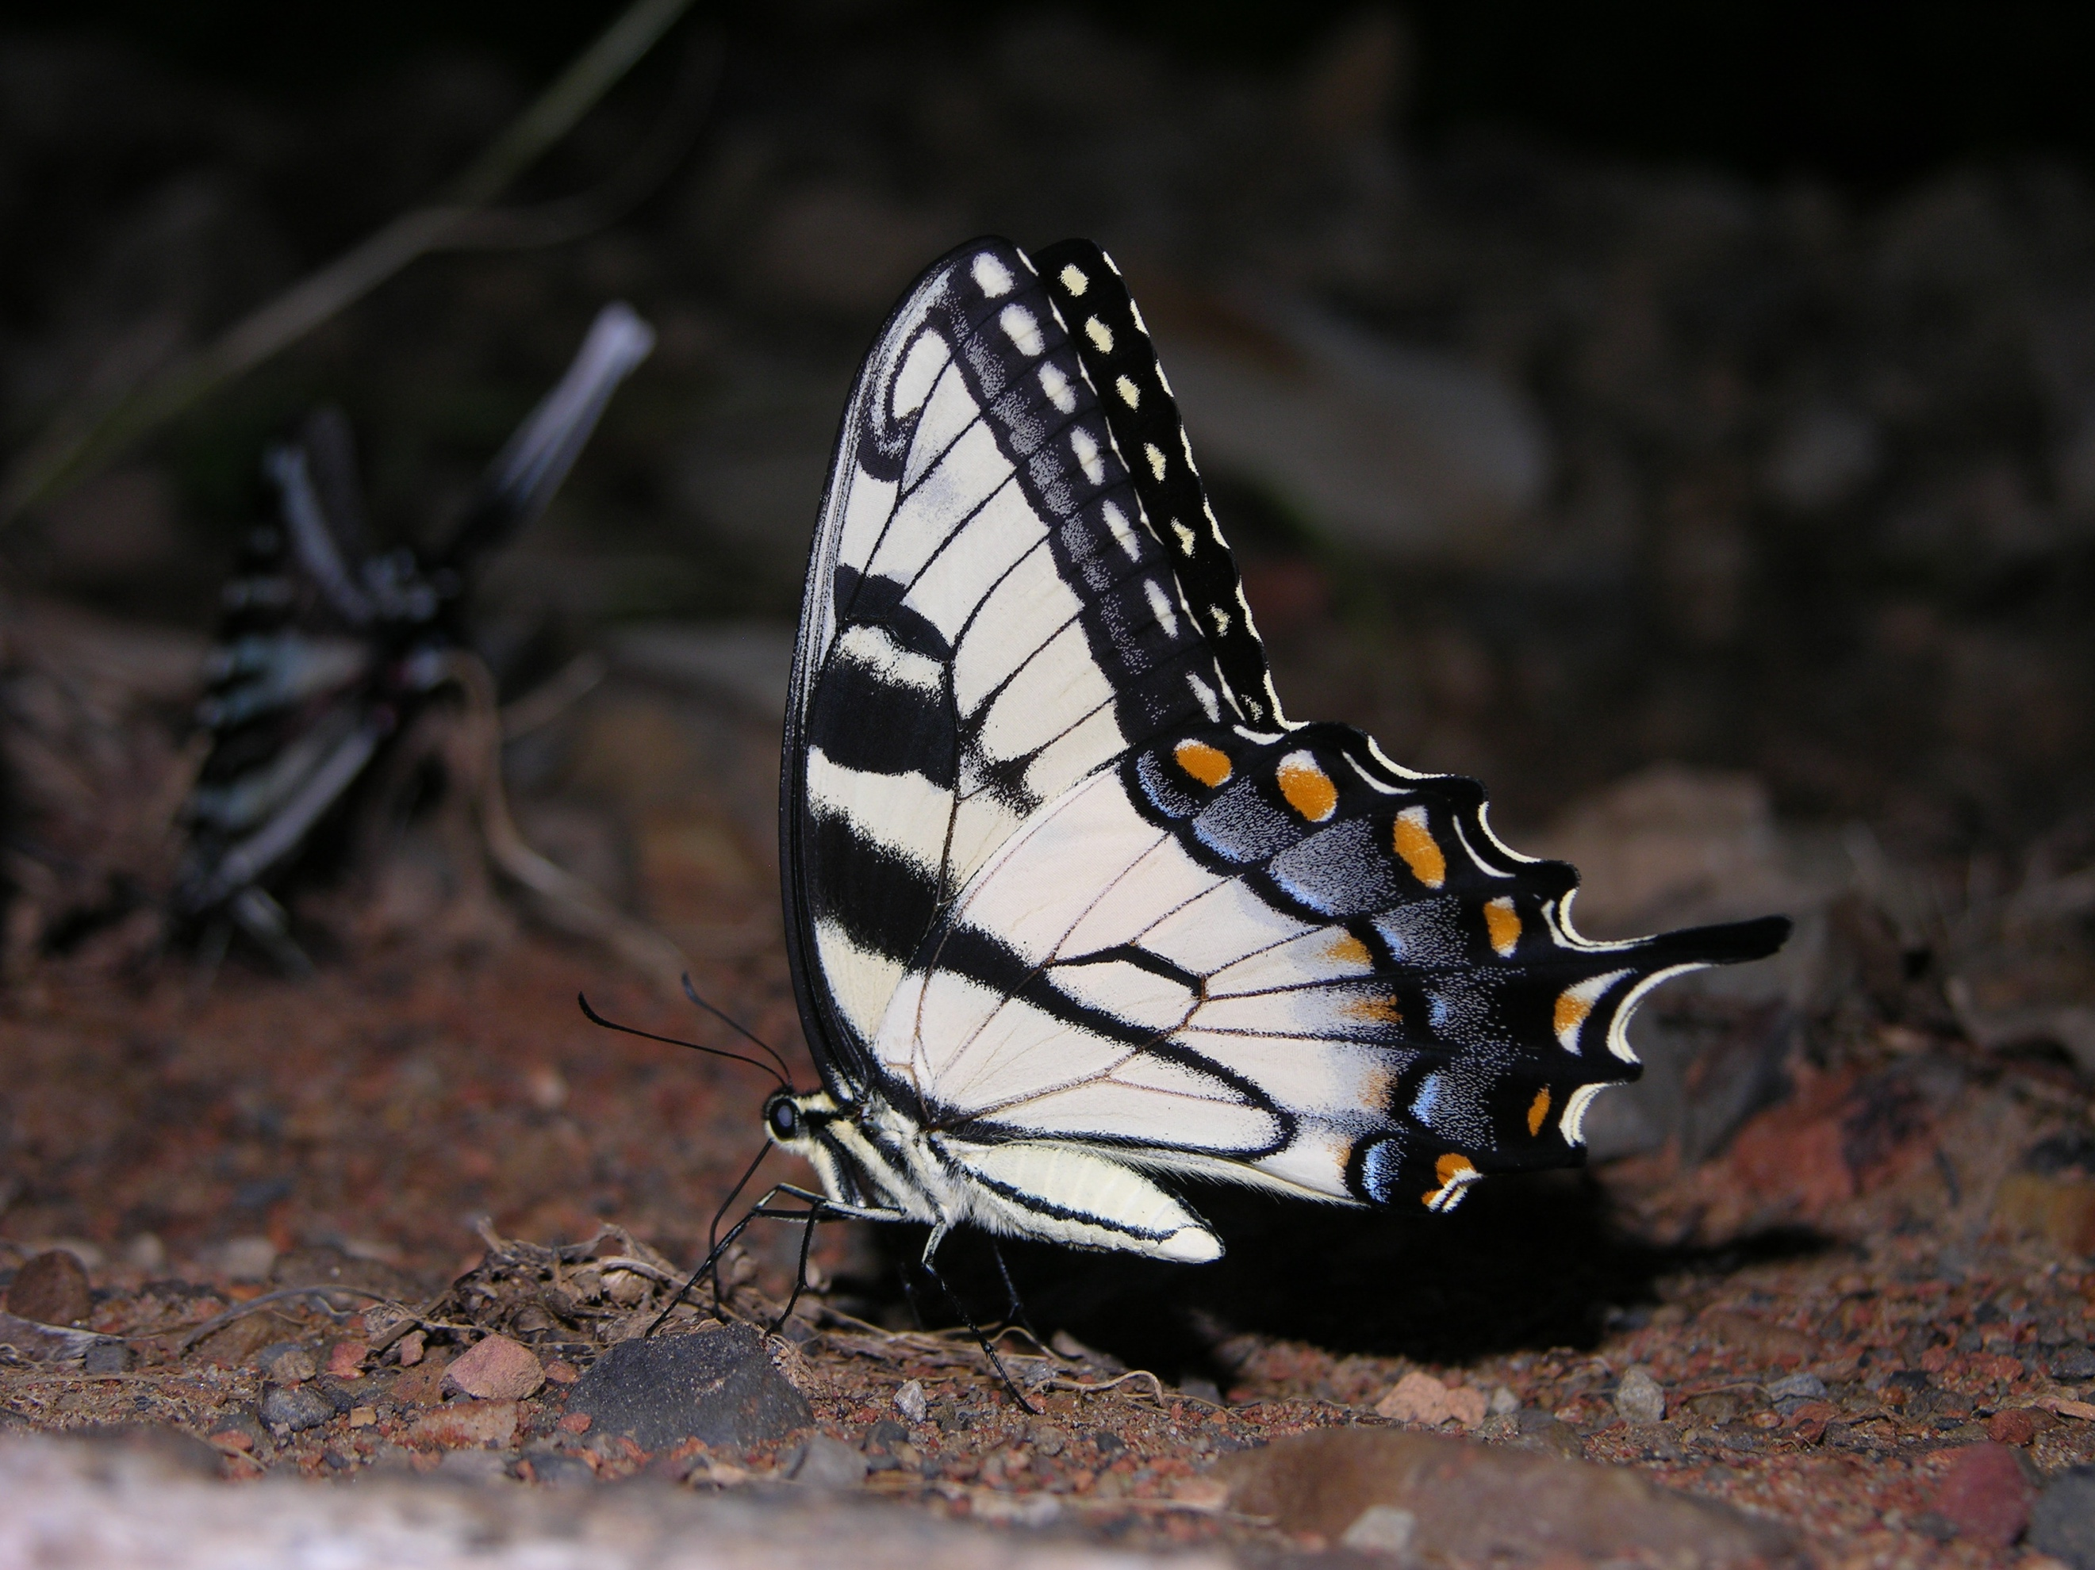
Species | Family | Order | trophic level
Papilio glaucus | Papilionidae | Lepidoptera | herbivore and pollinator

Eastern Tiger Swallowtail

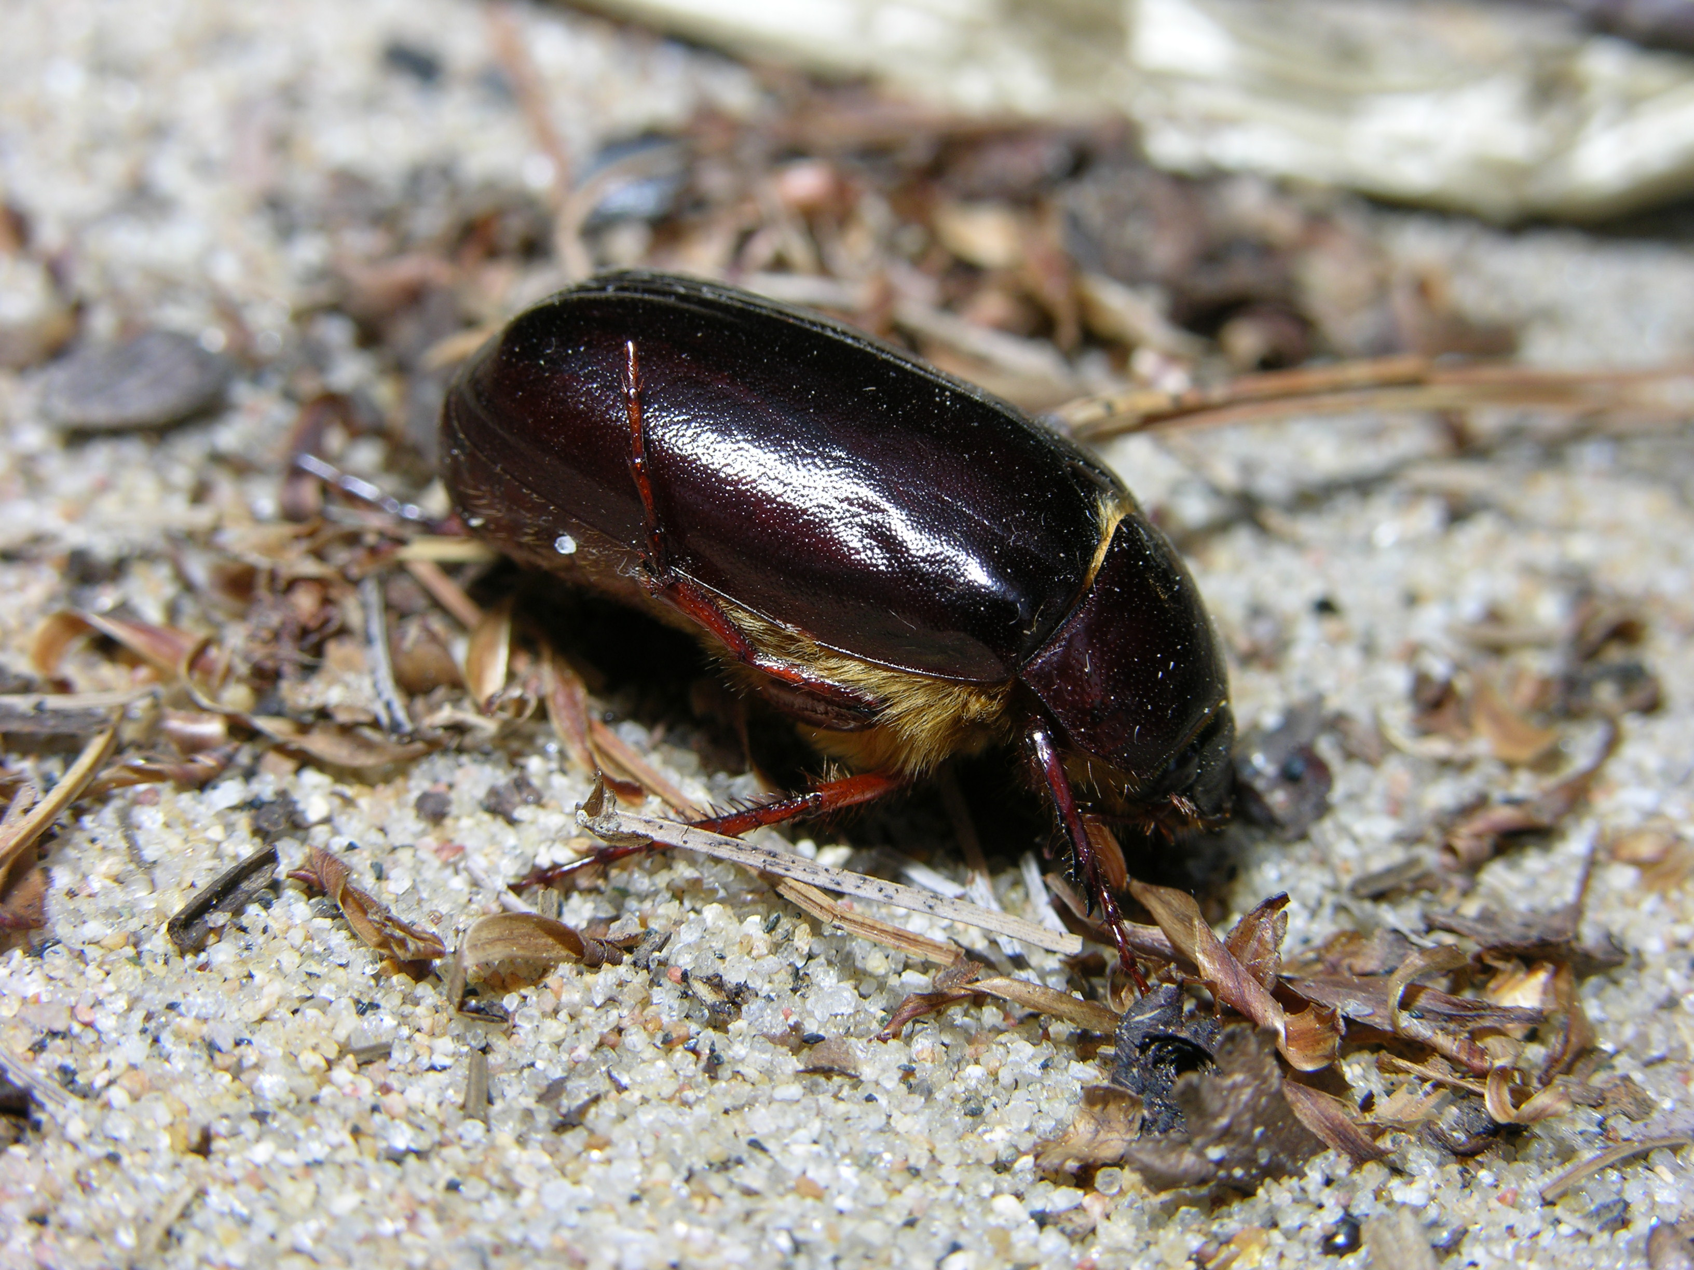
Species | Family | Order | trophic level
Phyllophaga sp. | Scarabaeidae | Coleoptera | herbivore

May Beetle

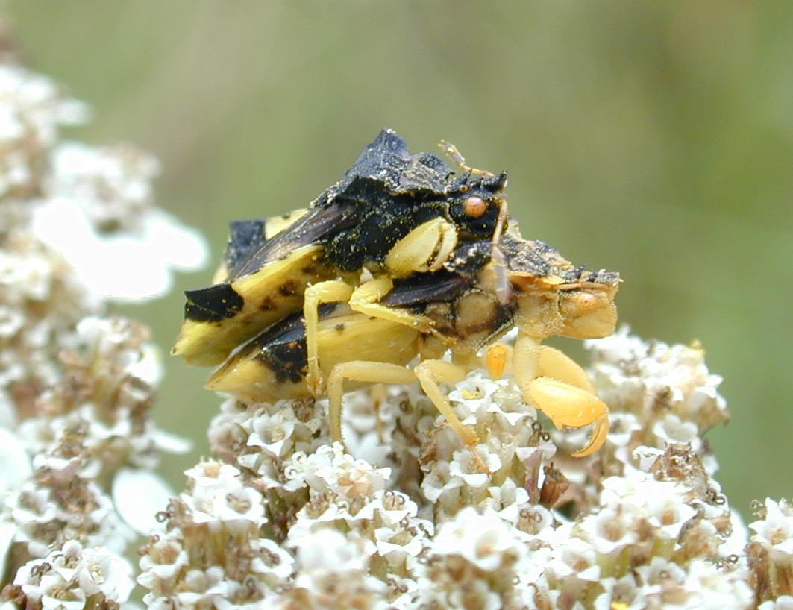
Species | Family | Order | trophic level
Phymata pennsylvanica | Reduviidae | Hemiptera | predator

Ambush Bug

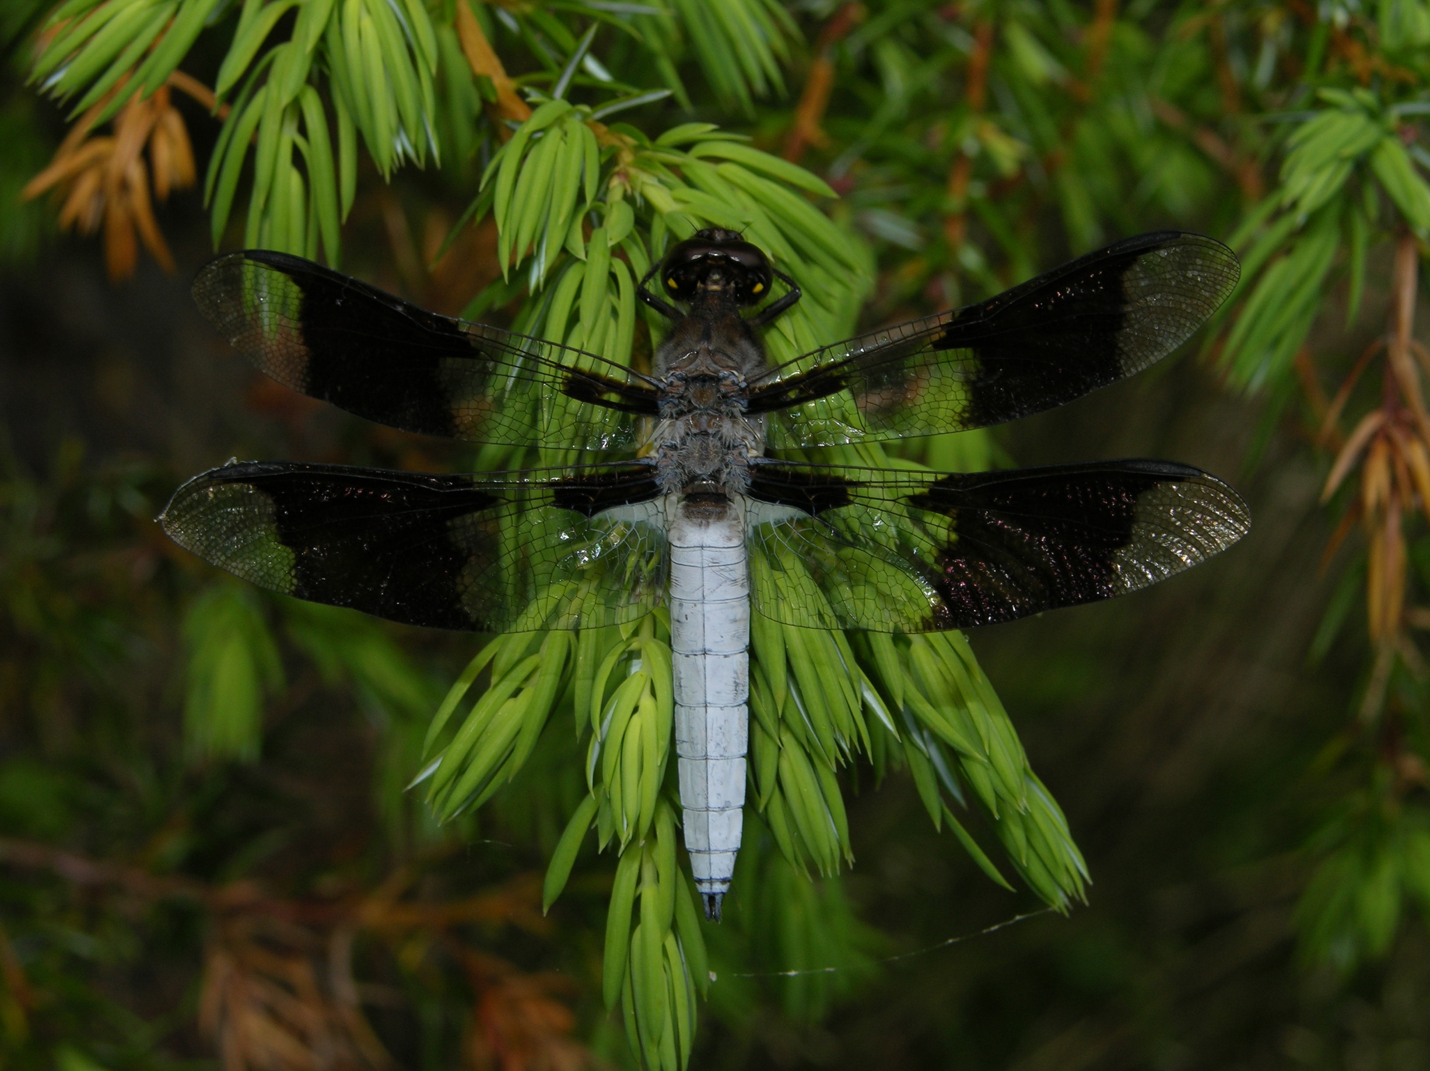
Species | Family | Order | trophic level
Plathemis lydia | Libellulidae | Odonata | predator

Common Whitetail

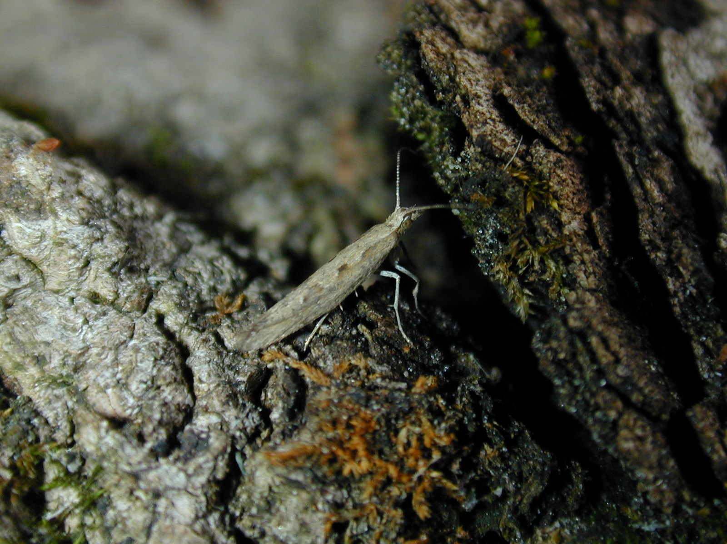
Species | Family | Order | trophic level
Plutella xylostella | Plutellidae | Lepidoptera | herbivore and pollinator

Diamondback Moth

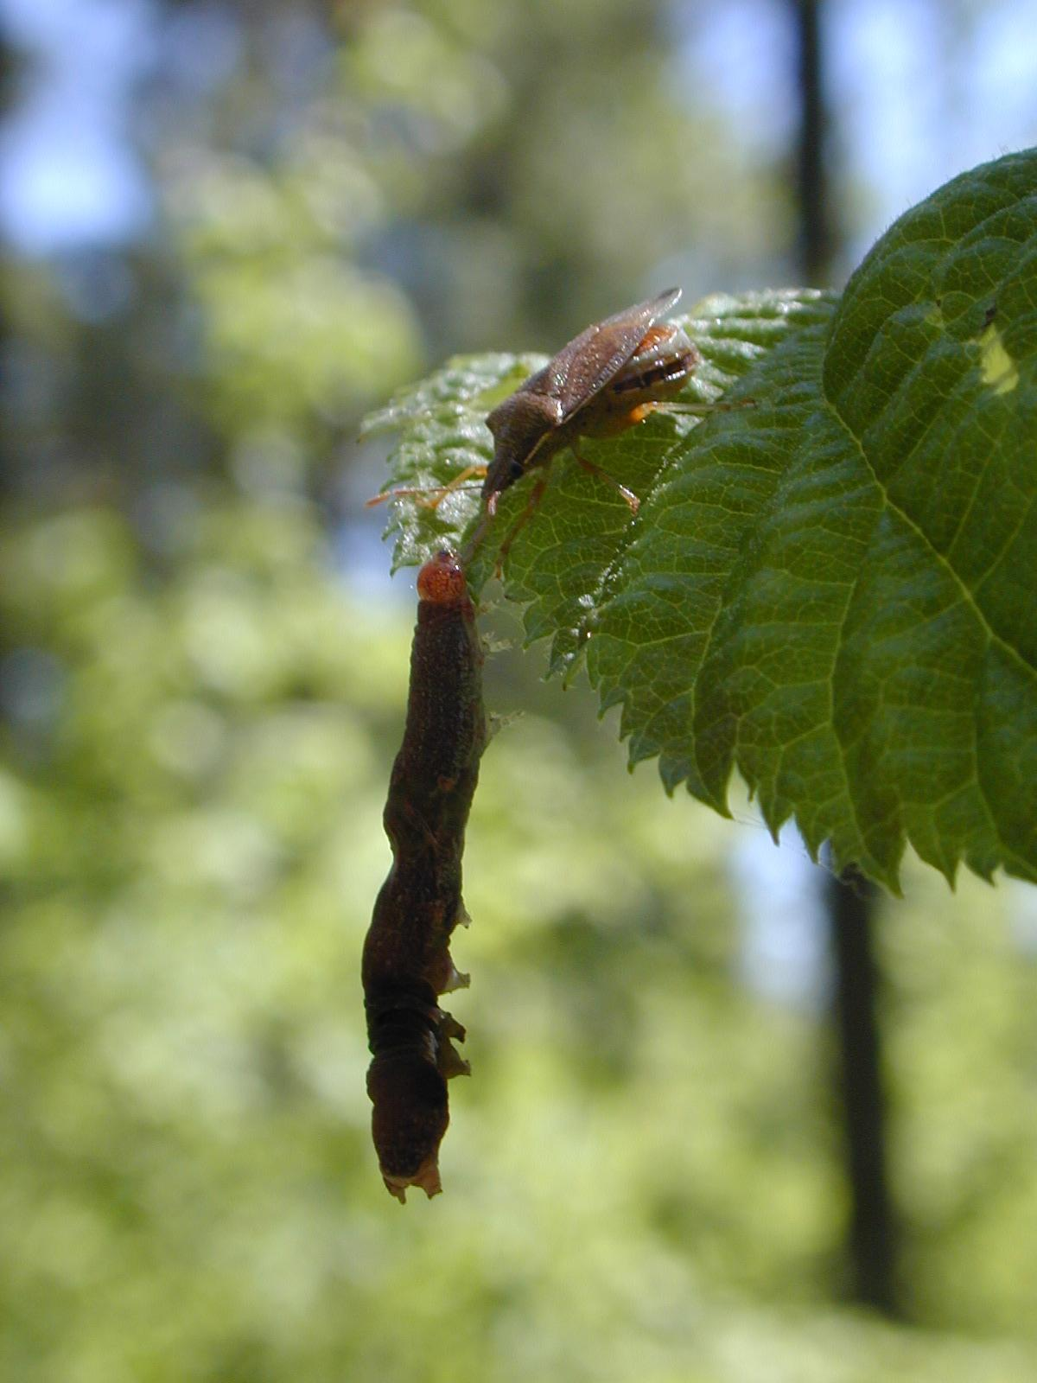
Species | Family | Order | trophic level
Podisus modestus | Pentatomidae | Hemiptera | predator

Stink Bug

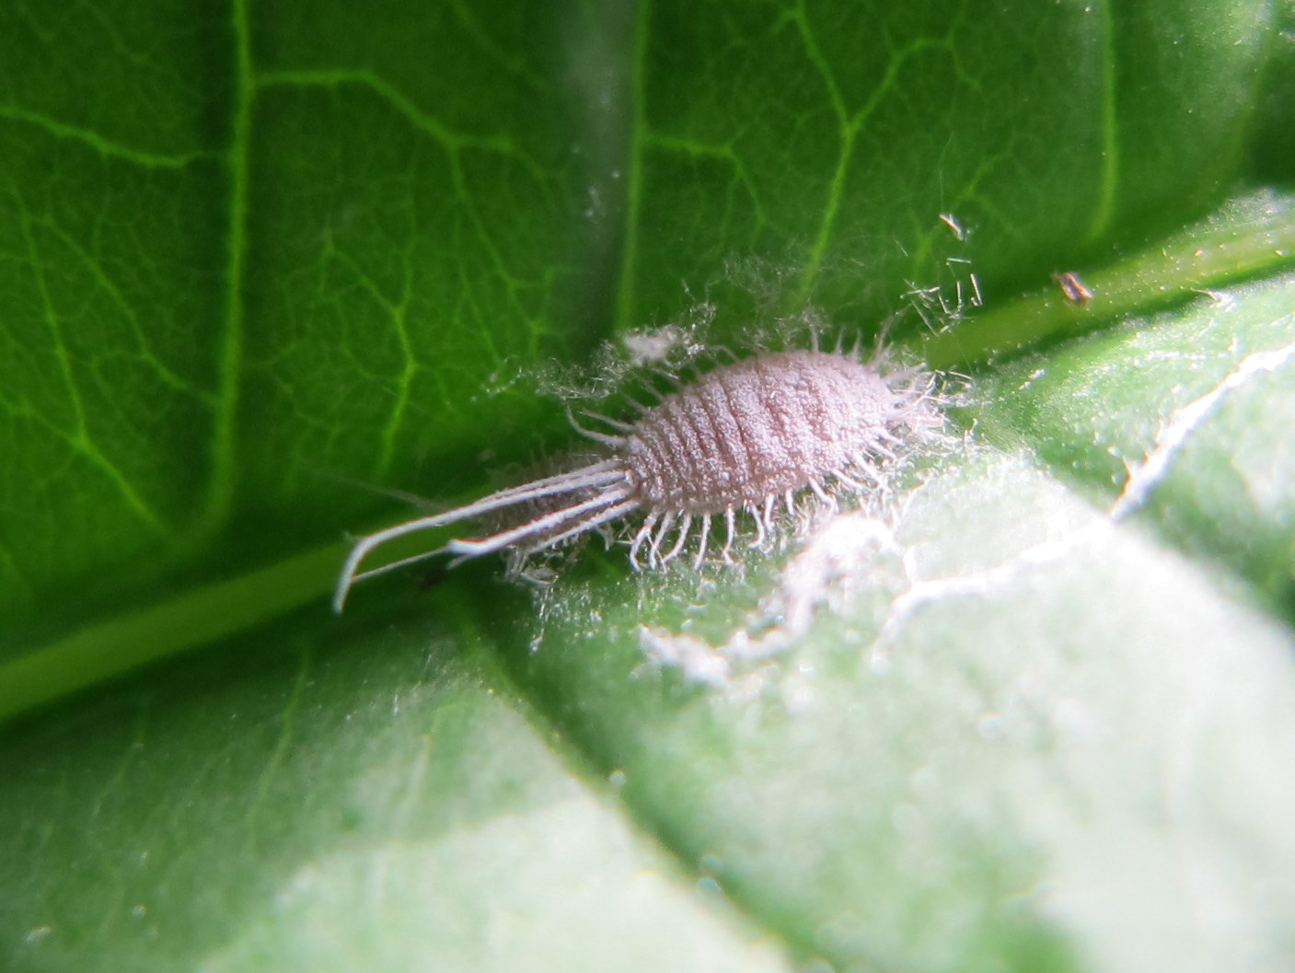
Species | Family | Order | trophic level
Pseudococcidae sp. | Pseudococcidae | Hemiptera | sap feeder

Mealy Bug

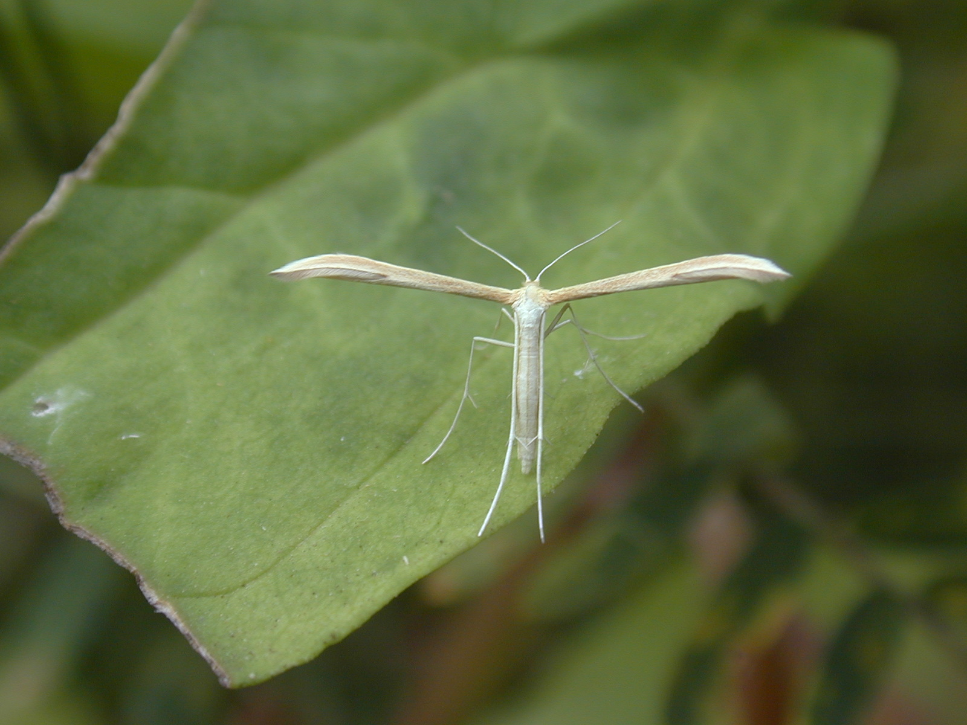
Species | Family | Order | trophic level
Pterophoridae sp. | Pterophoridae | Lepidoptera | herbivore

Plume Moth

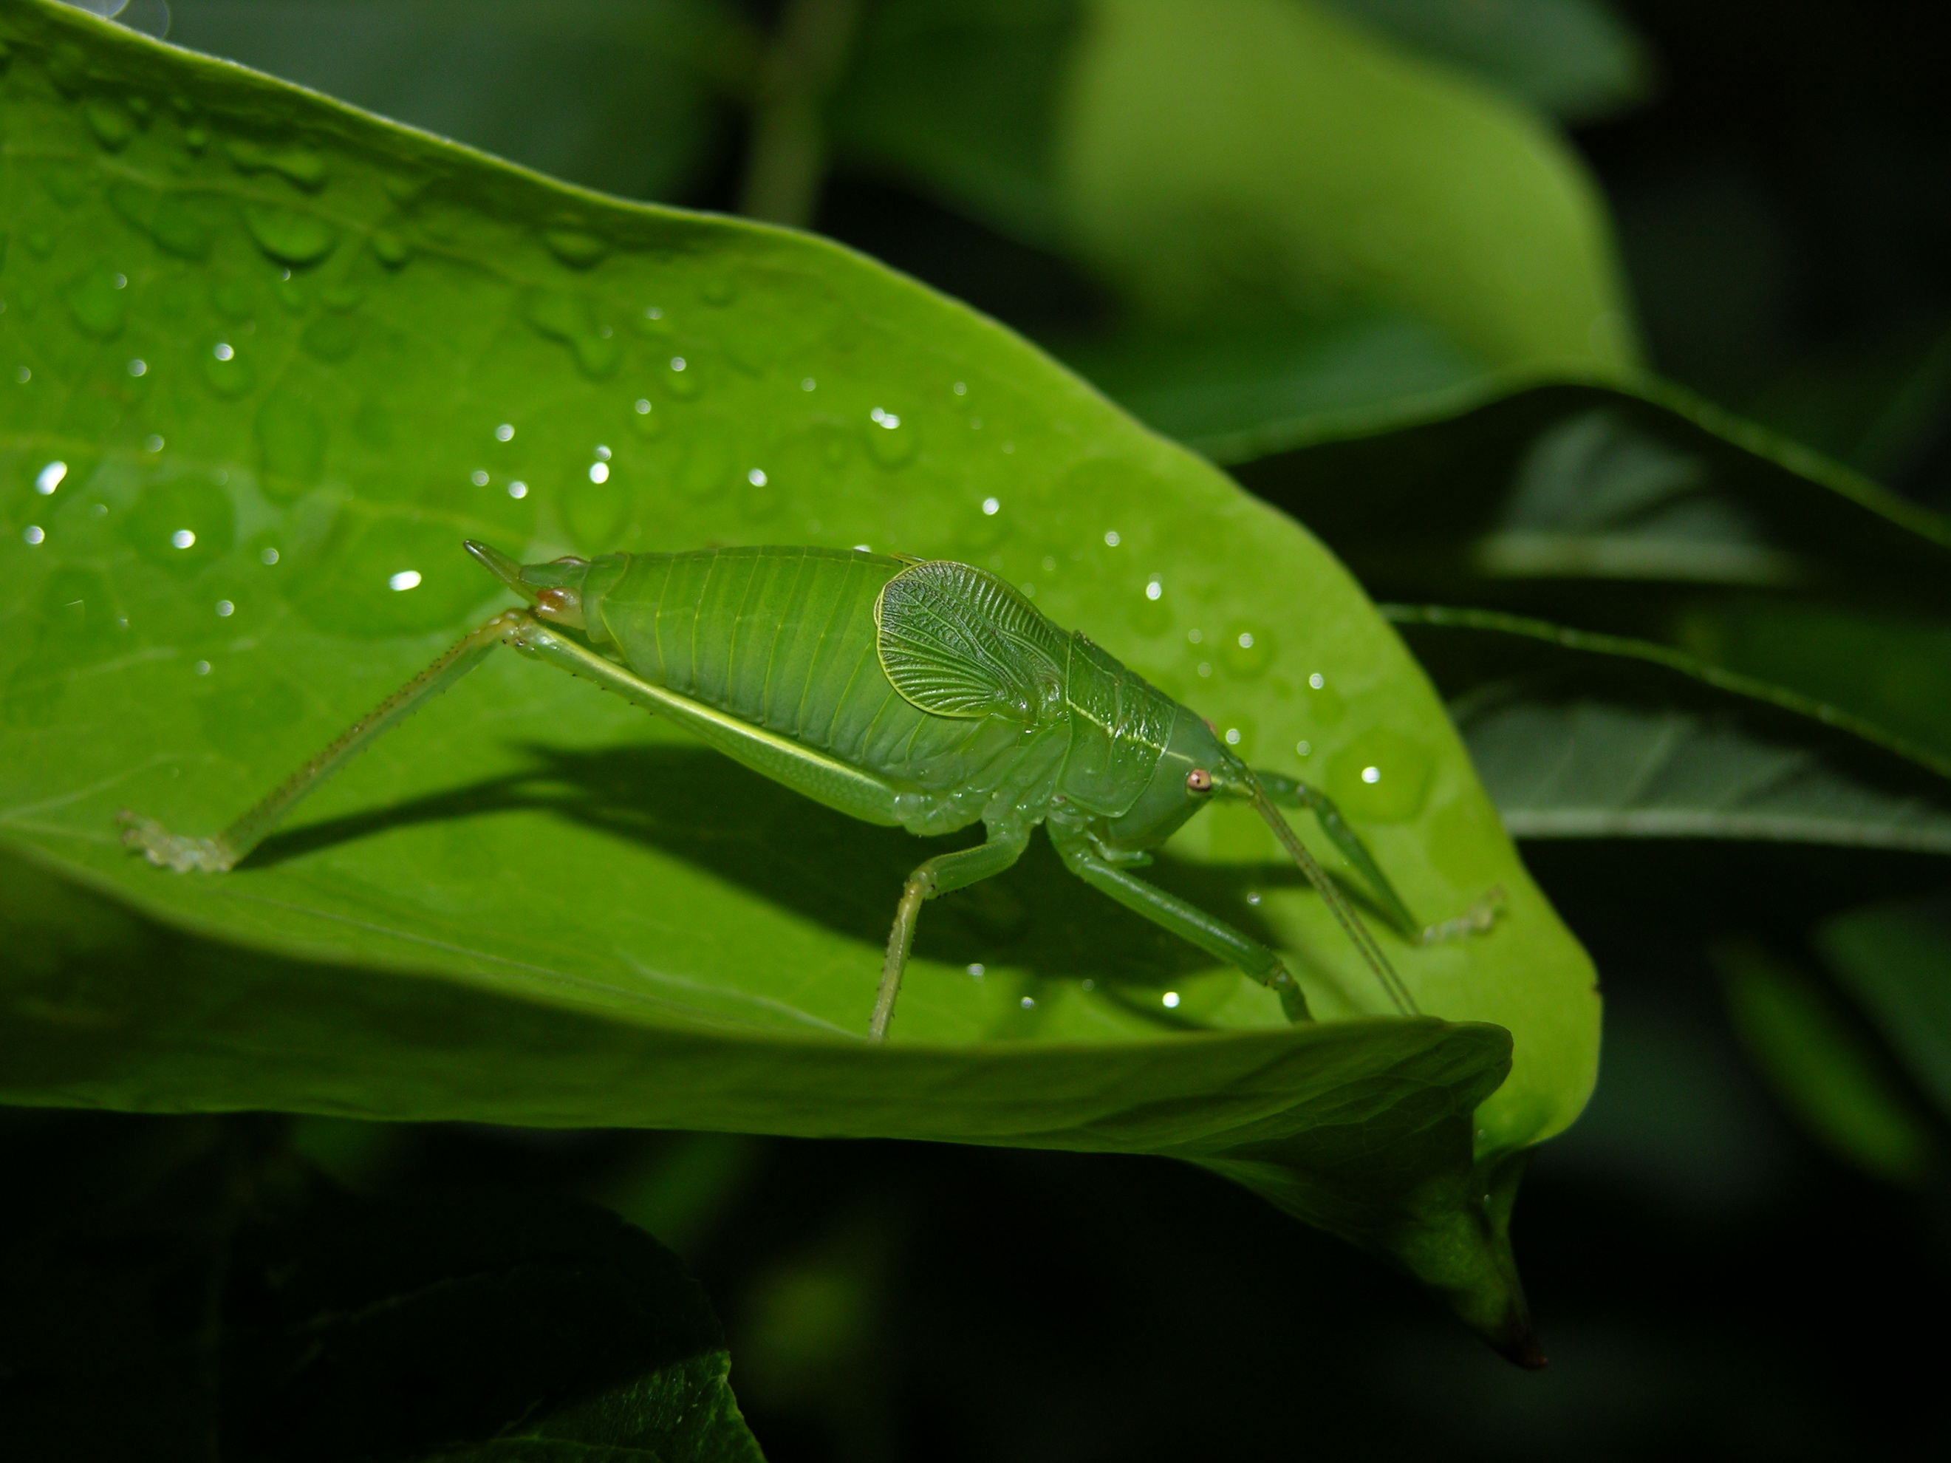
Species | Family | Order | trophic level
Pterophylla camellifolia | Tettigoniidae | Orthoptera | herbivore

Katydid

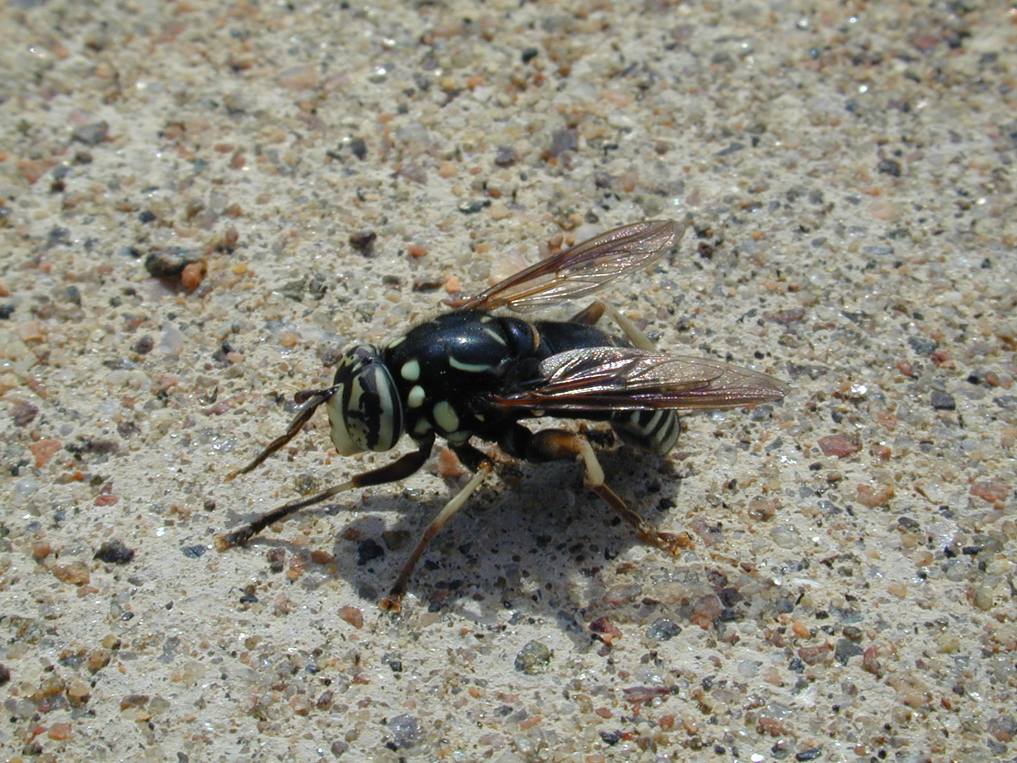
Species | Family | Order | trophic level
Spilomyia fusca | Syrphidae | Diptera | predator and pollinator

Hover Fly

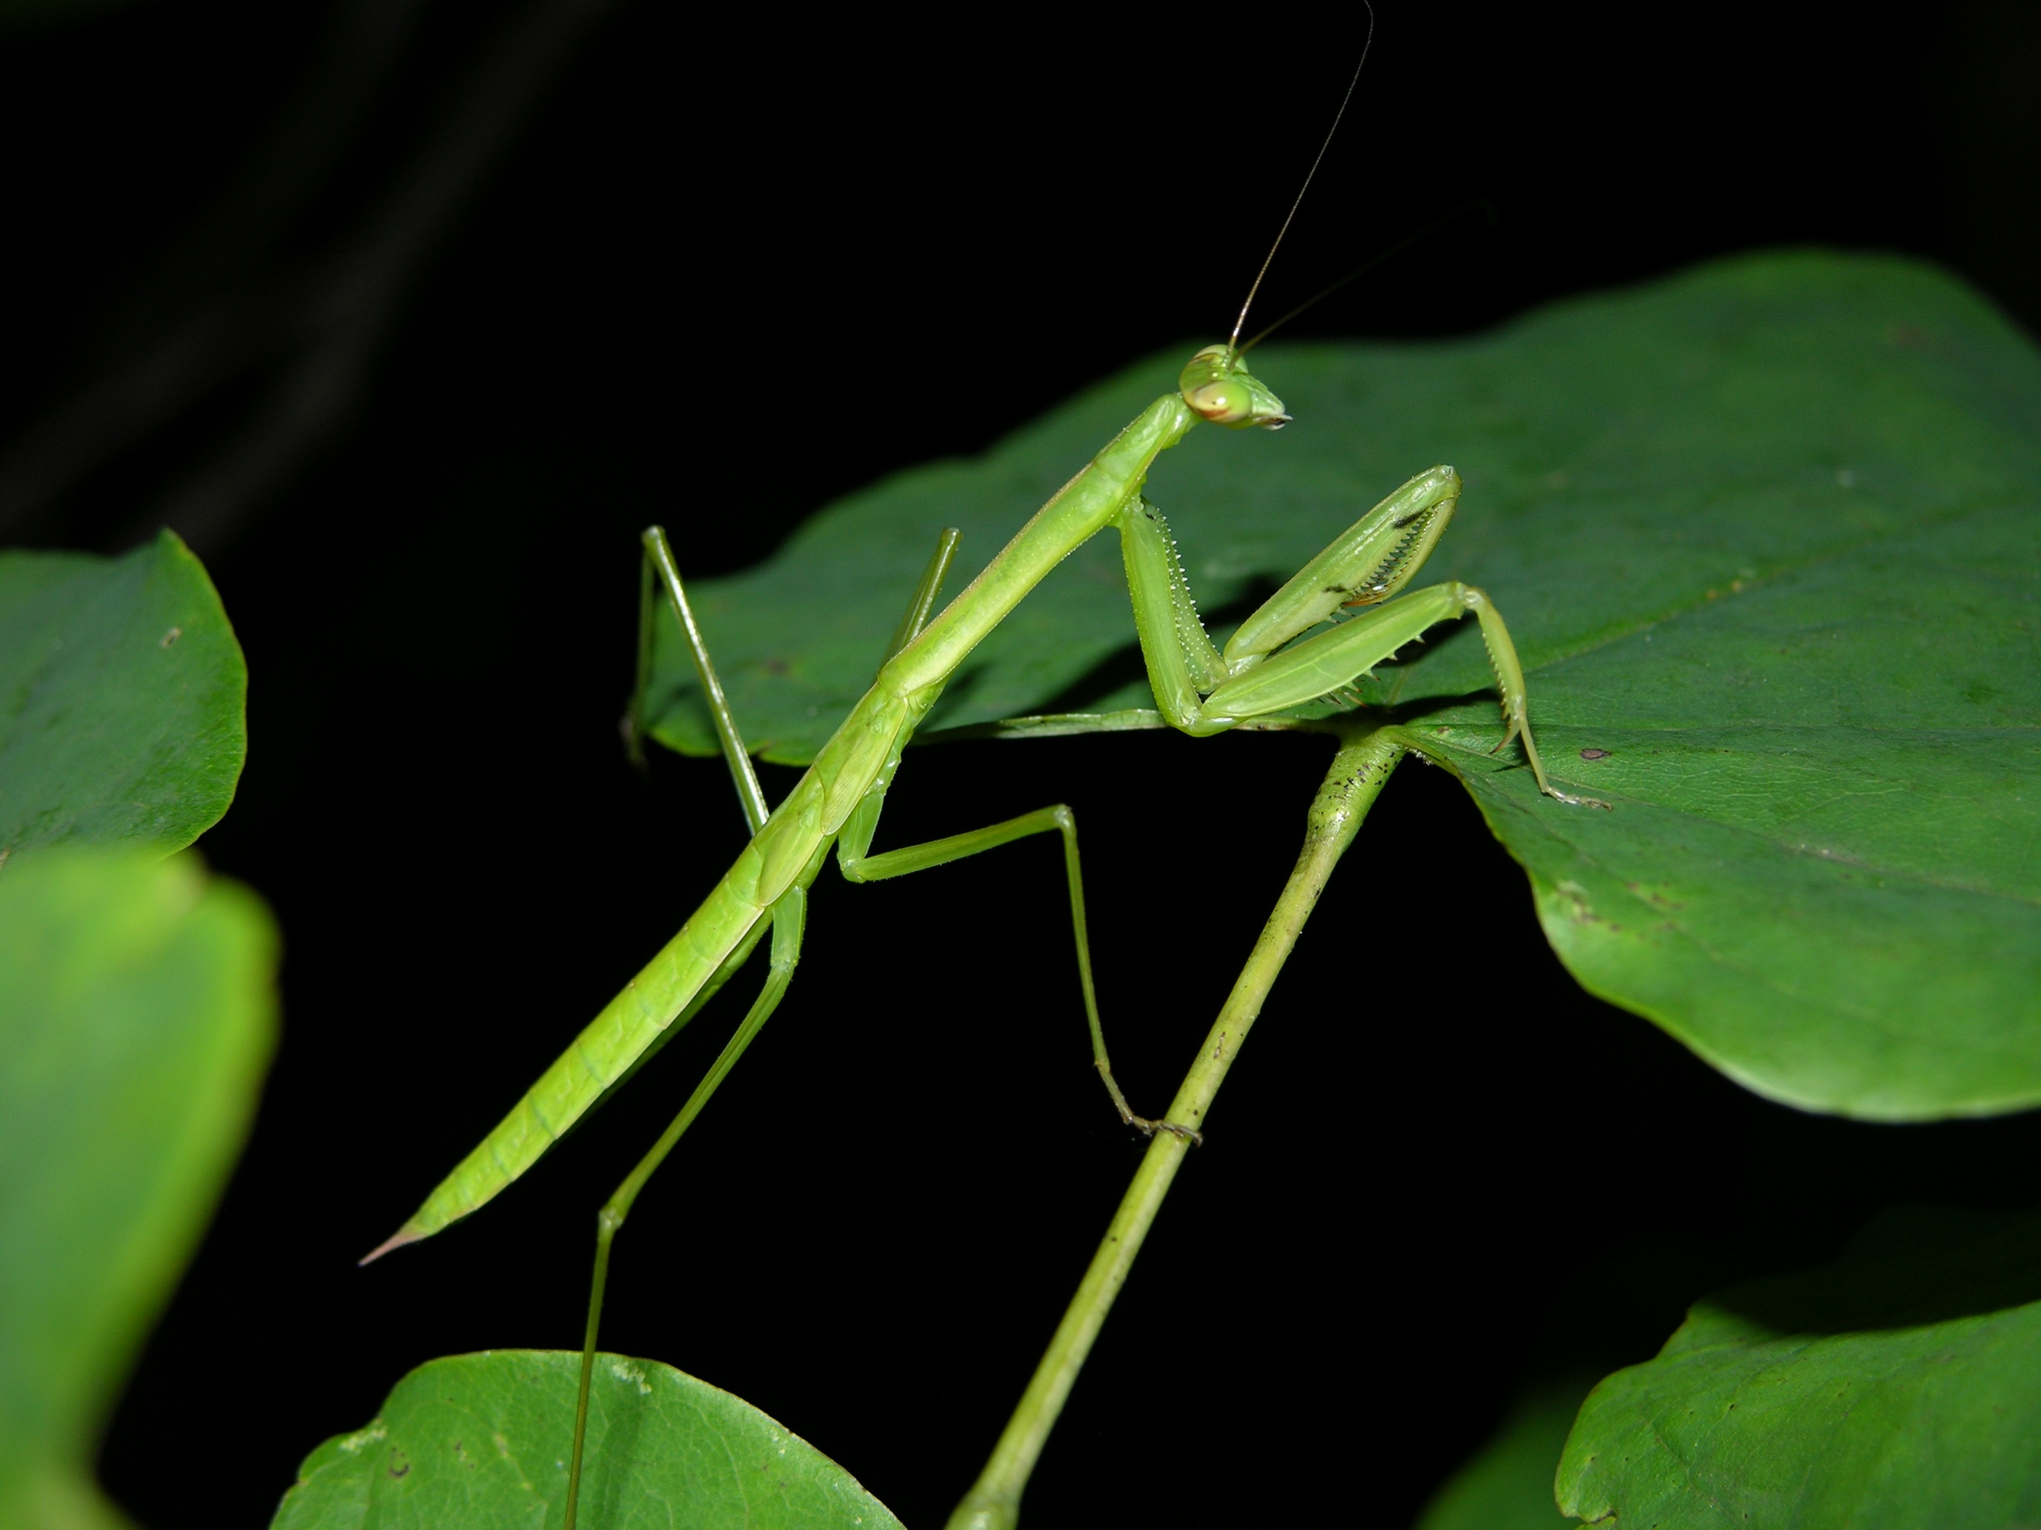
Species | Family | Order | trophic level
Tenodera sp. | Mantidae | Mantodea | predator

Mantis

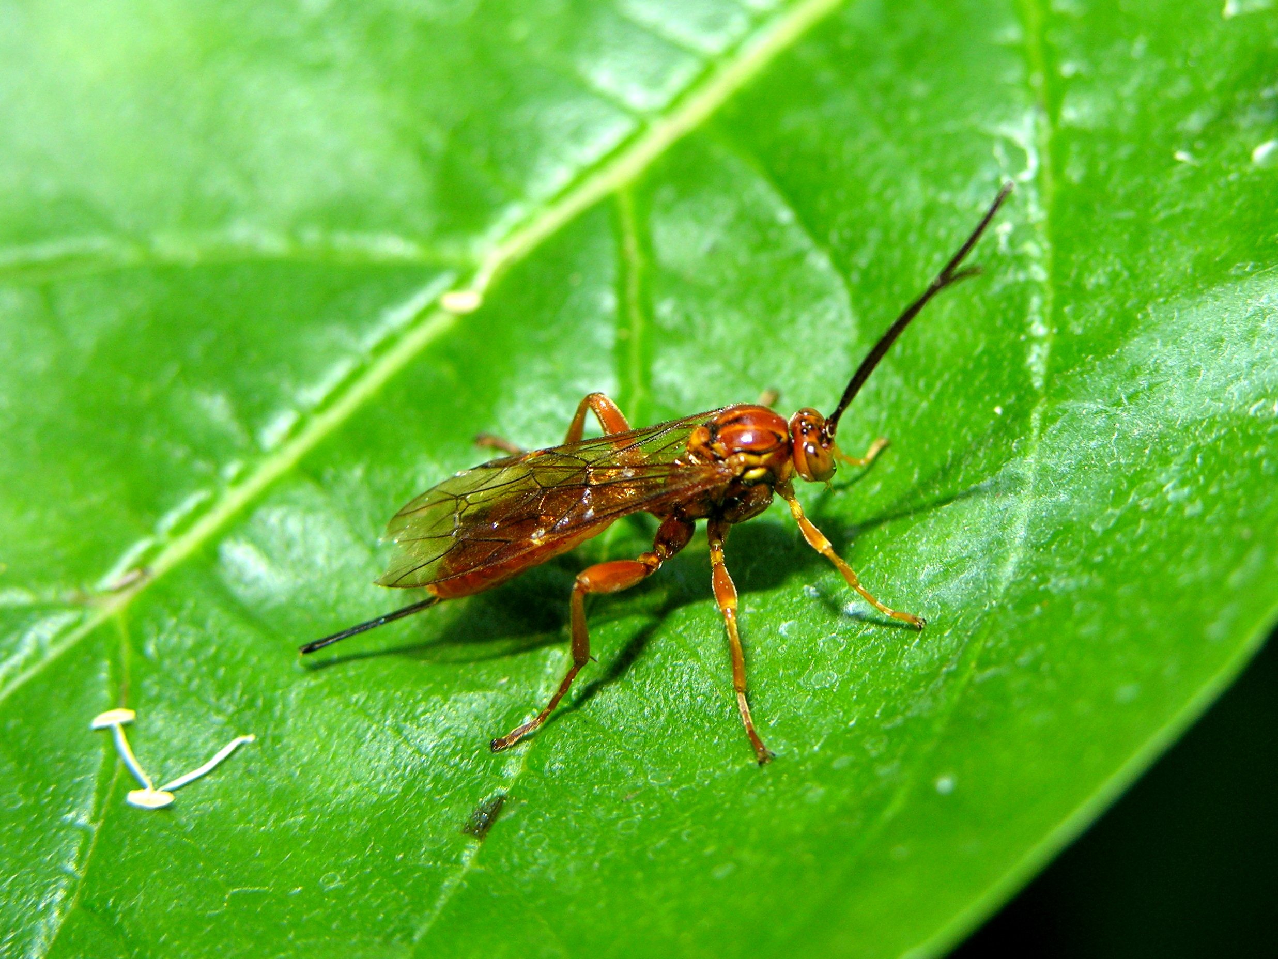
Species | Family | Order | trophic level
Theronia atalantae | Ichneumonidae | Hymenoptera | parasitoid

Princess Wasp

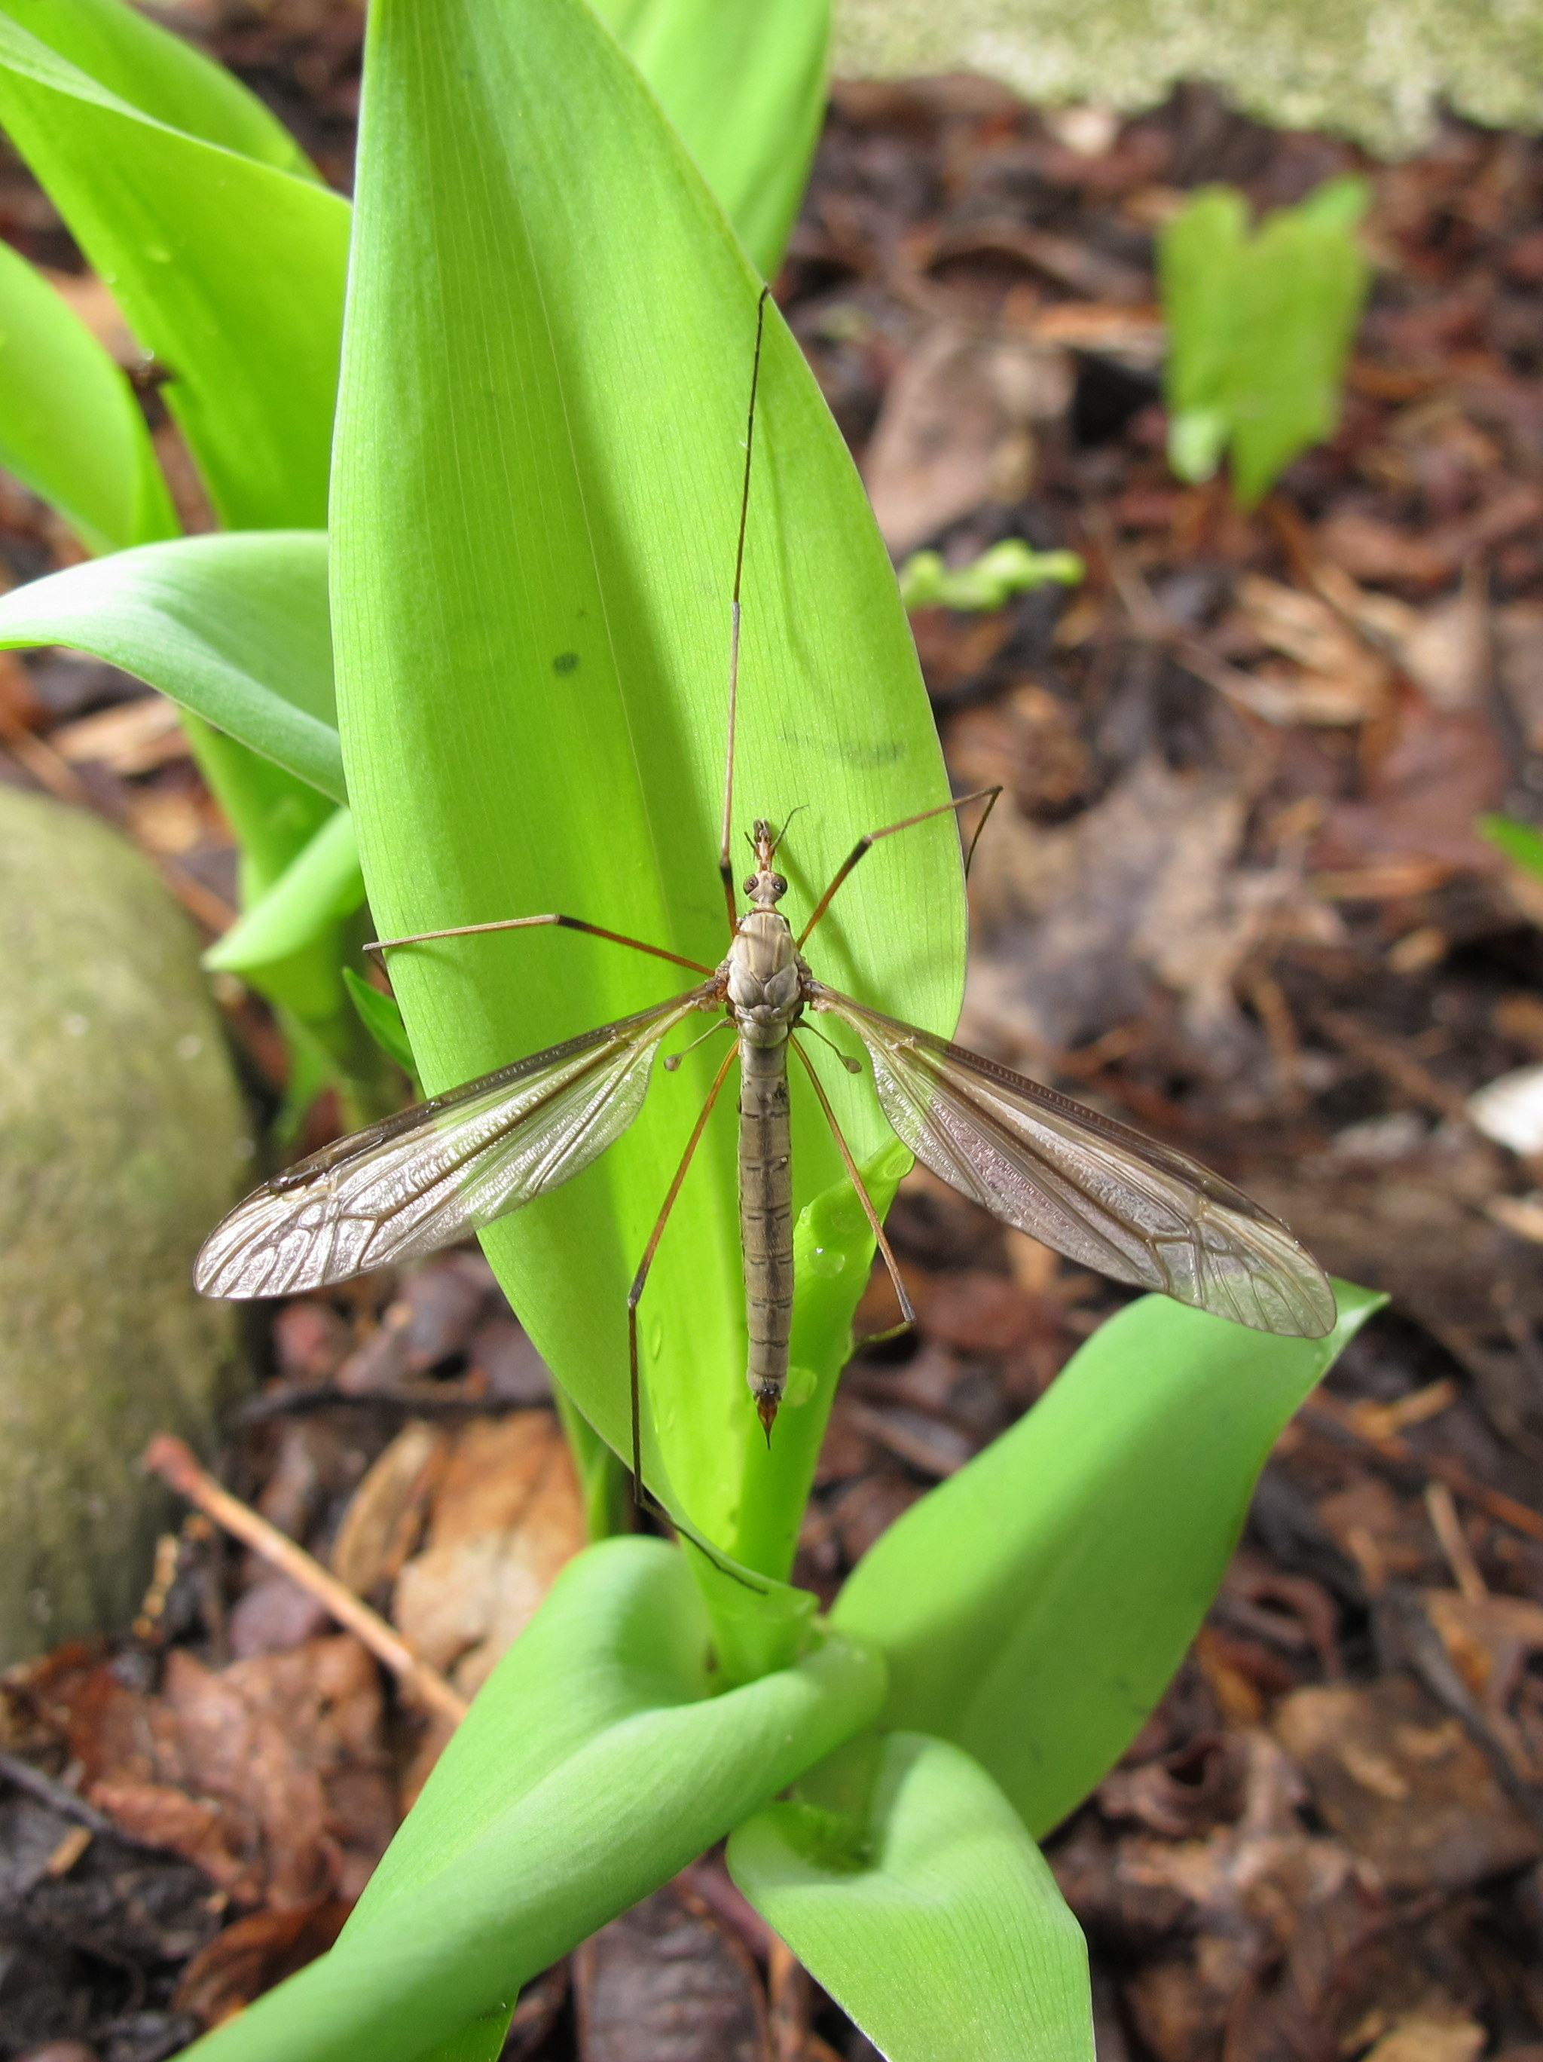
Species | Family | Order | trophic level
Tipula oleracea | Tipulidae | Diptera | herbivore, adults don't feed

Crane Fly

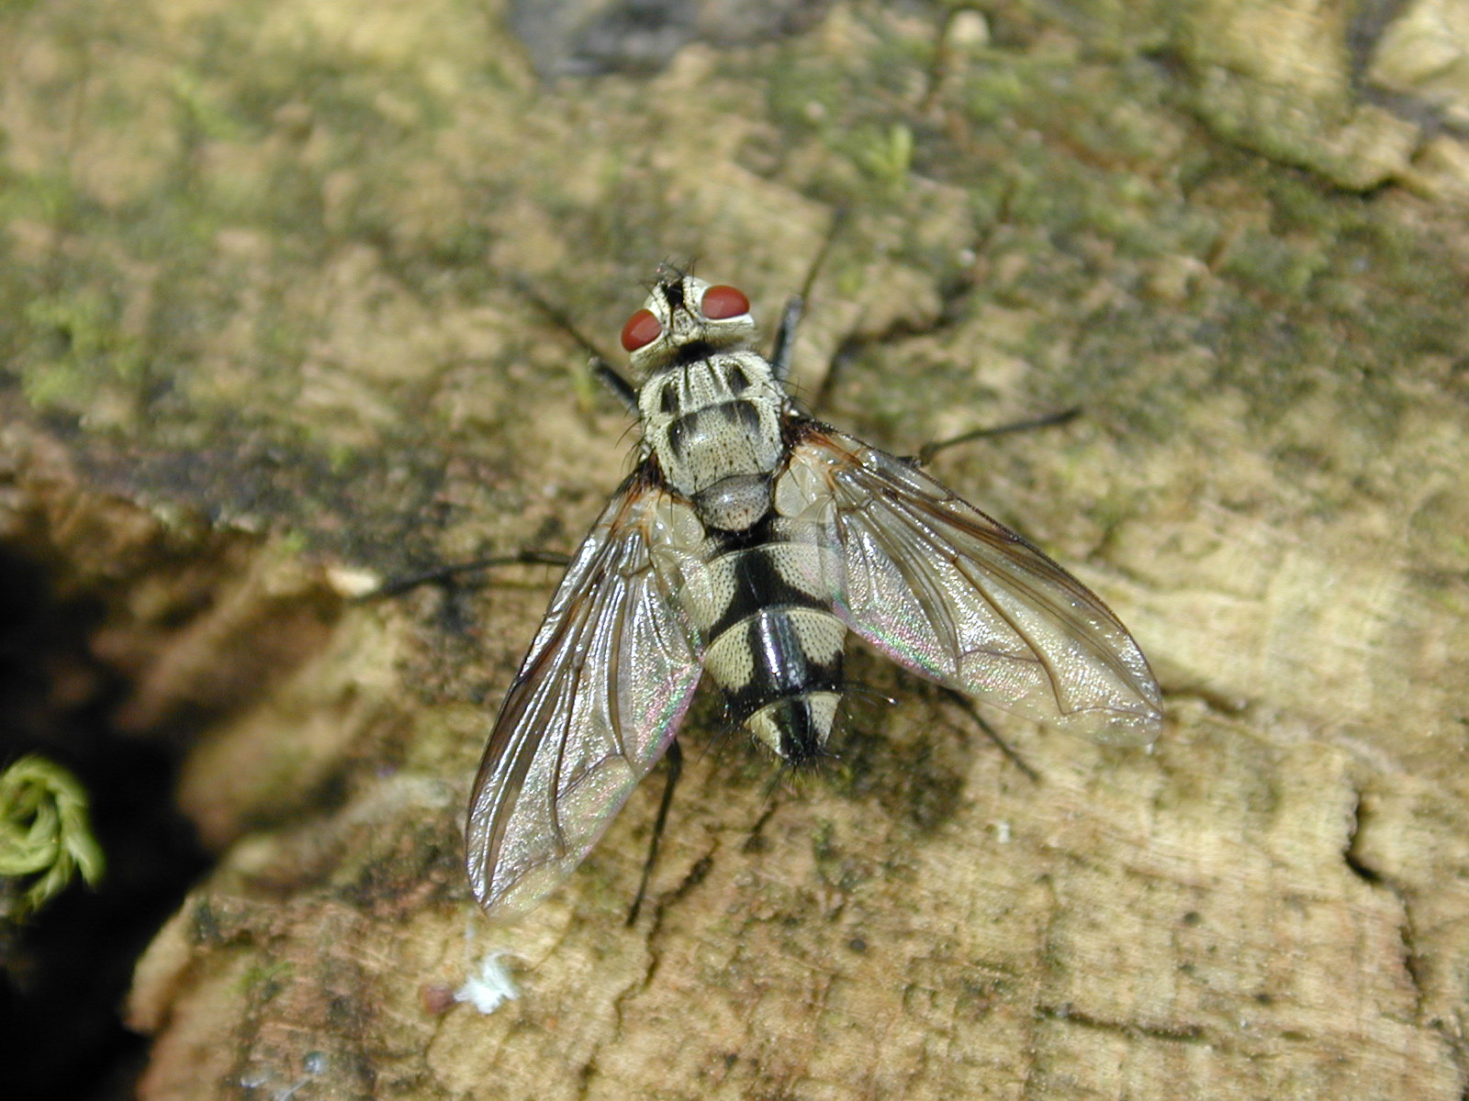
Species | Family | Order | trophic level
Zelia sp. | Tachinidae | Diptera | parasitoid

Tachiaid Fly

