Youth Development and School Gardens
Knowledge Check KEY
In the GB Learning Library - Core Preparation Sessions
this is Section 6.2 in Module 6: Youth Development and School Gardens
- List one or more benefits to youth when program organizers aim to reach a higher rung on Hart’s Ladder. Genuine engagement of youth, increased interest in gardening, empowerment, increased competence and confidence, strengthened relationships between youth and adults, more successful and sustained garden programs. (From Hart’s Ladder of Participation handout)
- Describe the four pillars of positive youth development that serve as the foundation for our garden-based learning activities. Mastery, Power/Independence, Generosity and Belonging. (See Planning for Positive Youth Development handout for a more in-depth description of each pillar)
- What is an action an organizer could take to incorporate “belonging” into a youth gardening program? Responses can vary but should include a thoughtful explanation. Examples: Encourage students to work together to complete tasks. Spend time gardening with students, and take your time! Think of ways to involve families and community. Work in small groups to encourage close relationships. Promote collaborative and cooperative learning. Show respect for the value of diverse cultures. Provide multiple opportunities for youth to develop relationships with adults. Be sure to have time for fun! (See Planning for Positive Youth Development handout)
- A group in your community is planning to start a youth garden project. What should be one of their first action steps if their goal is to promote interest in gardening among youth? Discuss and identify strategies to include youth in the planning and decision-making process. (From Planning for Positive Youth Development handout and Hart’s Ladder of Participation handout)
- Name an organization, program, book or website where you might look for youth garden curriculum or activities. Responses can vary widely but should include a resource for a GBL activity such as Junior Master Gardener, Garden Mosaics, Cornell Garden-Based Learning, Kidsgardening.org, NYS 4-H, etc. (From Learn More section)
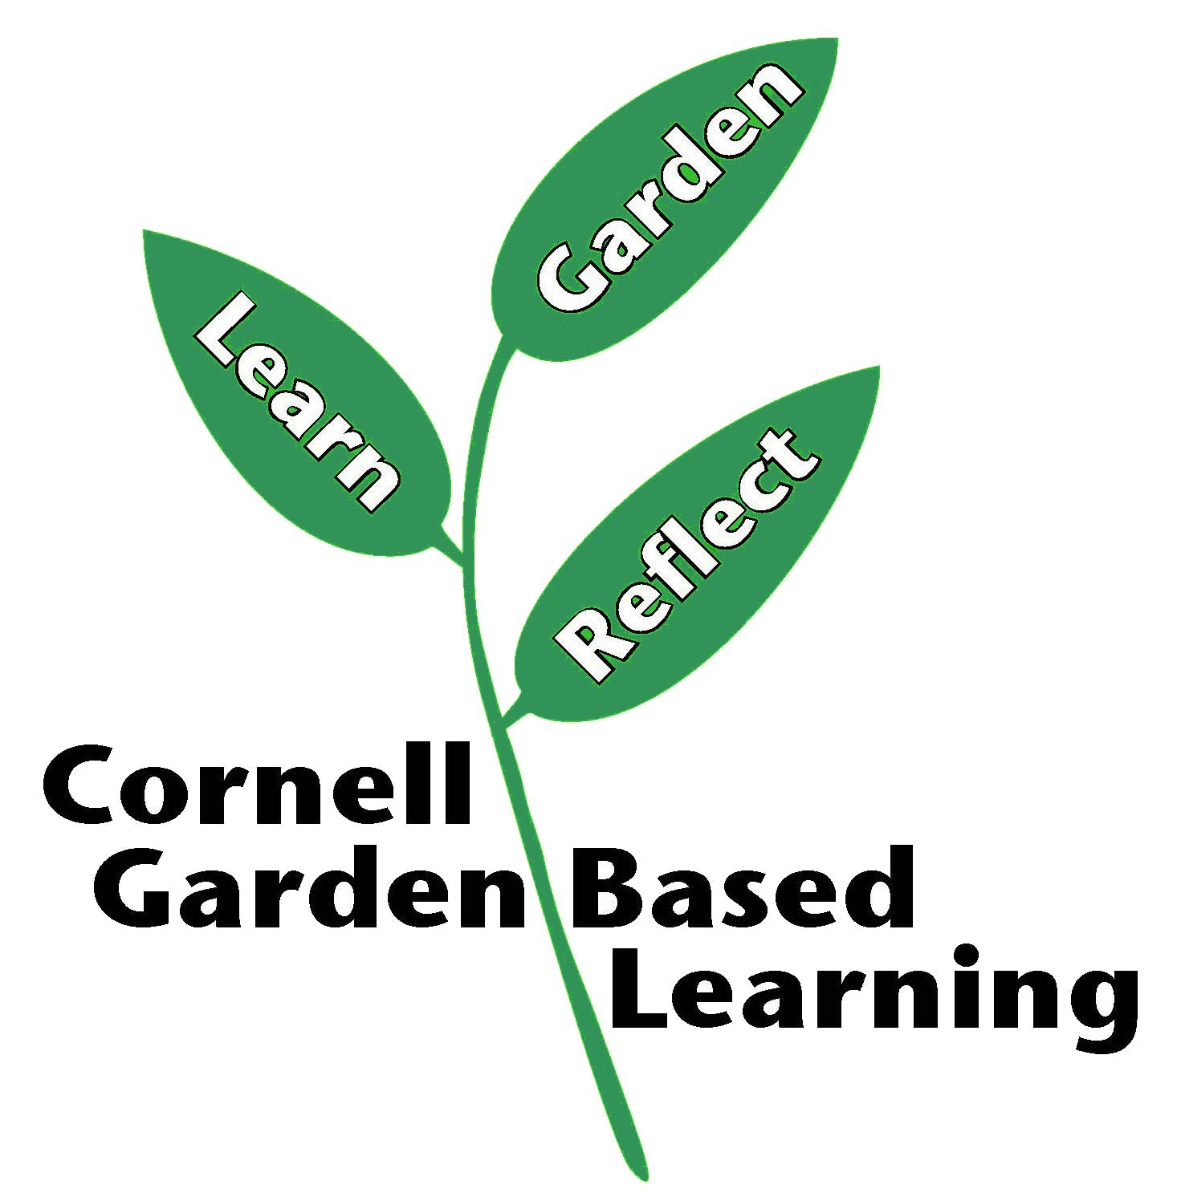
Date Published: April 2019
Author: Fiona Doherty
Reviewer(s): Marcia Eames-Sheavly, Michelle Podolec, Lori Brewer, Linda Gillilland, Holly Wise

