Adult Learning and Peer Learning Networks
Knowledge Check KEY
In the Learning Library - Core Preparation Sessions
this is Section 1 in Module 0: Introduction

1. List one or more general characteristics about adult learners.
In general adult learners: approach learning opportunities with goals shaped by their lived experience. Are motivated to find concrete solutions to real-world problems. Like to understand WHY they are learning something. Are task-oriented and like education with a practical end result. May expect that they are also leaders and learners, respected for sharing their lived experience. May come with unconscious biases and they don’t know what they don’t know – various expressions of this show up in the workshop setting. (From Lecture Basic Principles of Adult Learning)

2. Name a classroom tactic that encourages participation. Explain how you might integrate this tactic or another active learning technique into your own work as a peer educator.
Responses may vary: small group discussions, panel discussions, various forms of dialogue, role playing and brainstorming. (From Lecture Basic Principles of Adult Learning)

3. For the following statements mark each as either TRUE or FALSE.
- Most individuals do not make decisions about undertaking a behavior change on the basis of scientific studies or the consequences of doing it.
- Most people depend mainly upon subjective evaluations of ideas that are new to them; they rely on other individuals like themselves who have previously adopted the idea or behavior.
- The ability to make informed decisions will be based not on evaluation of what is true but on evaluation of whom to trust.
All are TRUE. (From Lecture Peer Learning Networks)

4. When should you use the CRAAP Test?
When you encounter any kind of source. It is a frame for evaluating:
Currency - The timeliness of the information.
Relevance -The importance of the information for your needs.
Authority - The source of the information.
Accuracy - The reliability, truthfulness & correctness of the content.
Purpose - The reason the information exists.
(From Lecture Peer Learning Networks and Fact sheet Evaluating Sources)
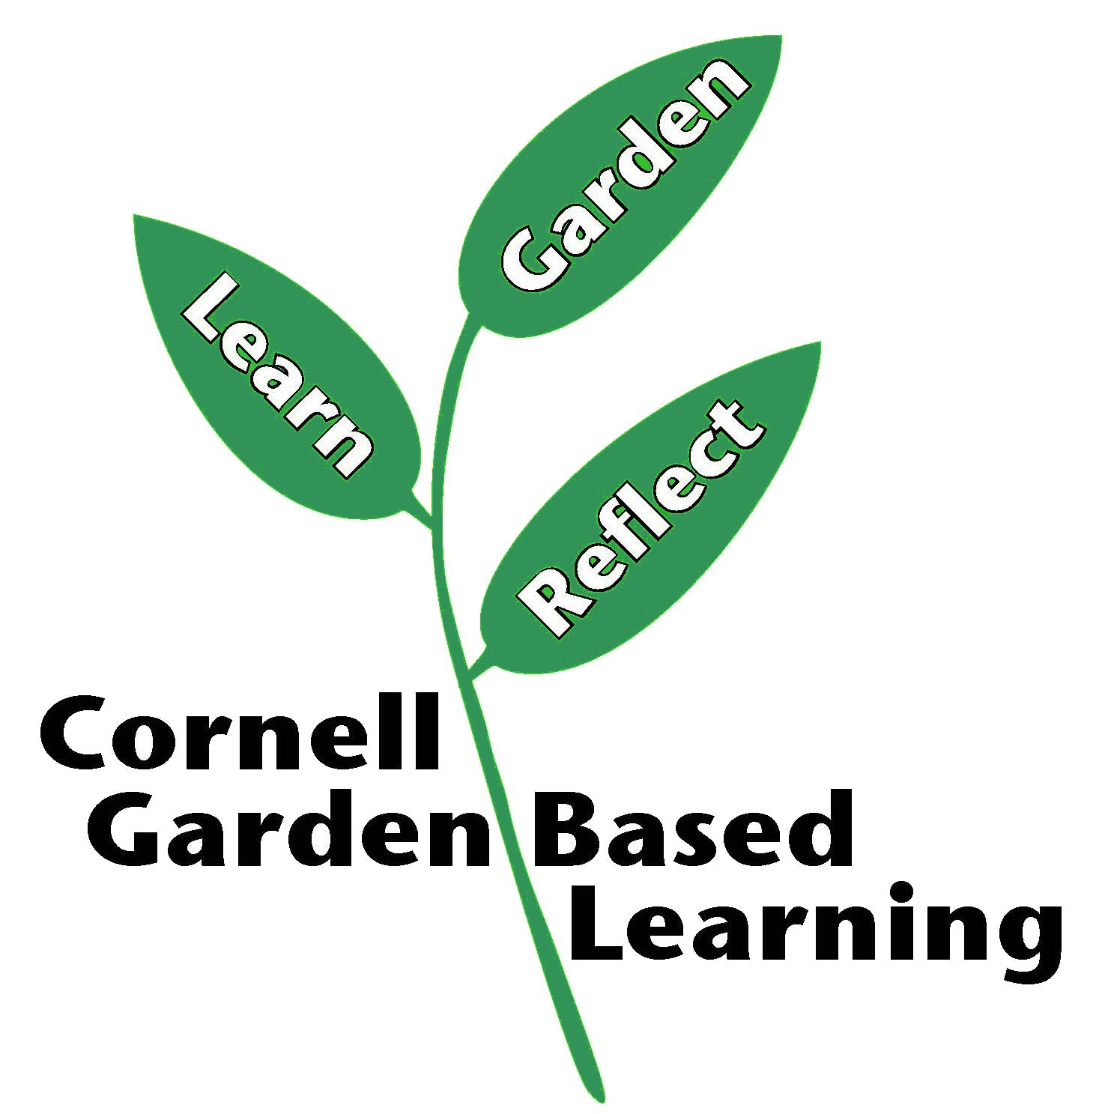
Published: April 2019
Author: Fiona Doherty
Reviewer(s): Marcia Eames-Sheavly, Michelle Podolec, Lori Brewer, Donna Alese Cooke

