Organic Waste Management: Composting
Knowledge Check KEY
In the GB Learning Library - Core Preparation Sessions
this is Section 5.1 in Module 5: Management Strategies
- What is vermicomposting?
(From: http://cwmi.css.cornell.edu/vermicompost.htm)
Vermicomposting is the process of using worms and micro-organisms to turn kitchen waste into a black, earthy-smelling, nutrient-rich humus.
- What is the correct ratio of “Browns” to “Greens” in an active compost container?
30:1 - 30 parts “browns” to 1 parts “greens” (From the Composting at Home presentation)
- Name 4 “Browns”:
Answers will vary:
Leaves
Pine needles
Paper
Peanut shells
Many others
(From the Composting at Home presentation)
- Name 4 “Greens”:
Answers will vary:
Vegetable waste
Coffee grounds
Grass clippings
Garden and lawn weeds
Many others
(From the Composting at Home presentation)

- Name 3 organic waste items that should NOT go into a compost pile:
Answers will vary:
Dairy products
Grease and fats
Treated paper
(From the Composting at Home presentation)
- Briefly describe a simple test to measure the maturity of a compost pile.
(From http://ccetompkins.org/gardening/composting/compost-resources factsheet “Is It Done Yet?”)
Jar test – Put material in jar, add water, seal and after a week check for odor; no odor = good
Germination test – Compare sprouting of seeds in compost “tea” compared to distilled water; significant delays or other difference indicate compost is not yet finished or mature.
- Why might animals be attracted to a compost pile? What is one possible strategy to minimize this issue?
Many animals would find good food in a compost pile especially if meat, fat, bones or other by products were being added instead of just plant waste or “browns.”
Minimize unwanted pests by selecting a bin that can exclude pest and by choosing to limit organic material to appropriate “greens” and “browns.” (From the Composting at Home presentation)
- Why might a compost pile smell like rotten eggs? What can someone do to correct this issue?
Might not have enough oxygen (air) and or be too wet. Turn the pile and if it is too wet, add some dried materials like leaves or straw to soak up moisture. (From the Composting at Home presentation)

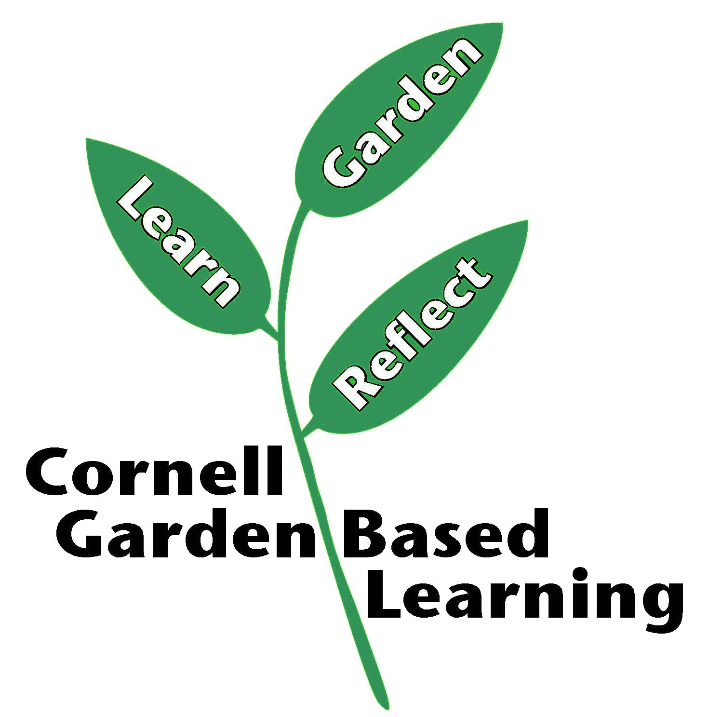
Date Published/Updated: April 2019
Contributors: Fiona Doherty, Lori Brewer
Reviewer(s): Michelle Podolec, Flip Filippi

