4.1b Pesticide Use and Reading Labels
Knowledge Check (1 of 4)
This Knowledge Check covers presentation segments
Pesticide Basics & Formulations

- What is a pesticide?
A pesticide is a mixture of substances used to kill pests or to prevent or reduce the damage pests cause. (presentation, slide 4)

- What is not a pesticide?
A product that controls a pest purely by mechanical or physical means is not a pesticide. It is called a pest control device. (presentation, slide 4)

- What are sources of pesticides?
Pesticides can come from our physical environment, from living organisms (like insects, plants, and microorganisms), or be man-made (manufactured). (presentation, slide 5)

- How do pesticides differ?
Pesticides differ in their mode of action (or how they act on a pest). Insecticides differ in how long they remain effective (residual versus nonresidual) and how they get into insect pests (contact, stomach poison, or systemic). Fungicides differ in how they control diseases (protectant versus systemic). Herbicides differ in how plants uptake them (contact versus systemic) or their selectivity (selective versus broad-spectrum). Rodenticides vary in how they kill rodents (acute versus multidose anticoagulants). (presentation slides 7 and 8)

- Identify materials that contain pesticides.
Treated seed, weed ‘n feed lawn care products, flea and tick collars, or treated lumber. (presentation, slide 9)

- What are some pesticide characteristics that make it useful?
Reasonably easy to handle, sufficiently safe to handle, in a form that can reach the pest, and are chemically stable. (presentation, slide 10)

- What is a pesticide formulation?
A pesticide formulation is the active ingredient(s) plus the inert ingredient(s). (presentation, slide 10)

- What is a pesticide active ingredient?
A pesticide active ingredient is the substance or substances that actually controls the pest. (presentation, slide 10)

- What is a pesticide inert ingredient?
A pesticide inert ingredient is a substance or substances that makes the entire product more useable. (presentation, slide 10)

- What is a pesticide trade name?
A pesticide trade name (also called the brand or product name) is the name a manufacturer gives a pesticide and is what’s commonly used to promote and advertise the product. (presentation, slide 12)

- What is a pesticide’s chemical name?
A pesticide’s chemical name identifies the chemical components in a pesticide as well as the chemical structure of the active ingredient. It is usually a complex chemical name. (presentation, slide 13)

- What is a pesticide’s common name?
A pesticide’s common name is a shorter, unique name that’s used more often than the chemical name. (presentation, slide 13)

- What is the relationship between a pesticide’s trade name and its active ingredient or ingredients?
There isn’t a connection between the trade name and a product’s active ingredients. Different trade names can have different active ingredients. Similar trade names can have the same or different ingredients as well. Because of this, you need to consider both the trade name and the active ingredient list. (presentation, slides 14 and 15)

- What might different trade names mean to a pesticide user?
These may indicate they are made by different companies, include different amounts of active ingredient(s), have different safety and risk precautions, or even have different uses. This is why it’s important to read the label. (presentation, slides 14 and 15)

- Why is a pesticide formulation important?
The pesticide formulation is important because it affects the exposure risk, how a pesticide can be used, the type of application equipment needed, and the need to measure and mix the pesticide prior to use. (presentation, slide 18)

- Name two pesticide formulations available to homeowners.
Answers could be any of the following: ready-to-use (RTU), ready-to-spray (RTS), concentrate, aerosol, dust, granular, pellets, baits, animal systemics (such as pour-on liquids, liquid sprays, or dusts). (presentation slides 19-23)

- When choosing a pesticide formulation, what should you consider?
When choosing a pesticide formulation, you should consider: what or where you’re treating and the pest is on the label; if the formulation will stay in place long enough to provide control; the risks to you, the environment, and the treated site; any application equipment needed; personal protective equipment needed; any handling and measurement needs; dilution needs; and whether you can use all of the product within a reasonable amount of time and not have to store it. (presentation, slide 24)

- Explain the responsibilities of Cornell Cooperative Extension educators and Master Gardener Volunteers when making pesticide recommendations.
Recommendations should be from documented authoritative sources; use the most current Cornell Crop and Pest Management Guidelines or updated Cornell department fact sheets that have been reviewed by the Pesticide Management Education Program at Cornell University; other sources can be used provided they’ve been reviewed by PMEP; minimum-risk (or 25(b)) pesticides can be recommended but they need to be vetted through PMEP first for compliance and use and the user needs to be informed that these products are not subject to EPA safety and efficacy testing. All recommendations – written or verbal – need to be documented, including the date, client’s name, summary of the situation, and the details of the recommendation (including specific products and rates). For minimum-risk pesticide recommendations, the CCE educator or Mater Gardener Volunteer must make a record that the client was notified that minimum-risk pesticides aren’t subject to EPA efficacy or safety testing. Recommendations can be documented using the "Recommendations Record Book Form" provided in FORM Code 1501 or in a secured computer file. Recommendation records must be kept for a minimum of 7 years according to the records retention policy.

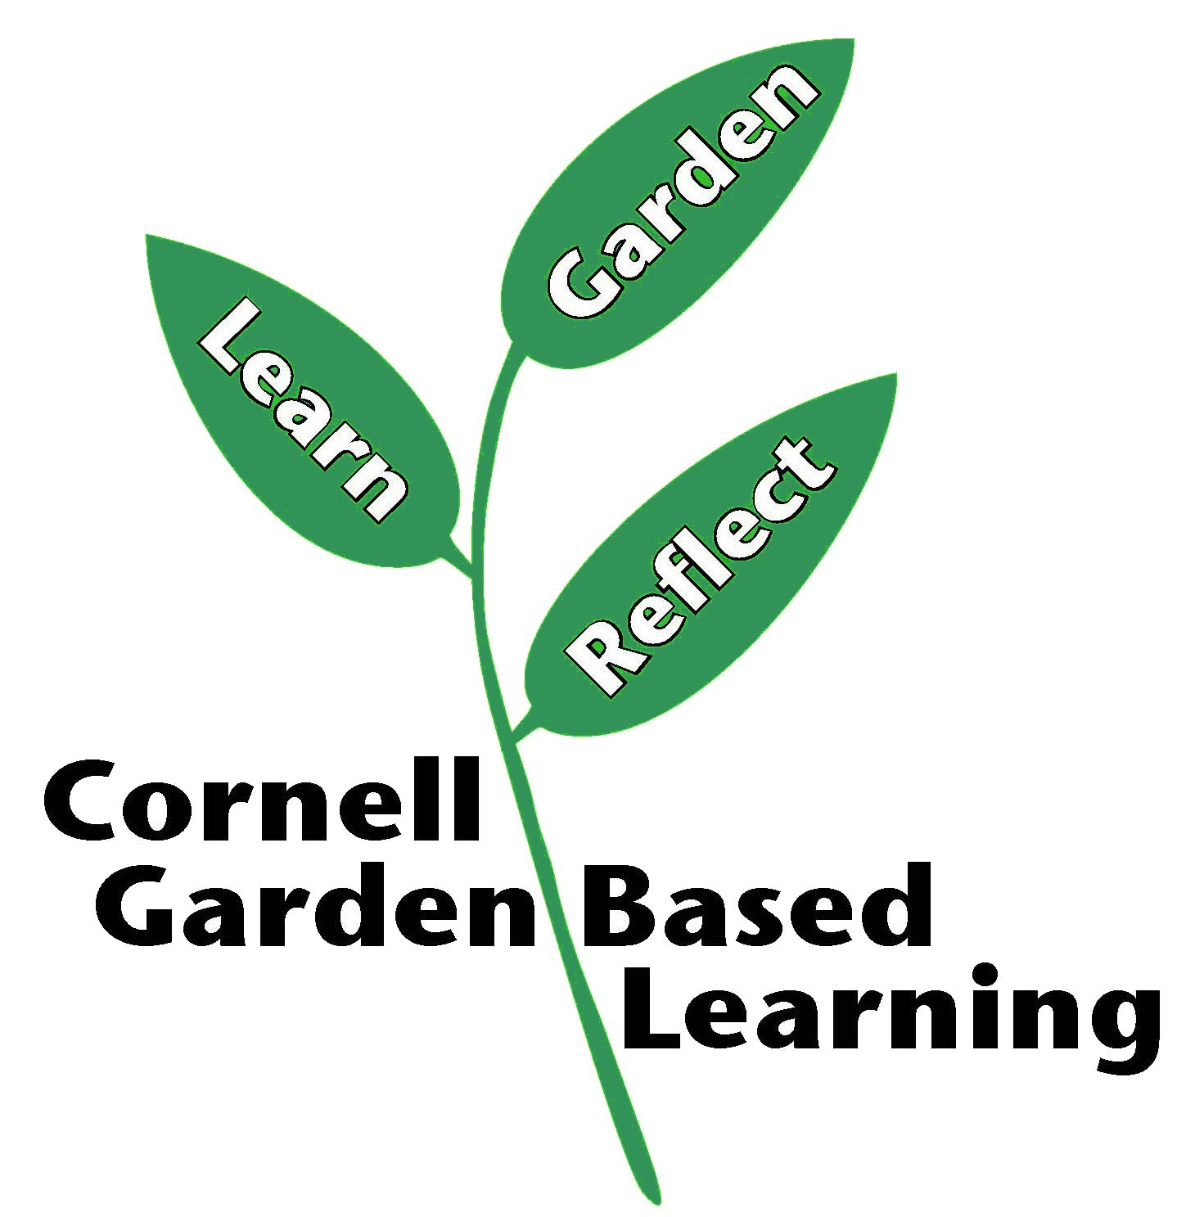

References: Pesticide Management Education Program (PMEP)
Date Published/Updated: September 2, 2020
Author(s)/Contributor(s): Michael Helms (PMEP)
Reviewer(s): Ashley M. Helmholdt, Donna Alese Cooke

