Problem Solving: Pests of Food Crops and Ornamental Plants

Knowledge Check

In the GBL Learning Library - Core Preparation Sessions

this is Section 4.3a in Module 4: Problem Solving

1. What are the ABCD’s of submitting samples to the Plant Disease and Insect Diagnostic Labs, for accurate and timely results?
2. What are best methods and tips for shipping materials for analysis?

3. Dead plant samples are as good as live samples for proper diagnosis. True or False

4. Avoid using railroad ties, telephone poles, pressure-treated wood and some painted wood, because they contain chemicals that can get into vegetable garden soil. True or False

5. What are the steps to help guide your observations and fact collection when making conclusions for vegetable and fruit problems?

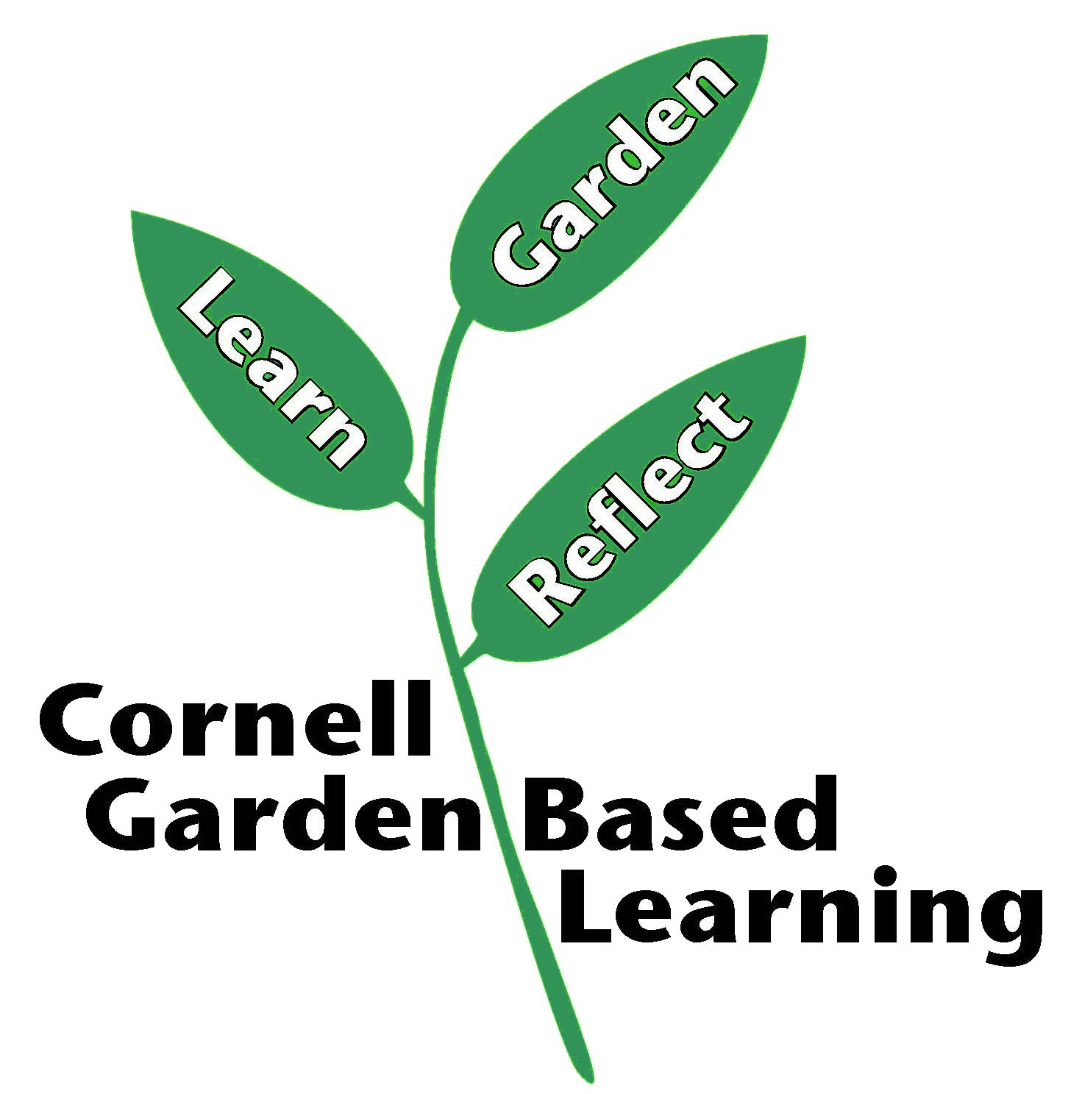

Date Published: April 2019
Author: Donna Alese Cooke
Reviewer: Fiona Doherty

