Lawns and Plant Ecosystems Services
Knowledge Check
In the GBL Learning Library - Core Preparation Sessions
this is Section 3.3 in Module 3: Ornamental Plants and Ecosystems Services

1. Name and briefly describe the 4 categories of ecosystems services.

2. Name one or more easy cultural practices that can improve lawn appearance and health.

4. What is an example of a strategy, using vegetation, to reduce energy consumption during the summer?

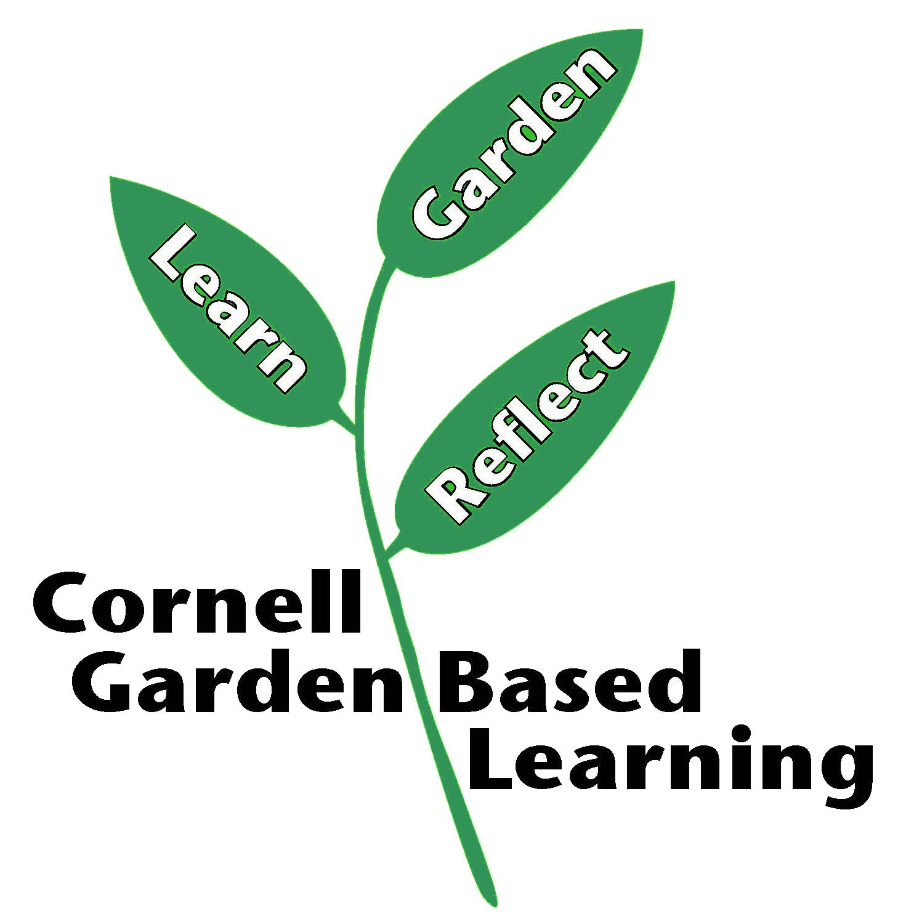
Date Published/Updated: April 2019

