Basic Plant Pathology
Knowledge Check KEY
In the GBL Learning Library - Core Preparation Sessions
this is Section 1.4 in Module 1: The Fundamentals

1. Name 5 living causal agents of disease and give examples of each. (From Basic Plant Pathology presentation)

Fungi - Many examples including apple scab
Bacteria - Many examples including fire blight
Viruses - Many examples including tobacco mosaic virus
Nematodes - Many examples including Golden Nematode
Phytoplasmas – Many examples including Ash Yellows

2. What are some examples of abiotic damage? (From Basic Plant Pathology presentation)

Many possible answers including herbicide injury, chemical spill, air pollution, freeze injury, nutrient deficiency, soil compaction, snow or salt damage.

3. How do plant parasites differ from plant saprophytes? (From Basic Plant Pathology presentation)

A parasite is an organism that derives nourishment from another living organism.

A saprophyte derives nourishment from dead or decaying organic matter such as fungi (mushroom).

4. Sketch and label the disease pyramid/triangle. (From Basic Plant Pathology presentation)
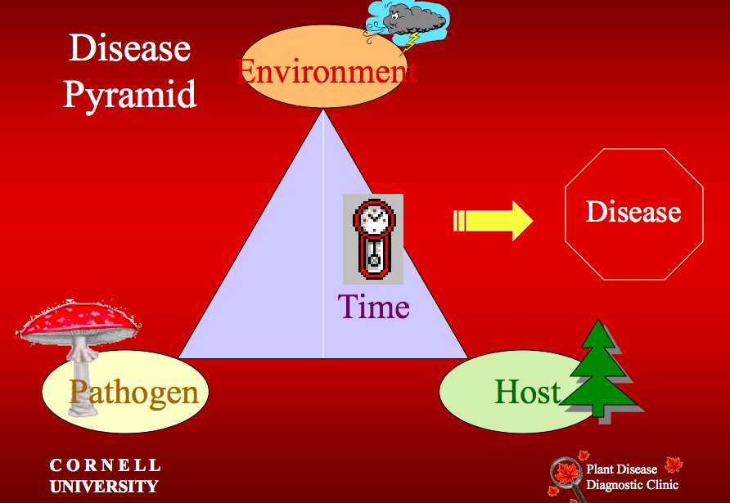

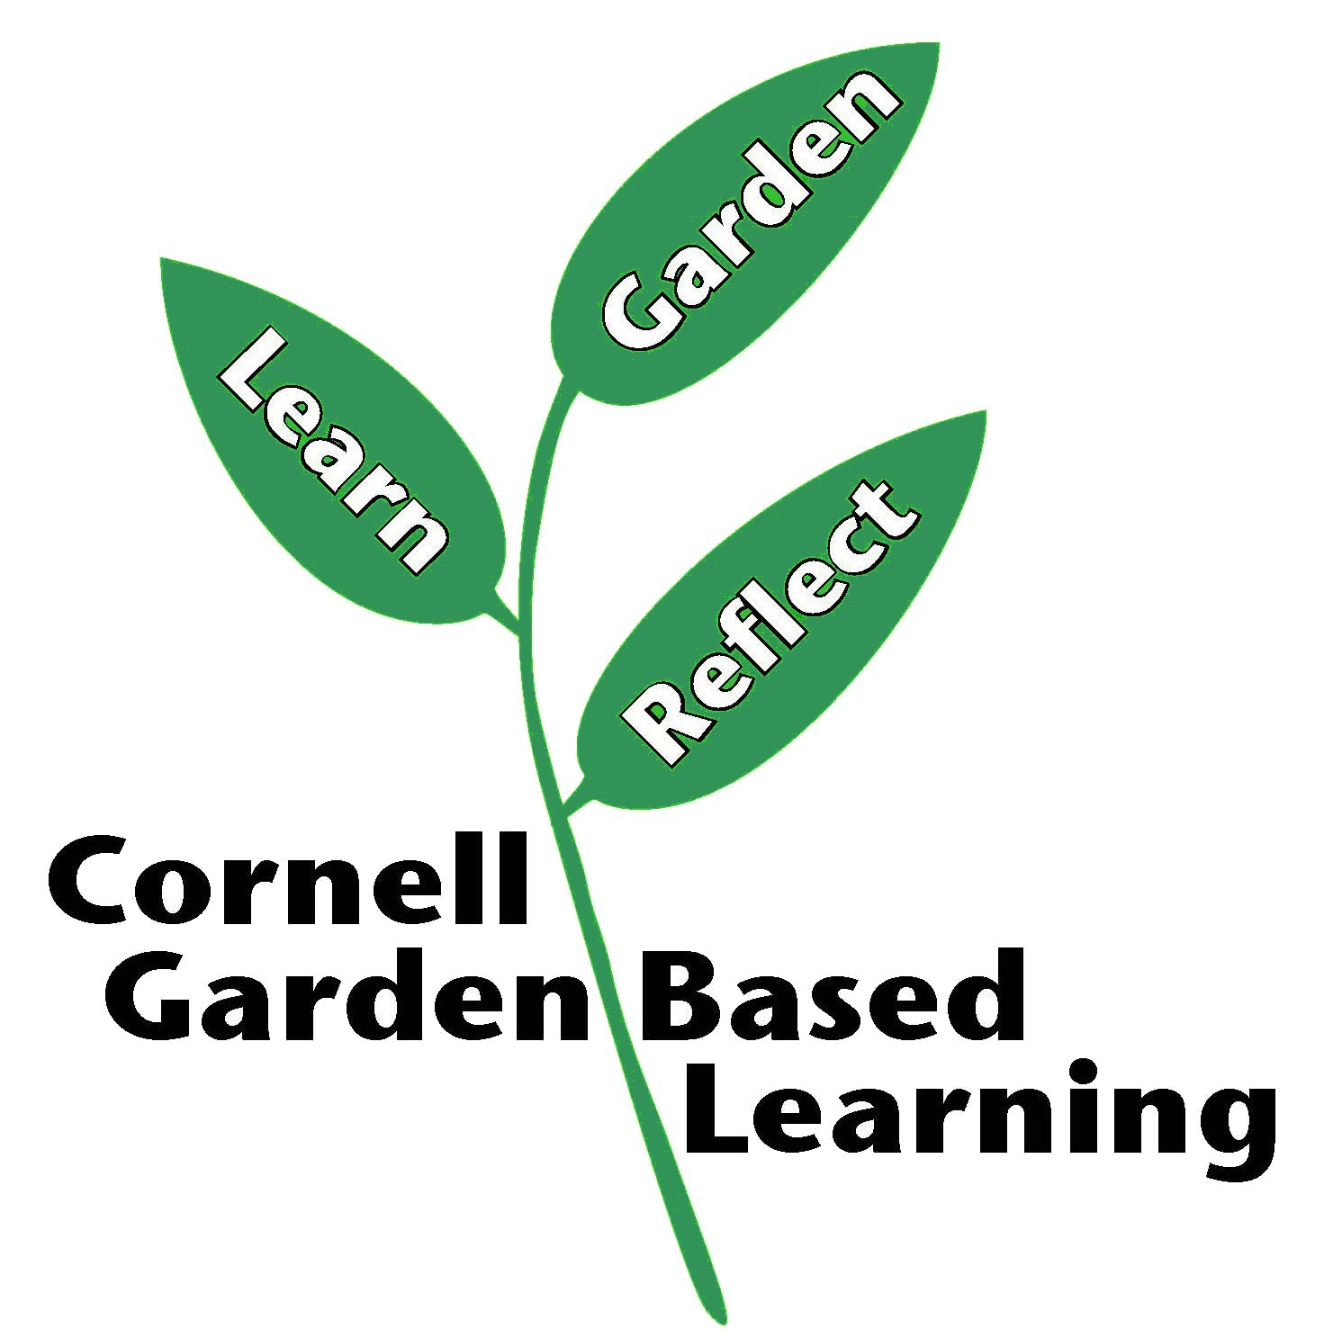

References: http://plantclinic.cornell.edu/mastergardner.html
Date Published/Updated: April 2019
Contributor(s): Fiona Doherty, Lori Brewer
Reviewer(s): Michelle Podolec, Donna Alese Cooke

