Beneficial Insects
Knowledge Check
In the GBL Learning Library - Core Preparation Sessions
this is Section 1.3 in Module 1: The Fundamentals

1. What is a key difference between the body parts of an adult insect and an adult arachnid?

2. Name a predatory insect that is considered to be a beneficial insect. What does it eat?

3. Two common life cycle types of insects are complete and incomplete metamorphosis. How do these life cycles differ?

4. What are the two broad categories of insect mouthparts are designed to do? Provide examples of specific insects and their mouthparts.

5. Name two strategies for attracting beneficial insects to the garden setting.

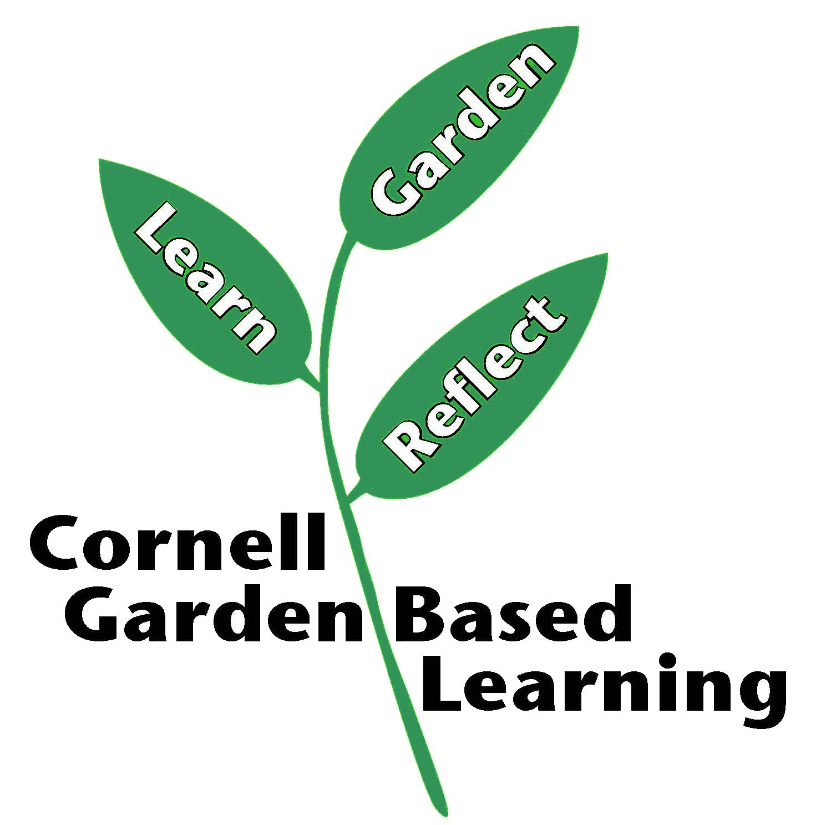
References: Basic Entomology for Identification, Jason Dombroskie
Date Published/Updated: April 2019
Author(s)/Contributor(s): Fiona Doherty
Reviewer(s):

