BugFinder Activity

Learning Objectives: Become familiar with beneficial & common garden insects.

Time: 30 minutes

Supplies:
- Insect net if you have one
- Glass jar
- Hand lens
- Paper and pencil
- Insect field guide
- Insect ID websites such as:
  - Insect Anatomy from Purdue University
  - Penn State Department of Entomology
  - Texas A&M Insects in the City
Directions:
Go into your garden, local park, or just look carefully at the leaves and stems of your houseplants. Some insects don't move visibly, so you might overlook them at first. If you have a net, try gently brushing it through tall grass or across a shrub to catch the insects that jump away from the disturbance.

After waiting a few minutes for the captured insects to settle down, take a closer look at them using the hand lens. What do you notice? Can you see mouthparts? Wings? Does it have some other body part of interest? What do you think this insect does for food? What makes you think so? What part of the plant did you find it on, and what does that suggest?

To the best of your ability, sketch one of the true insects you have caught. (You may have also found other arthropods - spiders, centipedes, ticks, etc.) Use the below websites for guidance with basic insect morphology. Don't worry about being an artist, try to capture the features that make this insect unique. Pay attention to details like wings, mouth, feet, and coloration.

Once you have sketched your insect, take out your insect identification guide, and try to identify. Don’t worry if you cannot identify it exactly, aim to place the insect within an order.

What does the insect identification guide say about this insect? What are this insect’s unique features? What does it eat? Where does it live? Does this match with where you found it? Is it beneficial, or a pest? Once done, release your insect back into its environment.

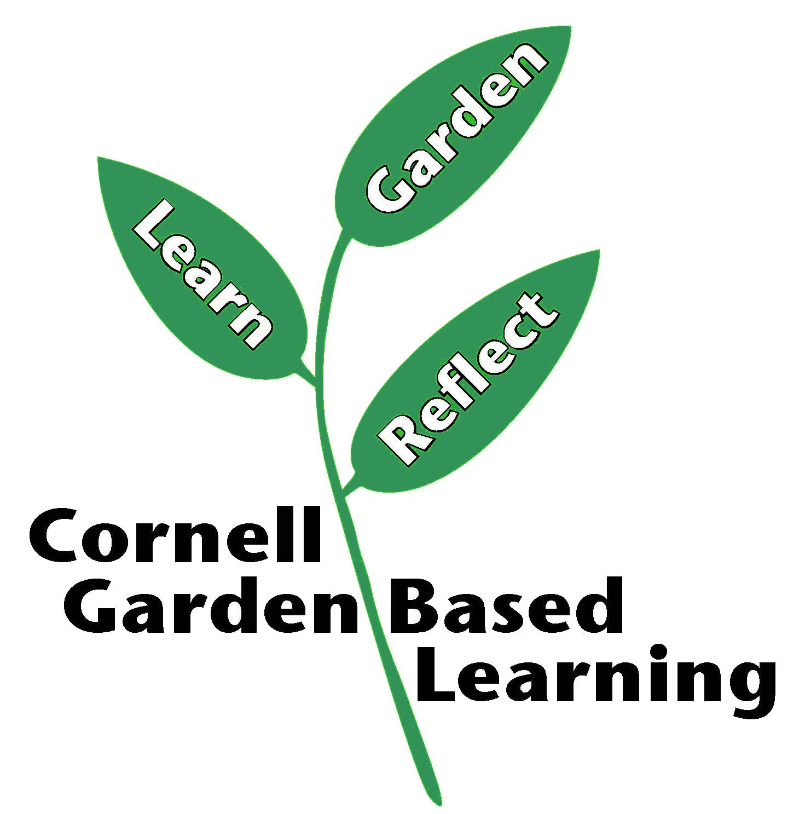
References: Cornell University Online Organic Gardening Course
Published: April 2019
Reviewer: Fiona Doherty, Michelle Podolec

