Site Assessment Activity

60 minutes

Learning Objective(s): Participants will…
- Apply basic site assessment criteria to a familiar landscape.

Supplies:
Handouts:  - Monocots and Dicots graphic | 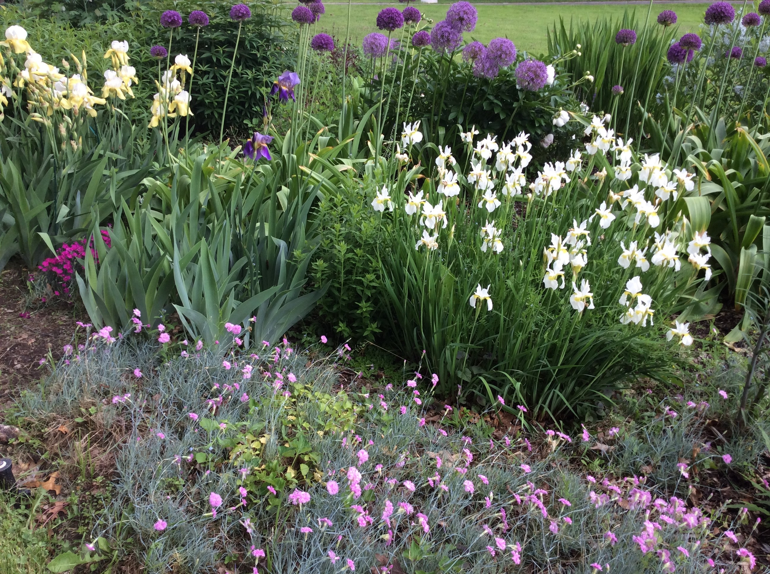
Materials:
- Paper, pencil and clipboard.
- Optional: Camera

Instructions:
Using your property or another familiar landscape such as a nearby park, walk through the site assessment checklist to learn more about the site. Make notes, draw a basic sketch or take photos to represent each bullet.

Date Published: April 2019
Author(s)/Contributor(s): Chrys Gardener, CCE Tompkins Community Horticulture Educator
Reviewer(s): Fiona Doherty

Site Assessment Checklist
Name of Property:
- USDA Hardiness Zone: | - Aspect, Include North Arrow
Last Spring Frost:  Last Fall Frost: | North  South  East  West
- Sunlight | - Slopes
Full sun (6 hours or more)  Partial sun  Shade | Steep  Moderate  Gradual or flat
- Microclimate factors: | Soil texture
Reflected heat  Frost pocket | Clayey  Loamy  Sandy  Silty
- Wind: | - Soil compaction
Windy site  Windy in isolated sections  Calm site | Compacted  Partially compacted  No compaction
- Obstructions | - Soil drainage characteristics
Below ground (e.g. utilities or irrigation system)  Above ground (e.g. overhead wires) | Wet  Well-drained  Dry
- Wildlife interference
Serious and obvious concerns
Marginal concerns
Not a problem

- Unusual conditions: | - Soil pH:  - Existing Plants:
Notes:

