Community Engagement
Knowledge Check
In the Learning Library - Core Preparation Sessions
this is Section 2 in Module 0: Introduction

- Identify one or more characteristics of an effective member of a peer-learning network.

- Reflect on one major takeaway you got from the community engagement video discussions or the facilitation scenarios. What is important to remember when working in community?

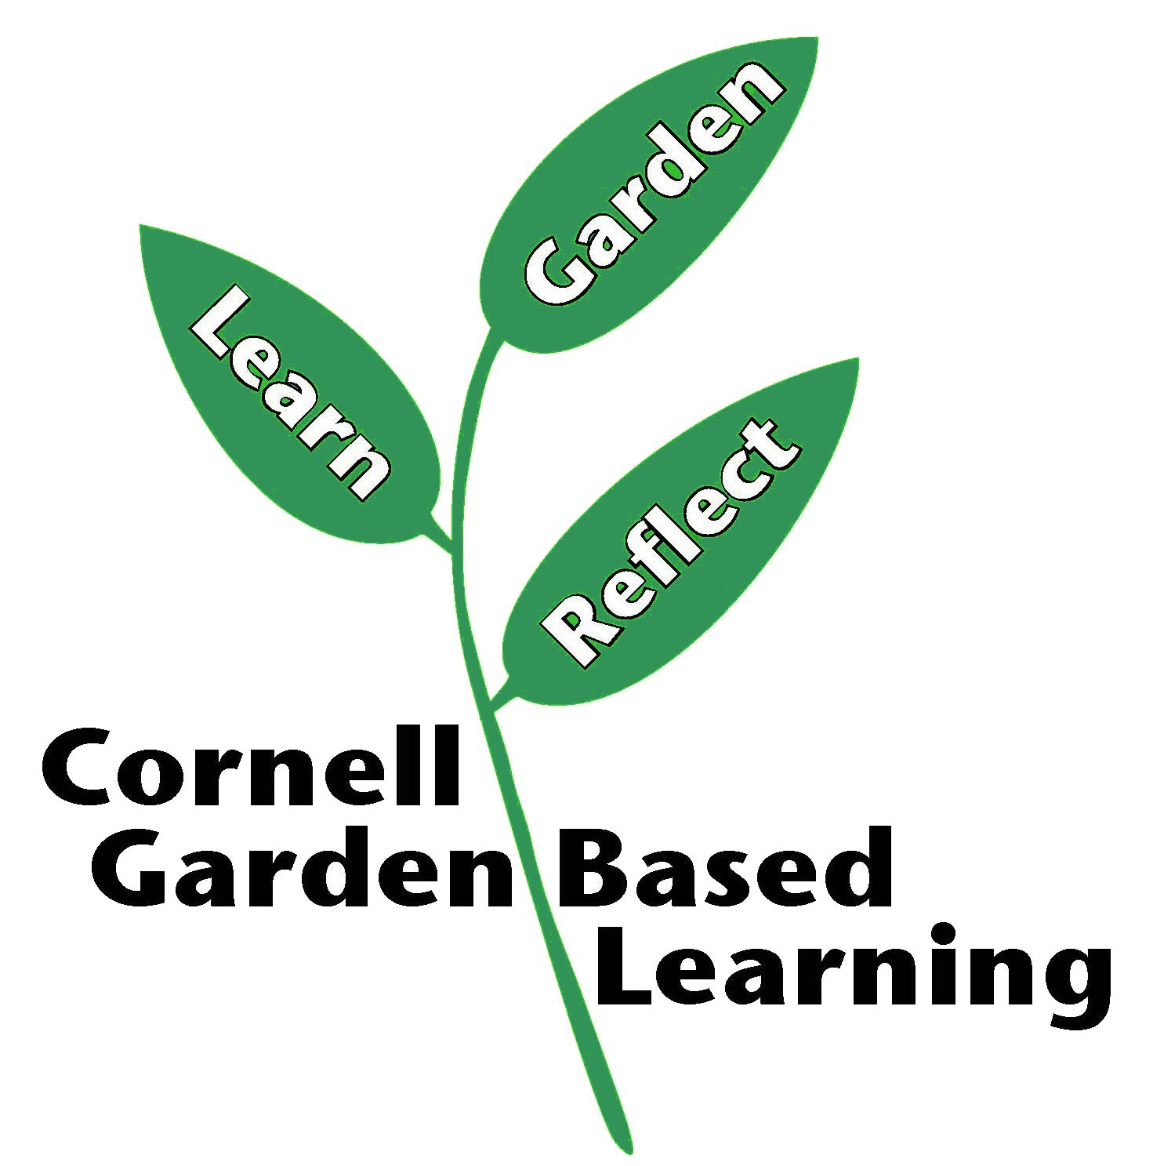

Date Published: September 2018
Author: Fiona Doherty
Reviewer(s): Marcia Eames-Sheavly, Michelle Podolec, Lori Brewer

