Invasive Species for Gardeners
Knowledge Check KEY
In the GB Learning Library - Core Preparation Sessions
this is Section 5.3 in Module 5: Management Strategies
1. What is the federal government’s definition of an invasive species?
(From Invasive Species for Gardeners presentation)
A non-native plant, animal or pathogen that causes harm to environment, economy or human health. Additionally other experts would add that invasive species:
•Thrive under a variety of environments
•Compete aggressively with native plants
•Grow and reproduce rapidly
•Lack natural enemies or pests in the new ecosystem
2. Name ways that humans may be assisting the spread of invasive species to and within North America. (From Invasive Species for Gardeners presentation)
Some species are (or have been in the past) deliberately brought into the United States for specific reasons (such as biocontrol or for use as pets) and are either released into the wild on purpose or escape where they then unexpectedly become an invasive species problem. These are called intentional introductions. One of the newest pathways for intentional introductions is mail order shopping through the Internet.
- Examples include: the gypsy moth, nutria (a muskrat-like rodent), exotic plants via the nursery trade such as kudzu and multiflora rose, plants from the seed trade such as crabgrass and johnsongrass, escapees from aquaculture facilities, and the mongoose in Hawaii. Examples of unwanted pets that get released into the wild include aquatic organisms dumped from unwanted aquariums, and snakes and lizards released when they get too large for their owners to take care of.
Many species arrive here accidentally, without our knowledge. These are called unintentional introductions. Pathways for such introductions include species arriving in foreign ballast water, hidden in wood packing material, in other vegetation via the nursery trade, aboard ships, as well as hitchhiking on other species, and many other pathways.
- Examples include: the Asian longhorned beetle, chestnut blight, zebra mussel.
3. List one or two phrases that are red flags for invasiveness:
(From Invasive Species for Gardeners presentation)
- “You couldn’t kill it if you tried!”
- “It’s bombproof”
- “Grows anywhere”
- Fruit dispersed by birds
- Exuberant, hardy grower
- Observed in nearby unmanaged areas
4. What might citizens and CCE volunteers do to assist efforts to manage invasive species?
There are numerous correct answers including…
Ask your Extension educators about activities they are engaged in or are planning to do.
Learn more about specific invasive species of interest by talking to your peers. Find out what they know and what their concerns are, and share information to raise awareness.
Scout for infestations, report your findings, and participate in citizen-science efforts.
Become active in your regional PRISM. Take an iMapInvasives training.

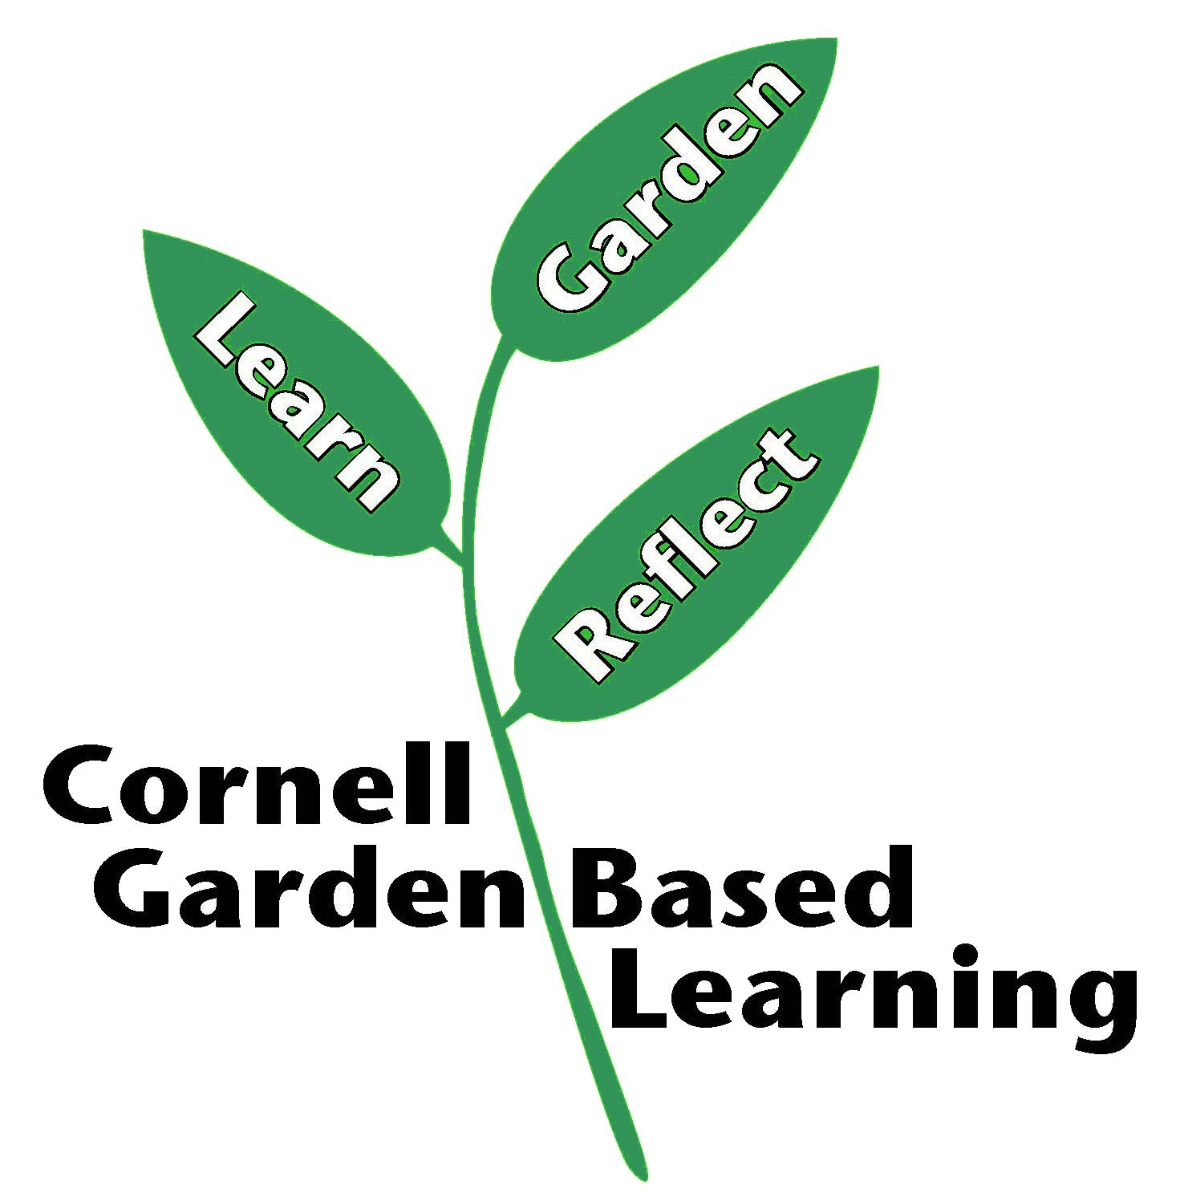
Published: April 2019
Author: Lori Brewer, Caroline Marshner
Reviewer: Fiona Doherty, Paul Hetzler, Donna Alese Cooke, Hilary Mosher, Michelle Podolec

