Invasive Species for Gardeners
Knowledge Check
In the GB Learning Library - Core Preparation Sessions
this is Section 5.3 in Module 5: Management Strategies

1. What is the federal government’s definition of an invasive species?

2. Name ways that humans may be assisting the spread of invasive species to and within North America.

3. List one or two phrases that are red flags for invasiveness:

4. What might citizens and CCE volunteers do to assist efforts to manage invasive species?

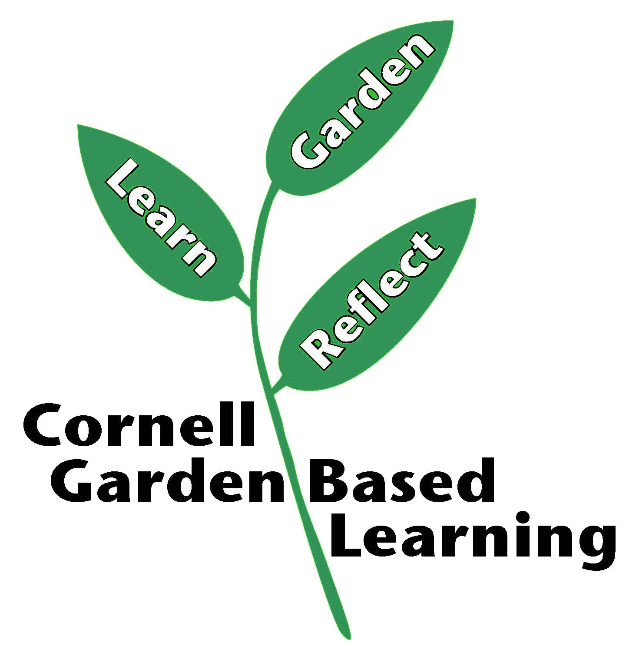

Published: April 2019
Author: Lori Brewer, Caroline Marshner
Reviewer: Fiona Doherty, Paul Hetzler, Donna Alese Cooke, Hilary Mosher, Michelle Podolec

