Integrated Pest Management (IPM)
Knowledge Check KEY
In the GB Learning Library - Core Preparation Sessions
this is Section 4.1 in Module 4: Problem Solving

- Integrated pest management (IPM) is integrated because it rarely relies on just one tactic; it brings together a range of biological, organic, cultural, mechanical, and chemical options for management of pests such as insects, weeds, fungi, bacteria, viruses, wildlife and more. True or False?
True (From https://nysipm.cornell.edu/about/defining-ipm)

- Name and briefly describe the seven IPM steps.
(From https://nysipm.cornell.edu/about/defining-ipm/ipm-communities)
- Prepare: Be aware of the potential problems and opportunities at your site. Know your pests—and keep good records.
- Prevent: Protect your landscape and buildings for the long term.
- Monitor: Scout your landscape and buildings to find out which pests are on your site or in your space.
- Analyze: Your threshold data will tell you if it’s time to act.
- Manage: Choose among tactics that provide the best balance of economic and environmental cost and effectiveness while reducing risk.
- Apply: When management is justified, do it right.
- Reevaluate: Look at your results, fine-tune your response—and make proactive plans for next time.

3. What are three methods of pest prevention?
(From https://nysipm.cornell.edu/about/defining-ipm/ipm-communities)
Answers will vary. Examples include:
- remove hiding places and shelter, both inside and outside buildings. Clean gutters, prune branches away from buildings
- build them out: repair or replace damp wood, install door sweeps and screens, plug all holes and cracks, fix the plumbing, seal the ductwork
- keep it clean: no food, no ants! Wipe up spills and crumbs right away. Keep pet food and birdseed in gnaw-proof, tightly closed containers; don’t leave pet food out overnight
- mow the right way to keep down weeds, help prevent diseases, and keep lawns healthy
- promote biological diversity in the landscape to give beneficial organisms a helping hand
- plant varieties that resist common disease and insect pests
- improve your soil for healthier plants with better “survival skills”

4. What is an IPM threshold?
(From https://nysipm.cornell.edu/about/defining-ipm)
The point when a few pests become a few too many.

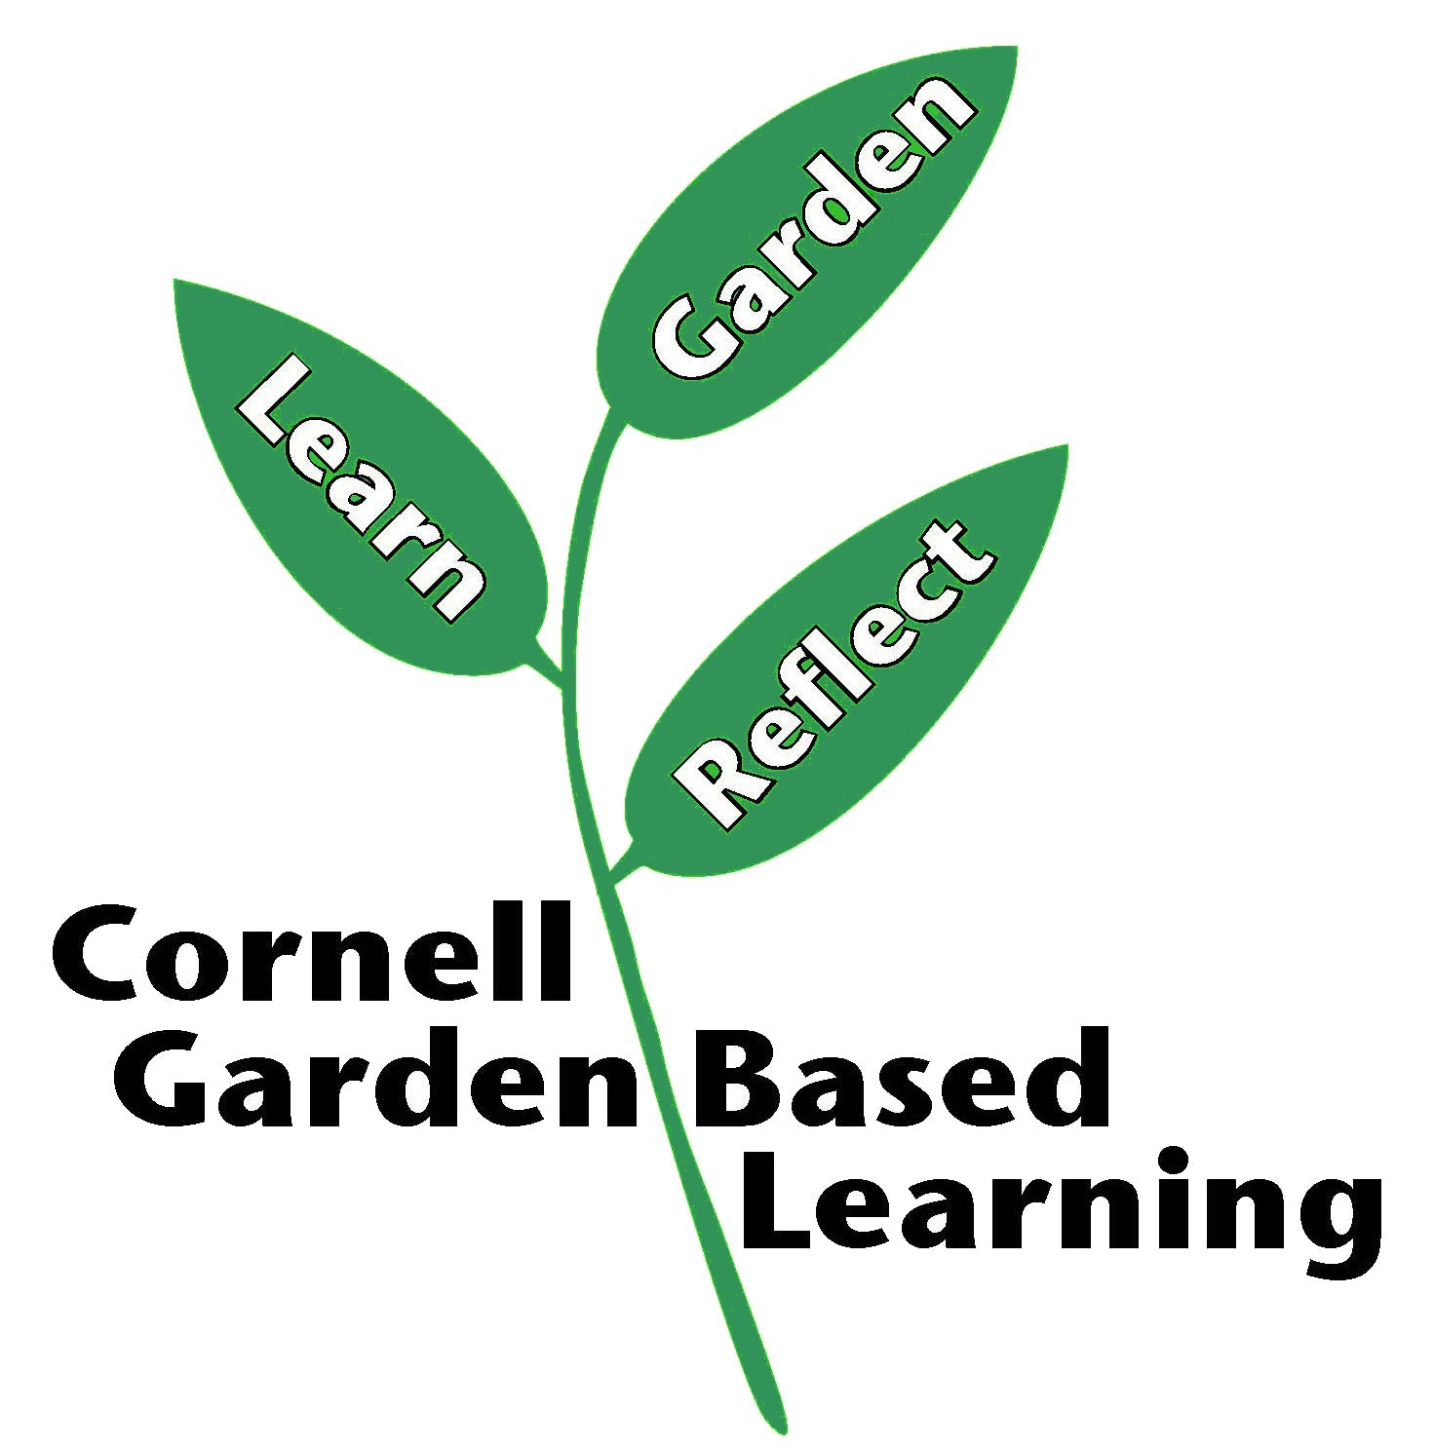

Date Published: April 2019
Contributor(s): Fiona Doherty
Reviewer(s): Annie Christian-Reuter

