Herbaceous Plants
Knowledge Check
In the GBL Learning Library - Core Preparation Sessions
this is Section 3.2 in Module 3: Plant Ecosystems Services

1. What distinguishes the following herbaceous plants: perennials, biennials and annuals. Provide an example of each.

2. How do you plant and care for a bulb?

3. Once plants are planted, what are three fundamentals of basic landscape maintenance?

4. What is a weed? What is the most important thing to remember about weeding?

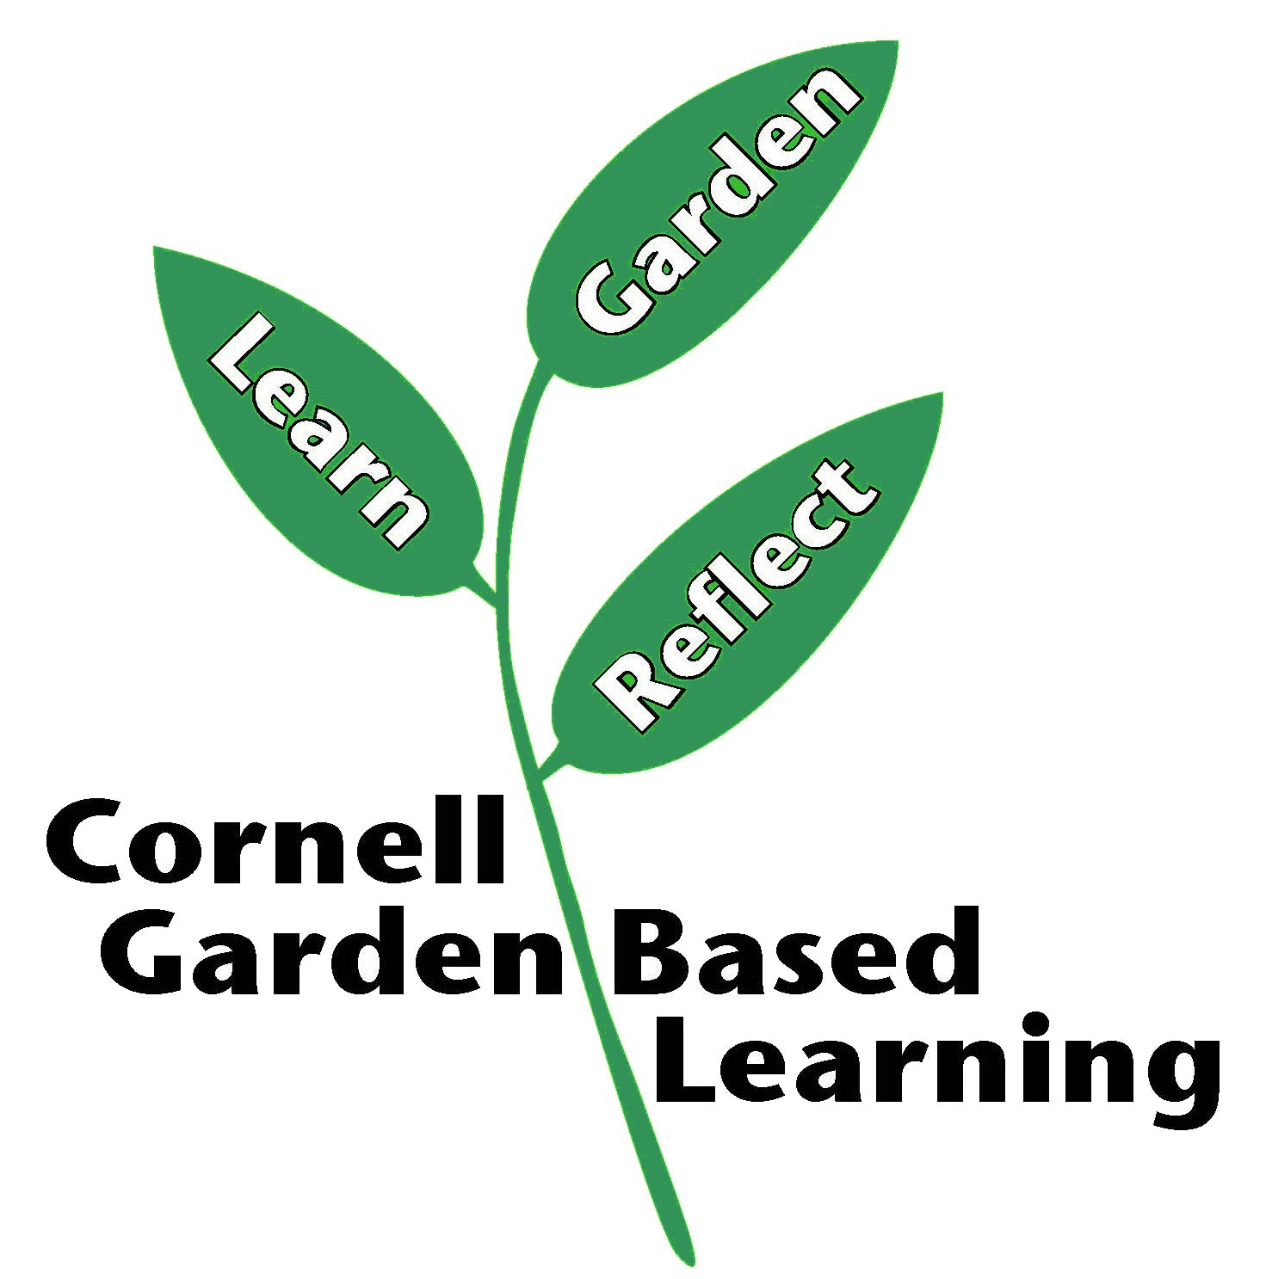
Date Published/Updated: April 2019
Author(s)/Contributor(s): Michelle Podolec
Reviewer(s): Fiona Doherty

