Nutrition, Food Safety and Food Security
Knowledge Check KEY
In the GBL Learning Library - Core Preparation Sessions
this is Section 2.3 in Module 2: Food Gardening

- What are the three key education messages for SNAP-Ed? (From the ESNY presentation.)
- Make half your plate fruit and vegetables.
- Be physically active and balance calories every day as part of a healthy lifestyle.
- Reduce the consumption of sugar sweetened beverages and increase consumption of water and low-fat dairy beverages.

- How might CCE Master Gardener Volunteers be a part of a sustainability plan for community and school gardens?
Many possible answers and should include provide technical assistance in addressing educational needs related to growing and managing food crops.

- Name one or more food preservation resources you might use or share with others interested in learning more.
Many possible answers including:
- Master Food Preserver Training
- National Center for Home Food Preservation – University of Georgia http://nchfp.uga.edu/
- USDA Complete Guide to Home Canning http://nchfp.uga.edu/publications/publications_usda.html
- So Easy to Preserve, 6th Edition – University of Georgia https://setp.uga.edu/
- Wild Harvest Table http://ccesaratoga.org/nutrition-food/wild-game
- CCE Saratoga Food Preservation website: http://ccesaratoga.org/nutrition-food/food-preservation

- Describe the 4 simple steps to food safety.
(From Food Preservation and Food Security presentation).
CLEAN - Wash hands and surfaces often
SEPARATE - Don’t cross-contaminate
COOK - Cook to the right temperature
CHILL - Refrigerate promptly

- Name one or more ways CCE Master Gardener Volunteers might incorporate food safety concepts into our work with school, community and home food gardens.
Many possible answers including:
- Sharing fact sheets.
- Encouraging gardeners to plant varieties well-suited to preservation.
- Sharing research-based recipes with information about new vegetable varieties.

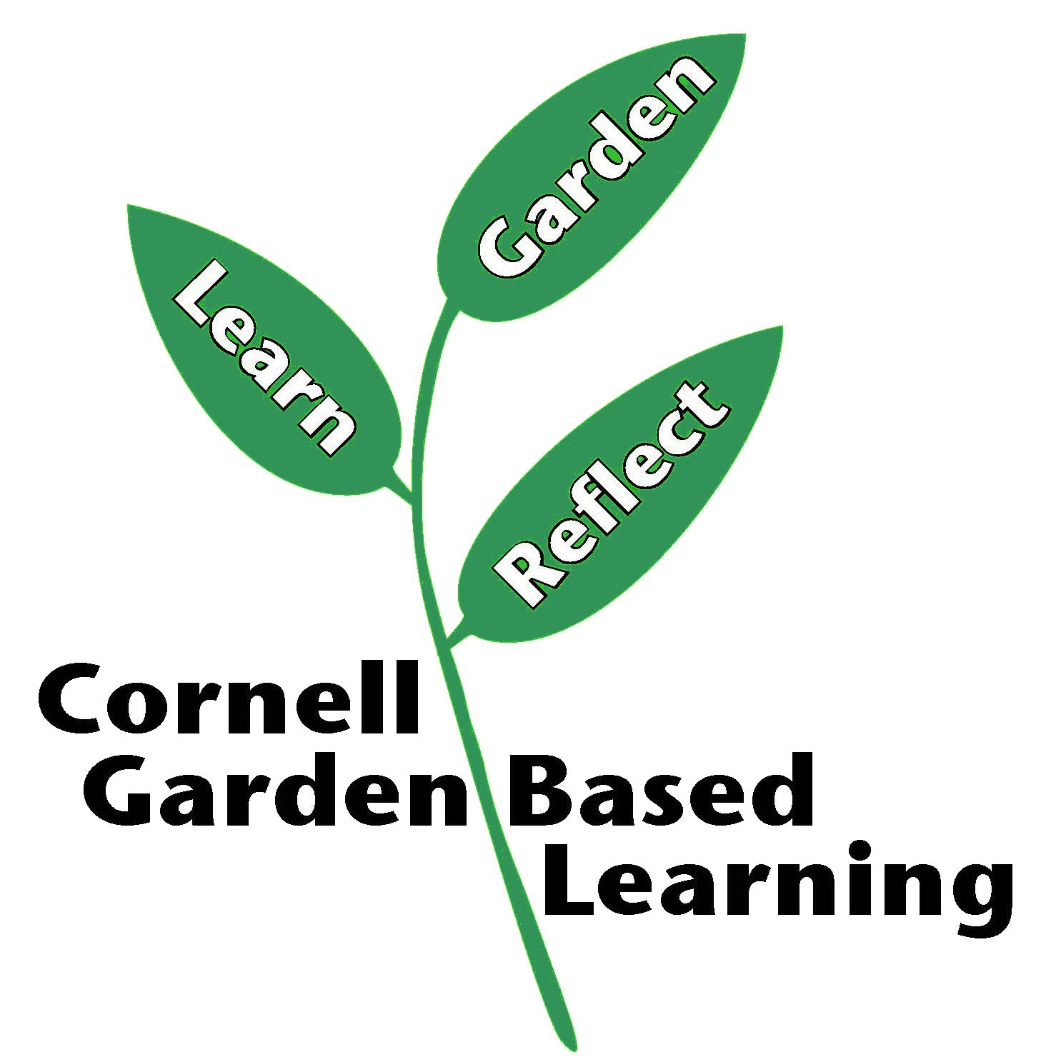
Date Published: April 2019
Author: Lori Brewer
Reviewer(s): Fiona Doherty, Donna Alese Cooke, Michelle Podolec, Annie Christian-Reuter

