Nutrition, Food Safety and Food Security
Knowledge Check
In the GBL Learning Library - Core Preparation Sessions
this is Section 2.3 in Module 2: Food Gardening

- What are the three key education messages for SNAP-Ed?

- How might CCE Master Gardener Volunteers be a part of a sustainability plan for community and school gardens?

- Name one or more food preservation resources you might use or share with others interested in learning more.

- Describe the 4 simple steps to food safety.

- Name one or more ways CCE Master Gardener Volunteers might incorporate food safety concepts into our work with school, community and home food gardens.

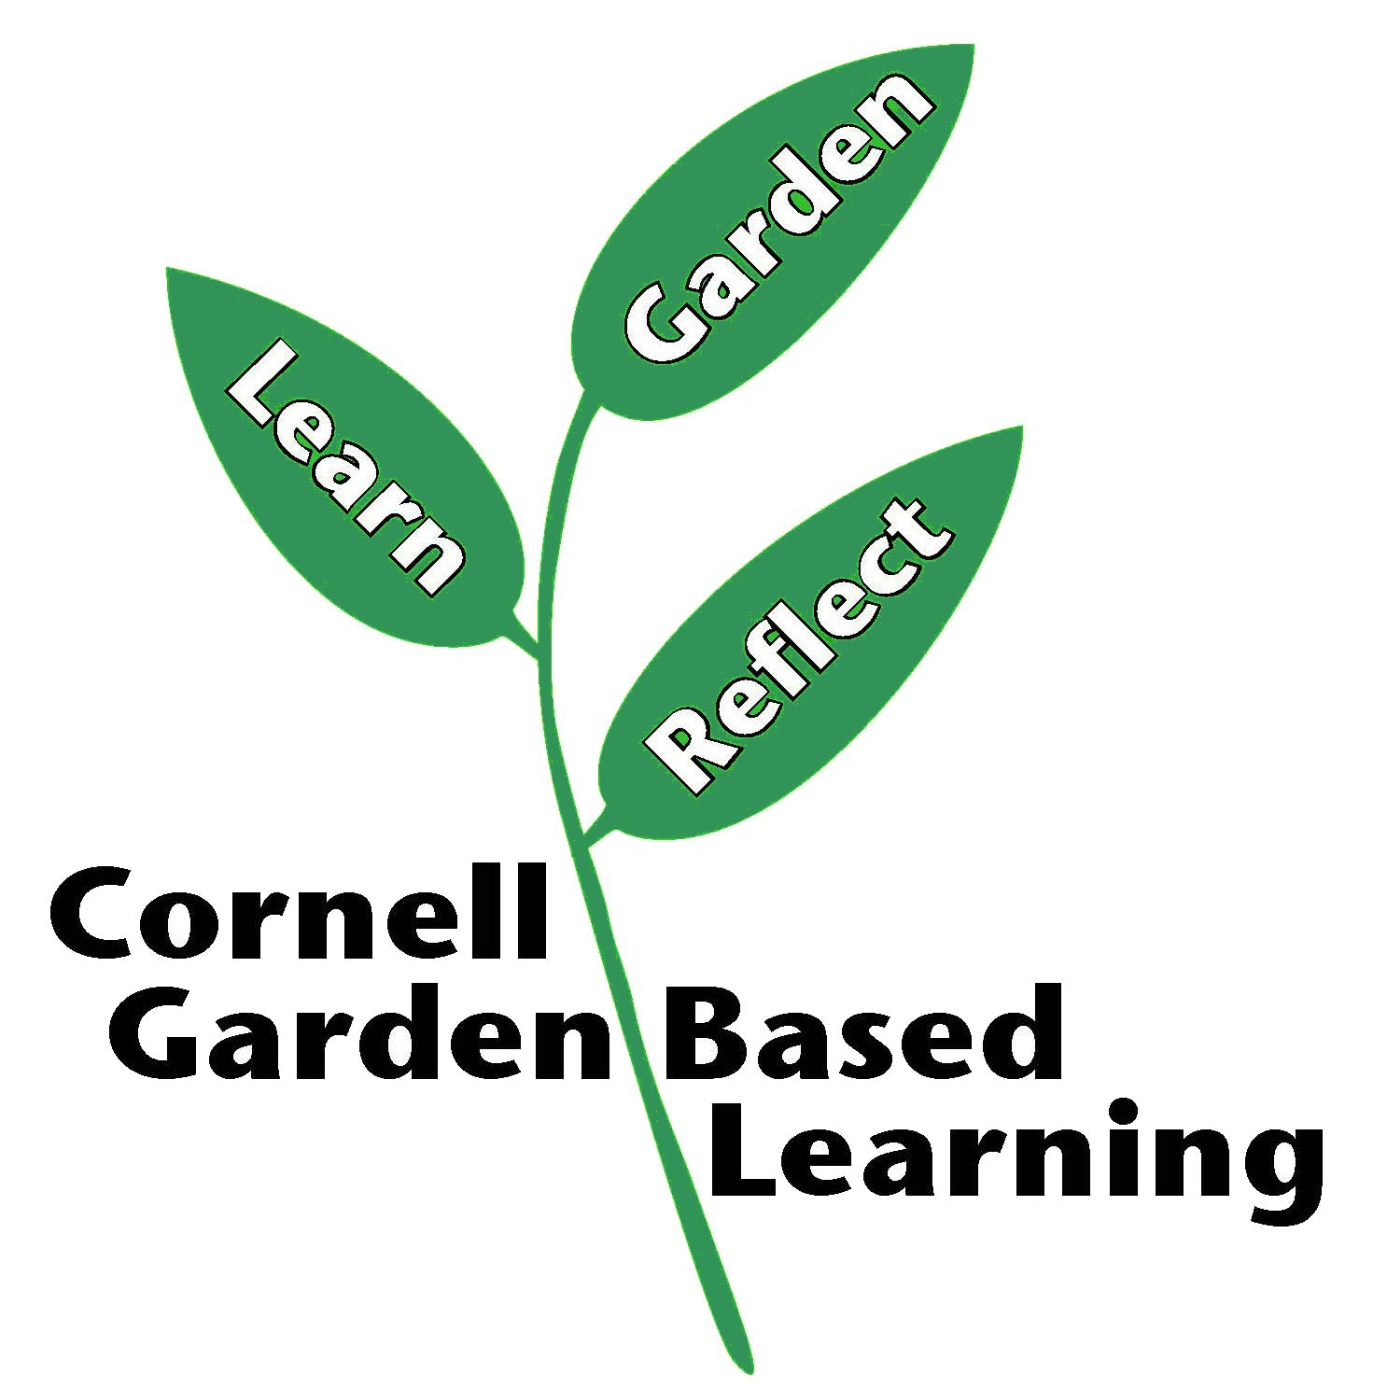
Date Published: April 2019
Author: Lori Brewer
Reviewer(s): Fiona Doherty, Donna Alese Cooke, Michelle Podolec, Annie Christian-Reuter

