Beneficial Insects
Knowledge Check KEY
In the GBL Learning Library - Core Preparation Sessions
this is Section 1.3 in Module 1: The Fundamentals

1. What is a key difference between the body parts of an adult insect and an adult arachnid?
Adult insects have three main body parts: head, thorax and abdomen. Arachnids have just two main body parts: the cephalothorax (a combined head and throax) and an abdomen. (Basic Entomology for Identification Factsheet and Jason Dombroskie’s Entomology 101 video).

2. Name a predatory insect that is considered to be a beneficial insect. What does it eat?
Many possibilities including:
Lady beetles who feed chiefly on aphids.
Ground beetles which feed on many pest insects and some feed on slugs and snails
Praying mantids which feed on many pest insects and are cannibalistic.
Dragonflies which will eat small midges, gnats, and mosquitos.
Hover flies which feed on aphids or the young of termites, ants, or bees
Fireflies - The larvae feed on various smaller insects, slugs, and snails
Lacewings - Larvae feed on aphids, scales, mealybugs, thrips, mites,and insect eggs.
(Covered in Jason Dombroskie’s Beneficial Insects video and in the Beneficial Insects-Nature’s Pest Control pre-work reading).

3. Two common life cycle types of insects are complete and incomplete metamorphosis. How do these life cycles differ?

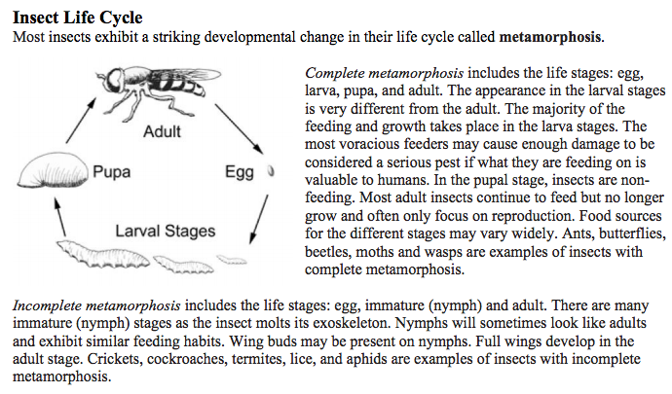
(Covered in Basic Entomology for Identification Factsheet)

4. What are the two broad categories of insect mouthparts are designed to do? Provide examples of specific insects and their mouthparts.
Insect mouthparts are designed for feeding in the two broad categories of chewing or sucking. These may be further broken down into rasping-sucking (thrips), chewing-lapping (honeybees, wasps and bumblebees), biting-sucking (mosquitos and biting flies) and sponging-lapping (houseflies and fruit flies). (Covered in Basic Entomology for Identification Factsheet)

5. Name two strategies for attracting beneficial insects to the garden setting.
Diversity, shelter, food. (Covered in Jason Dombroskie’s Beneficial Insects recording). Also see this in the learn more section: http://putnam.cce.cornell.edu/gardening/create-a-pollinator-paradise

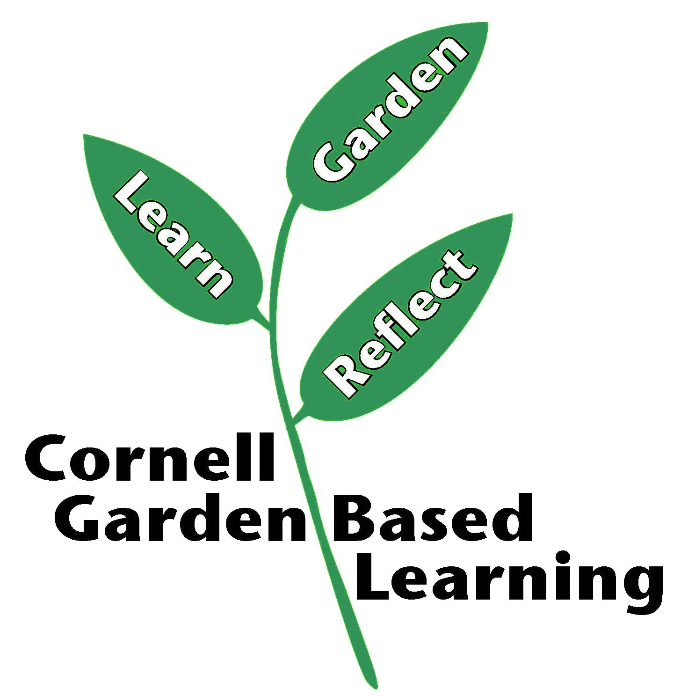
References: Basic Entomology for Identification, Jason Dombroskie
Date Published/Updated: April 2019
Author(s)/Contributor(s): Fiona Doherty
Reviewer(s):

