Right Plant, Right Place

Knowledge Check

In the MGV Learning Library - Core Preparation Sessions

this is Section 1.2 in Module 1: The Fundamentals

1. What are four components of a basic site assessment?

2. Describe *Systems Thinking* and its role in gardening.

3. What are the components of soil?

4. List these soil particles from smallest to largest: sand, silt and clay.

5. Describe the relationship of soil to plant growth and development.

6. Soil pH has no effect on nutrient availability and plant health. True or False?

7. Organic matter includes components both living and nonliving. True or False?

8. Imagine you have soil that is 50% silt, 25% sand, and 25% clay. Fill in the jar to represent what the Jar Test would look like.

Line drawing of an empty jar.

ttps://i.pinimg.com/736x/3e/d7/7a/3ed77a91757d05242156bbb233904a0b--bug-art-the-jar.jpg

<http://clipart-library.com/clipart/120557.htm>

9. One of this session’s learning objectives was that there is a right plant for right soil and the right soil for the right plant. Write 1-3 sentences supporting this statement.

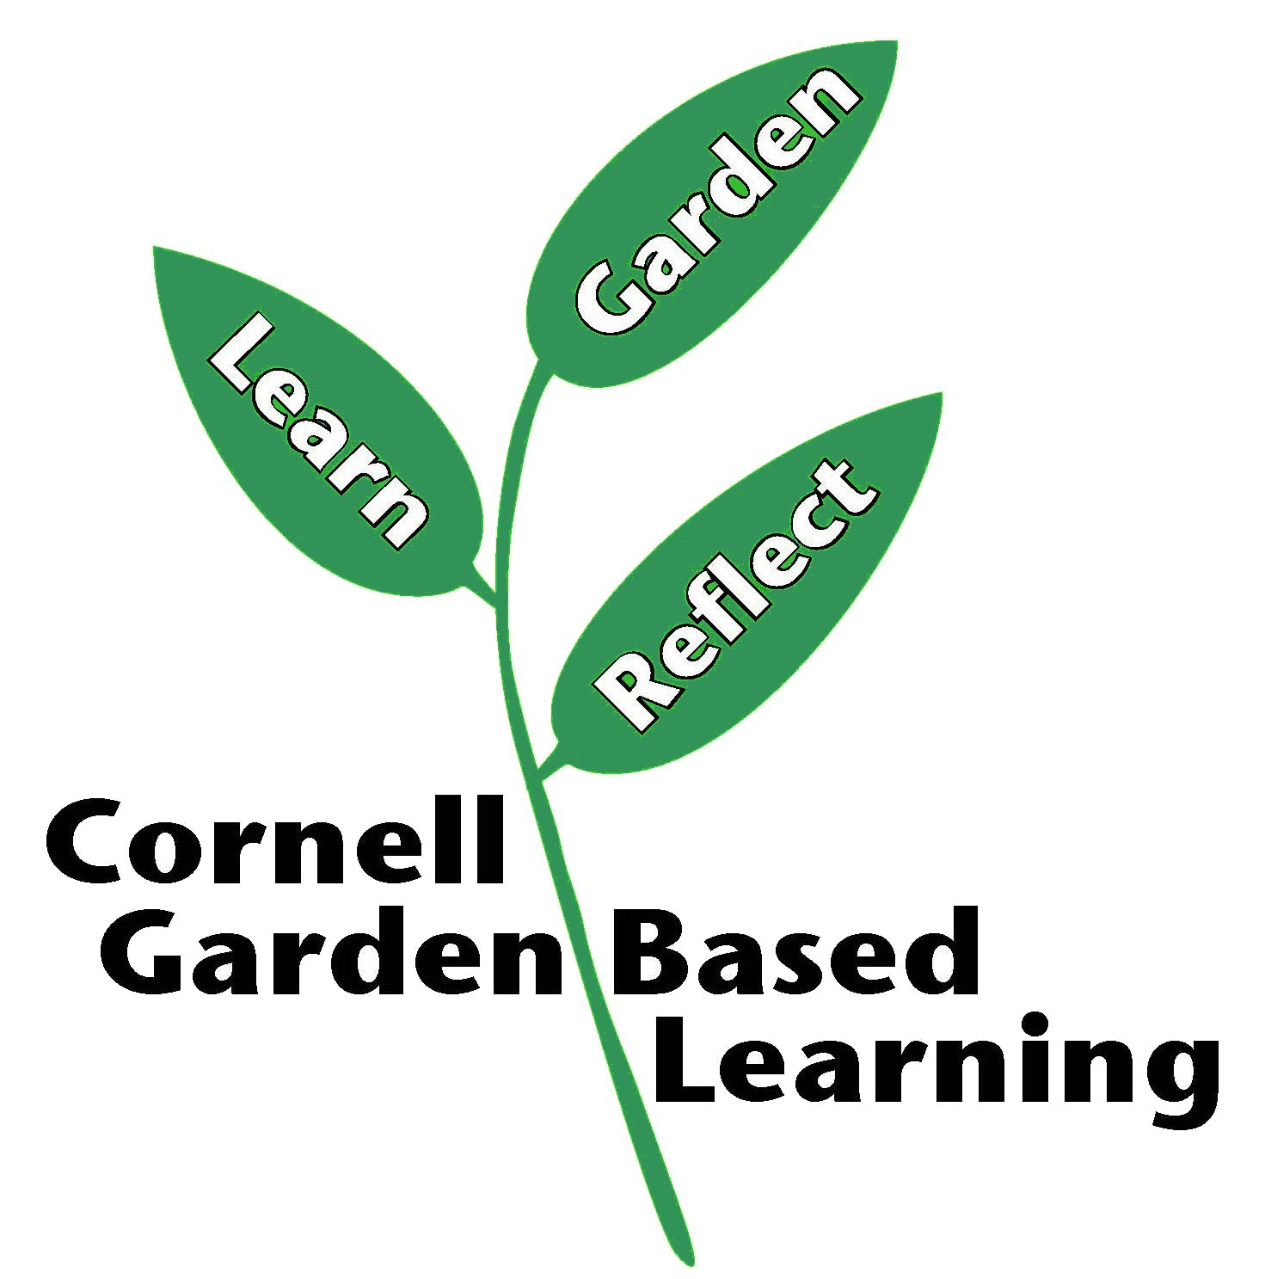

Date Published: April 2019

Contributor: Fiona Doherty

Reviewer(s): Donna Alese Cooke, Michelle Podolec, Jonathan Russell-Anelli