Basic Plant Pathology
Knowledge Check
In the GBL Learning Library - Core Preparation Sessions
this is Section 1.4 in Module 1: The Fundamentals

1. Name 5 living causal agents of disease and give examples of each.

2. What are some examples of abiotic damage?

3. How do plant parasites differ from plant saprophytes?

4. Sketch and label the disease pyramid/triangle.

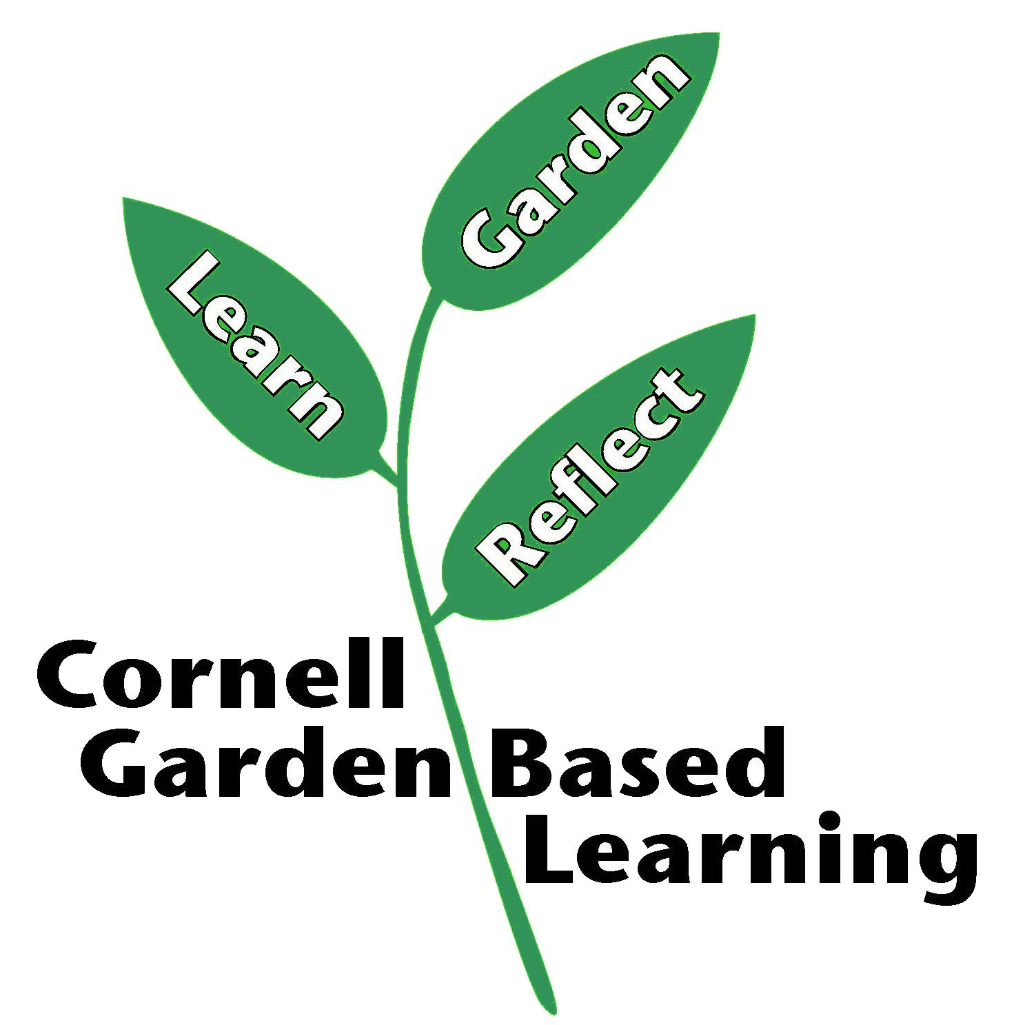

References: http://plantclinic.cornell.edu/mastergardner.html
Date Published/Updated: April 2019
Contributor(s): Fiona Doherty, Lori Brewer
Reviewer(s): Michelle Podolec, Donna Alese Cooke

