Site Assessment and Ecosystem Services Activity
Facilitator Guide
Time: 40 minutes

Learning Objectives:
- Practice applying criteria for basic site assessment.
- Identify ecosystem services in the landscape.

Supplies:
- Clipboards, graph paper, pencils, participant handouts

Directions:
- Divide into pairs or groups of three.
- Select a section of a nearby landscape or garden to work in. Aim for a smaller space that has some diversity of features.
- Create a basic sketch or take notes of the area. Use the site assessment checklist as a guide to fill in what you know about the site.
- Discuss the ecosystem services you observe in the area of focus.
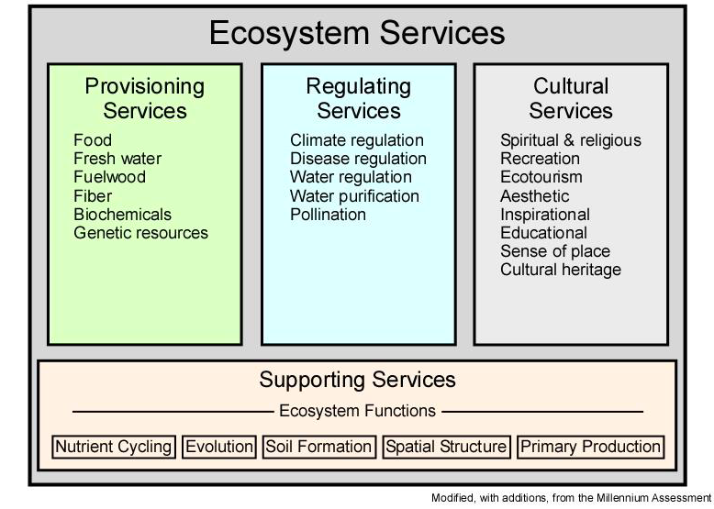
Site Assessment Checklist
Make notes regarding each bullet point on your sketch/map

Describe the landscape of focus:

- Size of space
- Compass directions
- USDA Hardiness Zone:
Last Spring Frost:
Last Fall Frost:
- Obstructions and other human structures
Below ground (e.g. utilities or irrigation system)
Above ground (e.g. overhead wires)
- Sunlight levels and patterns throughout the day
Full sun
Partial sun
Shade
- Wind amount and direction
Windy site
Windy in isolated sections
Calm site
- Soil Compaction
Compacted
Partially compacted
No compaction
- Soil drainage characteristics and patterns
Wet
Well-drained
Dry
- Soil texture
Clayey
Loamy
Sandy
Silty
- Soil pH: _________
- Slopes
Steep
Moderate
Gradual or flat
- Wildlife interference
Serious and obvious concerns
Marginal concerns
Not a problem

References:
Landscape for Life Student Manual, Lesson 6 & 7, pg. 72-97, (2014). www.landscapeforlife.org

Published: April 2019
Author: F. Doherty
Reviewer: Michelle Podolec

