Activity: Ecosystem Services in our Landscapes
Facilitator Guide

Time: 20 Minutes

Objectives: Discuss the concept of ecosystem services. Consider ways plants (woody, herbaceous, and lawns) in your landscape support ecosystem services as well as plans that would enhance support.

Supplies:
- Copies of The Basics of Ecosystem Services Handout
- Blank sheets of paper for sketches and notes
Activity:
- Briefly review The Basics of Ecosystem Services handout.
  - Ask participants to take a few moments to reflect individually: consider their home landscape or another landscape with which they are familiar. Note the ecosystem services in their landscape and the opportunities to enhance ecosystem services. They may sketch or write out their thoughts.
- Ask for volunteers to share existing ecosystem services along with the opportunities to enhance ecosystem services.
- Discuss specific opportunities in context of goals and site characteristics.
  - For example, for the idea to add flowers for pollinators, consider: what do you have blooming now, where would the addition go and what are the specifics for that location (soil moisture, sun exposure, etc.)? This will allow you to identify a specific action such as adding three, different types of perennials that bloom early in the season and can tolerate some shade.
Examples of ecosystem services from the Landscapes for Life manual:
- Mitigate the urban heat island - Plants cool the air by providing shade and evaporating soil moisture.
- Cleanse air and water - Vegetation removes pollutants from air and water.
- Provide oxygen -Through the process of photosynthesis, vegetation sequesters CO2 and releases oxygen.
- Control erosion - Plants reduce the intensity of rainfall hitting the ground, increase the absorption of water into the soil, and help hold soil together.
- Provide habitat - Vegetation provides refuge, breeding, and nursery habitat for wildlife both above and below the ground.
- Produce food and renewable non-food products - Plants provide resources such as wood, cloth fibers, oils, fruits, and vegetables.
- Create restful and peaceful settings - Trees and other vegetation create settings that allow us to refresh our minds, relax, and better manage stress.
- Reduce energy use and costs - Properly placed vegetation can reduce energy use and costs by shading a house during summer and providing insulation during cold winter months.
References:
Landscape for Life Student Manual, Lesson 6 & 7, pg. 72-97, (2014). www.landscapeforlife.org

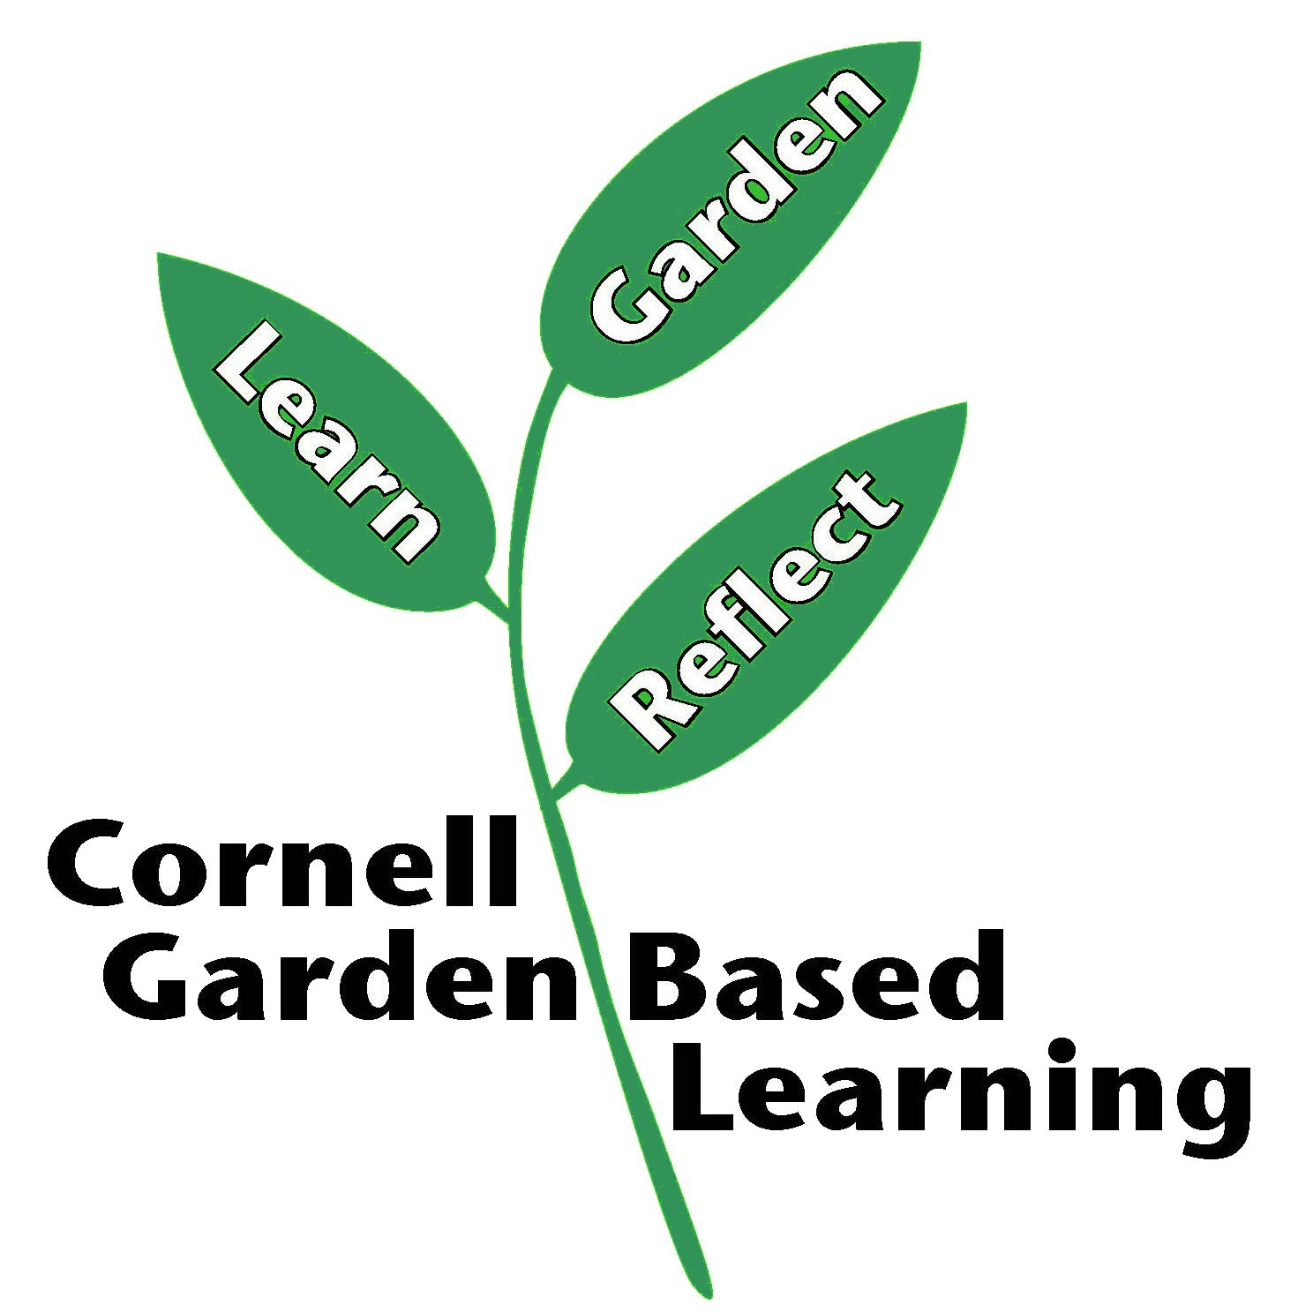
Published: April 2019
Author: Lori Brewer
Reviewer: Annie Christian-Reuter

