SCENARIO 1: Information for the “Community Member” Only

Background info: It is early fall in Central New York.
- Hand the group Photo A. Mention that you have noticed something unusual about the plant.
- The group will ask you a series of questions to gather more information. The goal is for them to practice asking the right questions.
- If/when prompted, provide the additional details:
  - You are an avid home gardener.
  - You think the plant is a hollyhock (Althaea spp.)
  - You first noticed yellow spots on the surface of the leaves in mid-summer (provide Photo B). Then you noticed orange pustules underneath the leaf (provide Photo C). Now most of the leaves are dead.
  - You do not use any sprays or fertilizers in your garden.
  - You’ve lived at the same property for 40+ years and the site as always been a garden.
  - Your neighbor walked by and mentioned that she is having the same issue with her hollyhocks.

About Scenario 1: A well-informed community member with a lot of information about the issue. The issue is Hollyhock Rust, more information can be found at: http://plantclinic.cornell.edu/factsheets/hollyhockrust.pdf

Photos sourced from the Plant Disease Diagnostic Clinic Website, http://plantclinic.cornell.edu/factsheets/hollyhockrust.pdf.

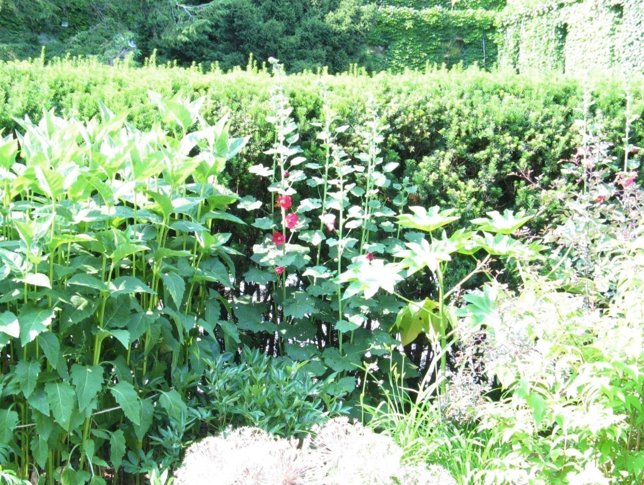
Photo A

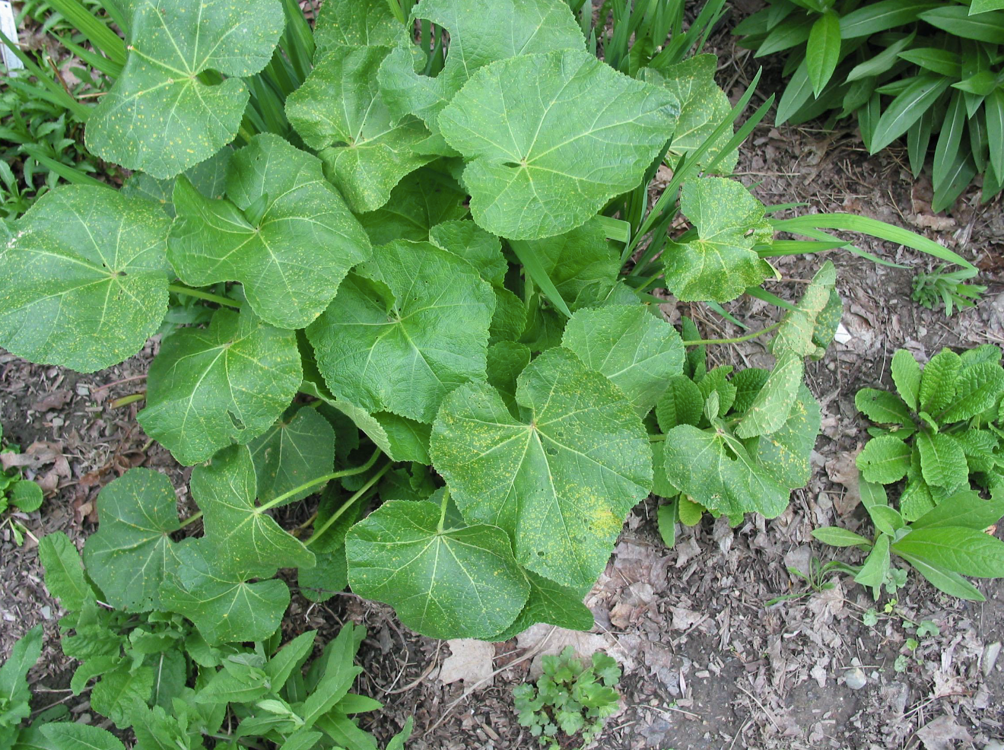
Photo B

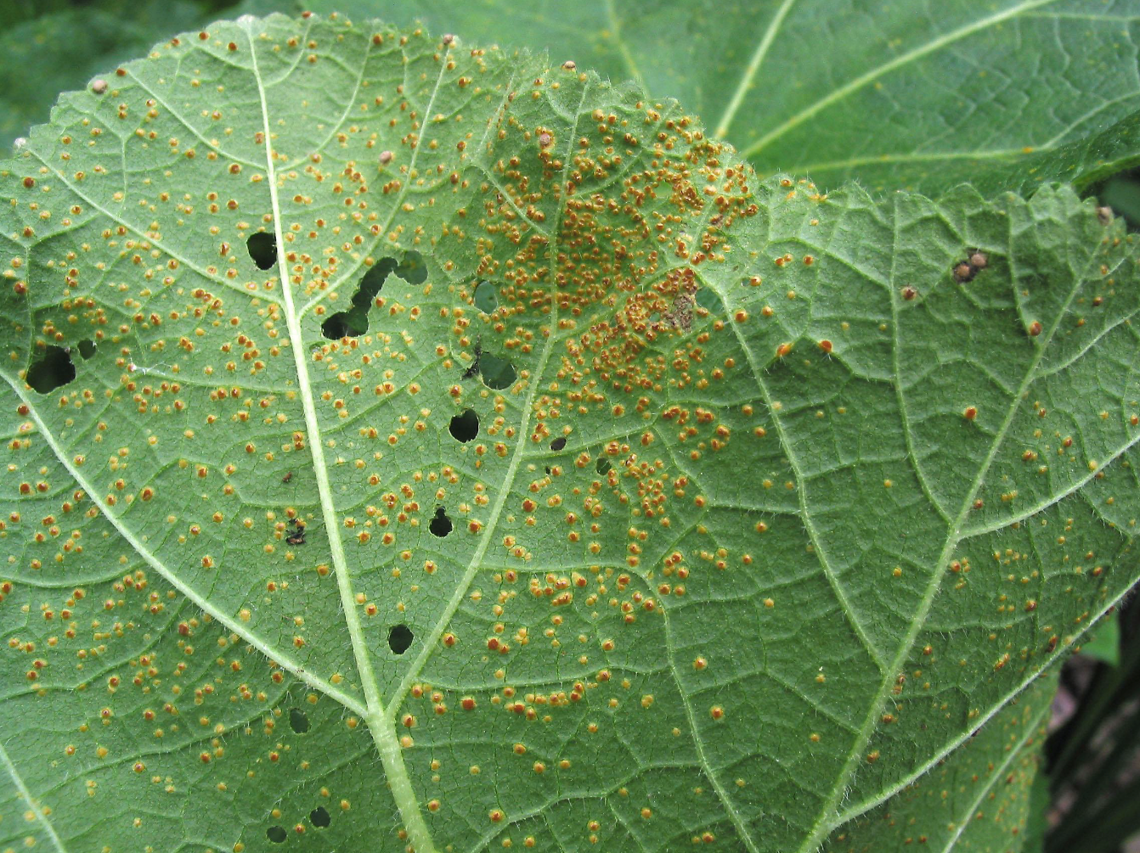
Photo C

SCENARIO 2: Information for the “Community Member” Only

Background info: It is mid-summer in Central New York.

- Tell the group the following: you have noticed yellowing leaves on your cucumber plants and you’d like to know what to spray.
- The group will ask you a series of questions to gather more information. The goal is for them to practice asking the right questions.
- You are a home gardener with a small vegetable garden plot.
- You have no photos.
- You just noticed the leaves yesterday.
- Your wife sprays something in the garden but you don’t remember what it is.
- You recently moved to the property, you do not know what the site was previously.
- You have no other information.

About Scenario 2: Not enough information is provided by the community member.

SCENARIO 3: Information for the “Community Member” Only

Background info: It has been a hot, dry and dusty summer in Central New York.

- Hand the group Photo A & B. Mention that you have noticed something unusual growing on your sweet corn plants.
- The group will ask you a series of questions to gather more information. The goal is for them to practice asking the right questions.
- If/when prompted, provide the additional details:
  - You are a commercial grower.
  - You do not use any sprays or fertilizers in your garden.
  - You spread manure on your fields each year.
  - You’ve talked to some neighboring farms and they are having the same issue.
  - The site has been a commercial growing site for several years.

About Scenario 3: A commercial agriculture focus.
Pass along to appropriate commercial horticulture expert at your local CCE. The grower is dealing with Corn Smut, http://plantclinic.cornell.edu/factsheets/cornsmut.pdf.

Photos sourced from the Plant Disease Diagnostic Clinic Website, http://plantclinic.cornell.edu/factsheets/cornsmut.pdf

Photo A:
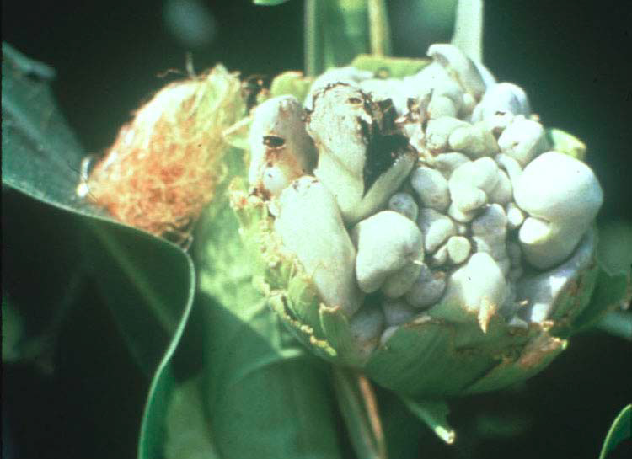

Photo B:

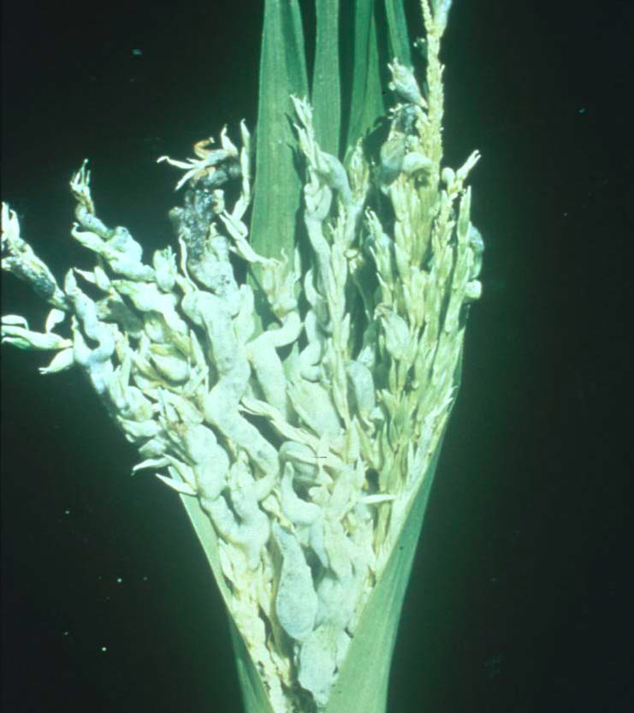

SCENARIO 4: Information for the “Community Member” Only

Background info: It is Spring in Central New York.

- Tell the group the following: You are a community gardener and you have noticed some strange symptoms in the red oak tree at the community garden. Browning and wilty leaves, branch dieback (share Photo A). You’ve heard of something called Oak Wilt and would like to know more.

(Photo sourced from DEC Oak Wilt website, https://www.dec.ny.gov/lands/46919.html)

About Scenario 4: A suspected regulatory issue.
Oak Wilt; report promptly to DEC (Department of Environmental Conservation).

Photo A
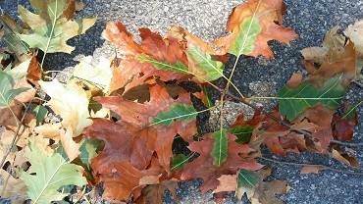

SCENARIO 5: Information for the “Community Member” Only

Background info: It is has been a wet summer with cool nights in Central New York.

- Hand the group Photo A and Photo B. Tell them the following: You have been observing the demise of your tomato plants and have seen a strange insect which you believe to be the next horrible invasive species. The insect has caused brown leaf spots on the tomato leaves which worsened to completely brown leaves and then the discoloration of stems. You’ve tried to wash off the tomato plants each night before bed but the insect keeps causing damage. You’ve never seen the insect before; it must be a new invasive species!!! Unfortunately, you were unable to catch it.
- The group will ask you a series of questions to gather more information. The goal is for them to practice asking the right questions.
- If/when prompted, provide the additional details:
  - You are a home gardener.
  - You do not use any sprays or fertilizers in your garden.

About Scenario 5: Someone who insists it is something that it isn’t. The person insists it is early blight but it is likely frost injury.

Photos sourced from Cornell Vegetable Pathology- Long Island Horticultural Research and Extension Center, http://blogs.cornell.edu/livegpath/gallery/tomato/tomato-late-blight/

Photo A
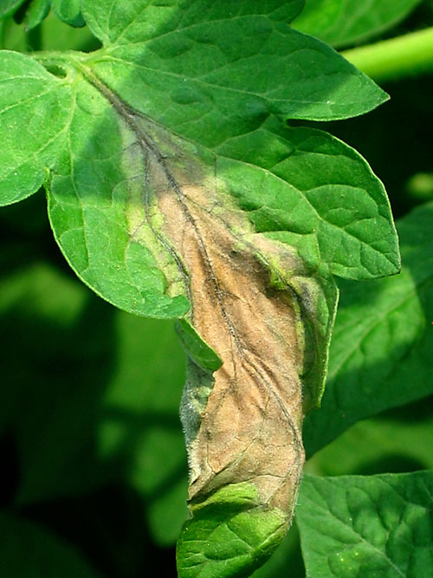

Photo B
