Diagnosing Plant Problems Scenarios

The CCE MGV Learning Library has the Activity Directions document as well as scenarios. You may wish to use your own scenarios these are provided as a place to start.

Scenario 1: A well-informed community member with a lot of information about the issue.
The issue is Hollyhock Rust, more information can be found at: http://plantclinic.cornell.edu/factsheets/hollyhockrust.pdf

Scenario 2: Not enough information is provided by the community member.

Scenario 3: A commercial agriculture focus.
Pass along to appropriate commercial horticulture expert at your local CCE. The grower is dealing with Corn Smut, http://plantclinic.cornell.edu/factsheets/cornsmut.pdf.

Scenario 4: A suspected regulatory issue.
Oak Wilt; report promptly to DEC (Department of Environmental Conservation).

Scenario 5: Someone who insists it is something that it isn’t.
The person insists it is early blight but it is likely frost injury.

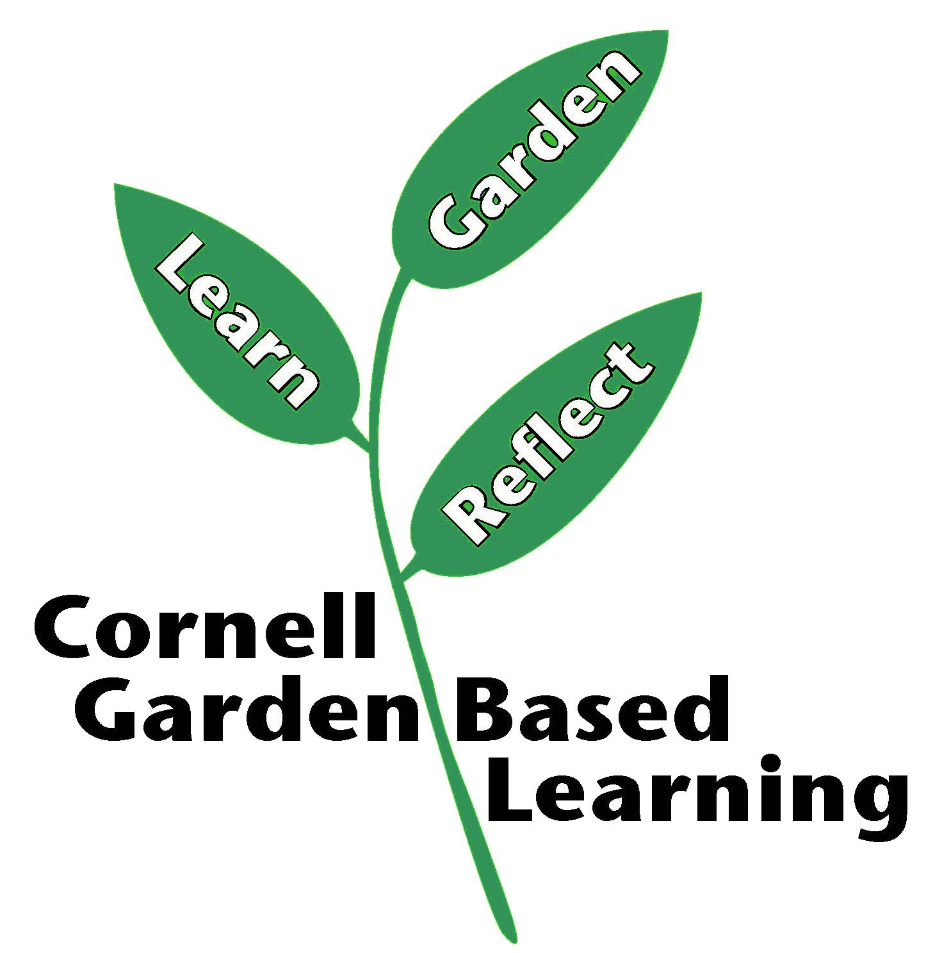
Published: April 2019
Authors: Karen Snover-Clift and Fiona Doherty
References: Cornell Plant Disease Diagnostic Clinic http://plantclinic.cornell.edu/
Diagnosing Plant Problems: A systemic approach to diagnosing plant damage, revised by Karen L. Snover-Clift, 2010.

