The Jar Test
Adapted from Landscape for Life, Lesson 2: The Role of Soil in Sustainable Gardens

20-30 minutes

Learning Objective(s): Participants will…
Understand the characteristics and basic properties of soil such as texture, pH and organic matter and their impact on nutrient availability.

Supplies:
Materials:  - Water  - 2 cups of soil  - Wet paper towels or wash rag  - Quart-sized jar with lid  - 1 teaspoon of liquid dish soap  - Rulers  Handouts: | 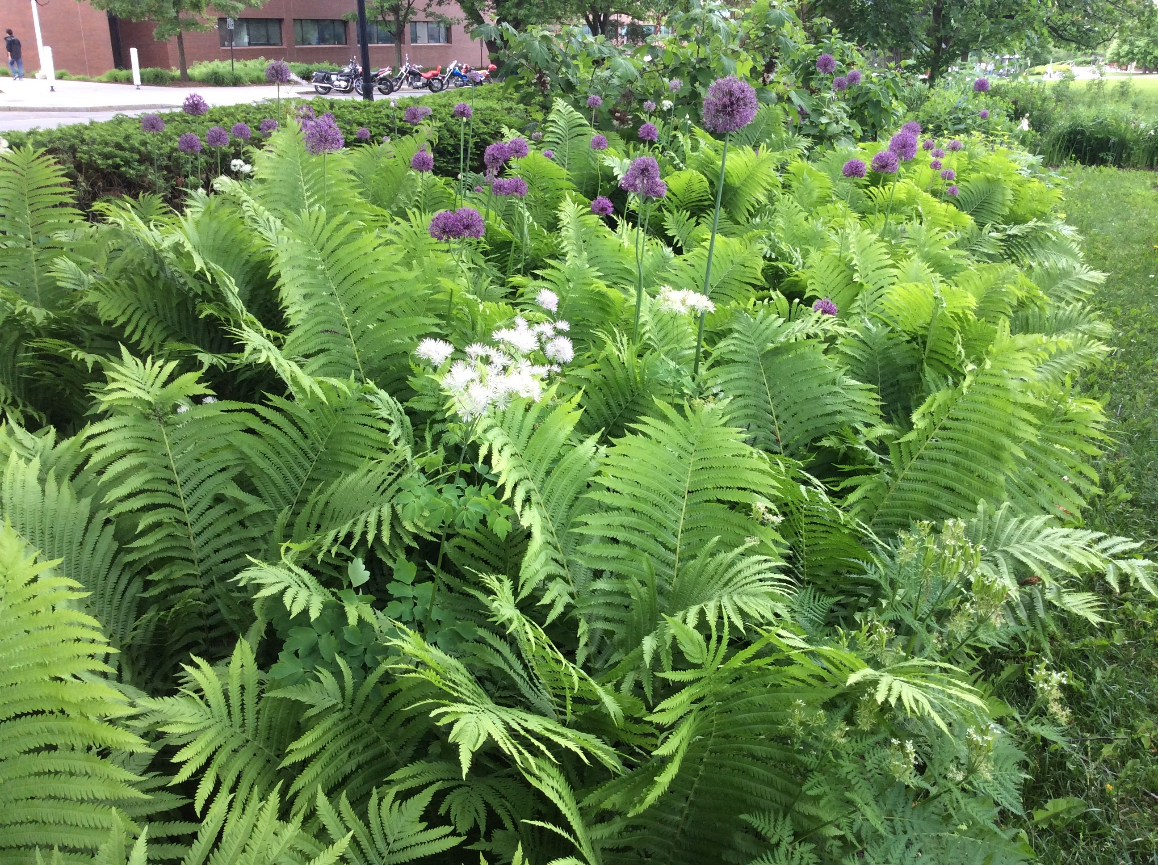
- Copies of the soil pH ranges
Instructions:
After removing stones or debris, place 2 cups of garden soil in a quart-sized jar. Add 1 teaspoon of liquid dish soap. Fill the jar to the top with water and close the lid tightly. Gently turn the jar upside down right-side up for about a minute to mix. Let it sit for a day so the particles can settle out.

Calculate the percentages of sand, silt, and clay in the jar. The position of sand, silt, and clay are dependent on the size and weight of each of the particle types. Sand should sink to the bottom of the jar due to its relatively large size. In addition to its position, the sand layer is typically lighter in color than the silt or clay soil layers. Silt, being the middle-sized particle, is found between the sand and clay layer. The clay layer, with the smallest sized particles, is found at the very top of the soil layers.

After identifying each of the soil types in the jar, place a ruler against the outside to measure the 1) total amount of soil in the jar in centimeters and 2) the amount of each soil type in centimeters. The final percentage of sand, silt, and clay can be found by dividing each of the soil types by the total amount of soil in the jar and then multiplying by 100.

Percent of sand = (amount of sand in cm/ total amount of soil in cm) x 100
Percent of silt = (amount of silt in cm/ total amount of soil in cm) x 100
Percent of clay = (amount of clay in cm/ total amount of soil in cm) x 100

Compare each of these percentages to the soil texture triangle to determine the texture class. First, locate the percentage of clay in their soil on the left side of the triangle and follow the purple line across. Next, find the percentage of sand along the bottom of the triangle and follow the blue line up to where it intersects with the purple line. The green line at this intersection represents the percentage of silt in the soil sample. The shaded area that contains the point where the lines intersect is the soil’s textural class.

Questions to consider:
- How to identify the sand, silt, and clay soil types layers in the jars.
- How to calculate the percent of sand, silt, and clay soil types in the jars.
- How might the soil texture triangle help determine the class of soil in the jar?
- What have you learned about your garden soil from your observations?
- What have you learned from your observations of other people’s jars?
- Were there any challenges to creating a soil jar?
- As a peer educator, how might you adapt this activity to engage others?

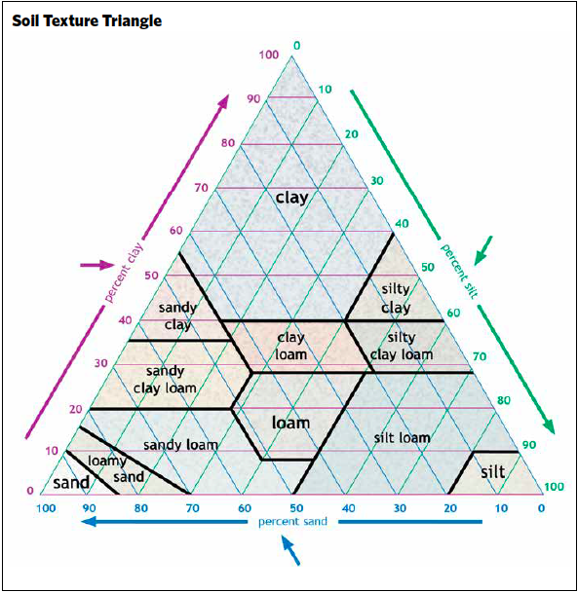
Image from Landscape for Life, Lesson 2: The Role of Soil in Sustainable Gardens, pg. 20.
References: Landscape for Life, Lesson 2: The Role of Soil in Sustainable Gardens
Date Published: April 2019
Author(s)/Contributor(s): Fiona Doherty
Reviewer(s): Amy Albam, Donna Alese Cooke, Jonathan Russell-Anelli

Site Assessment Checklist
Name of Property:
- USDA Hardiness Zone: | - Aspect, Include North Arrow
Last Spring Frost:  Last Fall Frost: | North  South  East  West
- Sunlight | - Slopes
Full sun (6 hours or more)  Partial sun  Shade | Steep  Moderate  Gradual or flat
- Microclimate factors: | Soil texture
Reflected heat  Frost pocket | Clayey  Loamy  Sandy  Silty
- Wind: | - Soil compaction
Windy site  Windy in isolated sections  Calm site | Compacted  Partially compacted  No compaction
- Obstructions | - Soil drainage characteristics
Below ground (e.g. utilities or irrigation system)  Above ground (e.g. overhead wires) | Wet  Well-drained  Dry
- Wildlife interference
Serious and obvious concerns
Marginal concerns
Not a problem

- Unusual conditions: | - Soil pH:  - Existing Plants:
Notes:

