Soil pH Activity
Adapted from Landscape for Life, Lesson 2: The Role of Soil in Sustainable Gardens

20 minutes

Learning Objective(s): Participants will…
Understand the characteristics and basic properties of soil such as texture, pH and
organic matter and their impact on nutrient availability.

Supplies:
Handouts:  - Soil pH kits (see below about ordering Cornell soil pH kits)  - Pipets  - Paper towels and a bowl of water to clean kit wells  - Soil sample(s) | 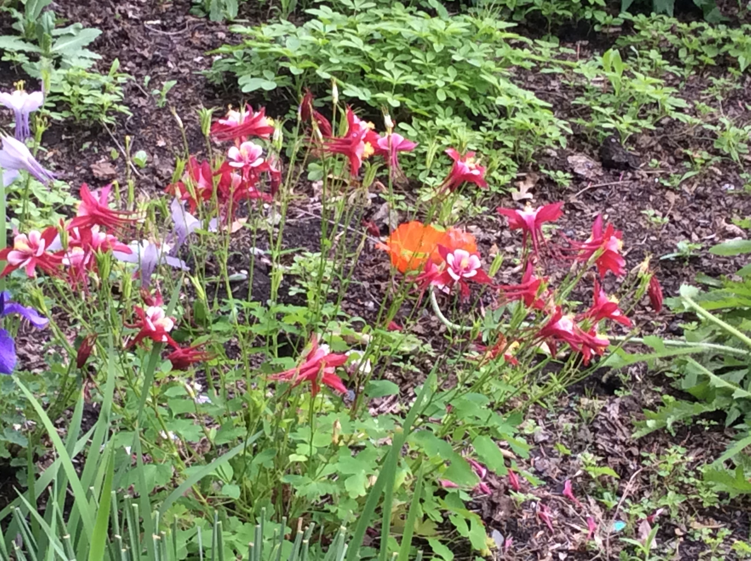
Materials:
- Copies of soil pH ranges
Instructions:
Soil pH is a measure of the acidity or alkalinity of the water held in its pores. The pH scale goes from 0 to 14, with 7 representing neutral. From pH 7 to 0 the soil is increasingly acidic, while from 7 to 14 it is increasingly alkaline.

Soil pH affects whether minerals and nutrients will be available to benefit plants. Before a nutrient can be used by a plant, it must be dissolved in the soil solution. Most plants prefer a slightly acidic to neutral soil, with a pH of 6 to 7, because that is the range in which all nutrients are readily available. In strongly acidic soils (pH 5.5 to 4), important nutrients such as phosphorus, potassium, calcium, and magnesium are in short supply. The availability of phosphorus, iron, copper, zinc, and manganese is reduced in slightly to moderately alkaline soil (pH 7 to 8).

Soil pH also affects the activity of soil microorganisms. Bacteria that decompose organic matter are hindered in strongly acidic soils. This prevents organic matter from breaking down and ties up nutrients, particularly nitrogen. Strongly acidic or alkaline soils can increase the solubility of some nutrients and minerals to the point that they become toxic to plants. For example, in very alkaline soils, the levels of calcium and magnesium are so high that they impede the availability of phosphorus.

How to determine soil pH
One of the smartest things a homeowner can do for their garden is get the soil tested. University extension labs or commercial labs conduct standard soil tests for about $25 to $40. It can save money on unnecessary fertilizer and plants that are not adapted to the natural soil conditions. A lab test can help avoid nutrient imbalances from excess fertilizer that can run off and pollute waterways. It will also help determine which plants are best suited to growing in the garden. Most soil labs will send a soil test kit that includes sampling instructions, a sample bag, and a survey form. Homeowners should be sure to fill out the survey in detail so the lab can make the most informed recommendations for their property. Although they can vary somewhat by state, a standard soil test typically will tell you:
- Soil pH
- Levels of potassium, phosphorus, calcium, magnesium, and sulfur
- Organic content
- Lead and other heavy metal contamination may also be tested for an extra fee
- Recommended nutrient or soil amendments

If they’re not part of the standard test, levels of nitrogen and other nutrients, sodium, soil texture, and other factors can be tested for an extra charge and must be specifically requested.

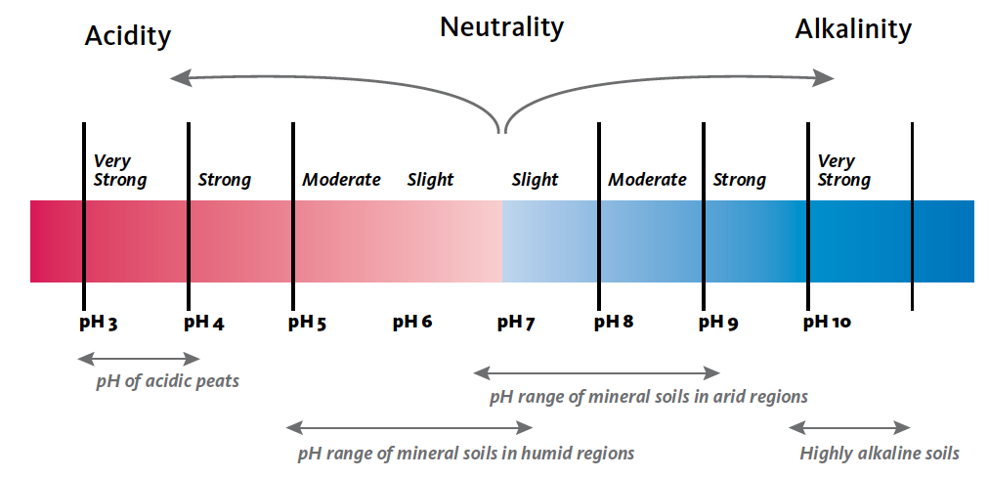

The common pH scale is from 0-14.
The pH ranges of various soil types displayed provide a reference point.
From Landscape for Life, Lesson 2: The Role of Soil in Sustainable Gardens, pg. 25.

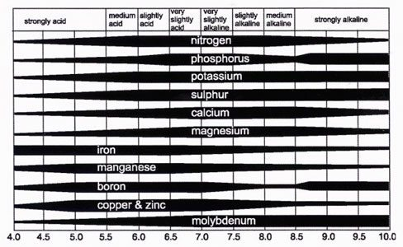
Soil pH affects whether minerals and nutrients will be available to benefit plants.
From Soils and Fertilizers, Jonathan Russell-Anelli and Joan Gruttadaurio (2004), pg. 19.

Directions for Making Soil Test for Lime
- Fill large “well” in spot plate ½ full with soil.
- Slowly add indicator until the soil is saturated, be careful not to oversaturate because doing so will impact your results.
- Tap or tilt spot plate from side to side for 1 minute to allow indicator to react with soil.
- Tilt spot plate so that excess indicator runs into channel with small “well.”
- Compare reacted indicator in small well or channel with color chart to get pH and degree of soil acidity.
- If the color is near the upper end of the Chlorphenol Red chart (reddish purple) or the lower end of the Bromthymol blue (yellow), retest with the other indicator.
- If the color is near the lower end of the Chlorphenol Red chart (golden yellow)
or the upper end of the Bromthymol blue (turquoise blue) the soil is outside the range
of the standard Cornell test kit and a wide-range test may be done.
- Clean spot plate with tissue or clean cloth. Rinse completely with plain water (no soap). Allow to air dry.

The Cornell pH Test Kit is designed to determine the soil pH in the garden or field. The pH kit cannot be used accurately by a color blind person. There are three types of soil pH kits:
- Standard Range Kit is suitable for soil pH measurements from 5.0 to 7.2.
- Wide Range Kit is suitable for measuring the soil pH over the range of 4.0 to 8.6.
- Low Range Kit is suitable for soil pH measurement from 4.0 to 6.2.
Contact details at: https://cnal.cals.cornell.edu/ph-kits/

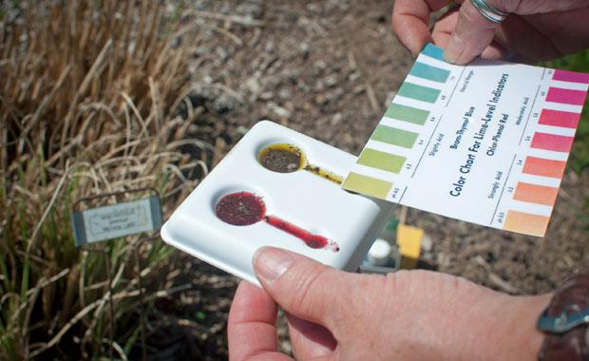

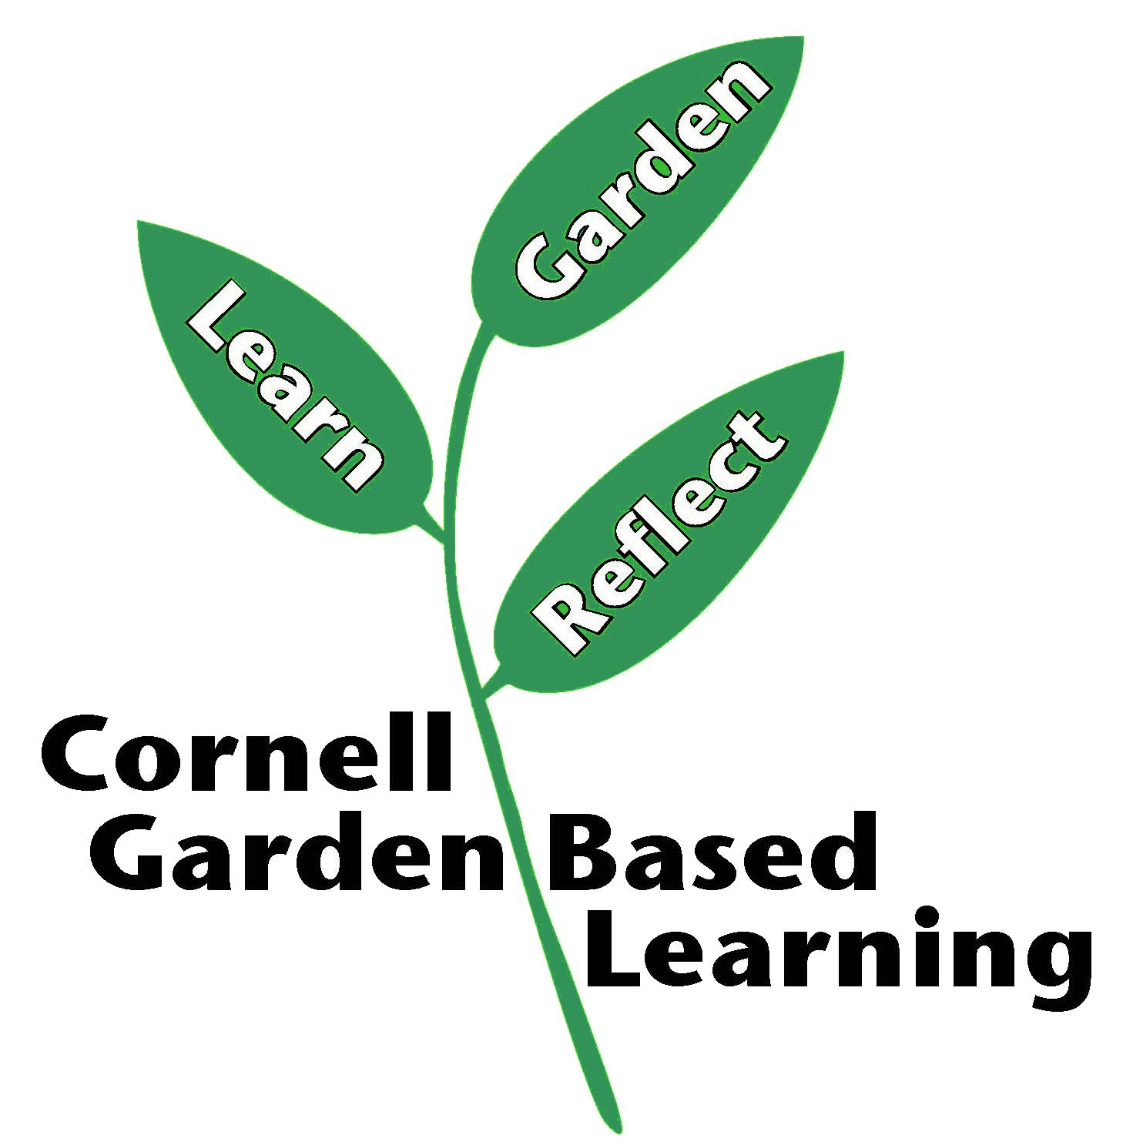
References: Soils and Fertilizers, Jonathan Russell-Anelli and Joan Gruttadaurio (2004). Landscape for Life, Lesson 2: The Role of Soil in Sustainable Gardens.
Published: April 2019
Compiled by: Fiona Doherty
Reviewed by: Amy Albam, Jonathan Russell-Anelli, Donna Alese Cooke

