Soil Texture Activity
Adapted from Landscape for Life, Lesson 2: The Role of Soil in Sustainable Gardens

20 minutes

Learning Objective(s): Participants will…
Understand the characteristics and basic properties of soil such as texture, pH and organic matter and their impact on nutrient availability.

Supplies:
Handouts:  - Garden Soil Samples  - Newspaper to lay on the table  - Paper towels for clean up | 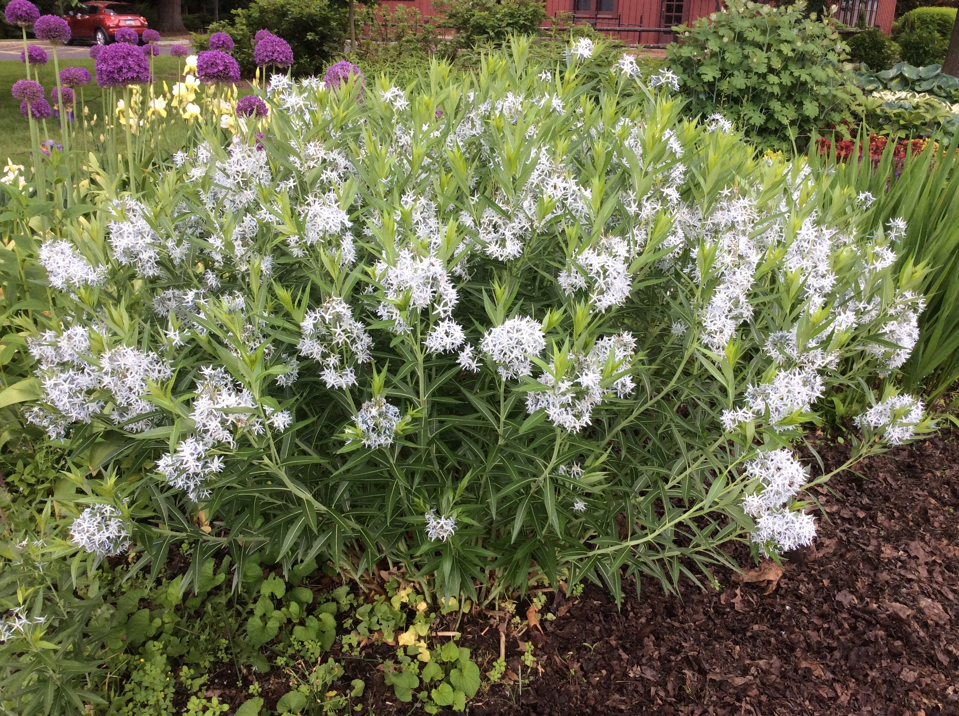
Materials:

Instructions:
Soil texture—how coarse or fine it feels—depends on the size of the mineral particles. Sand, silt, and clay, the major mineral particles, are responsible for the size and number of the soil’s pore spaces. Soil pore space determines the amount of air and oxygen, the drainage rate, and capacity to hold nutrients. Sand grains are the largest particles and create large pores. Sandy soils drain quickly and do not hold water and nutrients well. While sand can be seen by the naked eye, silt particles are microscopic, and feel velvety and smooth. Silt creates smaller pores in the soil and result in better water retention. Clay particles are the tiniest of all. When moist, they cling together and feel sticky. Clay soils have a tremendous capacity to hold water and nutrients, and soils rich in clay may suffer from poor air circulation and slow drainage.

Soils are rarely pure sand, silt, or clay but rather a mixture of all three. They’re often grouped into one of 12 textural classes based on the relative proportions of these particles. Sands and loamy sands, for example, are more than 70 percent sand and share the characteristics of sand. Clays, sandy clays, and silty clays are more than 40 percent clay and exhibit the characteristics of clay. Loams, the ideal soils celebrated in so much gardening literature, share the attributes of both—good aeration, drainage, and moisture and nutrient retention. Most vegetables do best in loamy soil. It is possible to grow a beautiful ornamental garden in any soil type, as long as the plants are adapted to the particular soil conditions.

The Feel Test—Rub a small amount of moist soil between your fingers. First feel for characteristics of sand, then silt, then clay. If it feels coarse and gritty, the soil probably has some sand. If it feels smooth and velvety, it is most likely a silt soil. If the soil clings together and feels sticky, it probably is largely composed of clay.

The Squeeze Test—Squeeze a moist soil sample in your hand and examine it closely. If soil clods resist crumbling and do not change shape when squeezed, you are likely working with a heavy clay soil. If clods break apart into individual particles, like cake mix, the soil probably is predominantly sand. Loam soils tend to stay together when squeezed, but unlike heavy clay soils, they change shape easily.
Soil structure can be related to other factors besides particle composition. For example, big clods may also be an indication of compaction, even in soils with relatively little clay. Sterile loam soils, in which natural microbial action has been impaired, are unable to form even small aggregates.

The Ribbon Test—Squeeze a moist ball of soil out between your thumb and fingers. If the ribbon that is formed easily breaks and is less than 1” you likely have a sandy soil. If the formed ribbon is between 1-2” your soil is likely composed of silt particles. Finally, if the ribbon holds together and is greater than 2” before breaking, your soil has a high concentration of fine-texture clay particles.

Questions to consider:
- What have you learned from your observations? Was anything surprising to you?
- Why is it important to know your soil type?

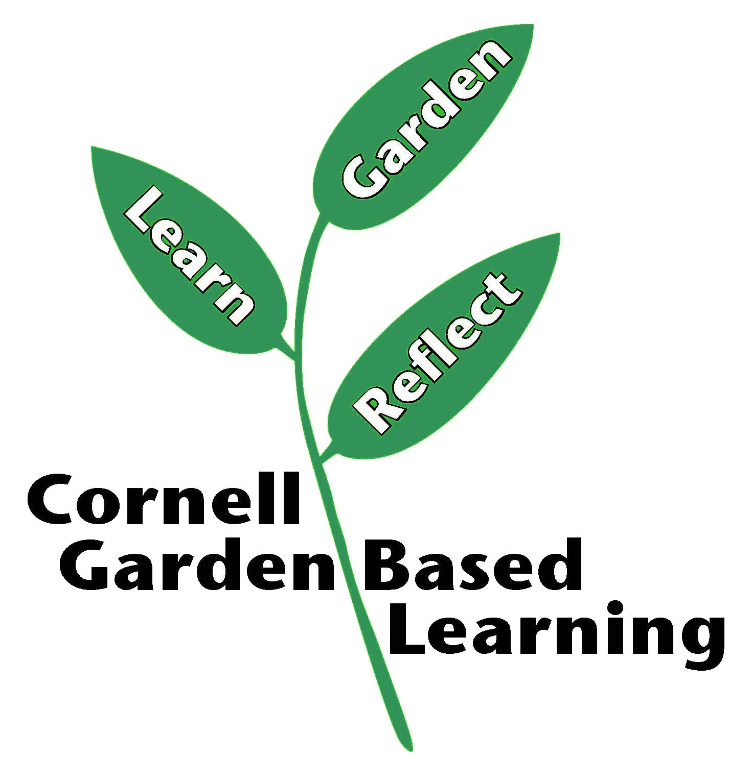
References: Landscape for Life, Lesson 2: The Role of Soil in Sustainable Gardens
Date Published: April 2019
Author(s)/Contributor(s): Fiona Doherty
Reviewer(s): Amy Albam, Donna Alese Cooke, Jonathan Russell-Anelli

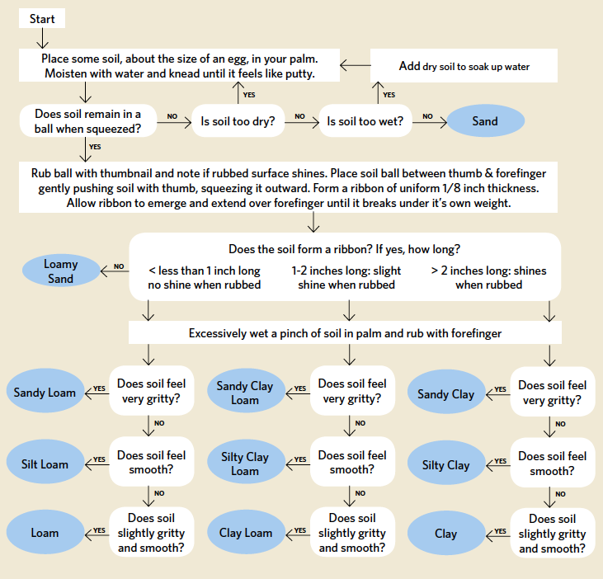

Sourced from Landscape for Life, Lesson 2: The Role of Soil in Sustainable Gardens, pg. 21.
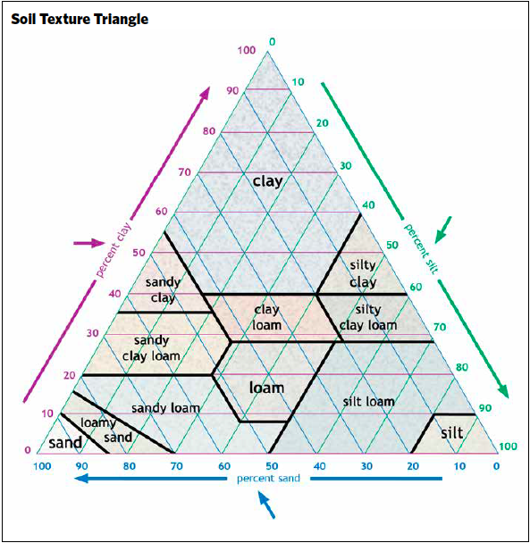

Sourced from Landscape for Life, Lesson 2: The Role of Soil in Sustainable Gardens, pg. 20.

