Sit Spot in Class Activity

20-30 minutes

Instructions:
Sit spot is a technique that is both simple and complex. It is a very effective way to begin to know your landscape because it encourages prolonged, thoughtful observation of one place in the natural world with you, the observer, continually asking questions, noticing patterns, and seeking information to apply to your garden design.

From Wilderness Awareness teacher Jon Young:
Find one place you can get to know really, really well. This is the most important routine you can develop. Know it by day; know it by night; know it in the rain and in the snow, in the depth of winter and in the heat of summer. Know the stars and where the four directions are there; know the birds that live there, know the trees they live in. Get to know these things as if they were your relatives, for, in time, you will come to know that they are. That is the most important thing you can do in order to excel at any skill in nature. Nature and your own heart are the best teachers, but your body, mind and spirit all have to attend the class, and do the homework. There is no replacement for this experience! From Kamana One: Exploring Natural Mystery by Jon Young

The purpose of a sit spot is ultimately to improve and deepen your understanding of natural systems by devoting yourself to consistent time in them. Seeing the same spot at different times of day and during different seasons allows you to see the dynamics of nature unfold. This is a chance to spend time in your landscape, in your garden, learning directly from it.

Directions:
- Go outside and find a sit spot in a garden, lawn or forest. Sit quietly for 5-15 minutes. Set an alarm so you can be fully present.
  - Focus on one sense at a time, trying to “stretch” the sense as far as possible. For instance, cupping your hands around your ears helps amplify any sounds and you can learn to discern sounds that are close by versus those that are far in the distance. Or spend the entire time with your eyes closed.
  - Ask a multitude of questions beginning with “Why?”
  - Examine the layers of vegetation, evidence of animals, patterns of past human use.
  - Zoom your focus from the entire scene in front of you to the smallest leaf/insect/spec of earth. Then repeat; back and forth.
- Pair up with a partner and discuss what you experienced.
- This exercise can become part of your personal routine. See Sit Spot at Home activity.
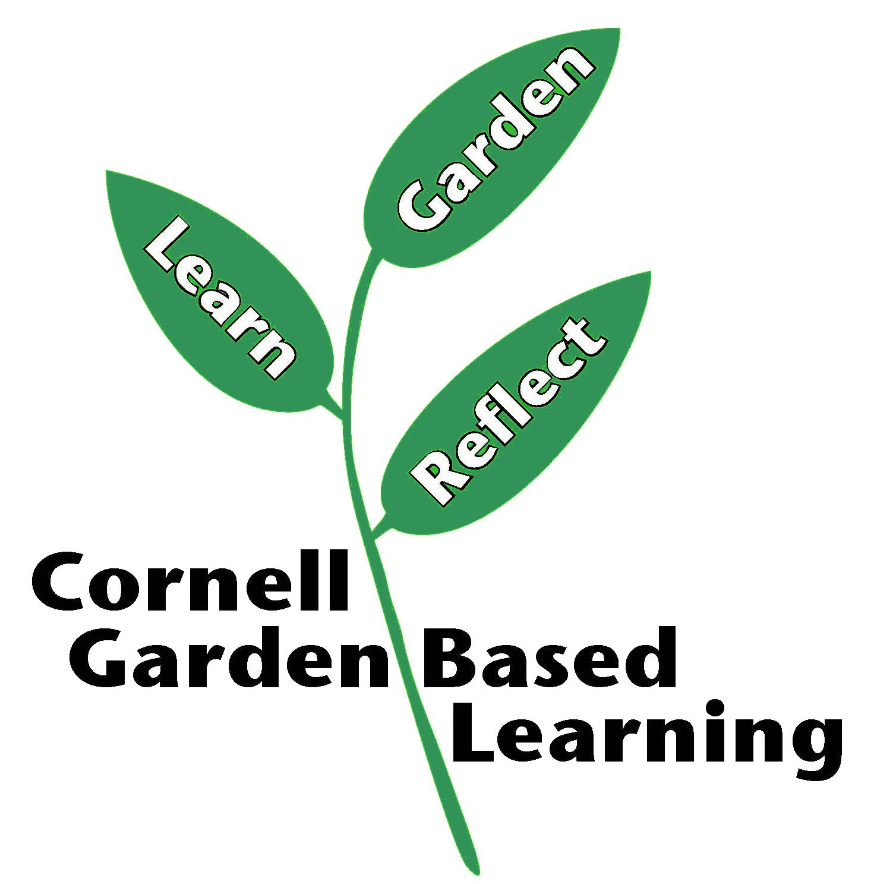

References: Adapted from Cornell Organic Gardening online course
Published: April 2019
Reviewer: Fiona Doherty, Michelle Podolec, Donna Cooke

