Sit Spot at Home Activity
Variable (as little or as much as you like)

Supplies:
Handouts: | 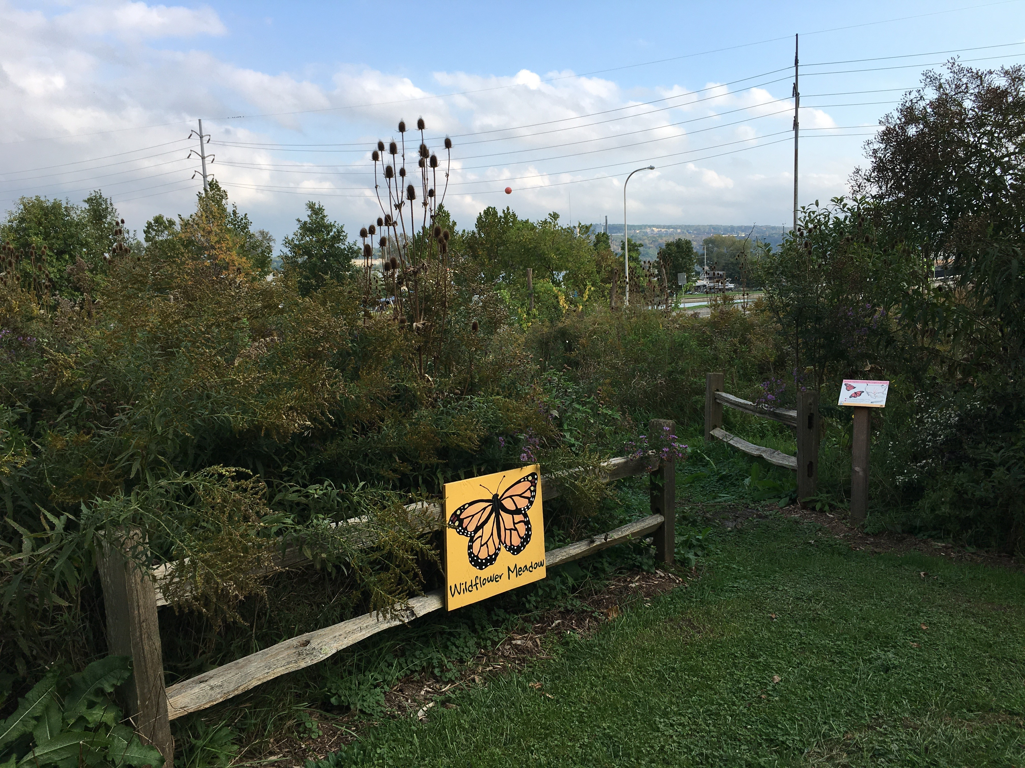
Materials:
- a pad of paper or journal

Sit spot is a technique that is both simple and complex. It is a very effective way to begin to know your landscape because it encourages prolonged, thoughtful observation of one place in the natural world with you, the observer, continually asking questions, noticing patterns, and seeking information to apply to your garden design.
From Wilderness Awareness teacher Jon Young:
Find one place you can get to know really, really well. This is the most important routine you can develop. Know it by day; know it by night; know it in the rain and in the snow, in the depth of winter and in the heat of summer. Know the stars and where the four directions are there; know the birds that live there, know the trees they live in. Get to know these things as if they were your relatives, for, in time, you will come to know that they are. That is the most important thing you can do in order to excel at any skill in nature.
Nature and your own heart are the best teachers, but your body, mind and spirit all have to attend the class, and do the homework. There is no replacement for this experience!
From Kamana One: Exploring Natural Mystery by Jon Young, page 98.
The purpose of your sit spot is ultimately to improve and deepen your understanding of natural systems by devoting yourself to consistent time in them. Seeing the same spot at different times of day and during different seasons allows you to see the dynamics of nature unfold. This is a chance to spend time in your landscape, in your garden, learning directly from it.
Your task is to:
- Find a sit spot in your garden/home site that is easy to visit and where you can feel safe and somewhat secluded from a human-dominated landscape (this will vary on your urban/rural location). Water features, trees, and the likelihood of sighting wildlife are all desirable attributes, but it is most important that the spot be a place you will be easily able to visit. (Even if you're in a very cold climate, TRY to push yourself a bit and make this sit spot outside. If you are physically limited, cannot handle the cold, or have no access to outside space, your sit spot can be from a window of your house, presuming you can see your garden site).
- Visit your sit spot 2-3 times this week and 2-3 times next week for a minimum of 5 minutes each visit. On your first visit, 20 -30 minutes is ideal. If you are antsy, set an alarm and try to be present. Here are some ideas to maximize your experience:
  - Focus on one sense at a time, trying to “stretch” the sense as far as possible. For instance, cupping your hands around your ears helps amplify any sounds and you can learn to discern sounds that are close by versus those that are far in the distance. Or spend the entire time with your eyes closed.
  - Bring a pad of paper or journal and sketch a scene, leaf, or plant specimen (try not to sketch the whole time though.)
  - Ask a multitude of questions beginning with “Why?”
  - Examine the layers of vegetation, evidence of animals, patterns of past human use.
  - Zoom your focus from the entire scene in front of you to the smallest leaf/insect/spec of earth. Then repeat; back and forth.
  - Continue visiting your sit spot 2 to 3 times for at least one more week.
Hopefully your sit spot is something that becomes part of your routine. Visit it at different times of the year. You may, after some time, decide to change your sit spot if this practice continues for you for more than 6 months. At that point, a fresh spot might improve the practice for you.

Looking for more? Read Exploring Natural Mystery: Kamana One by Jon Young or The Forest Unseen: A Year’s Watch in Nature by David George Haskell.

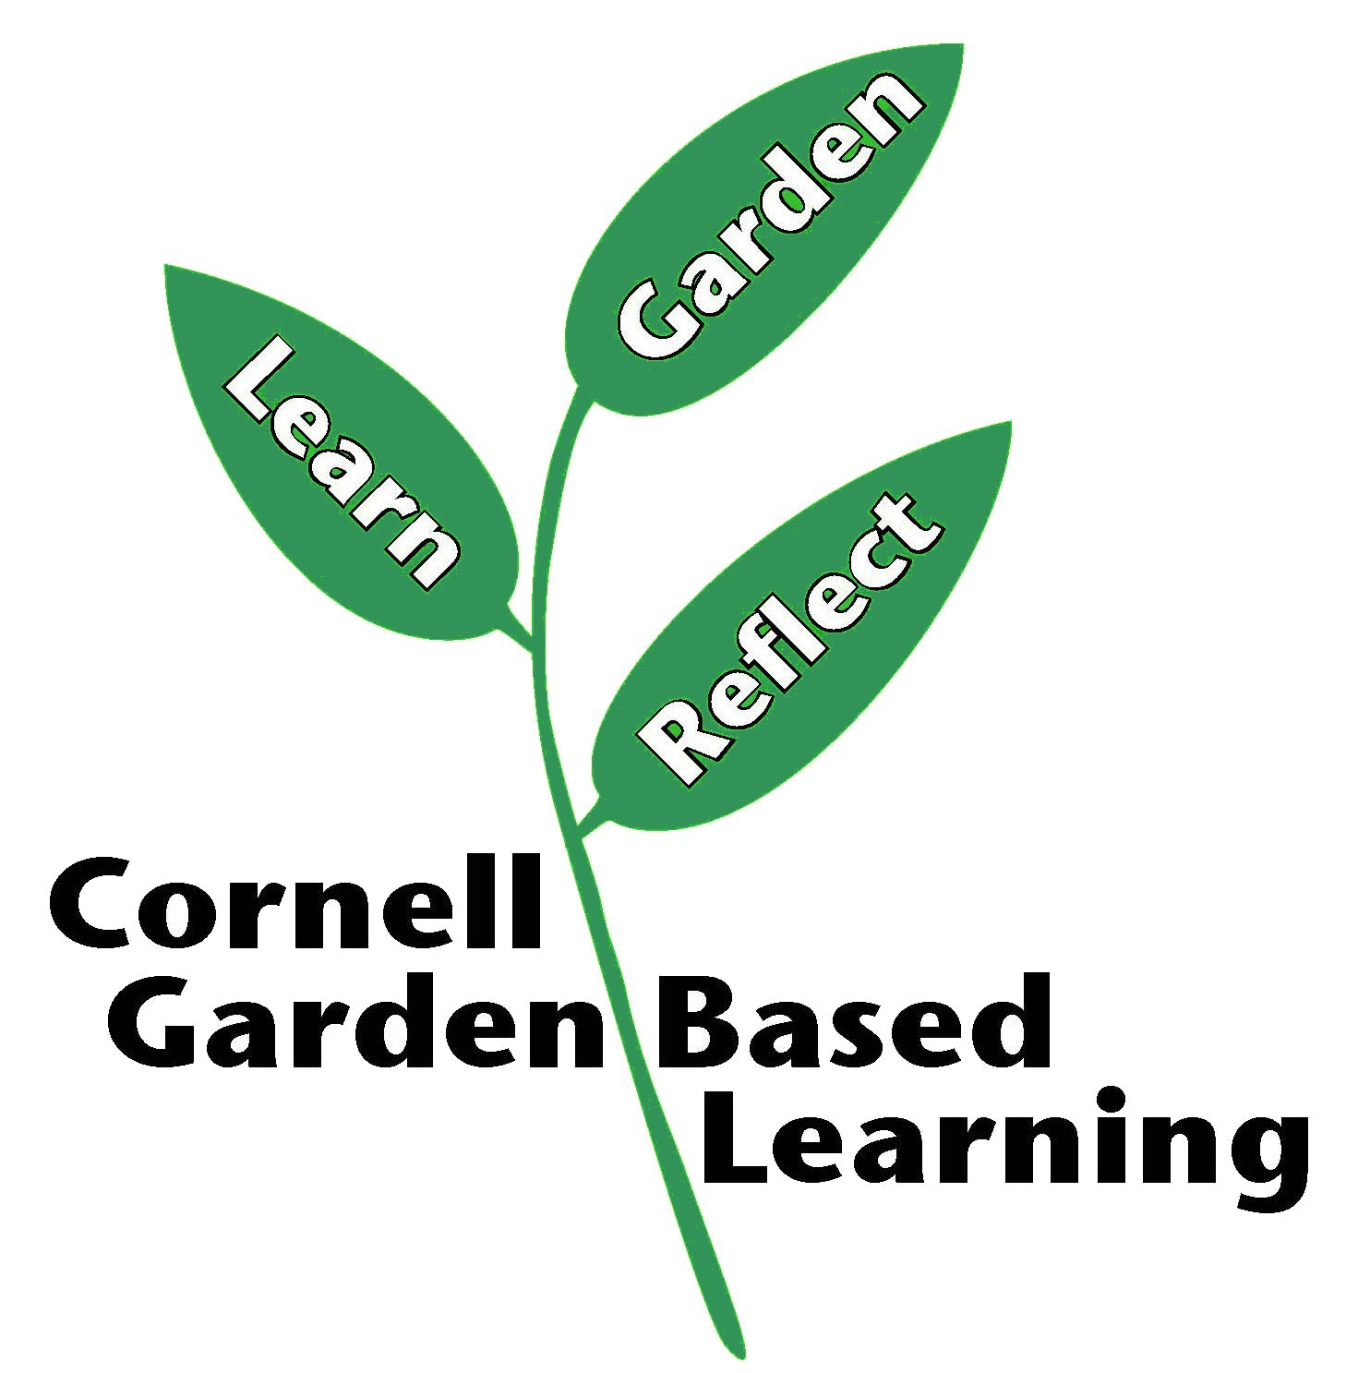
References: Adapted from the Cornell Horticulture Online Organic Gardening Course
Published: April 2019
Reviewer: Fiona Doherty, Michelle Podolec, Donna Cooke

