Garden and Landscape Area Activity

1 hour

Learning Objective(s): Participants will…
Knowing the dimensions of sections of your property, such as lawn areas, an alcove, or an extra area in an odd-shaped property will be useful when making decisions. The square footage is needed to know how much materials you need to purchase, including plants, grass seed, fertilizer, compost and mulch. The success of landscape or garden plans depends on accurate information to match the layout with the realities of the site size. For instance, an ornamental tree that matures within the boundaries of available space will save replacement or pruning costs. - from Site Assessment for Better Gardens and Landscapes by Charles Mazza (2013)

Supplies:
Handouts:  - Retractable 25,’ 50’ or 100’ measuring tape, or yardstick  - Paper, letter or legal size, preferably grid lined  - Property survey  - Pencil  - Clipboard | 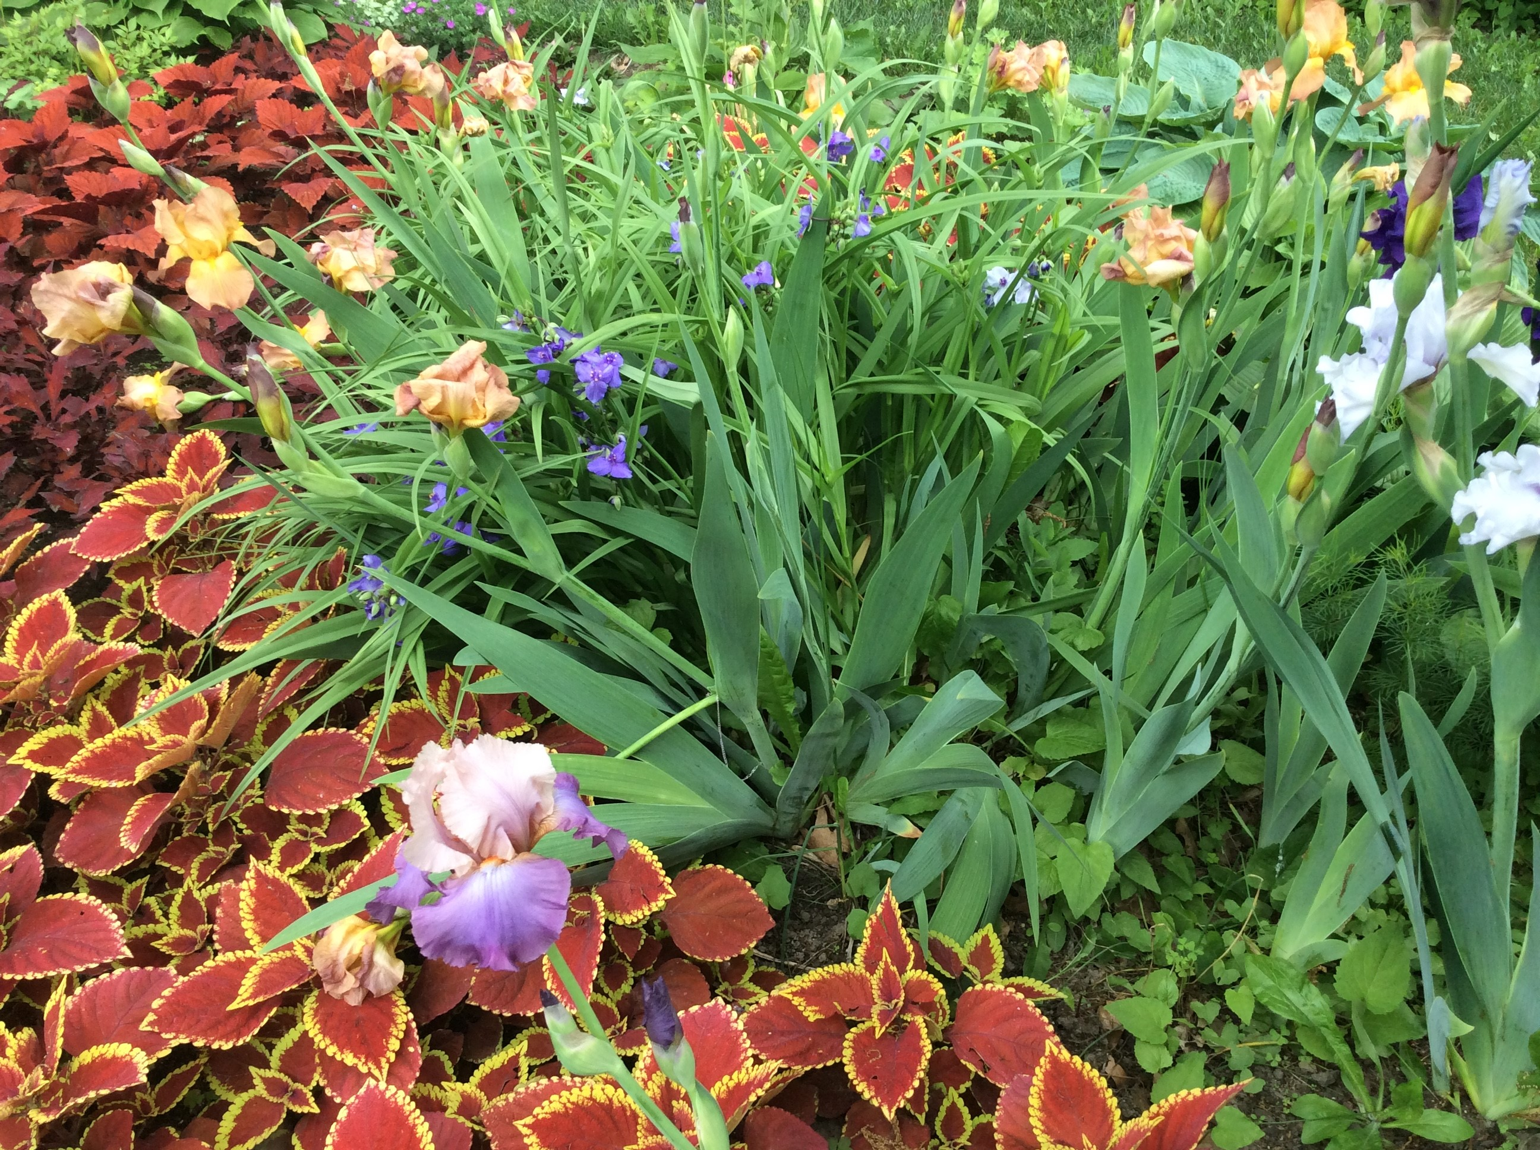
Materials:

Directions:
Find your property survey, part of the deed to the property. Get the overall length and width of the property from the property survey. Draw a sketch of the property to scale as if you were looking at the site from an airplane. Choose a scale that allows you to fit the sketch on the paper you are using. For example, the scale could be 1-inch equals 50 feet. For large properties, use more than one sheet, but clearly mark how they fit together. Grid lined paper makes it easy to draw areas to scale and is available at office supply stores.

You don’t need to be a good artist to add the house, outbuildings, fences, walls, ponds and other features to your sketch at their approximate size and location. Also, mark the location of permanent pathways, patios, driveways, electrical outlets and hose outlets or other water sources.

Use the retractable measuring tape or yardstick to measure areas within the property. If part of the property is wooded or natural meadowland, measure the area that is currently used for lawns, landscapes and gardens. The property survey may have some of this information. Measure undeveloped areas as well as they can be considered for new garden, landscape or lawn areas.

When an area is too large to be measured with a measuring tape or yardstick, use the length of your average step. Use whatever is handy to mark the beginning and end of a straight line 20 feet long. The average length of your step is 20 feet divided by the number of steps it takes you to walk the distance. Now, count the number of steps it takes to walk the area’s length and multiply it by your average step length. Do the same for the area width. Measuring your pace step gives you an estimate, not an exact measurement.

Convert length and width measurements for the whole or sections of your garden to square footage and mark it on your sketch.
Length (ft.) x width (ft.) = square feet

For areas that are not rectangular, imagine a rectangle around the space and calculate the area of the rectangle. Then, estimate the percentage of the rectangle that is occupied by the irregular shape. Multiply this percent by the area of the rectangle. This will yield an estimate of the area of the irregular area. If you have some knowledge of geometry, you may want to estimate using circles, partial circles and triangles as well as rectangles.

New to measuring garden areas? Here are a few tips from Michelle Podolec, MLA

1. Pick a ‘hard corner’ that will serve as the foundation for your map. The corner of a building/room works well. Use a screwdriver to hold the other end of the tape measure if you are measuring on your own. Draw that ‘corner’ in the corner of your paper.

2. Create a ‘long line’ next – this should measure the longest length of the garden. Write down (neatly) the measurement next to the line on your paper.

3. Using this ‘long line’, take measurements of the other elements in your garden (to the beginning of a garden bed, to the end of the garden bed, to your garage, to the sidewalk).

Do you think that other people would be able to recognize what you drew as this space/garden? What would you do differently next time? What additional information do you think you would need to put on the paper if you were going to take this ‘garden ‘drawing to a garden center?

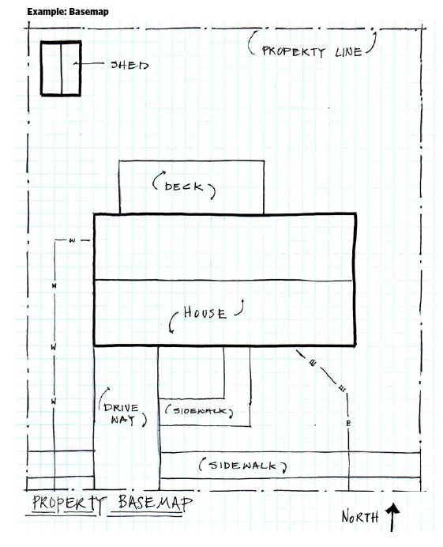
Image from Landscape for Life Manual, http://landscapeforlife.org/

References: Landscape for Life Manual, http://landscapeforlife.org/
Site Assessment for Better Gardens and Landscapes by Charles Mazza (2013)
Published: April 2019
Compiled by: Fiona Doherty
Reviewed by: Donna Alese Cooke, Jonathan Russell-Anelli

