A Close Look: Cultivating Plant Observation Skills

25 minutes

Learning Objective(s): Participants will…
Recognize the parts of a plant and their functions.

Supplies:
Handouts: Copy Cornell fact sheet: Botany Language Basics for Plant Identification  and/or other resources that provides terminology for plant characteristics. | 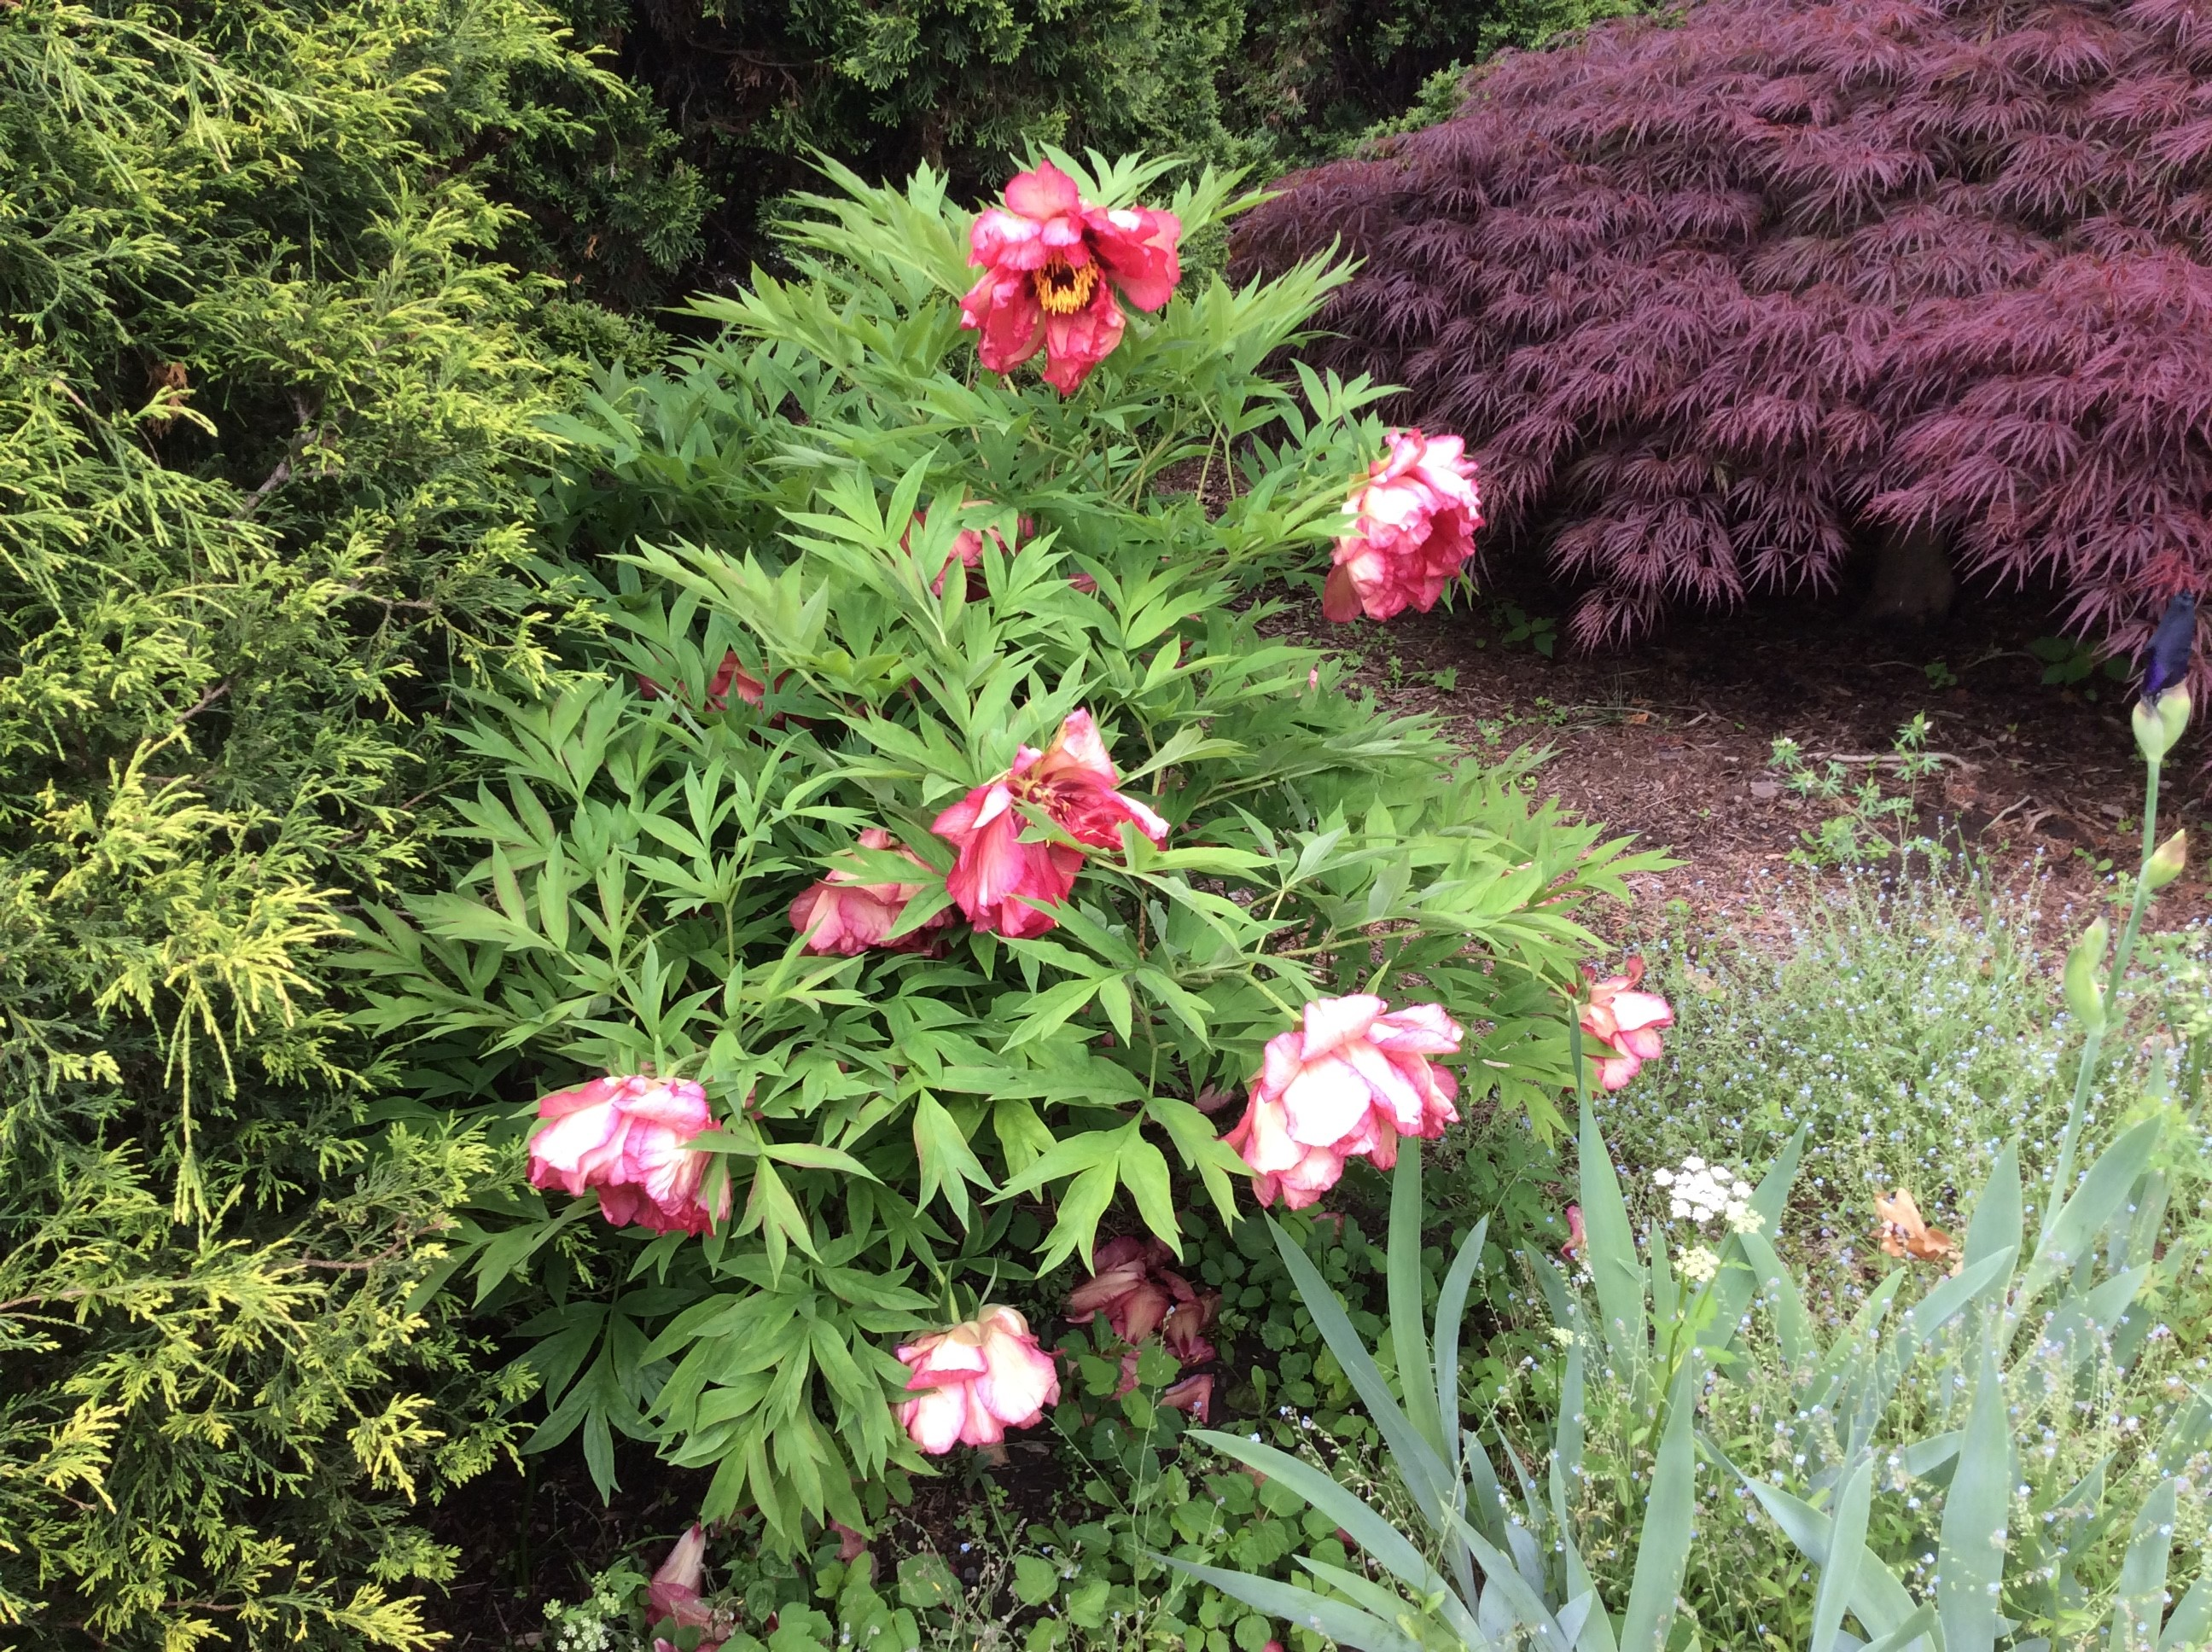
Materials: Collected one vascular plant sample per participant or ask participants to collect and bring a sample. The samples can be from any indoor or outdoor plant; herbaceous or woody plant; annuals or perennials; or another type. Do not collect materials that are poisonous to touch. Place each plant sample in its own paper or plastic bag that cannot be seen through. paper and pencils for sketching.

Instructions:
- Given each participant a bagged plant sample. Instruct them to keep what is in their
bag secret as they find a partner in the room (preferably someone they do not know).
- Partners take turns using sight, smell and touch to share the characteristics of the plant
hidden in their bag while the other sketches an image/diagram based on the verbal
description. The sketcher can keep the picture private or share with describer in further
clarification discussion. Each partner takes no more than 3 to 5 minutes to describe
plant material. Once complete participants continue to keep plant material secret.
Note: The goal is not to identify the plant. It is to observe characteristics and describe
those clearly enough that another can create a sketch without looking at the plant.
- Partners consider how each might revise their plant characteristic descriptions and
sketches after reviewing Botany Language Basics and other terminology resource
provided.
- As a whole group consider how participants’ plant descriptions and sketches changed
when provided the added terminology resources. How familiar are the botany terms?
How was having a shared terminology language valuable? In addition to observing plant feature what other observations and information can aid understanding the type of plant, what it needs to thrive and possibly it specific identity? Consider creating
collections of plant families that may include pressed material, sketches and/or pictures.

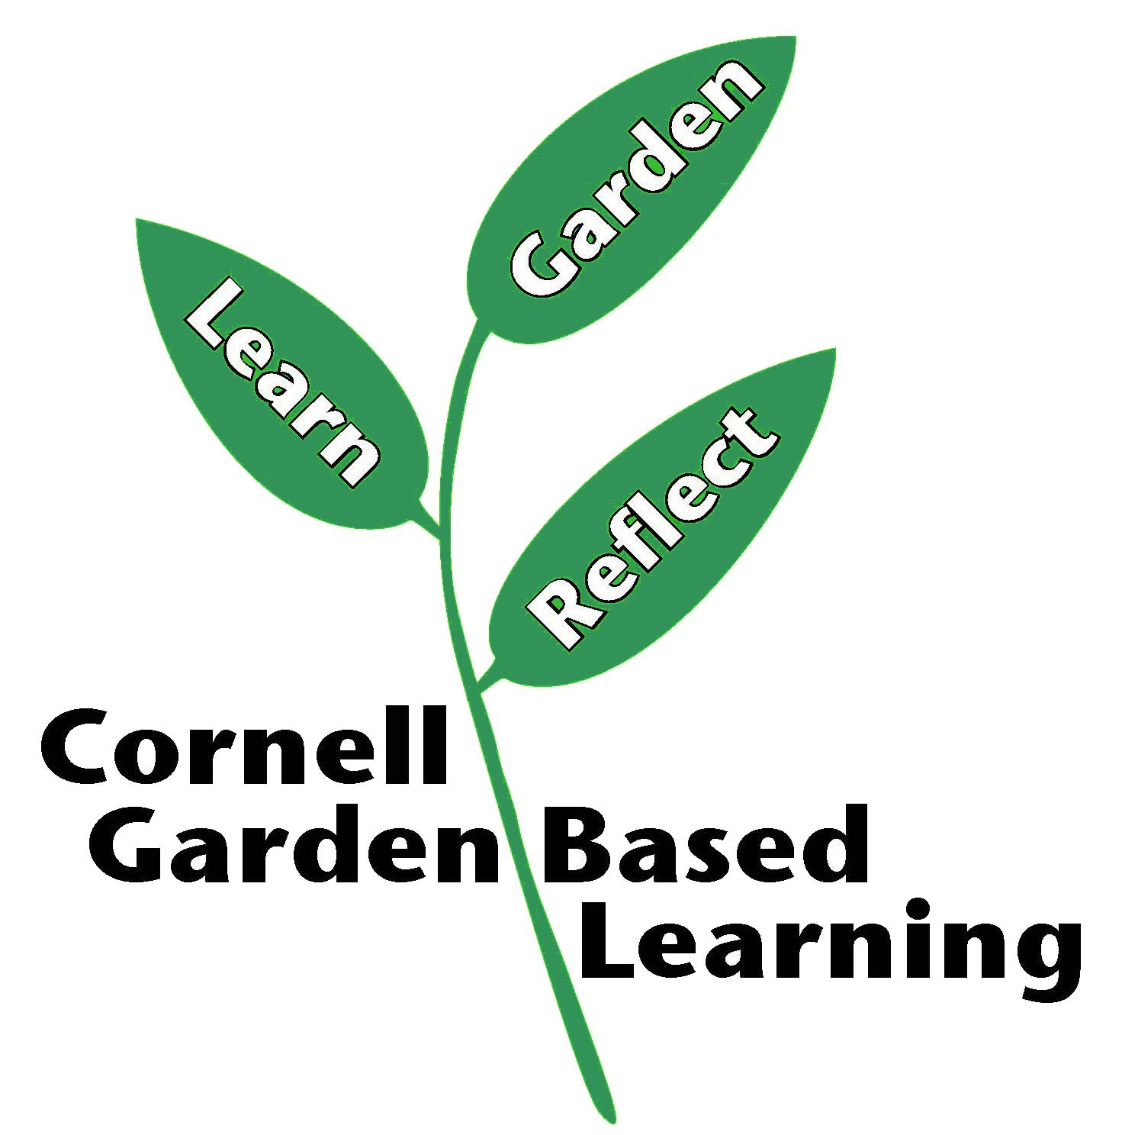
Date Published: April 2019.
Author(s)/Contributor(s): Lori J. Brewer
Reviewer(s): Michelle Podolec

