Your Garden Lifeline Worksheet

Time: 15 to 30 minutes

Leaning Objective: Consider the value of garden-based learning.

A lifeline exercise helps you to see and interpret patterns in your life by building a comprehensive overview of your experiences. In this lifeline exercise focus on your experiences related to gardens and gardening.

Find one or more blank large sheets of paper on which you can sketch these two timelines. To develop your timelines, go back as early as you can remember and work towards the future.

For the first timeline, identify activities and experiences related to gardens and gardening that directly influenced your social and personal development. For example, you planted a seed in a cup in first grade or you created an insect collection in a college entomology class. Try to identify 10 to 15 items to record on this timeline. Allow positive experiences to move the line upward and negative to move the line downward.

positive impact

negative impact

earliest childhood memory 5 years in the future

For the second timeline, identify activities and experiences related to gardens and gardening that directly influenced your relationships and relationship issues. For example, you help your grandmother can vegetables from her garden, or your first boss was a landscaper and you both mowed lawns all summer. Again, try to identify 10 to 15 items to record on this timeline and allow positive experiences to move the line upward and negative to move the line downward.

The following questions to might help guide your reflection:
- How did you spend your time when you were a child? What did you like and not like?

- What garden related classes have you taken, what did you do in those classes?

- How has food, plants, soil, insects, wildlife…been a part of your life?

- What guided you in making choices about what to study, where to work and what to do in your free time? Where did you find the most success and least?

- What was the impact of each of these relationships, achievements and events in shaping your perspective and how you are in the world?

- What patterns or evolution do you see? Where do you think you are headed with your gardening experiences?

- What does this tell you about your garden interest and what you care most about?

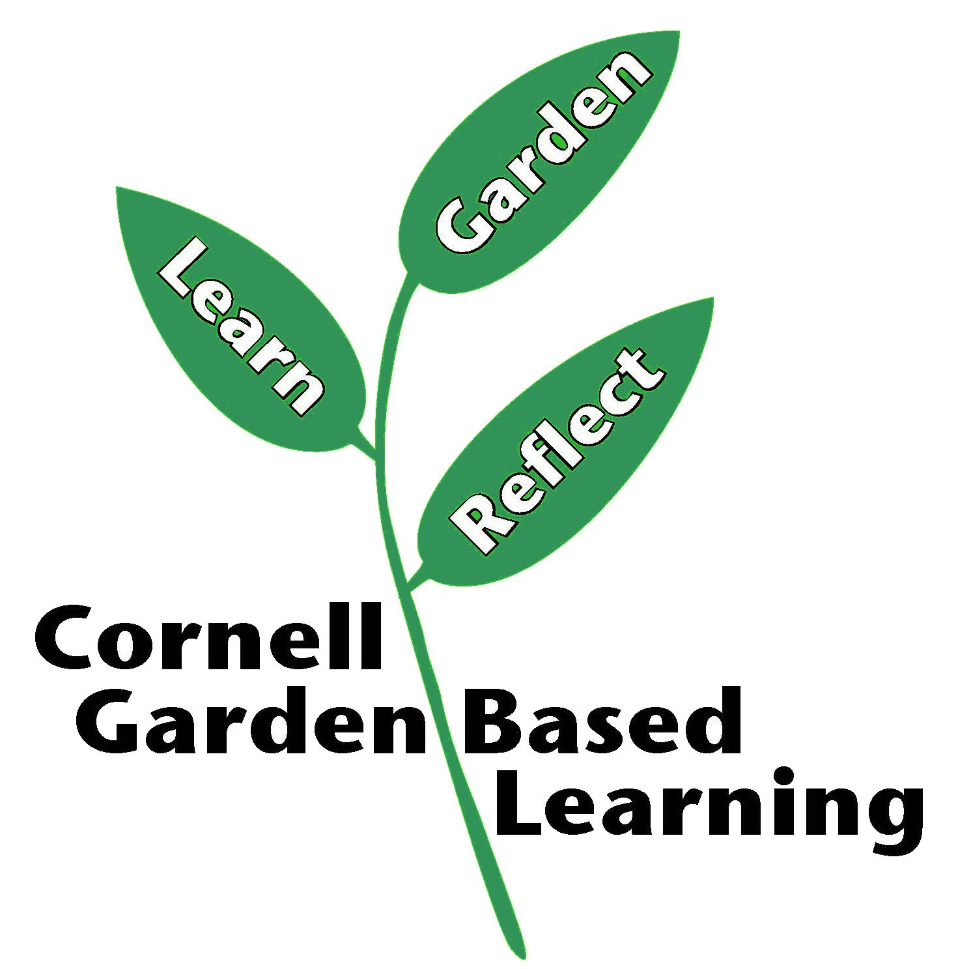
Reference:
Mark J. Miller (1993) The Lifeline: A Qualitative Method to Promote Group Dynamics, Journal for Specialists in Group Work, 18:2, 51-54, DOI: 10.1080/01933929308413737

Published: April 2019
Author: Lori Brewer
Reviewer: Donna Alese Cooke

