Facilitating Adult Learning Worksheet

Time: 15 to 30 minutes

Leaning Objective: Understand the basic principles of facilitating adult learning.

Facilitation of adult learning involves actively engaging participants in building their knowledge and self-reflection. It is different from a lecture style of classroom learning. Malcolm Knowles (1980) identified several practices that embody effective facilitation….
- Establish a climate conducive to learning.
- Involve participants in framing their own learning outcomes.
- Encourage participants to identify and use a variety of resources to accomplish their learning outcomes.
- Help participants implement, evaluate and reflect on their learning.

Daniel Goleman (1995) also describes emotional intelligence as a foundation in facilitating adult learning. Emotional intelligence is the ability to recognize and understand our own emotions (self-awareness) and the emotions of others (social awareness) and then to use this ability to guide our behavior (self-management) and manage our relationships (relationship management). What might this actually look like in the context of facilitating adult learning? An emotionally intelligent leader is easy to relate to and creates an atmosphere in which participants feel comfortable and listened to (even when she has her own work load to manage.) Her door is open, so to speak, she listens carefully, asks good questions, and her participants feel that she understands their learning needs. At the same time, she has clear boundaries, prioritizes her own self-care, and is not a door mat.

When exams are not the primary motivator, self-direction is a critical aspect in adult facilitation. Self-directed learning is often appreciated as a journey in addition to a destination, taking place not in isolation, rather, in connections with others as resources and fellow sojourners. As Cheryl Lowry (1989) said, facilitating self-directed learning means inspiring learners to view knowledge and truth as contextual, to see value frameworks as cultural constructs, to appreciate that they can act on their world individually or collectively to transform it. You’ll want to consider and be sensitive to such things as…
- Fostering partnerships.
- Helping participants identify goals and learning outcomes based on their (and their community’s) needs.
- Use multiple modalities – not just didactic teaching – to achieve those objectives.
- Attend to, notice, tweak and generally manage the learning experience with participants’ needs in mind.
- Help partners stay focused on the overarching goals, outcomes, and learning strategies, and periodically revisit goals to stay on track.

Facilitating learning experiences can be transformational for leaders and participants. Transformation is fundamentally about being open to possibilities and perspectives by critically reflecting on one’s lived experience. This generates new insights and signals a change in how we see and make sense of the world. It brings about more aligned, sustainable and synergistic behavioral patterns and actions because these relationships are collaborative. When all of us are learning, we can make changes we have never considered before (Mezirow and Associates 1990).

Unlocking the Magic of Facilitation: Key Concepts You Didn’t Know That You Didn’t Know (from Killerman and Bolger 2016)
- Understanding facilitation as a nuanced skill. Facilitation is both nuanced and a skill.
- Facilitation vs. Teaching vs. Lecturing. Facilitation is a different style of engagement from teaching or lecturing.
- Being neutral. Being a facilitator is not about being neutral, but instead about being honest and open with your group about your goals together and recognizing the implicit bias in those goals.
- How to read a group. Try to get to know the group before the session. You might ask them to complete a pre-session worksheet or answer a few questions about themselves on the registration form. Once the session begins, start by listening. Pay attention to what they are expressing and use that to help direct the flow of the session.
- Both/and is greater than but/or. The power of replacing “but” with “and” is incredible. Pulling ourselves out of the duality of either/or, the almighty “and” helps us see multiple realities as feasible and present.
- The “Yes, and…” rule. By adding to someone’s reality rather than negating it, you can often learn much more about a person’s perspective, understanding and ideas, than any “no” could ever bring you.
- Asking good questions. Good questions are more than just “open-ended” questions. Effective facilitators know how to do this – and it takes practice.
- Safe spaces for vulnerability. Facilitating can be challenging; showing up and really being seen while you’re facilitating can be even harder.
- Triggers. Not all experiences in a workshop or training are pleasant or wanted and sometimes they leave our heart racing – or our blood boiling. To be an effective facilitator, it’s our responsibility to manage our triggers.
- Learning from emotions. Emotions happen. As facilitators, we have a choice of whether to invite emotions into our training and what to do when they show up.
- Role modeling continuous learning (or the myth of the expert). As a facilitator, we must lean into the unknown, own our journeys and role model the importance of saying “I don’t know.”

And at the Best Teachers Institute (2017) Ken Bains shared that people learn most deeply, in ways that have a sustained and substantial influence on the future way they think, act or feel, when…
- They are trying to answer questions or solve problems they find interesting, intriguing, important or beautiful;
- They can try, fail, receive feedback, and try again before anyone makes a judgment of their work;
- They can work collaboratively with other learners struggling with the same problems;
- They face repeated challenges to their existing fundamental paradigms;
- They care that their existing paradigms do not work;
- They can get support (emotional, physical, and intellectual) when they need it;
- They believe that their work will be considered fairly and honestly;
- They believe that their work will matter;
- They believe that intelligence and abilities are expandable, that if they work hard, they will get better at it.
- They believe other people have faith in their ability to learn;
- They believe that they can learn.

Reflection on your experiences.

Recall a time in which you played a role in someone else’s learning. (Alternatively, consider a time in which you witnessed someone who facilitated learning in a particularly vivid way). Describe this experience.

What did you do? What did the learner do?

When you think about your efforts and what you aimed to do, what factors affected/contributed to the success of the experience? (On the other hand, if it was a ‘train wreck’ that you learned from, what contributed to its derailment…?)

If anything, what might you do differently next time?

What metaphor best describes how this whole experience felt for you?

References:
Knowles, Malcolm. 1980. The Modern Practice of Adult Education: from Pedagogy to Andragogy. River Grove, IL: Follett.

Goleman, Daniel. 1995. Emotional Intelligence: Why it can matter more than IQ. NY: Bantam.

Lowry, Cheryl. 1989. Supporting and Facilitating Self-Directed Learning. Columbus, OH: ERIC Clearinghouse on Adult, Career, and Vocational Education.

Mezirow, J. and Associates. 1990. Fostering Critical Reflection in Adulthood: A Guide to Transformative and Emancipatory Learning. San Francisco: Jossey-Bass.

Killerman and Bolge. 2016 Unlocking the Magic of Facilitation: 11 Key Concepts you Didn’t Know that you Didn’t Know, Impetus Books.

Bain, Ken. 2017. “What the Best Teachers Do.” Best Teachers Institute. http://www.bestteachersinstitute.org/who-we-are, accessed Summer 2017.

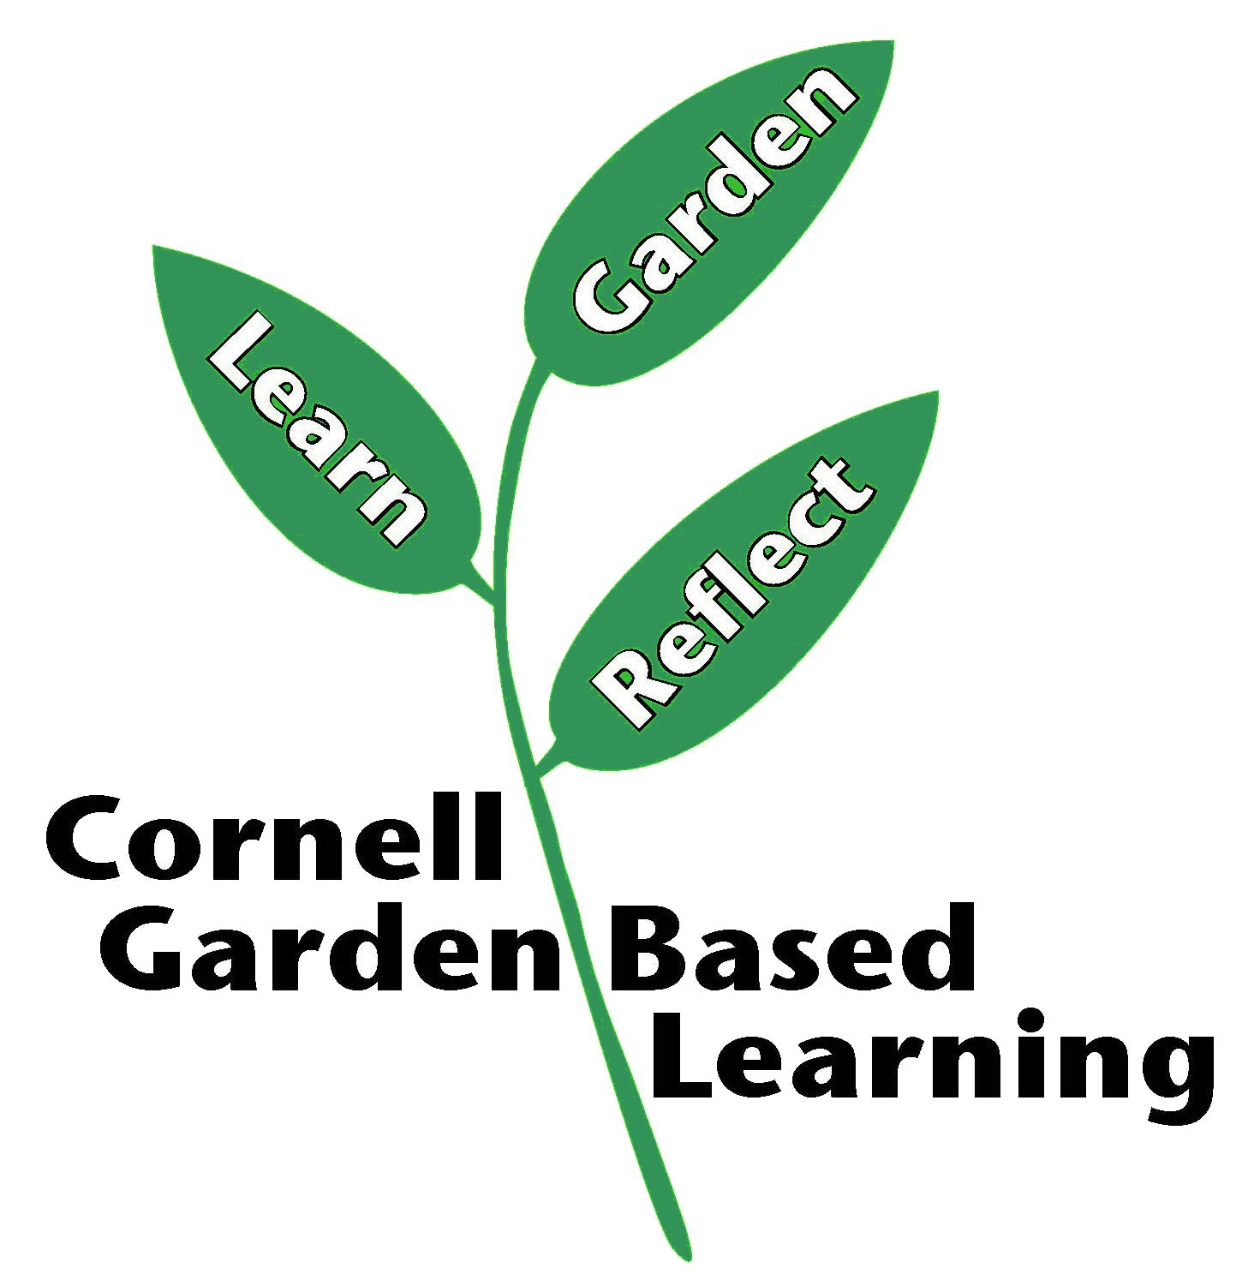

Published: April 2019
Author: Marcia Eames-Sheavly
Reviewer: Fiona Doherty

