Garden-Based Learning Facilitation Scenarios

Time: 30 minutes

Learning Objective: Participants will understand the basic principles of adult learning.

Supplies:
Handouts:  The Basic Principles of Adult Learning presentation or video  Facilitating Adult Learning Worksheet | 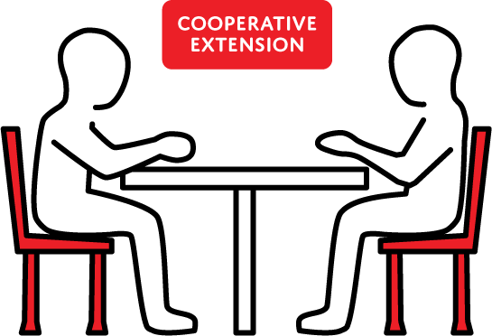
Materials:
4 facilitation scenarios for each group – cut roles for each scenario into separate strips

Instructions:
In advance review presentation or video on The Basic Principles of Adult Learning and complete Facilitating Adult Learning Worksheet.

Break class into groups of 4 people and provide each group with the facilitation scenario with the 4 roles for each scenario cut into separate strips. Each group member takes on 1 role per scenario. Do not let other group members read your role – simply play your role in the group discussion for that scenario. After 3 to 5 minutes, de-brief then choose another scenario - picking new roles for each group member. Repeat until the whole group reunites.

For the last 5 to 10 minutes discuss with whole group:
- How did the role-playing experience feel?
- Were there moments when you felt uncomfortable? If so, when?
- What tactics did you take to:
  - Keep the conversation on track
  - Resolve conflict
  - Mediate interpersonal conflict
  - Respond to misinformation
- When might you experience this in real life?

Facilitation Scenario 1 (Keeping the Conversation on Track):

A: You are the facilitator. Your garden has been having trouble finding a stable water source and you’re concerned you won’t be able to make it through the summer, and want to get input from garden users about what should be done.

B: You are a participant in the Seed to Supper (S2S) program and start talking about your newly installed rainwater harvesting system: the cost, the time it took to install and how well it is working out for you.

C: Time to get side-tracked. Tell a really long story about something completely unrelated that happened to you recently and do not stop unless directly re-directed by the facilitator.

D: You are observing. Write down what you notice. What did the facilitator do well? What could have been improved? What skills did they use?

Facilitation Scenario 2 (Conflict Resolution):

A: You are the facilitator. One of the members of your garden has not been maintaining their plot and weeds are starting to spread to surrounding beds. You are having a conversation with the owner of the under-managed plot and the one next to it.

B: Someone’s unmanaged plot is affecting your planting space and you’ve been very careful and diligent with your plot-space. You are frustrated and you know exactly whose plot has gone unmanaged, and do not care to learn about the circumstances because you think it is completely unacceptable. You’re busy, too, but you find the time to weed!

C: You have never gardened before and didn’t know how much of a time commitment it would be. You feel really bad that your plot is causing problems for other people, especially since you really admire B’s gardening skills. Do not speak unless directly asked to contribute by the facilitator.

D: You are observing. Write down what you notice. What did the facilitator do well? What could have been improved? What skills did they use?

Facilitation Scenario 3 (Interpersonal Conflict):

A: You are the facilitator. Today you will be leading a discussion about fertilizing.

B: You are a very experienced gardener. You’ve just moved to the area and were very active in the community garden in your last neighborhood. This garden was in a very wealthy area and used a well-renowned brand of organic fertilizer. You think this is the only option to have a successful garden!

C: You have never gardened before because you think it’s a very expensive thing to get involved in. You are annoyed by B, but don’t confront it directly. When they speak use body language such as crossing your arms, rolling your eyes, or pursing your lips to signal your disagreement.

D: You are observing. Write down what you notice. What did the facilitator do well? What could they have been improved? What skills did they use?

Facilitation Scenario 4 (Responding to Misinformation):

A: You are the facilitator. Your garden is facing a significant pest problem with cucumber beetles destroying many people’s cucumber, zucchini, and squash.

B: You are really frustrated because all of your squash has been destroyed. You are convinced these bugs have become a problem because someone bought cheap seeds that had beetle eggs mixed in. You have had good experiences using chemical pesticides and think it is necessary to make sure this pest is completely eradicated.

C: You don’t really care about this issue because you don’t even like any of the vegetables the pest has been destroying. You think any sort of chemical pesticide will alter the DNA of your vegetables and make them taste bad.

D: You are observing. Write down what you notice. What did the facilitator do well? What could they have improved on? What skills did they use?

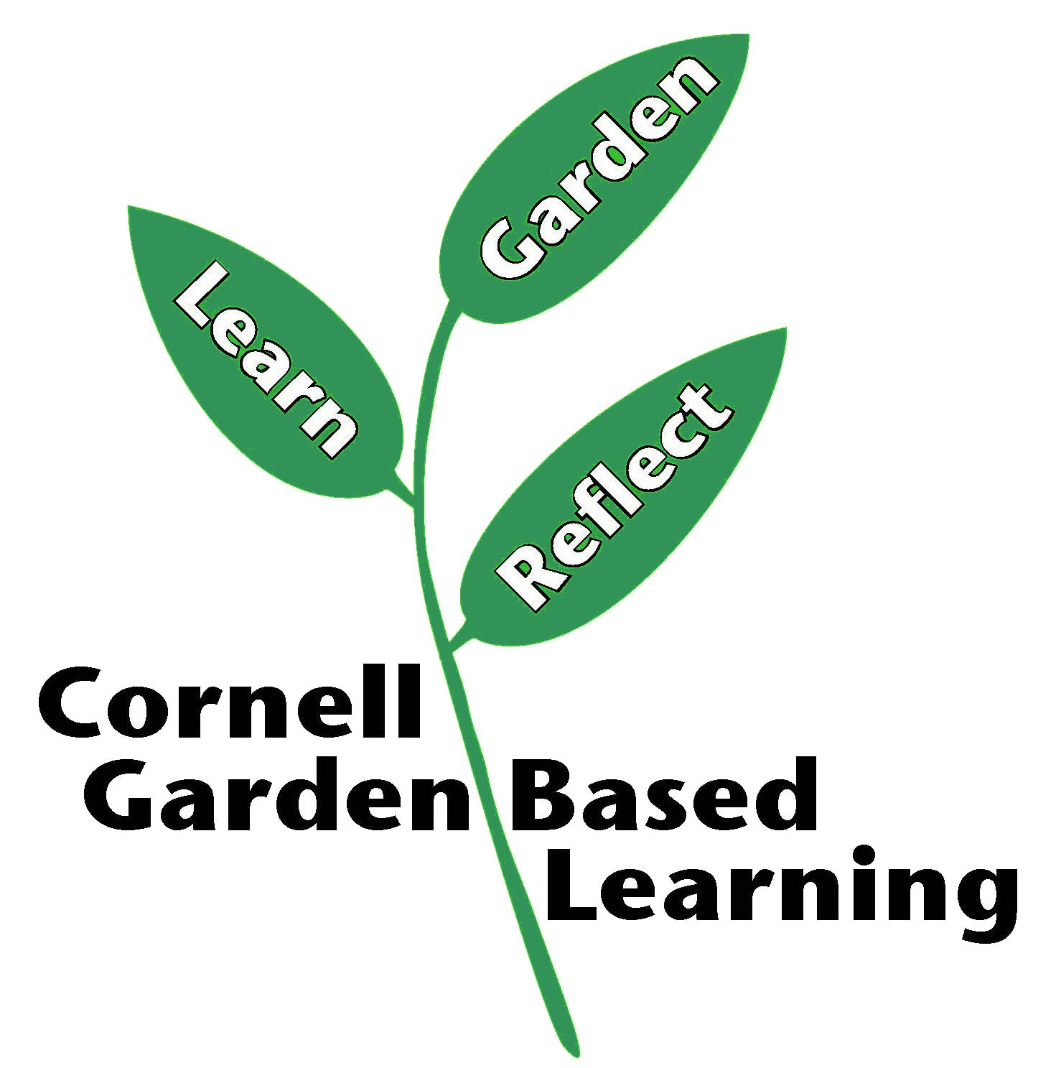
Published: April 2019
Contributors: Fiona Doherty, Lori Brewer, Cornell Garden-Based Learning
Sourced from Cornell University’s Seed to Supper course, Spring 2018.
Reviewer(s): Donna Alese Cooke

