Youth Development and School Gardens
Knowledge Check
In the Learning Library - Core Preparation Sessions
this is Section 6.2 in Module 6: Youth Development and School Gardens
- List one or more benefits to youth when program organizers aim to reach a higher rung on Hart’s Ladder?

- Describe the four pillars of positive youth development that serve as the foundation for our garden-based learning activities.

- What is an action an organizer could take to incorporate “belonging” into a youth gardening program?

- A group in your community is planning to start a youth garden project. What should be one of their first action steps if their goal is to promote interest in gardening among youth?

- Name an organization, program, book or website where you might look for youth garden curriculum or activities.

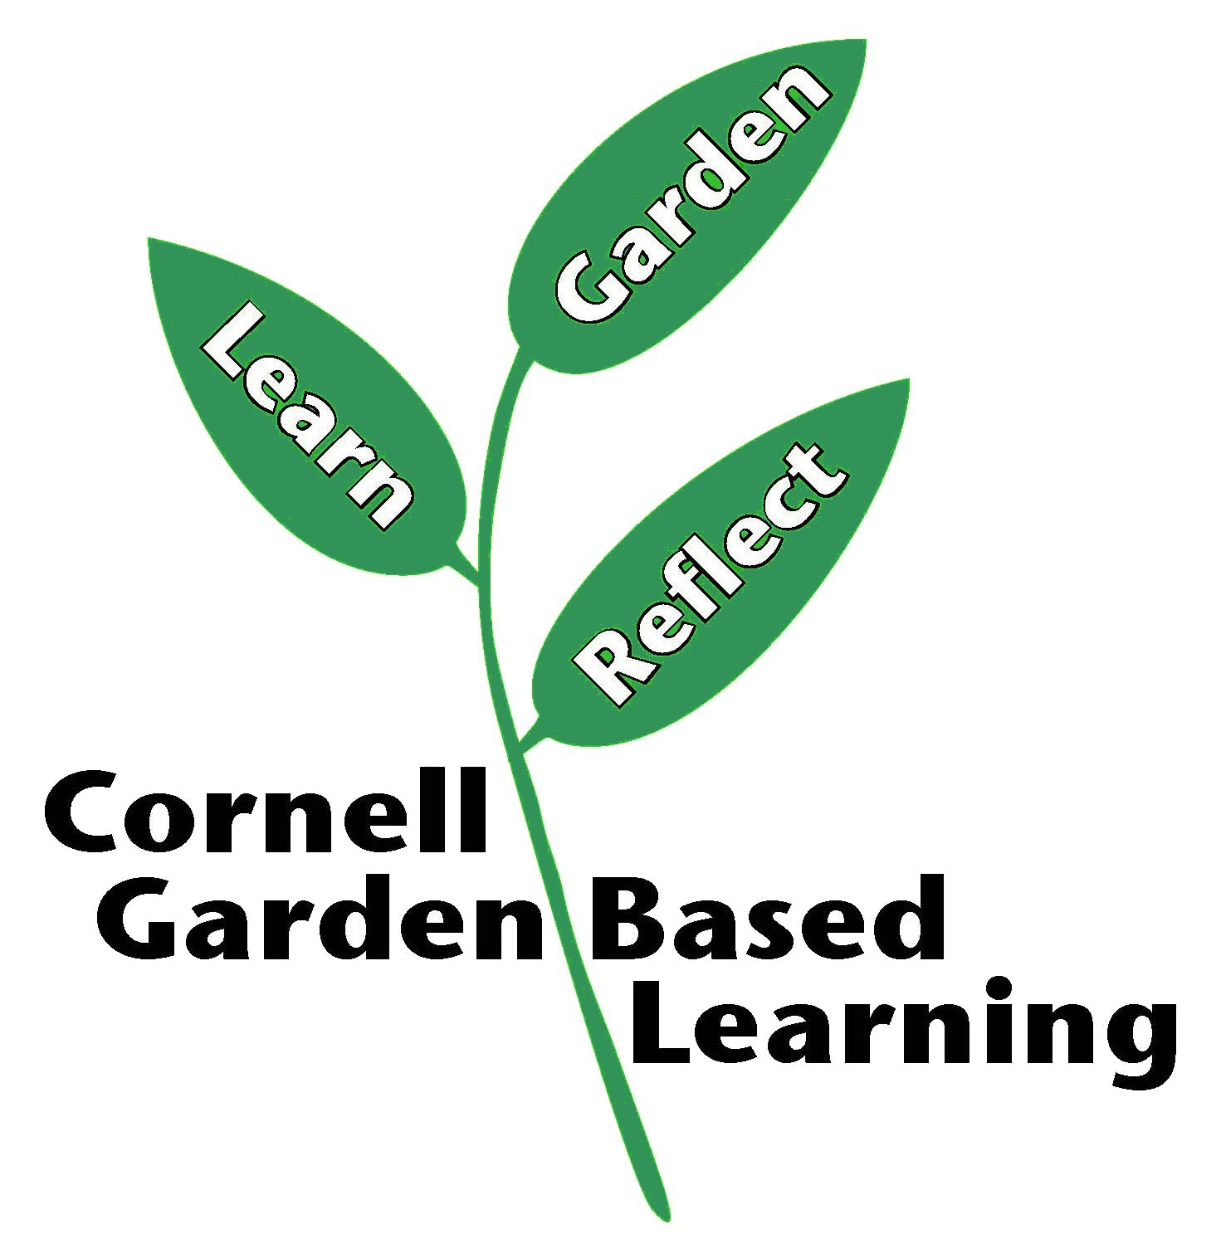
Date Published: April 2019
Author: Fiona Doherty
Reviewer(s): Marcia Eames-Sheavly, Michelle Podolec, Lori Brewer, Linda Gillilland, Holly Wise

