Vegetable Gardening I
Knowledge Check
In the GBL Learning Library - Core Preparation Sessions
this is Section 2.1a in Module 2: Food Gardening

1. What are some best watering practices for a vegetable garden?

2. List three examples of cool season crops.

3. List three examples of warm season crops.

4. What are three things that will help reduce diseases in your plants?

5. True or False: It is best to wash all vegetables immediately after harvesting.

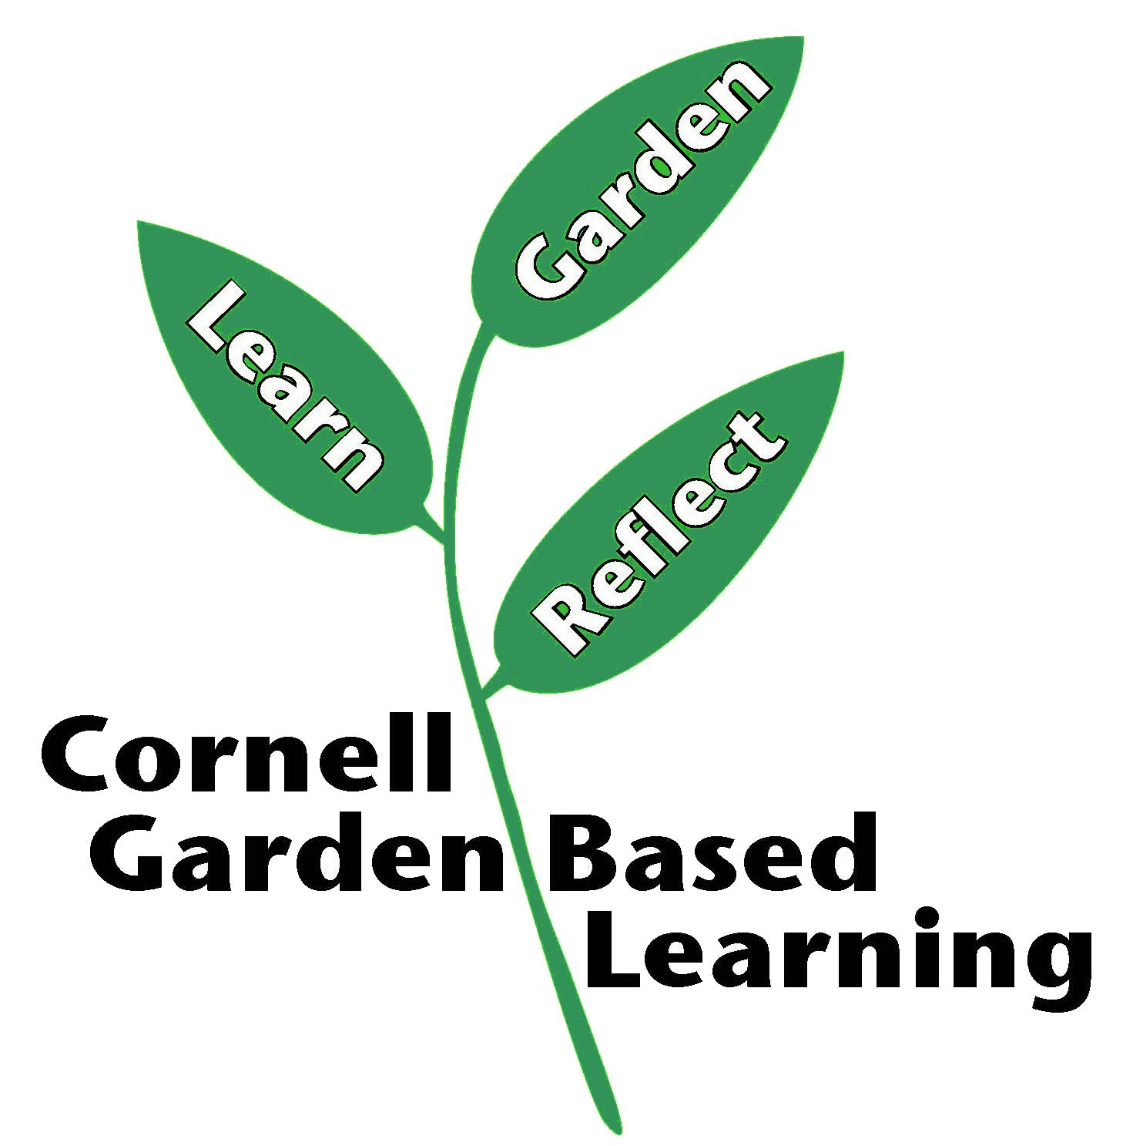

Date Published: April 2019
Contributor: Fiona Doherty
Reviewer(s): Laurie VanNostrand, Donna Alese Cooke

