Group Gardens and New York State Seed to Supper
Knowledge Check KEY

- What are some best practices for responding to insensitive statements in the Seed to Supper context?
- Pause. Reflect on your own internal response. Do you have any assumptions? What comes to mind for you...?
- Draw them in. Invite people into a dialogue, asking them more about what they may have meant. “Please tell me more about...help me understand...”
- Bring it out. This is where we name what we observed, how we feel and the actual/potential impact on ourselves and others. How can they use their intent in a constructive way?
- Invite them forth. Ask how they will take action with their new awareness that comes from our dialogue.

- List a few of the potential group garden partnerships that you could make in your community.
  - Food Pantry Garden – For food insecure individuals.
  - Religious Organization Gardens – Tend to focus on needs of congregation community and service.
  - Special Population Groups – Public health non-profits or private facilities focused on mental illness, addiction, senior citizens and groups with disabilities.
  - Immigrant Community Garden – Affiliated with refugee or new arrival communities.
  - School and Community Center Gardens – Often focused on youth programming, in school and after school (see CGBLL Youth Development and School Gardens Folder)
  - Neighborhood Association - Focused on residential use.

- Name a few of the roles and responsibilities within the Seed to Supper program.

- Program Participants- Primary audience is low-income adults on a limited income
- Garden Educators - volunteer garden educator teams (facilitators) lead classes/experiences with program participants at community host sites
- Satellite Partners – Organization responsible for coordinating S2S Programs
  - Provide Garden Educator Course and program coordination – CCE County Assoc. or Food Bank
- Host Agencies – Secure community sites for hosting the beginning gardening course

- Name one resource from the Participant Guide that can help you research issues of poverty and inequity in your community.

The following are just a few examples referenced in the guides and slides:
- Teaching Tolerance
- NAAEE
- Cornell Garden-Based Learning Program
- CCE Program Work Team on Poverty and Economic Hardship

- What groups have seen an increase in interest in vegetable gardening in a National Gardening Association Report?

- 63% increase - Millennials (18 to 34)
- 25% increase - Households with children
- 38% increase - Households w/incomes < $35K

6. If you have questions about how to engage Low-Literacy Audiences, what resources can you use?

Guidelines for Best Practices: How Do We Reach Low-Literacy Audiences
https://cpb-us-e1.wpmucdn.com/blogs.cornell.edu/dist/f/575/files/2019/02/Guidelines-for-Best-Practices-113zgba.pdf

7. In your own words, define Equitable vs. Equal ways to recruit participants in Seed to Supper?

According to the World Health Organization External link (WHO), equity is "the absence of avoidable or remediable differences among groups of people, whether those groups are defined socially, economically, demographically or geographically.“ Equality is often described as “leveling the playing field,” but in truth we cannot provide equal programming for unequal differences in resources across participants in our program.

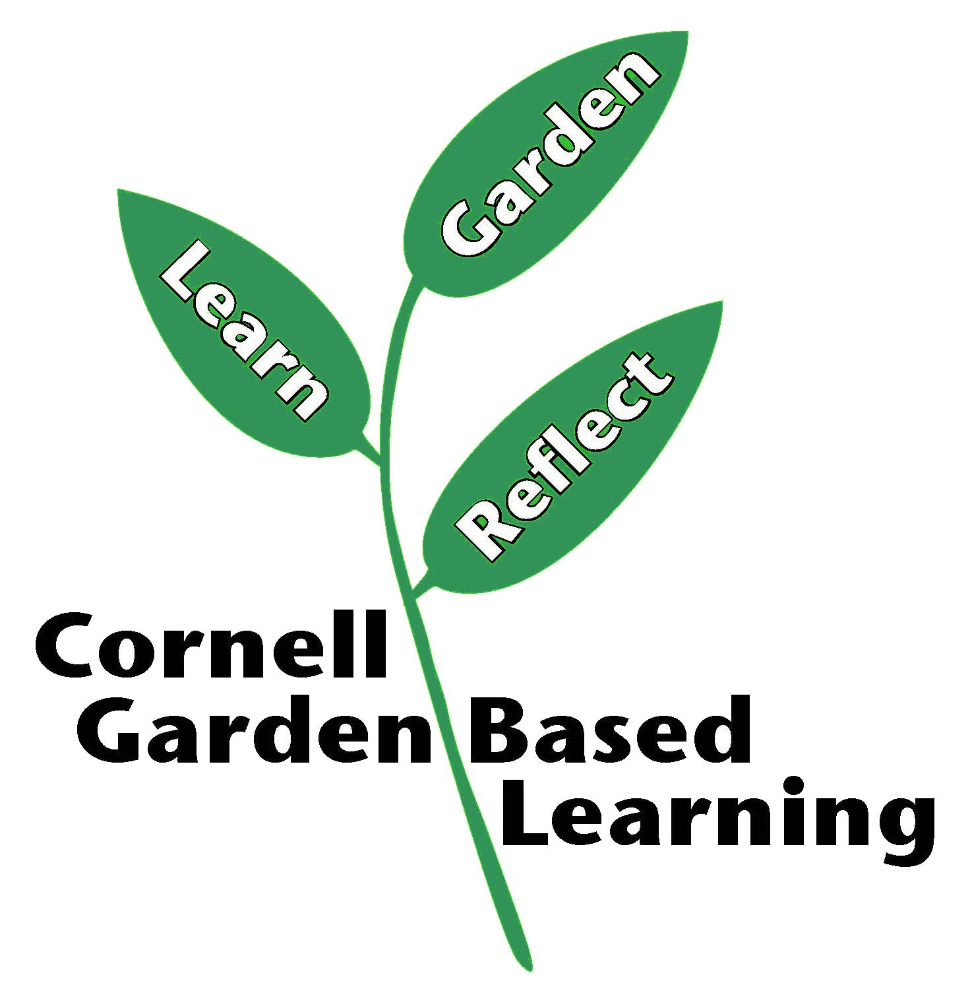
Date Published/Updated: 2/5/2020
Author(s)/Contributor(s): Ashley Miller Helmholdt
Reviewer(s): Marcia Eames -Sheavley

