Vegetable Gardening Part 2
Knowledge Check KEY
In the GBL Learning Library - Core Preparation Sessions
this is Section 2.1b in Module 2: Food Gardening

1. Why is it best to avoid planting crops from the same family in the same place 2 years in a row? How many years should you wait?
(From the Planning your Garden Chapter in the Seed to Supper Manual)
Changing the location of plant families from season to season can help prevent disease, pest problems, and loss of nutrients from the soil.
When possible, wait 4 years or more before rotating a family back into the same spot. If your space does not allow for crop rotation, you can still keep your garden healthy. Do it by building up your soil with compost, growing cover crops, keeping the garden clean, and choosing disease-resistant plant varieties.

2. Provide an example of succession planting. Why might it be valuable strategy in promoting soil health?
(From page 3, Planning your Garden Chapter in Seed to Supper Manual)
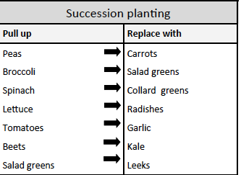
Bare soil is prone to erosion, keeping plants growing in the soil can help hold it in place. If a plant material such as a cover crop is incorporated into the soil when it dies, it adds organic matter as well.

3. My squash plant looks terrible, what is wrong with it? 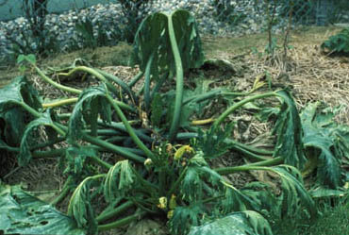
Image Sourced: https://extension.illinois.edu/vegproblems/vineborer.cfm
(From Top 10 Vegetable Garden Questions) The Squash Vine Borer larva borrows into the stems, destroying the vascular system and causing wilt.

4. What is one season extension technique?
(From Advanced Vegetable Gardening Presentation) Row covers, hot caps, wall of water.

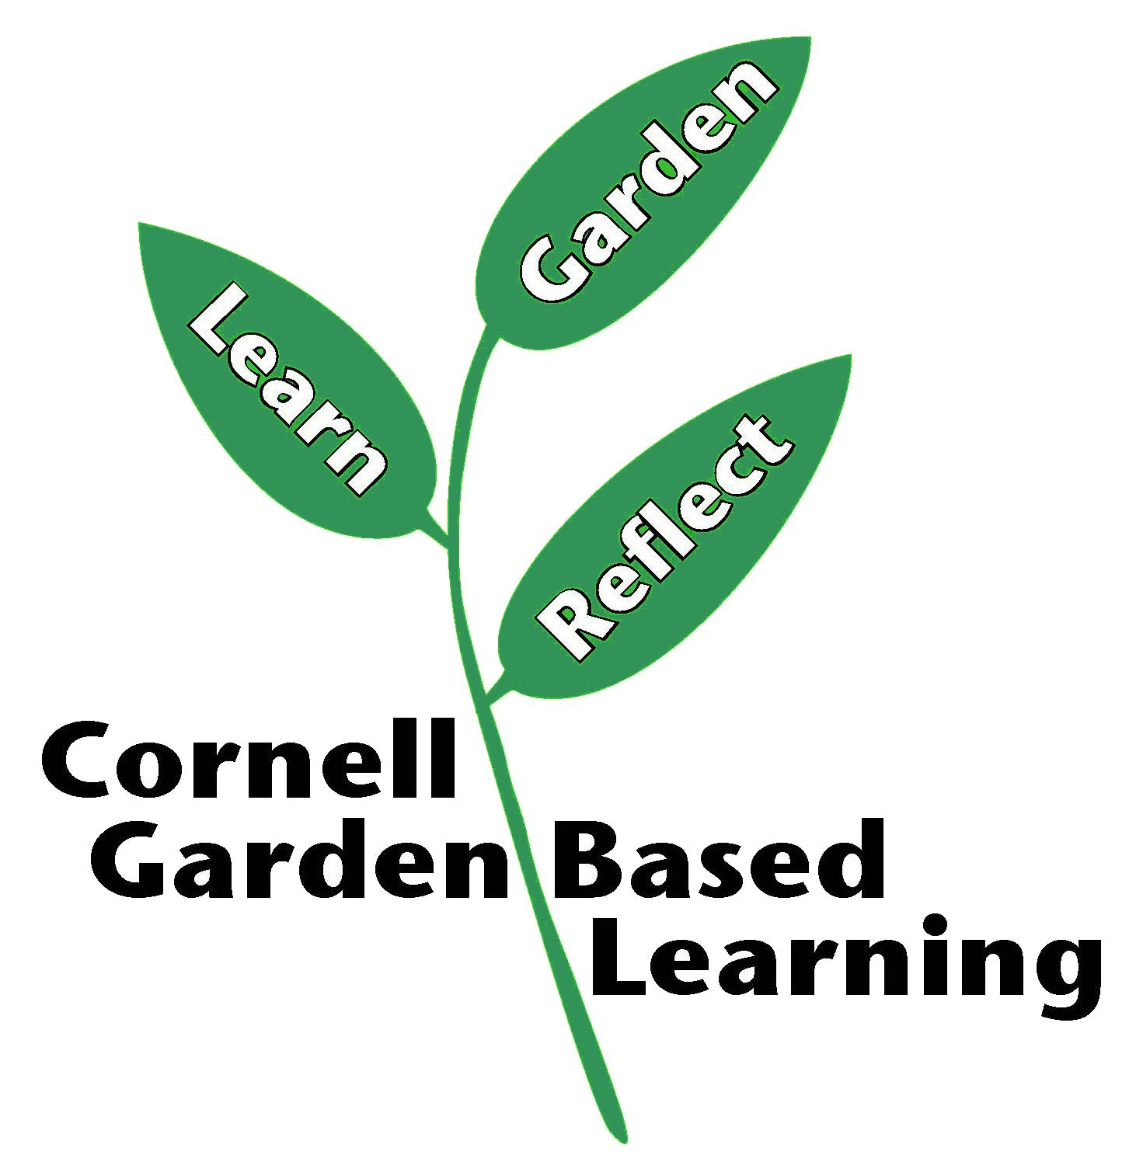
Published: April 2019
Author: Fiona Doherty
Reviewer: Laurie VanNostrand, Michelle Podolec, Donna Alese Cooke

