Vegetable Gardening I
Knowledge Check KEY
In the GBL Learning Library - Core Preparation Sessions
this is Section 2.1a in Module 2: Food Gardening

1. What are some best watering practices for a vegetable garden?
(From Vegetable Garden 10 Things to Know presentation) Needs about 0.5-1.5 inches of water per week; For overhead watering the best time to water is in the early morning; Avoid shallow watering.

2. List three examples of cool season crops.
(From Vegetable Garden 10 Things to Know presentation) Peas, spinach, chard, cabbage, broccoli, kale, carrots, beets, onions, potatoes, radish, etc.

3. List three examples of warm season crops.
(From Vegetable Garden 10 Things to Know presentation) Tomato, pepper, eggplant, snap beans, cucumbers, basil, sweet corn, sweet potatoes, etc.

4. What are three things that will help reduce diseases in your plants?
(From Vegetable Gardening Pests presentation) Several possible answers including plant resistant varieties if possible, keep the leaves dry, remove sick plants immediately.

5. True or False: It is best to wash all vegetables immediately after harvesting.
(From U-W Extension MGV Level 1 video ‘Vegetables 6 Harvest’). False: It is best to wash vegetables immediately before consuming. Wet produce is more prone to rotting.

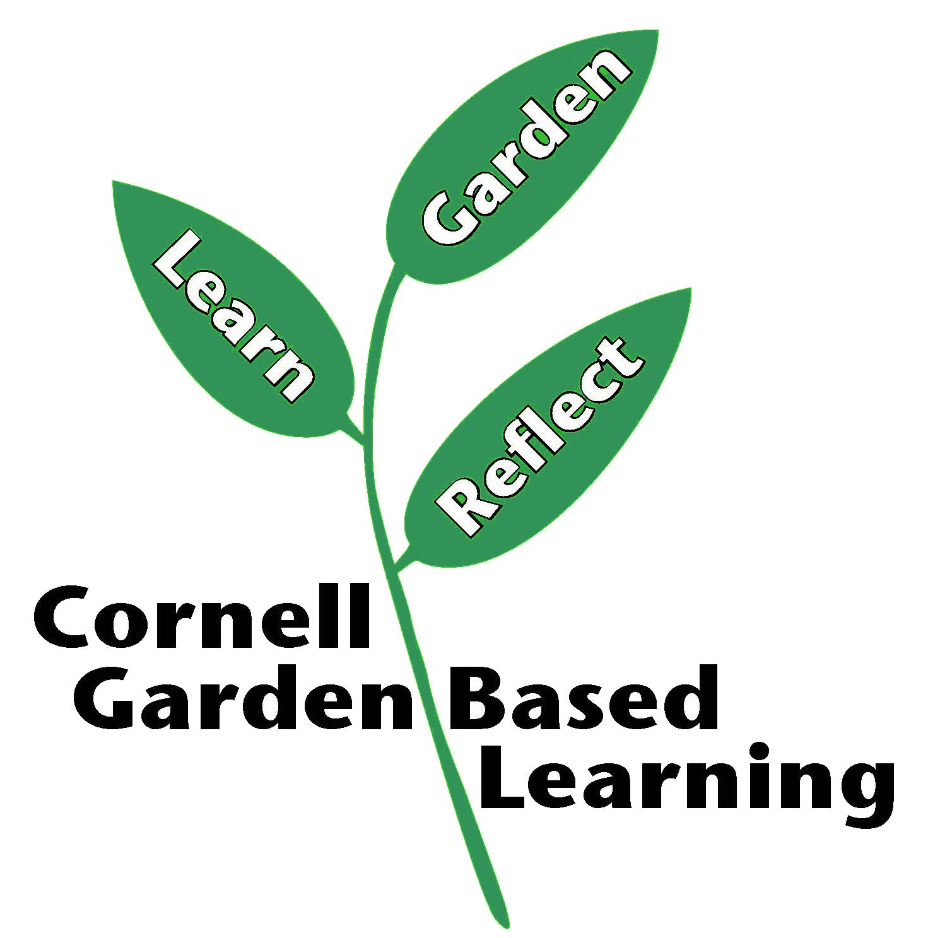

Date Published: April 2019
Contributor: Fiona Doherty
Reviewer(s): Laurie VanNostrand, Donna Alese Cooke

