Fruit Gardening
Knowledge Check
In the GBL Learning Library - Core Preparation Sessions
this is Section 2.2 in Module 2: Food Gardening

1. What is critical to consider before a gardener plants a fruit crop?

2. Name several keys to success for growing fruit trees in the garden.

3. Name several keys to success for growing grape vines in the garden.

4. Name several keys to success for growing strawberries in the garden.

5. Name several keys to success for growing brambles (raspberries and blackberries) in the garden.

6. Name several keys to success for growing blueberries in the garden.

7. Name several keys to success for growing ribes (gooseberries and currants) in the garden.

References: Cornell Guide to Growing Fruit at Home, https://ecommons.cornell.edu/bitstream/handle/1813/67/Cornell_Guide_to_Growing_Fruit.pdf?sequence=2&isAllowed=y

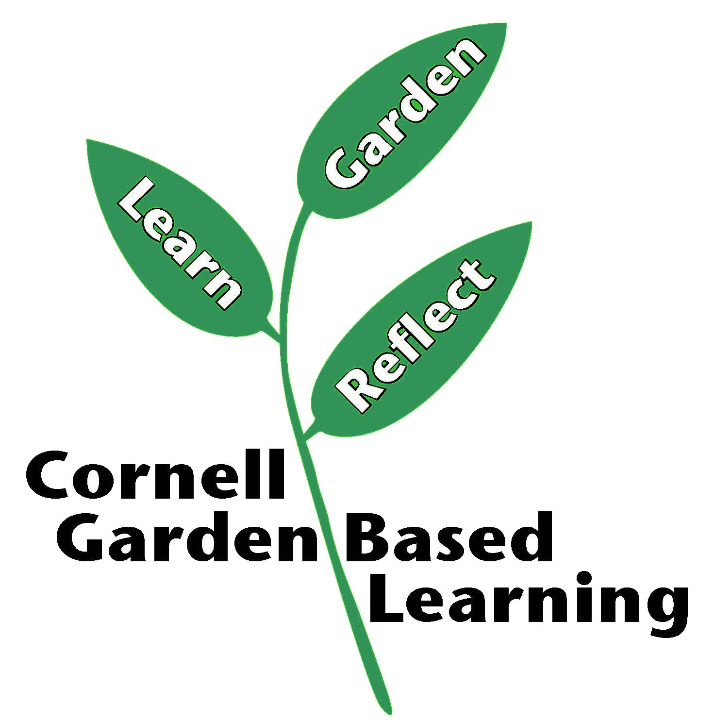
Published: April 2019
Compiled by: Fiona Doherty
Reviewed by: Donna Alese Cooke, Michelle Podolec, Russell Welser

