Plant Biology for Gardeners

Knowledge Check **KEY**

In the MGV Learning Library - Core Preparation Sessions

this is Section 1.1 in Module 1: The Fundamentals

1. Use print publications or other reliable resources to research the botanical names (formal scientific name) of the following plants:

1. Redbud (Eastern Redbud) ***Cercis canadensis***
2. Arrowwood ***Viburnum dentatum***
3. White oak ***Quercus alba***

Cornell Woody Plant database:[*http://woodyplants.cals.cornell.edu/home*](http://woodyplants.cals.cornell.edu/home)

2. Can you identify the error(s) in each of the following botanical names? What is a common name or names for each plant?

1. Cornus florida *Cornus florida* (italic needed); Flowering Dogwood
2. *Prunus subhirtella* “Pendula” *Prunus subhirtella* ‘Pendula’ *(use ‘ not “)* or *Prunus subhirtella* var. *pendula;* Higan Cherry or Rosebud Cherry
3. *Acer Rubrum* ‘October Glory’ *Acer rubrum* ‘October Glory’ (lower case R); Red Maple
4. *Acer palmatum* ‘waterfall’ *Acer palmatum* ‘Waterfall’ (upper case W) or

*Acer* *palmatum* var. *dissectum* 'Waterfall'; Japanese Maple

[*Latin 101*](http://blogs.cornell.edu/gblblog/files/2016/08/Latin-101-by-Dora-Galitzki-in-Garden-Design-magazine-Oct-2000-p88-to-89-2clthf6.pdf) by Dora Galitzki

3. Identify the bud and leaf arrangement for each twig. Is it opposite, alternate or whorled?

alternate Line drawing of two twigs with leaves in different arrangements.

Description: http://www.butler.edu/herbarium/treeid/altopp.jpg opposite

*(Botany Language Basics* Factsheet)

4. What word is used to describe the overall form of these trees? columnar

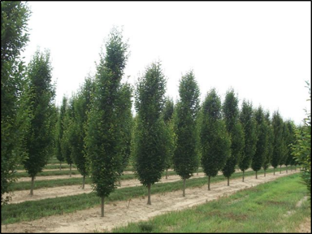

Crown form

https://www.na.fs.fed.us/spfo/pubs/uf/sotuf/chapter_3/appendix_a/appendixa.htm

*(Botany Language Basics* Factsheet)

5. How do we describe each of the three leaves?

Line drawing of three different leaf types. 
Description: http://www.butler.edu/herbarium/treeid/cmpndleaves.jpg

From left to right: pinnate compound; palmate compound; pinnate compound (or twice pinnate compound) (*Botany Language Basics* Factsheet)

6. Study the drawing below and write the plant part name on each line.

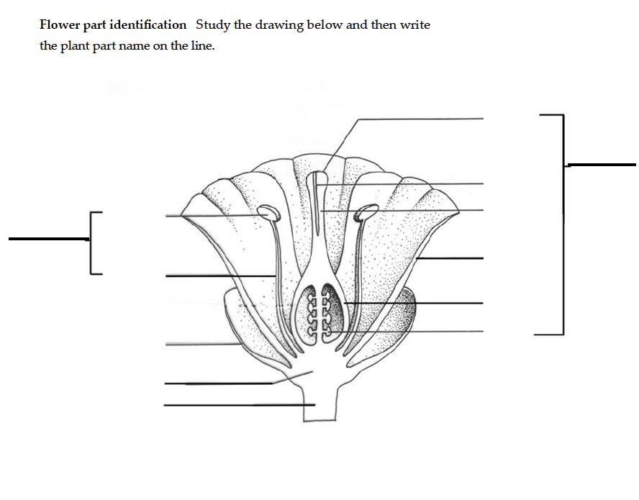

Stigma

Pistil

(note pistil only includes stigma, style, ovule, and ovary)

Pollen

Tubee

Anther

Filament

Stamen

Stylee

Petale

Ovarye

Sepal

Ovulee

Receptaclee

Pedicel

7. Is the diagram above a perfect or imperfect flower? What characteristic distinguishes the two?

Perfect because it has "male" stamens and the "female" pistil. An imperfect has either male parts or female parts, not both. (*Botany Language Basics* Factsheet)

8. Is the diagram above a complete or incomplete flower? What characteristic distinguishes the two?

It is complete because it has the 4 main flower parts (sepal, petal, stamen and pistil). An incomplete flower lacks one or more of these 4 main parts. *(Botany Language Basics* Factsheet)

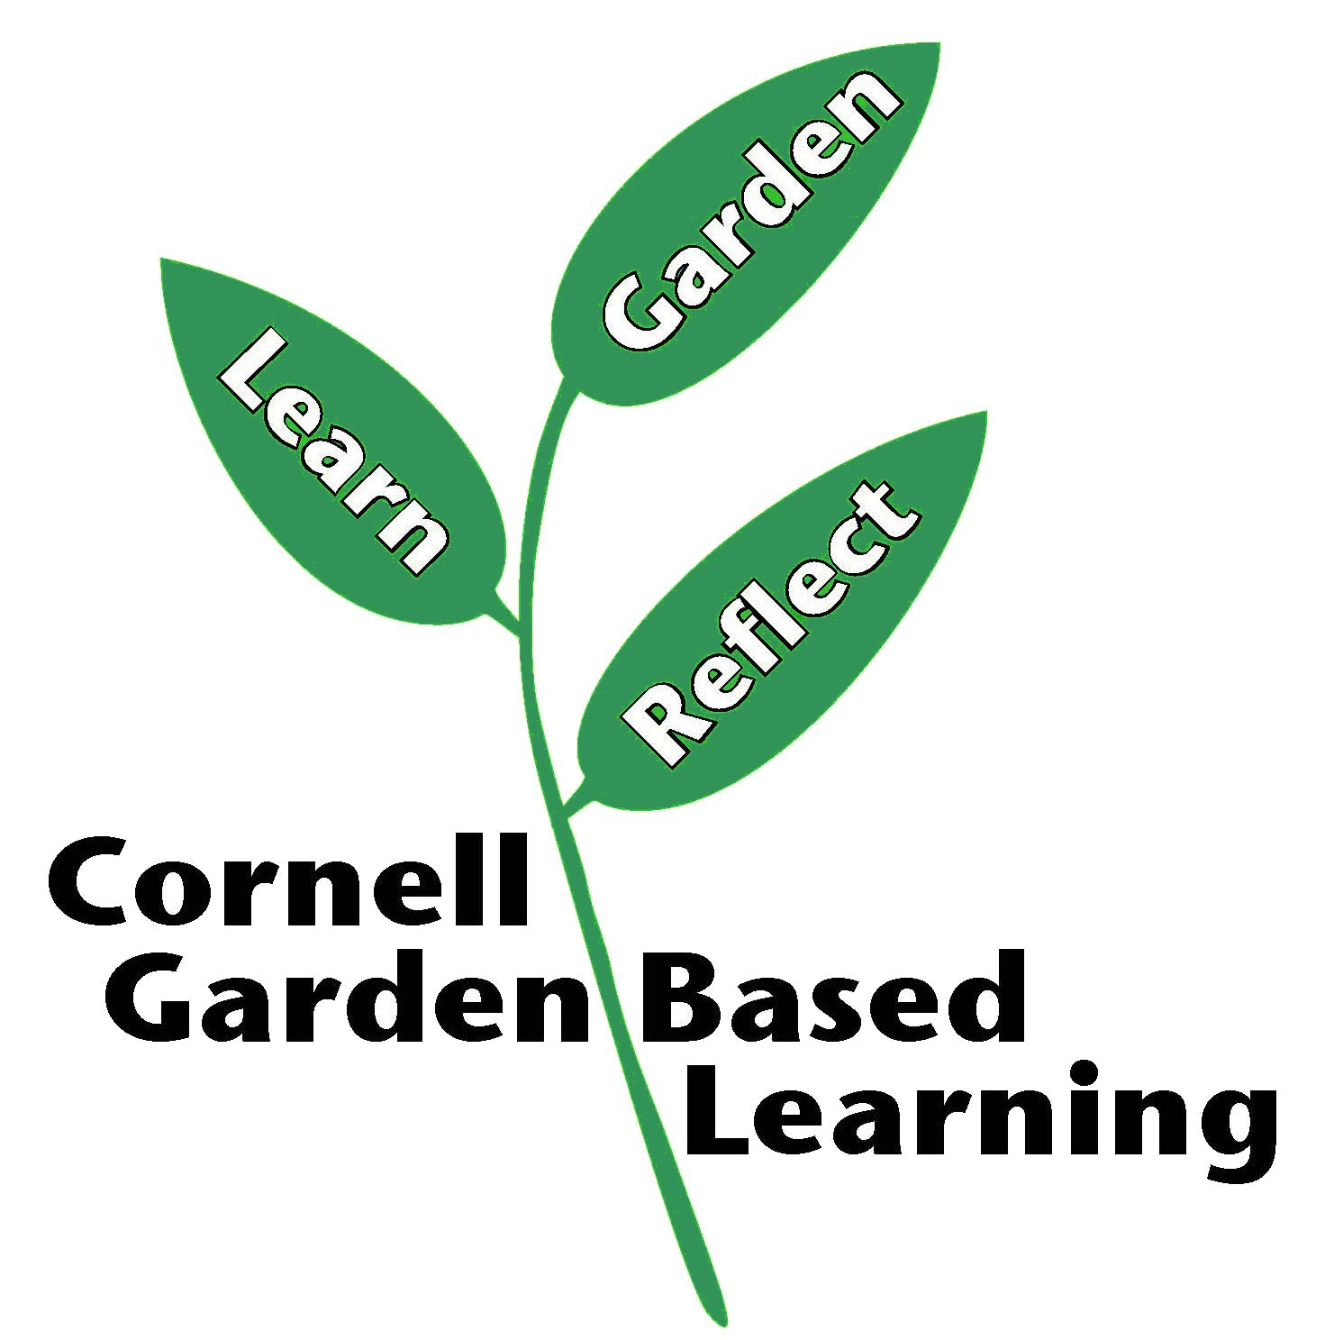References: [*Latin 101*](http://blogs.cornell.edu/gblblog/files/2016/08/Latin-101-by-Dora-Galitzki-in-Garden-Design-magazine-Oct-2000-p88-to-89-2clthf6.pdf) by Dora Galitzki, *Botany Language Basics* <https://blogs.cornell.edu/gblblog/files/2015/12/fact-sheet-botany-language-156ysah.pdf>, Cornell Woody Plant database,[*http://woodyplants.cals.cornell.edu/home*](http://woodyplants.cals.cornell.edu/home)

Date Published: April 2019

Author(s)/Contributor(s): Barb Neal, Lori Brewer

Reviewer(s): Fiona Doherty