Group Gardens and NYS Seed to Supper
Knowledge Check

- What are some best practices for responding to insensitive statements in the Seed to Supper context?

- List a few of the potential group garden partnerships that you could make in your community.

- Name a few of the roles and responsibilities within the Seed to Supper program.

4. Name one resource from the Participant Guide that can help you research issues of poverty and inequity in your community.

5.What groups have seen an increase in interest in vegetable gardening in a National Gardening Association Report?

6. If you have questions about how to engage Low-Literacy Audiences, what resources can you use?

7. In your own words, define Equitable vs. Equal ways to recruit participants in Seed to Supper?

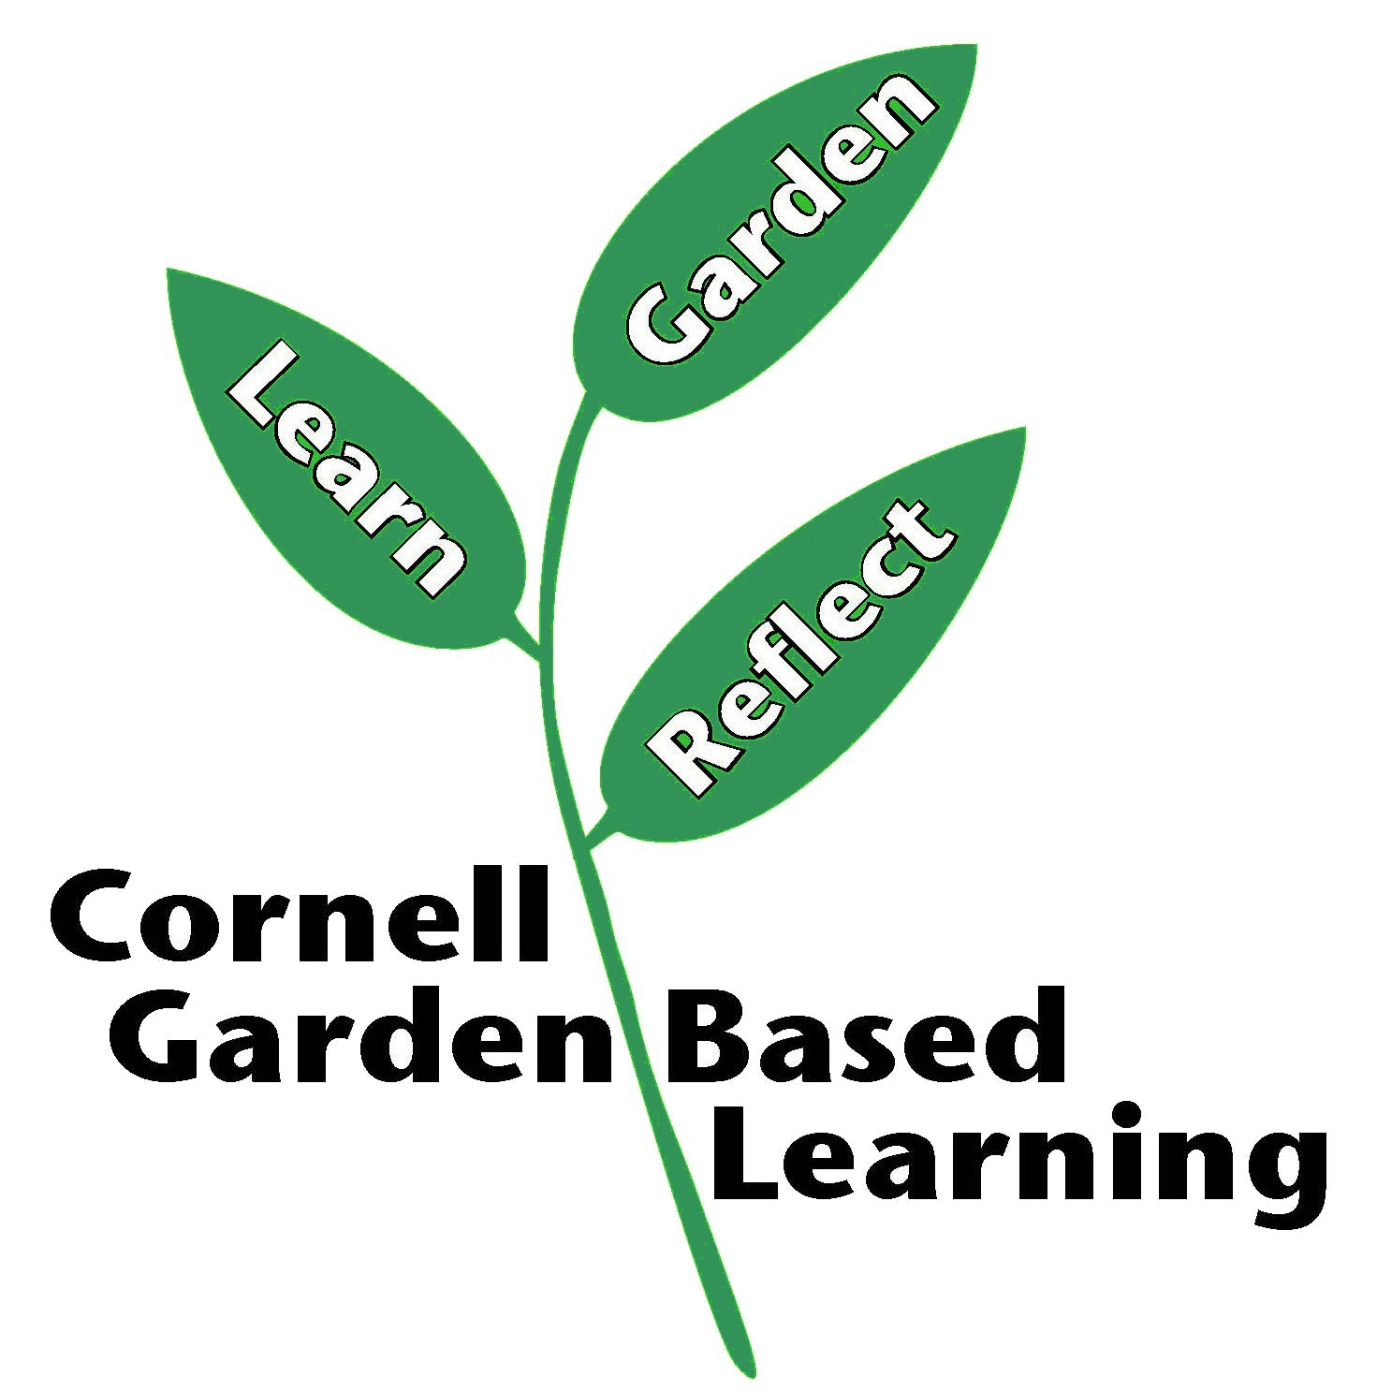
References:
Date Published/Updated:
Author(s)/Contributor(s):
Reviewer(s):

