Soil Contaminant Discussion Activity KEY
15 Minutes
Learning Objective(s):
Participants will…
- Recognize that soils can be impacted by lead and other contaminants and it is important to consider the quality of any material that you add to your garden in order to avoid unknowingly spreading contamination.
- Become familiar with the Cornell Waste Management Institute and Healthy Soils, Healthy Communities Project website and materials.
- Recognize that there are things people can DO to address these soil contamination concerns.
Supplies:
- Sources and Impacts of Contaminants in Soils handout for each participant
- What Gardeners Can Do: 10 Best Practices for Healthy Gardening handout for each participant
Instructions:
Ask participants to read the articles, Sources and Impacts of Contaminants in Soils and What Gardeners Can Do: 10 Best Practices for Healthy Gardening. Then, in pairs or small groups, discuss the following questions:
1. What are some potential sources of soil contaminants?
A: Certain chemical elements occur naturally in soils as components of minerals, yet may be toxic at some concentrations. Other potentially harmful substances may end up in soils through human activities.
Soil properties are affected by past land use, current activities on the site, and nearness to pollution sources. Human activities have intentionally added substances such as pesticides, fertilizers and other amendments to soils. Accidental spills and leaks of chemicals used for commercial or industrial purposes have also been sources of contamination. Some contaminants are moved through the air and deposited as dust or by precipitation.
2. What are some factors that affect the fate of soil contaminants?
A: Different contaminants vary in their tendency to leach through the soil and end up in water, evaporate into the air or bind tightly to the soil.
Soil characteristics also have an impact on the behavior of contaminants. These characteristics include:
- Soil mineralogy and clay content (soil texture);
- pH (acidity) of the soil;
- Amount of organic matter in the soil;
- Moisture levels;
- Temperature; and
- Presence of other chemicals.
3. What can people DO in response to known or suspected contamination? What type of healthy gardening practices?
A:
- Use clean soil and compost.
- Use raised beds.
- Avoid treated wood.
- Maintain soil nutrients and pH.
- Cover (or mulch) soil.
- Keep an eye on children.
- Leave the soil in the garden.
- Wash your hands.
- Wash and/or peel produce.
- Put a barrier under play areas.
4. What are the possible effects of soil contaminants?
A: Elevated levels of soil contaminants can negatively affect plant vigor, animal health, microbial processes, and overall soil health.
Regarding human exposure, the likelihood that health effects will occur depends on the toxicity of the contaminant (how harmful it is to humans), how much of the contaminant is in contact with humans, and how long and how often the exposure occurs. Other potentially important factors include how healthy the person is, and his or her age, diet, gender, family traits and lifestyle.
5. A community member contacts you; they are interested in planting vegetables in a nearby vacant lot. What are some questions you might discuss with them?
A:
- Has lead paint been used on the outside of homes or other buildings on or near the property?
- Are pesticide chemicals currently used on the property? Were pesticides used in the past, such as for old orchards or farms?
- Is the property near an industrial or commercial site that may be using chemicals or might have used chemicals in the past? Was the property formerly the site of industrial or commercial activity?
- Is the property located near a roadway with frequent traffic?
- Were decks, swing sets, playscapes, or other structures on the property built from pressure treated wood?
- Is there a history of spills or leaks of fuel oil, gasoline or other petroleum products on or near the property?
- Has automobile or other machine repair work been done that may have resulted in chemical spills or dumping on or near the property? Are junk vehicles stored on or near the property?
- Is the property near a landfill or garbage dump? Was it formerly the site of a landfill or garbage dump?
- Are fertilizers used for lawns or gardens on the property? Is the property near farmland or was it formerly used for agriculture?
- Has furniture been refinished on or near the property?
6. What remaining questions do you have about soil contaminants? Where might you look to learn more?
A:
- Healthy Soils, Healthy Communities FAQs: http://blogs.cornell.edu/healthysoils/faqs/
- Resources from Healthy Soils, Healthy Communities project (http://cwmi.css.cornell.edu/healthysoils.htm):
  - “What Gardeners Can Do: 10 Best Practices for Healthy Gardening” http://cwmi.css.cornell.edu/WhatGardenersCanDoEnglish.pdf
  - “What Gardeners Can Do: Tips for Urban Chicken Keepers” http://cwmi.css.cornell.edu/WhatGardenersCanDoChickens.pdf
- Agency for Toxic Substances and Disease Registry ToxFAQsTM - Information about contaminants: http://www.atsdr.cdc.gov/toxfaqs/index.asp
- Cornell Waste Management Institute fact sheets and other Resources for Healthy Soils: http://cwmi.css.cornell.edu/soilquality.htm
- NYSDOH brochure Healthy Gardening: Tips for New and Experienced Gardeners: http://www.health.ny.gov/publications/1301/index.htm
- NYSDOH Environmental Laboratory Approval Program (ELAP) list of certified laboratories: http://www.wadsworth.org/labcert/elap/elap.html
- NYSDOH Lead Poisoning Prevention website: http://www.health.ny.gov/environmental/lead
- U. S. Environmental Protection Agency information about Brownfields and Urban Agriculture: http://www.epa.gov/brownfields/urbanag/
- Agro-One Services - Testing for soil pH and fertility: http://www.dairyone.com/AgroOne/Form_H_Lawn_Garden_Landscape
References:
- Sources and Impacts of Contaminants in Soils, https://ecommons.cornell.edu/handle/1813/14282
- What Gardeners Can Do: 10 Best Practices for Healthy Gardening, https://ecommons.cornell.edu/handle/1813/48154
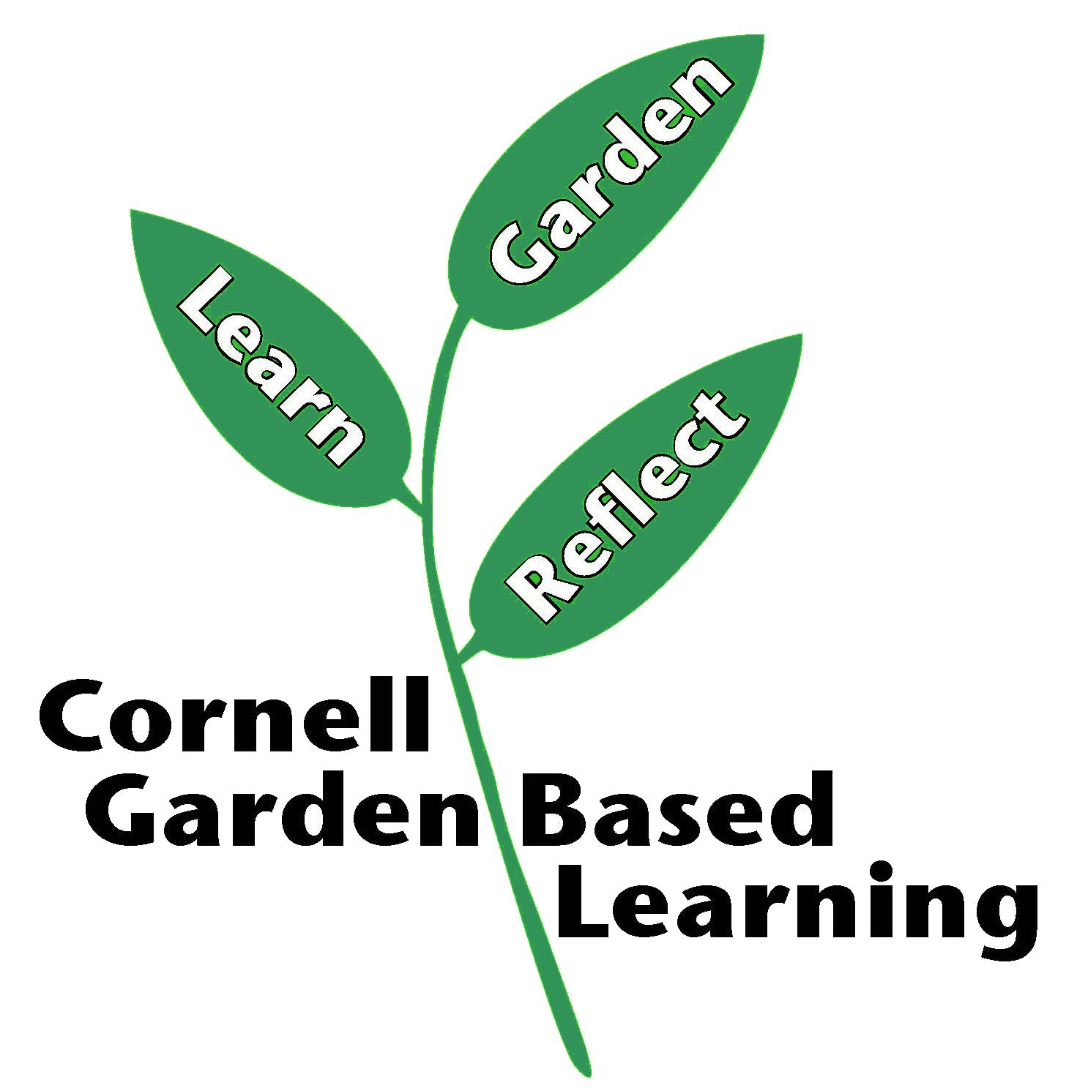
Date Published/Updated: April 2019
Contributors: Fiona Doherty, Hannah Shayler
Reviewer(s):Michelle Podolec

