Organic Waste Management: Composting
Knowledge Check
In the GB Learning Library - Core Preparation Sessions
this is Section 5.1 in Module 5: Management Strategies
- What is vermicomposting?

- What is the correct ratio of “Browns” to “Greens” in an active compost container?

- Name 4 “Browns”:

- Name 4 “Greens”:

- Name 3 organic waste items that should NOT go into a compost pile:

- Briefly describe a simple test to measure the maturity of a compost pile.

- Why might animals be attracted to a compost pile? What is one possible strategy to minimize this issue?

- Why might a compost pile smell like rotten eggs? What can someone do to correct this issue?

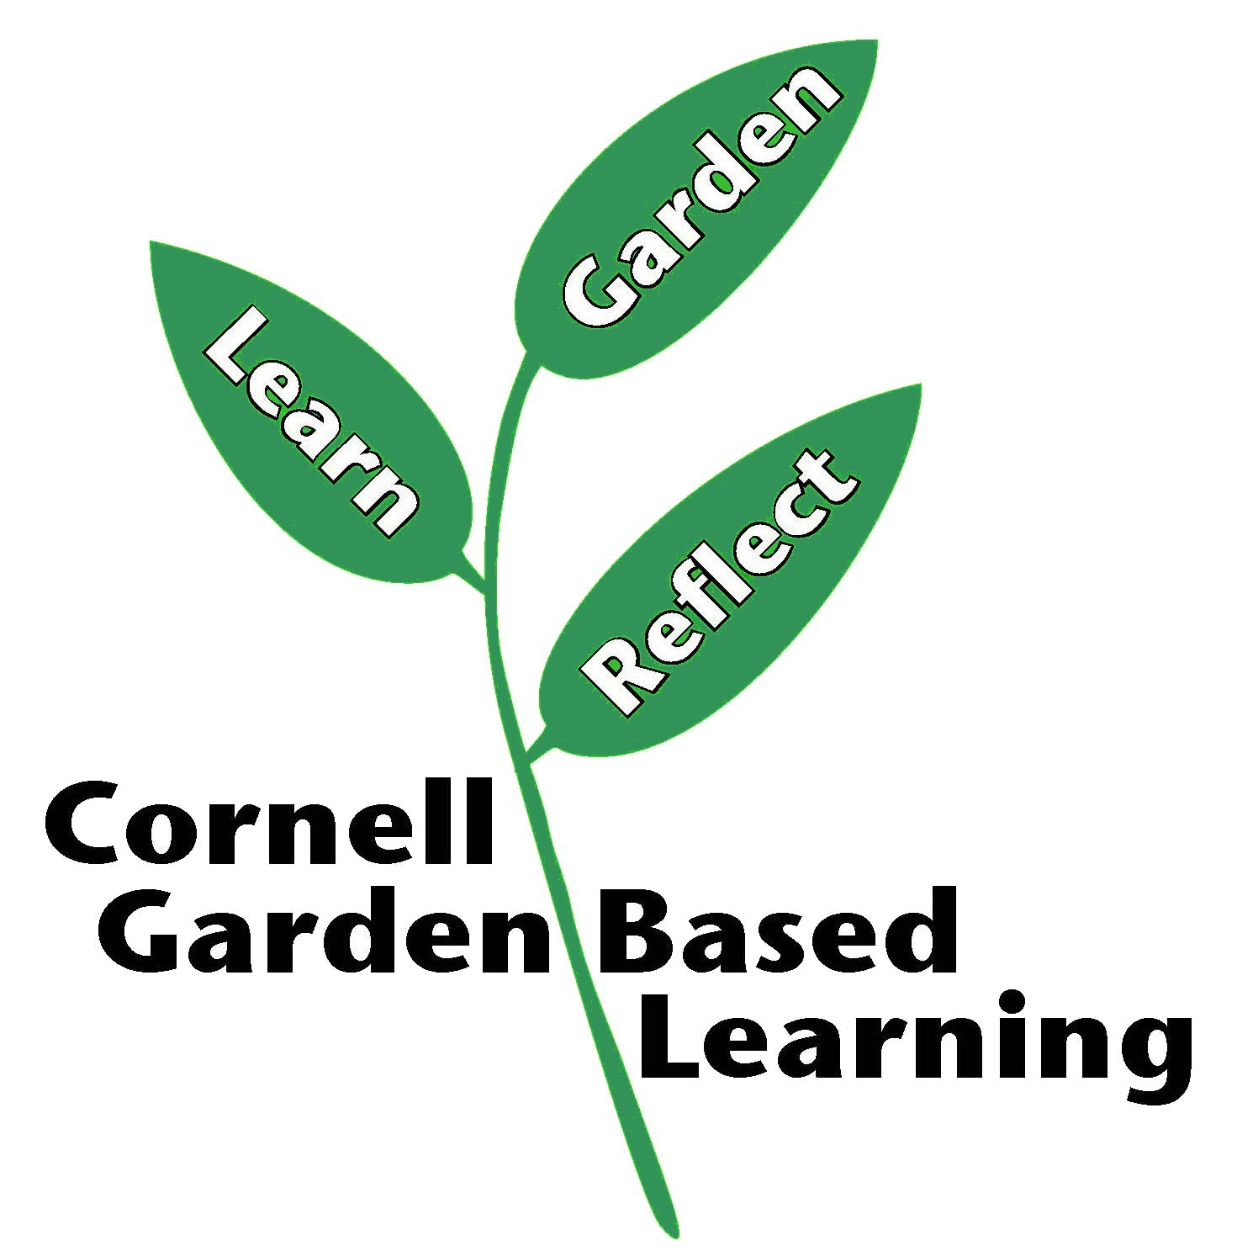
Date Published/Updated: April 2019
Contributors: Fiona Doherty, Lori Brewer
Reviewer(s): Michelle Podolec, Flip Filippi

