Right Plant, Right Place

Knowledge Check **KEY**

In the MGV Learning Library - Core Preparation Sessions

this is Section 1.2 in Module 1: The Fundamentals

1. What are four components of a basic site assessment?

There could be a variety of answers here including: obstructions above and below; sunlight levels; wind; soil compaction; soil drainage characteristics; soil texture; soil pH; Wildlife interference; USDA Hardiness Zone; traffic/usage level; organic or not organic; moisture level. (Right Plant, Right Place presentation)

2. Describe *Systems Thinking* and its role in gardening.

Answers should include a definition of systems thinking and a clear explanation of its connection to gardening. For example: Systems thinking considers the formulation, diagnosis and resolution of issues that arise from complex forms of interaction in systems. Different parts of a system are so interconnected that if we alter one part of a system it will change other parts. Systems thinkers focus on wholes rather than on parts. Gardeners can be systems thinkers when they consider the actions they take in their gardens and the environmental consequences that result form those actions. (Being a Systems Thinker reading and activity)

3. What are the components of soil?

Minerals, organic matter, water and air.

(Right Plant, Right Place presentation; Introduction to Soils reading)

4. List these soil particles from smallest to largest: sand, silt and clay.  
Clay is the smallest with particles less than 0.02mm in size  
Then comes silt with particles 0.05 – 0.02 mm in size  
The largest particles are sand particles sized 2.00-0.05 mm  
(Right Plant, Right Place presentation)

5. Describe the relationship of soil to plant growth and development.

Answers should include: Soils provide nutrients and oxygen for plants, store and supply water for plants, provides a habitat for plants and provides support for growth. (Right Plant, Right Place presentation: Introduction to Soils reading)

6. Soil pH has no effect on nutrient availability and plant health. False. (Right Plant, Right Place presentation: Introduction to Soils reading)

7. Organic matter includes components both living and nonliving. True. (Right Plant, Right Place presentation: Introduction to Soils reading)

8. Imagine you have soil that is 50% silt, 25% sand, and 25% clay. Fill in the jar to represent what the Jar Test would look like. The jar should have three bands. A band at the bottom about 25% of the width to represent sand, the middle band should be about 50% wide to represent silt and the top band should be about 25% wide to represent clay. (Jar Test activity)

Line drawing of an empty jar.

ttps://i.pinimg.com/736x/3e/d7/7a/3ed77a91757d05242156bbb233904a0b--bug-art-the-jar.jpg

<http://clipart-library.com/clipart/120557.htm>

9. One of this session’s learning objectives was that there is a right plant for right soil and the right soil for the right plant. Write 1-3 sentences supporting this statement. Answers may vary. Soil properties vary between environments and different varieties of plants thrive in these different environments. Trying to change our environment can have unintended consequences (systems thinking). Doing a site assessment to see what properties your site has and choosing plants that suit those characteristics will lead to a more productive and sustainable garden or landscape. (Right Plant, Right Place presentation: Introduction to Soils reading)

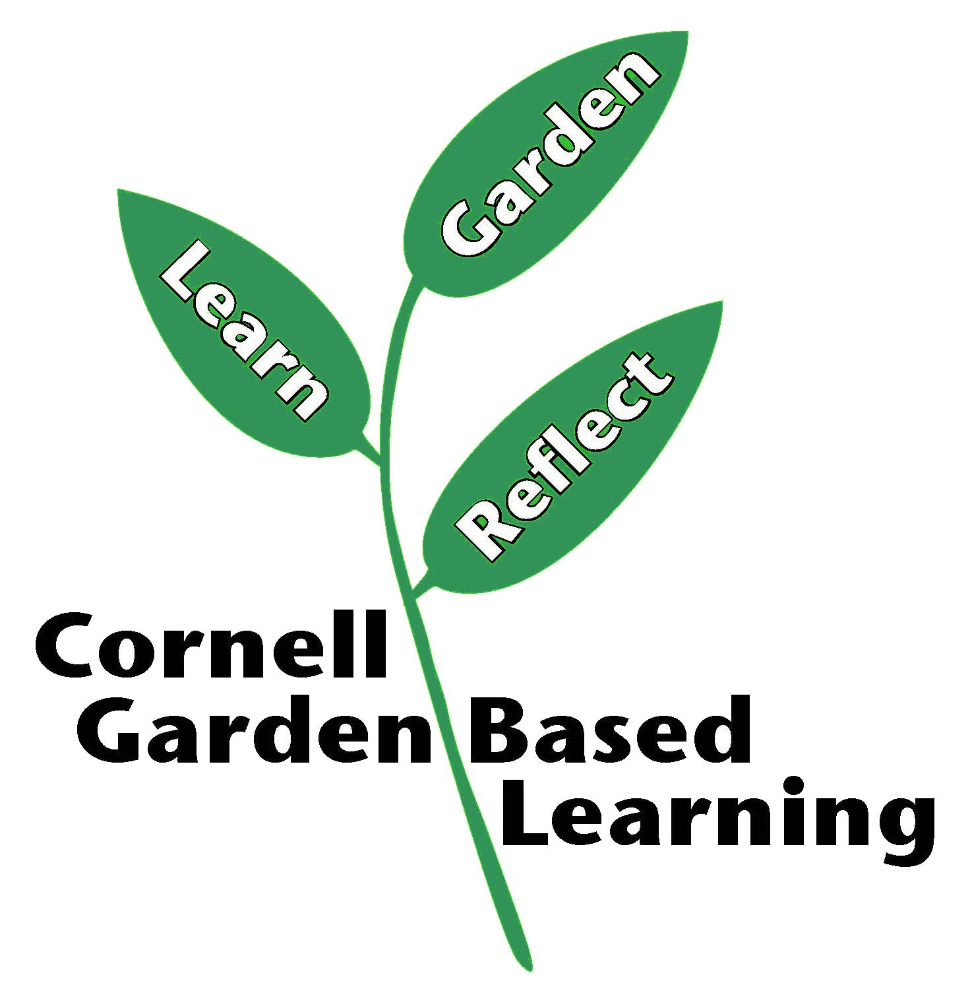

Date Published: April 2019

Contributor: Fiona Doherty

Reviewer(s): Donna Alese Cooke, Michelle Podolec, Jonathan Russell-Anelli