Plant Biology for Gardeners
Knowledge Check
In the MGV Learning Library - Core Preparation Sessions
this is Section 1.1 in Module 1: The Fundamentals

1. Use print publications or other reliable resources to research the botanical names (formal scientific name) of the following plants:

- Redbud
- Arrowwood
- White oak

2. Can you identify the error(s) in each of the following botanical names? What is a common name or names for each plant?

- Cornus florida
- Prunus subhirtella “Pendula”
- Acer Rubrum ‘October Glory’
- Acer palmatum ‘waterfall’

3. Identify the bud and leaf arrangement for each twig. Is it opposite, alternate or whorled?
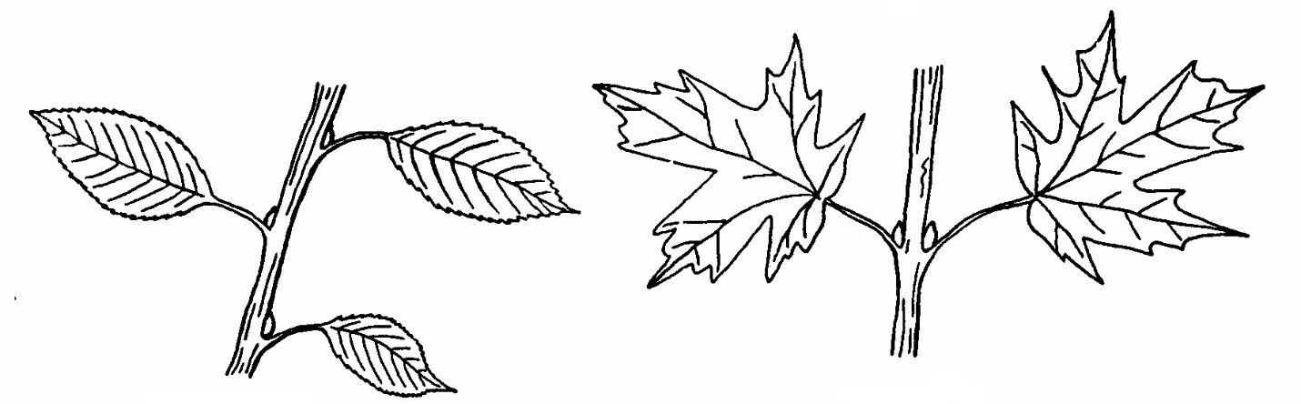

4. What word is used to describe the overall form of these trees?

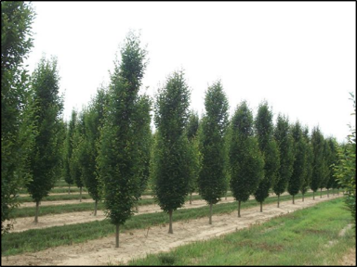
5. How do we describe each of the three leaves?
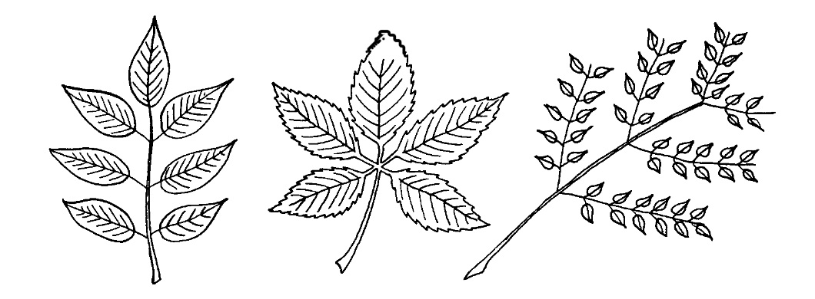

6. Study the drawing below and write the plant part name on each line.
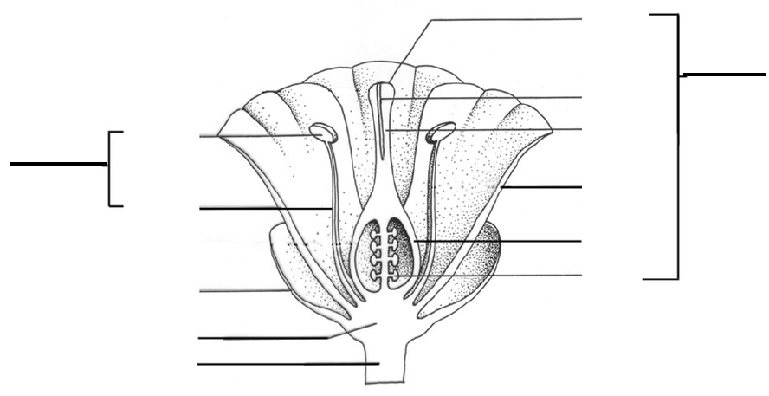

7. Is the diagram above a perfect or imperfect flower? What characteristic distinguishes the two?

8. Is the diagram above a complete or incomplete flower? What characteristic distinguishes the two?

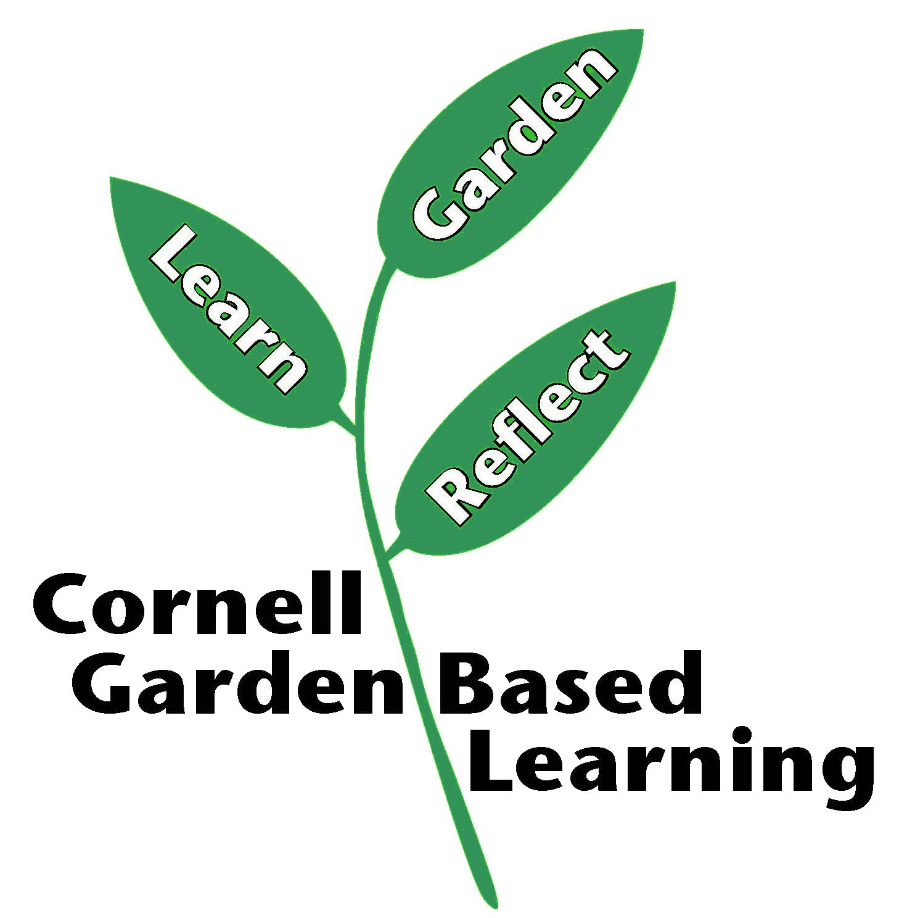
References: Latin 101 by Dora Galitzki, Botany Language Basics https://blogs.cornell.edu/gblblog/files/2015/12/fact-sheet-botany-language-156ysah.pdf, Cornell Woody Plant database, http://woodyplants.cals.cornell.edu/home

Date Published: April 2019
Author(s)/Contributor(s): Barb Neal, Lori Brewer
Reviewer(s): Fiona Doherty

